Additional appendices
Appendix A: Text message delivery
Table A6 shows the distribution of text messages delivered to students assigned to receive messages. All of the students who received zero messages (roughly 12%) did not provide valid cell-phone numbers. All students affected by the spam filter blockage received at least two of the scheduled messages, and many still received all six messages.
Aside from not fully communicating the intervention content as intended, these undelivered messages could bias our results if the affected students were concentrated within a specific treatment group – if this was the case, we would be unable to disentangle any estimated impacts from the content of the intervention versus the students receiving fewer texts. We test this explicitly by regressing the number of messages a student received on their treatment status. Panel 1 of Table A6 shows results of these regressions, which shows that treated students receive no more or fewer text messages compared to control students; Panel 2 show similar results across the four content variations. This pattern of results is true for both the full experimental sample (column 1) and the NSC 2018 match sample (column 2). This finding is not surprising: because text messages were delivered in “batches” organized by states and cell-phone carrier, there are certain carrier by state combinations for which messages were more likely to be blocked by spam filters. Our high-school level block randomization helped to maintain balance of messages delivered across treatment variations.
After confirming there is no relationship between text message delivery and treatment status, we tested whether the spam filter blocking appeared to occur “at random” – if so, then we could use the variation in the number of messages received to estimate differential treatment impacts based on the number of messages received. We test this explicitly by regressing student-level characteristics on indicators for the number of messages received. Appendix Table A7 displays the results of these regressions. We find that students who received more messages are observationally different than students who received fewer messages. Specifically, we find that students who received more text messages were less likely to be first generation college-goers; less likely to be eligible for a fee-waiver, and have higher entrance exam scores. Given that student differ substantially on observable characteristics based on the number of messages they received, it is reasonable to assume that students also differ substantially on unobservable characteristics for which we cannot control in our regression models. For this reason, we cannot take advantage of this implementation issue to estimate the impact of receiving the full set of intervention texts versus receiving fewer. We indeed find that students who received more text message had better enrollment outcomes (results available upon request), but we cannot draw any meaningful conclusions from these results.

Appendix B: Intervention content
To investigate the hypotheses we describe above for different behavioral strategies to encourage students to complete the FAFSA, we designed the following content variations. In Appendix A we present the text message content and postal mailers associated with each treatment variation. The emails we sent to students were essentially a combination of the textual and visual content in the text messages and postal mailers, and are available upon request.
Financial benefits of FAFSA completion
The financial benefits treatment variation focused on making the monetary gains associated with FAFSA completion highly salient to students. We highlighted that the average student from a lower-income student earns thousands of dollars in grant aid, and that students tend to earn more grant aid by filing FAFSA as early in the calendar year as possible. To make the financial gain associated with FAFSA particularly salient, we provided a visual comparison of how many hours they’d have to work in a job to earn the same amount of money for college that they would receive by investing a few hours to complete the FAFSA. The financial benefits treatment arm also used the potential financial gain associated with FAFSA as a motivation for students to pursue the steps necessary to file their FAFSA and finalize their financial aid applications (e.g. “$1000s could be waiting for you, but submitting the FAFSA is just step 1…To learn the steps that may be required to get your aid: http://bit.ly/fafsanext.”)

Positive Identity Activation
We designed messages in this treatment condition to prompt students to behave in ways consistent with a desirable identity—in this case, the identity of a motivated student. Messages identified the student as having behaved in a goal-oriented manner by completing their college applications, and provided graphical evidence of the student’s history of completing college-related tasks successfully. Messages primed students towards internal consistency by explicitly connecting the traits necessary for completing college applications to FAFSA submission (e.g. “You’re the kind of student who cares about their future: that’s why you applied to college. Now take action to control your financial future—submit the FAFSA.”) The identity activation condition also prompted students to complete FAFSA early in the calendar year by associating a forced social choice with early FAFSA completion: “Do you want to be in the group of students who maximize their financial aid award OR Are you OK being in the group that receives less financial aid?” Finally, message framing throughout the identity activation variation continually reinforced positive traits for students (e.g. “Hard-working students like you…”; “You’re the type of student who knows the value of time…”).

Planning Prompts
The planning treatment arms encouraged students to think about the logistics and time needed to complete the FAFSA, and to make a concrete plan for when and how they would work on the FAFSA. Planning messages acknowledged that students led busy lives, and that this business made it important to have a detailed plan for when they would complete FAFSA. Messages leveraged graphic representations to convey the importance and benefit of making a concrete plan for FAFSA completion. Separate visuals explicitly directed students to identify a specific date and time when they could spend 90 minutes working on FAFSA, and to set an alarm in their phone to remind them of this time. Finally, the planning treatment variation provided more detailed step-by-step guidance on how to complete the FAFSA (e.g. “Do you have a plan for completing the FAFSA? Step #1 is creating an FSA ID: http://bit.ly/myfsaid.”).
Control condition
Students assigned to the control condition received the same number of emails as the other content variations (four total for students in the fall and winter campaign; two for students in the winter-only campaign) providing general information about and encouragement to complete the FAFSA. The control emails informed students that completing the FAFSA could qualify them for grant aid for college and that completing the FAFSA early in the calendar year tended to qualify students for additional grant aid. The control emails directed students to the fafsa.gov website to learn more about the FAFSA or to begin their application.

Large State
Infographics condition
The infographics treatment condition provided similar information to students as the text-only condition but used visual images to capture attention and increase the salience of the information. The treatment used graphics to convey the importance of making a plan to apply for financial aid, to encourage students to apply early, to give step-by-step instructions for applying for financial aid, and to provide tips for transitioning to a new campus.
Motivation framing condition
We designed messages in the motivation framing condition to activate a positive identity – a motivated student – and encourage students to link behaviors that led then to successfully apply to college to applying for financial aid (e.g., “We know you’re the kind of person who gets important stuff done—like doing FAFSA to avoid losing your federal/state aid”). Since students had already applied for college successfully, text messages reminded them of what they had already accomplished and reinforced these positive traits when it came to the next step in the college-going process. Additionally, text messages encouraged students to continue making progress toward completing FAFSA (e.g., “Way to go! You’re partway to maximizing your aid for next year! But don’t stop before you reach the finish line”) and reminded them of resources for FAFSA completion (e.g., “You’ve got a team to help: The US Department of Ed has a FAFSA live chat and a phone hotline you can contact w/ any questions: http://bit.ly/FAFSALiveChat”).

Appendix C: Intervention materials
Common Application
Planning Mailer

Planning Text Messages
Number | Text
1 | (1/2) Hi [first_name], it’s Scott from The Common Application. As the New Year starts we want to make sure you get all the financial aid you’re eligible for.  (2/2) Stay tuned for texts about key financial aid tasks. Save the # so you know it’s us. Learn more: www.commonapp.org/fafsa.
2 | (1/2) Hi, it’s Scott again (from Common App). Do you have a plan for completing the FAFSA? Step #1 is creating a FAFSA ID: http://bit.ly/myfsaid  (2/2) Watch this short 3-minute video to learn the steps to apply for financial aid: http://bit.ly/fafsahow.
3 | (1/2) Hi [first_name]. You’ll need family income info to fill out FAFSA, but you can start even if your family hasn’t done 2015 taxes yet.  (2/2) For a list of paperwork you need, along w/ other next steps you can take, visit: http://bit.ly/fafsadocs. Add a phone reminder to gather these documents.
4 | (1/2) Hey [first_name]. How else besides FAFSA can you invest a couple hours of your time to potentially get $1000s in grants you don’t pay back?  (2/2) Take a minute to think about your schedule, and when you can block out 1-2 hours to start FAFSA: http://fafsa.ed.gov.
5 | (1/2) Hi [first_name]. Your time is valuable, and there are tools (like pre-populating the FAFSA w/ IRS tax info) that make FAFSA easier & faster.  (2/2) Set aside time to work w/ someone on FAFSA. FAFSA has live chat: http://bit.ly/myfafsahelp  Or visit www.commonapp.org/fafsa for local resources.
6 | (1/2) Hey [first_name]. Last financial aid text: After FAFSA colleges will send you letters about how much aid they will award you.  (2/2) If you need help understanding the award letter, call the aid office or visit www.commonapp.org/fafsa to find help near you.

Financial Benefit mailer

Financial Benefit text messages

Number | Text
1 | (1/2) Hi [first_name], it’s Scott from The Common Application. As the New Year starts we want to make sure you get all the financial aid you’re eligible for.  (2/2) Stay tuned for texts about key financial aid tasks. Save the # so you know it’s us. Learn more: www.commonapp.org/fafsa.
2 | (1/2) Hi, it’s Scott again (from Common App). Don’t forget that $1000s in college grant money may be available to you from the Dept. of Education & your state.  (2/2) Completing the FAFSA is the first step to getting your share of this financial aid. Step #1: Create your FAFSA ID today: http://bit.ly/myfsaid.
3 | (1/2) Hi [first_name]! Max your aid by doing FAFSA soon! Students who do FAFSA by March 1 get $1000s more in grants (on average) than students who file later.  (2/2) Go to http://fafsa.ed.gov to get started. Visit www.commonapp.org/fafsa to find FAFSA help near you.
4 | (1/2) Hey [first_name], how else besides FAFSA can investing a couple hours of your time result in potentially $1000s in free grants?http://fafsa.ed.gov  (2/2) For help, live chat with FAFSA: http://bit.ly/myfafsahelp. Hotline 800-4FED-AID. Or visit www.commonapp.org/fafsa for a list of local resources.
5 | (1/2) Hi [first_name]. $1000’s could be waiting for you, but submitting the FAFSA is just step 1. Check your email for info about additional steps.  (2/2) To learn the steps that may be required to get your aid: http://bit.ly/fafsanext. For help w/ FAFSA, visit www.commonapp.org/fafsa
6 | (1/2) Hi there. Last financial aid text: After FAFSA colleges will send you letters about how much aid they will award you.  (2/2) If you need help understanding the award letter, call the aid office or visit www.commonapp.org/fafsa to find help near you.

Identity/Norms Mailer

Identity/Norms text messages
Number | Text
1 | (1/2) Hi [first_name], it’s Scott from The Common Application. As the New Year starts we want to make sure you get all the financial aid you’re eligible for.  (2/2) Stay tuned for texts about key financial aid tasks. Save the # so you know it’s us. Learn more: www.commonapp.org/fafsa.
2 | (1/2) Hi, it’s Scott again (from Common App). We know you’re the kind of student who maximizes your potential: now do the same with your financial aid.  (2/2) Completing the FAFSA is the first step to getting your share of this aid. Step #1: Create your FAFSA ID today: http://bit.ly/myfsaid.
3 | (1/2) Hi [first_name]. Activating your motivation to do FAFSA pays off: Students who do FAFSA by March 1 get $1000s more in grants (on average).  (2/2) Go to http://fafsa.ed.gov to get started. Visit www.commonapp.org/fafsa to find FAFSA help near you.
4 | (1/2) Hi [first_name]. You’re the type of student that knows the value of time: 1-2 hours on FAFSA opens the door to potentially get $1000s in free grants.  (2/2) For help, live chat with FAFSA: http://bit.ly/myfafsahelp. Hotline 800-4FED-AID. Or visit www.commonapp.org/fafsa for a list of local resources.
5 | (1/2) Hi [first_name]. Hard-working students like you can have $1000s waiting for them: FAFSA is step 1.Check your email for info about additional steps.  (2/2) To learn the steps that may be required to receive your aid: http://bit.ly/fafsanext For help w/ FAFSA www.commonapp.org/fafsa
6 | (1/2) Hi there. Last financial aid text: After FAFSA colleges will send you info about how much aid they will award you.  (2/2) If you need help understanding the award package, call the aid office or visit www.commonapp.org/fafsa to find help near you.

Intervention materials for Large State

Number | Text
1 | (1/2) Hi, it’s [Large State application portal]. We want to help you achieve your goals to get a college degree. We’ll text you tips to succeed, or to enroll if you haven’t yet.  (2/2) Learn more: [link to Large State application portal information about outreach]. Msg&DataRatesMayApply. Text STOP to stop.
2 | (1/2) Hi it’s [application portal] again. Did you enroll in college this fall? Reply YES or NO  IF YES: That’s great, congrats! We’re cheering you on as you take on all the challenges that college offers. Are you feeling connected to your campus? Text Yes/No  Response to YES: That’s great! Having a strong community on campus is a great foundation for success. Reply TIPS for ideas to further strengthen your campus connection.  IF TIPS: (1/2) Look for a student group with people who share your interests or who you identify with. Grads say this is super important! Text NEXT  Response to Next:(2/2) Keep in touch with mentors from your community. The same people who supported you in high school want to help you succeed in college.  Response to NO: That’s OK, adjusting to college takes time for everyone. Reply TIPS for ideas that might help you build a sense of belonging on campus.  IF TIPS: (1/2) Look for a student group with people who share your interests or who you identify with. Grads say this is super important! Text NEXT  Response to NEXT: (2/2) Keep in touch with mentors from your community. The same people who supported you in high school want to help you succeed in college.  IF NO: That’s OK! Starting and completing college can be more affordable than you think. Reply AFFORD to learn more about how you can access financial aid resources.  If AFFORD: (1/3) First step is doing FAFSA. See [link to site] to learn which form you should submit. 1/3 of college students get free grants. Text NEXT  If NEXT: (2/3) With new changes to FAFSA, you can apply NOW using information from the 2015 taxes you or your family already filed. Text NEXT  If NEXT: (3/3) If you need help, there’s a FAFSA live chat & phone hotline: bit.ly/FAFSALiveChat. The [Large State] Financial Aid Center has bilingual advisors [link to site]
3 | (1/2) Hi! FAFSA needs to be renewed each year to keep your financial aid for next academic year. But there are new and important changes to FAFSA...  (2/2) THIS year, you can start FAFSA now and can use the 2015 taxes your family already filed. Ready to start? Reply YES or NO  If YES: That’s great! Doing FAFSA ASAP can maximize how much $$ you receive. Text FAFSA for concrete steps to get started.  Response if FAFSA:(1/5) Step #1 is to set up or look up your FSA ID at fafsa.gov. An FSA ID is necessary to access the FAFSA and federal loan websites. Text NEXT.  If NEXT: (2/5) Step #2: After you log on to fafsa.gov w/ FSA ID, click on “FAFSA Renewal.” This allows you to pull in data you’ve already submitted to FAFSA. Text NEXT  If NEXT: (3/5) Step #3 is to gather the documents you’ll need to complete FAFSA: social security #, driver’s license (if you have one), and 2015 tax returns. Text NEXT  If NEXT: (4/5) For short videos showing you how to set up/look up FSA ID and do FAFSA: http://bit.ly/FAFSAvideos. Text NEXT  If NEXT: (5/5) Now set aside a time to start the FAFSA! Think about your schedule this week and find a 20-minute block to do this.  If NO: We know fall seems early, but doing FAFSA as early as you can will maximize how much $$ you receive. Text NOW for more info on the benefits of filing now  If NOW: (1/3) Some colleges give $$ on a 1st come/1st serve basis, so doing FAFSA/State Application for Aid now means you’re more likely to get your share of this money. Text NEXT.  If NEXT: (2/3) Students who file early tend to earn thousands more in grants--$$ you don’t pay back. Text NEXT.  If NEXT: (3/3) You’ll learn how much federal aid you’re likely to receive for the 2017-2018 academic year. This could help inform your budgeting for the coming months.
4 | (1/1) Hi, it’s [application portal] again! Have you found helpful resources and supports to turn to if you run into any challenges with classes? YES/NO.  Response to YES: That’s awesome! Reply TIPS for ideas on how get even more out of your academic networks.  Response to TIPS: (1/3) Going to professors’ office hours is a great way to get questions answered about course materials. Profs can also help you find internship/jobs. Text NEXT  Response to NEXT: (2/3) Most schools have tutoring centers where students can get 1:1 help with classes! Check your college’s website or ask at the library. Text NEXT  Response to NEXT: (3/3) Creating study groups with peers in your classes or with friends is great for bouncing ideas off each other, especially when prepping for midterms.  Response to NO: That’s OK, it’s normal for it to take time to build a network on campus—you’ll get there! Reply TIPS for ideas on how to build your college support network.  Response to TIPS: (1/3) Going to professors’ office hours is a great way to get questions answered about course materials. Profs can also help you find internship/jobs. Text NEXT  Response to NEXT: (2/3) Most schools have tutoring centers where students can get 1:1 help with classes! Text NEXT  Response to NEXT: (3/3) Creating study groups with peers in class or with friends is a great way of dividing up course readings and materials, especially for midterms.
5 | (1/1) Hi! Renewing FAFSA is required to keep your federal/state aid for next year. Have you been able to start FAFSA yet? Reply YES or NO  If YES: Way to go! Renewing FAFSA is a major first step. You may have to do more to complete your app. Reply FAFSA for next steps to keep an eye on.  If FAFSA: (1/4) Remember you need your FSA ID to digitally sign your application at fafsa.gov. Text NEXT.  If NEXT: (2/4) Check your email often to see if you get emails from Federal Student Aid. Your aid office may contact you if you have to verify your income info. Text NEXT  If NEXT: (3/4) The US Department of Ed has a FAFSA live chat and a phone hotline you can contact w/ any questions: http://bit.ly/FAFSALiveChat. Text NEXT  If NEXT: (4/4) The financial aid office at your college may be able to help you with FAFSA, or can direct you to free help somewhere else on campus.  If NO: How about starting FAFSA this week? This can earn you more $$. Reply SUPPORT for a list of FAFSA help available online or in your community.  If SUPPORT: (1/4) The US Department of Ed has a FAFSA live chat and a phone hotline you can contact w/ any questions: http://bit.ly/FAFSALiveChat. Text NEXT  If NEXT: (2/4) The [Large State] Financial Aid Information Center has an email and phone hotline with bilingual representatives for help: [link to site] Text NEXT  If NEXT: (3/4) The financial aid office at your college may be able to help you with FAFSA, or can direct you to free help somewhere else on campus. Text NEXT  If NEXT: (4/4) There may be FAFSA completion events near where you live where there is additional free help: http://bit.ly/FAFSAevents
6 | (1/1) Hi again. We know how busy fall term can be busy. Can you make time over Thanksgiving break to do FAFSA? Reply YES, NO, or STARTED.  If STARTED: (1/6) Way to go! For FAFSA: Remember you need your FSA ID to digitally sign your application at fafsa.gov. Text NEXT.  If NEXT: (2/6) If you did [state application]: make sure to mail [state application] and other necessary documents to your college. Text NEXT  If NEXT: (3/6) Check your email regularly to see if you get any emails about FAFSA. Contact your aid office if you have to verify your income info. Text NEXT.  If NEXT: (4/6) The US Department of Ed has a FAFSA live chat and a phone hotline you can contact w/ any questions: http://bit.ly/FAFSALiveChat. Text NEXT  If NEXT: (5/6) The [state] Financial Aid Information Center has an email and phone hotline with bilingual representatives for help: [link to site]. Text NEXT  If NEXT: (6/6) The financial aid office at your college may be able to help you with FASFA, or can direct you to free help somewhere else on campus.  If YES: That’s great! Step #1 for FAFSA is to set up or look up your FSA ID at fafsa.gov. You’ll need FSA ID to access the FAFSA and federal loan websites. Text NEXT  IF NEXT: (2/5) FAFSA Step #2: After you log on to fafsa.gov w/ FSA ID, click on “FAFSA Renewal” so you can pull in data you’ve already submitted to FAFSA. Text NEXT  If NEXT: (3/5) Doing [state aid application]? Step #1 is to download and complete the 2017-2018 application: [link to site]. Text NEXT  If NEXT: (4/5) Next for FAFSA: Gather the documents you’ll need to complete FAFSA, like social security #, tax returns & income info. Text NEXT  If NEXT: (5/5) Now set aside a time to start the FAFSA! Think about your schedule this week and find a 20-minute block to do this.  If NO: That’s OK. You can still do FASFA in December or after the new year. Good luck with the rest of the semester and we’ll follow up in January!
7 | (1/1) Happy New Year! We want to make sure you get financial aid to help pay for college. Did you finish FAFSA in the fall? Reply YES or NO  If YES: That’s great, congratulations! Reply FAFSA for reminders of what to keep an eye out for with financial aid in 2017:  Response if FAFSA: (1/4) Now that you’ve started FAFSA, remember you’ll need your FSA ID to digitally sign your application at fafsa.gov. Text NEXT.  If NEXT: (2/4) Check your email regularly to see if you get any emails about FAFSA. Contact your aid office if you are required to verify your income info. Text NEXT.  If NEXT: (3/4) You should receive a financial aid award letter some time in spring. This will show how much you’ll get in grants, loans, and work-study. Text NEXT  If NEXT: (4/4) Meet with a counselor to discuss your award letter. They can help you understand what money is free, what comes in loans, and how much your family owes.  If NO: That’s OK, you can still do FAFSA now! Reply FAFSA for concrete steps you can take to unlock your aid:  Response if FAFSA: (1/6) Step #1 is to set up or look up your FSA ID at fafsa.gov. An FSA ID is necessary to access the FAFSA and federal loan websites. Text NEXT.  Response to Next:(2/6) Step #2: After you log on to fafsa.gov w/ FSA ID, click on “FAFSA Renewal.” This allows you to pull in data you’ve already submitted to FAFSA. Text NEXT  If NEXT: (3/6) Step #3 is to gather the documents you’ll need to complete FAFSA: social security #, driver’s license (if you have one), and 2015 tax returns. Text NEXT  If NEXT: (4/6) The US Department of Ed has a FAFSA live chat and a phone hotline you can contact w/ any questions: http://bit.ly/FAFSALiveChat. Text NEXT  If NEXT: (5/6) There may be FAFSA completion events near where you live where there is additional free help: http://bit.ly/FAFSAevents. Text NEXT  If NEXT: (6/6) For short videos showing you how to set up/look up FSA ID and do FAFSA: http://bit.ly/FAFSAvideos.

Examples of infographics for message 3:
3 | (1/2) Hi! FAFSA needs to be renewed each year to keep your financial aid for next academic year. But there are new and important changes to FAFSA...  (2/2) THIS year, you can start FAFSA now and can use the 2015 taxes your family already filed. Ready to start? Reply YES or NO  If YES: That’s great! Doing FAFSA ASAP can maximize how much $$ you receive. Text FAFSA for concrete steps to get started.  If FAFSA:  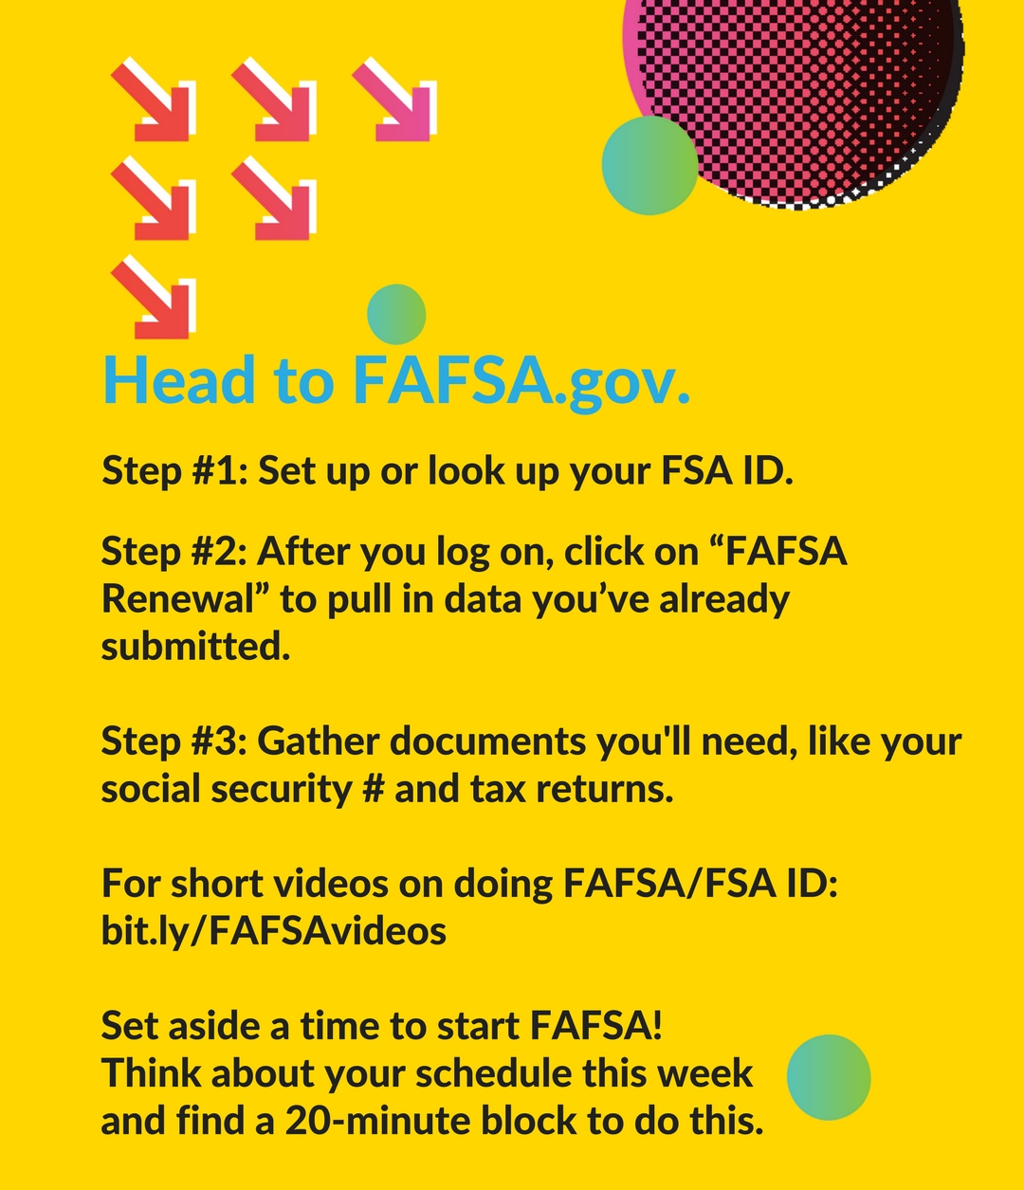  If NO: We know fall seems early, but doing FAFSA as early as you can will maximize how much $$ you receive. Text NOW for more info on the benefits of filing now  IF NOW:  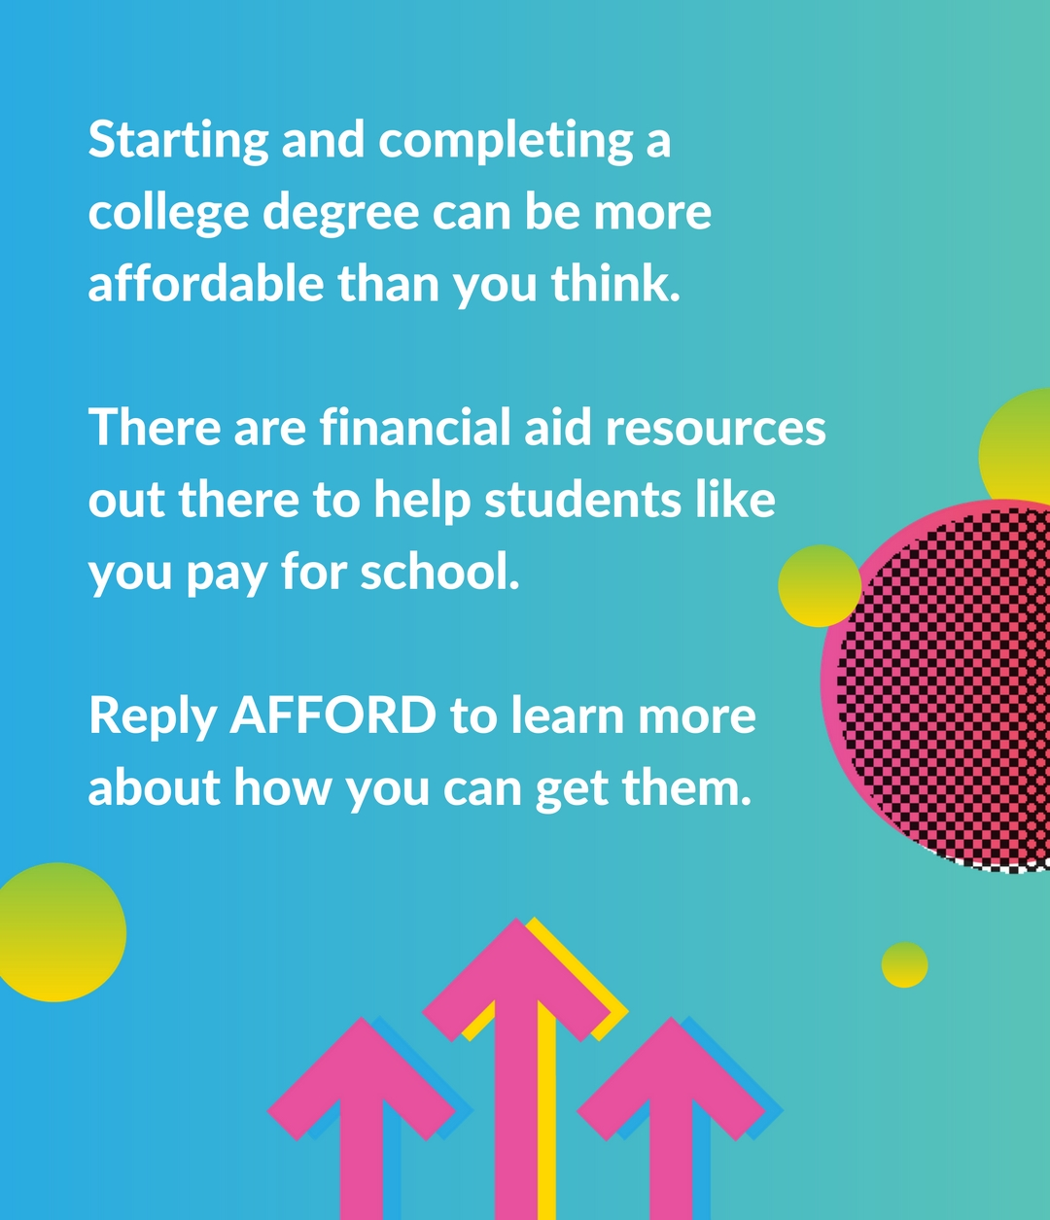

Motivation framing text messages
Number | Text
1 | (1/2) Hi [first_name], it’s [Large State application portal]. There are new and important changes to how you renew financial aid for next year in college...  (2/2) We’ll text you over the coming weeks with info about FAFSA and [state financial aid application]. Learn more: [link to site] (Msg&DataRatesMayApply. Text STOP to stop.
2 | (1/2) Still figuring out which financial aid application you should complete for next year--FAFSA or [state application]? This site can help: [link to site].  (2/2) If you prefer to stop receiving these texts, please reply STOP.
3 | (1/2) Hi! FAFSA or [state application] need to be renewed each year to keep your financial aid for next academic year. Don’t miss these new and important changes to FAFSA...  (2/2) THIS year, you can do FAFSA or [state application] early (anytime after 10/1) and can use the 2015 taxes your family already filed. Ready to start? Reply YES or NO  Response to YES: We’re glad you’re ready! Doing FAFSA ASAP can maximize how much $$ you receive. Text FAFSA or (State Application for Aid) for concrete steps to get started.  Response to FAFSA:(1/5) Step #1 is really important: set up or look up your FSA ID at fafsa.gov. An FSA ID is necessary to access the FAFSA and federal loan websites. Text NEXT.  Response to NEXT: (2/5) Step #2 should save you time: After you log on to fafsa.gov click on “FAFSA Renewal” so you can pull in data you’ve already submitted to FAFSA. Text NEXT  Response to NEXT: (3/5) Step #3 should be easy: gather the docs you’ll need to complete FAFSA: social security #, driver’s license (if you have), and 2015 tax returns. Text NEXT  Response to NEXT: (4/5) Step #4: Become an expert – for short videos showing you how to set up/look up FSA ID and do FAFSA: http://bit.ly/FAFSAvideos. Text NEXT  Response to NEXT: (5/5) Now set aside a time to start the FAFSA! Schedule a 20-minute block for this; put it in your phone or calendar. Reward yourself when you get this done!  Response to NO: Getting ready could pay off in $$: doing FAFSA ASAP after 10/1 can maximize your aid. Text NOW for more info on the benefits of filing now  Response to NOW: (1/3) Don’t lose out on $$ that you deserve. Money given1st come/1st serve could be gone if you wait. Get your share by doing FAFSA by 10/1! Text NEXT.  Response to NEXT: (2/3) Long-term payoffs: Students who file early tend to earn thousands more in grants—FREE $$ you never pay back. Text NEXT.  Response to NEXT: (3/3) You can plan ahead: Learn how much aid you’re likely to receive for next academic year. This could help inform your budgeting for the coming months
4 | (1/2) Hi! Filing FAFSA now can earn you more aid, but every day you wait could lose you $$. Here are some concrete steps to filing:  (2/2) For FAFSA: Step #1 is to set up or look up your FSA ID at fafsa.gov. An FSA ID is necessary to access the FAFSA and federal loan websites. Text NEXT.  Response to NEXT: (1/5) Step #2 should save you time: After you log on to fafsa.gov click on “FAFSA Renewal” so you can pull in data you’ve already submitted to FAFSA. Text NEXT  Response to NEXT: (2/5) Still figuring out which financial aid application you should complete for next year--FAFSA or [state application]? This can help: [link to site]. Text NEXT  Response to NEXT: (3/5) For [state application]: Step #1 is also key: Download and complete the 2017-2018 application anytime after 10/3 [link to site]. Text NEXT  Response to NEXT: (4/5) Next step for both: Gather documents you’ll need to complete FAFSA, like social security #, tax returns & income info. Text NEXT  Response to NEXT: (5/5) Now set aside a time to start! Schedule a 20-minute block for this; put it in your phone or calendar. Reward yourself when you get this done!
5 | (1/1) We know you’re the kind of person who gets important stuff done—like doing FAFSA to avoid losing your federal/state aid. Have you started? Reply YES/NO  Response to YES: Way to go! You’re partway to maximizing your aid for next year! But don’t stop before you reach the finish line - reply FAFSA for next steps:  Response to FAFSA: (1/4) Remember you need your FSA ID to digitally sign your application at https://fafsa.gov. Text NEXT.  Response to NEXT: (2/4) Check your email regularly to see if you get any emails about FAFSA. Contact your aid office if you are required to verify your income info. Text NEXT.  Response to NEXT: (3/4) You’ve got a team to help: The US Department of Ed has a FAFSA live chat and a phone hotline you can contact w/ any questions: http://bit.ly/FAFSALiveChat. Text NEXT  Response to NEXT: (4/4) The financial aid office at your college may be able to help you with FAFSA, or can direct you to free help somewhere else on campus.  Response to NO: Every day that passes could cost you $$ - starting FAFSA this week can help max your funding. Reply SUPPORT for FAFSA supports you can lean on.  Response to SUPPORT: (1/4) You’ve got people: The US Department of Ed has a FAFSA live chat and a phone hotline you can contact w/ any questions: http://bit.ly/FAFSALiveChat. Text NEXT  Response to NEXT: (3/4) Your college wants to help: The aid office may be able to help you with FAFSA, or can direct you to free help somewhere else on campus. Text NEXT  Response to NEXT: (4/4) Sometimes talking with other people in person is key: There may be FAFSA completion events near where you live: http://bit.ly/FAFSAevents.
6 | (1/1) We all need down time to get important things done. Can you make time over Thanksgiving break to do FAFSA, or have you started? Reply YES/NO/STARTED  Response to STARTED: (1/6) Way to go! For FAFSA: Remember you need your FSA ID to digitally sign your application at https://fafsa.gov. Text NEXT.  Response to NEXT: (2/6) If you did [state application], make sure to mail [state application] and other necessary documents to your college. Text NEXT.  Response to NEXT: (3/6) Don’t miss FAFSA email! Check email regularly and contact your aid office if you have to verify your income info. Text NEXT.  Response to NEXT: (4/6) Experts are here to help: The US Department of Ed has a FAFSA live chat and a hotline you can contact w/ questions http://bit.ly/FAFSALiveChat. Text NEXT  Response to NEXT: (5/6) Help is also close by: The [Large State] Financial Aid Info Center has bilingual reps to help via email & phone: [link to site]. Text NEXT  Response to NEXT: (6/6) You’re not in this alone: The financial aid office at your college may be able to help you with FAFSA  Response to YES: (1/5) That’s great! For FAFSA step #1 is really important. Set up or look up your FSA ID at fafsa.gov. FSA ID lets you access the FAFSA and loan websites. Text NEXT.  Response to NEXT: (2/5) Step #2 should save you time: After you log on to fafsa.gov click on “FAFSA Renewal” so you can pull in data you’ve already submitted to FAFSA. Text NEXT  Response to NEXT: (3/5) For [state application]: Step #1 is also key: Download and complete the 2017-2018 application: [link to site] Text NEXT  Response to NEXT: (4/5) Next step for both: Gather docs you’ll need to complete FAFSA like social security #, tax returns & income info. Txt NEXT  Response to NEXT: (5/5) Now set aside a time to start! Schedule a 20-minute block this week; put it in your phone or calendar. Reward yourself when you get this done!  Response to NO: Consider making a resolution to start 2017 by making sure college is affordable-you can complete FAFSA after the New Year.
7 | (1/1) Happy New Year! We want to make sure you get financial aid to help pay for college. Did you finish FAFSA or [state application] in the fall? Reply YES or NO  Response to YES: Congratulations! Now stay on top of your financial aid: Reply FAFSA for reminders of what to keep an eye out for in 2017:  Response to FAFSA:(1/4) Make sure you cross the finish line: Remember you need your FSA ID to digitally sign your application at https://fafsa.gov. Text NEXT.  Response to NEXT: (2/4) Don’t miss FAFSA email! Check email regularly to see if FAFSA contacts you & contact your aid office if you have to verify your income info. Text NEXT.  Response to NEXT: (3/4) Your effort pays off: You should receive a financial aid award letter this spring, which shows how much you get in grants, loans, and work-study. Text NEXT  Response to NEXT: (4/4) You can become an expert: work with an aid officer to understand what is free money, how much you’ll take in loans, and how much your family will owe  Response to NO: That’s OK – just make sure you do FAFSA now! Reply FAFSA for concrete steps you can take to avoid losing your aid:  Response to FAFSA:(1/6) Step #1 is really important: set up or look up your FSA ID at fafsa.gov. An FSA ID is necessary to access the FAFSA and federal loan websites. Text NEXT.  Response to NEXT: (2/6) Step #2 should save you time: After you log on to fafsa.gov click on “FAFSA Renewal” so you can pull in data you’ve already submitted to FAFSA. Text NEXT  Response to NEXT: (3/6) Step #3 may be easy: gather the docs you’ll need to complete FAFSA: social security #, driver’s license, and tax returns for you and your family. Text NEXT.  Response to NEXT: (4/6) Take advantage of help: The US Department of Ed has a FAFSA live chat and a phone hotline you can contact w/ any questions: http://bit.ly/FAFSALiveChat. Text NEXT  Response to NEXT: (5/6) You’re not alone: There may be FAFSA completion events near where you live where there is additional free help: http://bit.ly/FAFSAevents. Text NEXT  Response to NEXT: (6/6) Become an expert: for short videos showing you how to set up/look up FSA ID and do FAFSA: http://bit.ly/FAFSAvideos.

Appendix D – Estimating treatment impact on FAFSA completion

By virtue of the school-level nature of publicly-available FAFSA completion data, we cannot leverage the student-level experimental design of the intervention, since the randomization was performed within schools. We attempt two methods to estimate the impact of our intervention using the available school-level data; however, these methods were unsuccessful.
First, we attempt a quasi-experimental method to estimate the impact of the intervention on FAFSA completion. Specifically, we use two sources of variation to conduct a quasi-experimental analysis of the impact: variation over time – the pre-intervention year (2015) and the intervention year (2016) – and variation between schools in the share of students that were assigned to any treatment condition. Schools with a larger share of students that were assigned to any treatment condition are likely different from other schools, because by construct these schools have more low-SES Common Applicants. To account for these differences, we incorporated their 2015 FAFSA filing rates into our models. Therefore, we leveraged variation between schools in the share of treated students and variation over time in exposure to the intervention, to estimate the impact of the financial aid nudge campaign on FAFSA completion. The validity of this method depends on schools with different shares of low-SES Common Applicants having parallel trends with respect to FAFSA filing rates. However, using two years of FSA data prior to our intervention to estimate a placebo treatment effect, we find evidence that strongly suggests this is not the case.
Second, we attempt to leverage variation that occurred due to our randomization procedure in the number students who were assigned to any treatment condition. For example, consider two schools that have five students in our overall sample. By virtue of our randomization procedure of these schools may have three students assigned to a treatment condition, while the other school may have four students assigned to a treatment condition. Using this variation, we attempt to estimate the treatment impact by including a number of low-SES Common Applicants fixed effect. While this variation is truly random, the amount of variation that exists across schools within a number of low-SES Common Applicants cell is too small for us to estimate the treatment impacts with any meaningful level of precision.

Note that the analytic sample for these models include only students assigned to receive text messages.

