“Searching for STARs: Work Experience as a Job Market Signal for Workers without Bachelors Degrees”

Authors: Peter Blair (Harvard & NBER), Tomas Castagnino (Accenture), Erica Groshen (Cornell), Papia Debroy (Opportunity@Work), Byron Auguste (Opportunity@Work), Shad Ahmed (Opportunity@Work), Fernando Garcia Diaz (Accenture), Cristian Bonavida (Accenture).

Abstract: The demand for a skilled workforce is increasing even faster than the supply of workers with college degrees -- the result: rising wage inequality by education levels, and firms facing a skills gap. While it is often assumed that increasing the number of college graduates is required to fill this gap, this paper explores the extent to which workers without BA college degrees can help fill this gap. To find workers without BA degrees who are potentially skilled through alternative routes (STARs), we use data on the skill requirements of jobs to compute the “skill distance” between a worker’s current occupation and higher wage occupations with similar skill requirements in their local labor market. Based on our calculations, of the 18 million non-college educated workers with skills for high-wage work (> twice median earnings), 13 million whom we term “Rising STARs” are currently employed in middle- to low-wage work. We propose a general taxonomy for STARs to identify potential job transitions to higher wage work within their current earnings category and across earnings categories.

Introduction
Over the past several decades, the US economy has been characterized by the increasing number of workers obtaining college degrees and increasing returns to college (Katz and Murphy 1992; Autor, Goldin, and Katz 2020). Workers with less than a bachelor's degree, however, have experienced declining fortunes with the returns to sub-BA levels of education remaining stagnant for women and falling for men during the past 3 decades (Autor 2014). While the rising college wage premium is explainable in part by skill-biased technological change increasing the relative returns to college educated workers, as in (Tinbergen 1974), the concurrent decline of real wages of non-college educated workers runs counter to the maintained assumption that skilled and unskilled labor are complements, as Autor points out in his 2019 Ely Lecture at the American Economic Association (Autor 2019). To add further to this puzzle, the demand for college-educated workers in the US has not abated even 10 years following the great recession as the U.S. labor market has tightened (Blair and Deming 2020).
Explaining aspects of this puzzle is the subject of a growing literature within economics (Autor, Katz, and Kearney 2006; 2008; Goos and Manning 2007; Goos, Manning, and Salomons 2014; Autor, Goldin, and Katz 2020). In this paper we provide some descriptive facts that are consistent with the hypothesis that some of the college wage premium and the stagnant/declining fortunes of workers without college degrees may due to ineffective signaling of the relevant skills (which many non-college graduates acquire through work experience) rather than to differential skill levels per se between workers with and without BA degrees. The goal of this paper is to describe facts about the skills of workers without BA degrees and to define a population of working adults without bachelor’s degrees who have work experience and skills that could position them for transitions to higher wage jobs. These “STARs” (i.e., “Skilled Through Alternative Routes”) make up almost 70 million workers in the US economy today. To do this, we construct a simple index of work experience similarity that illustrates the compatibility between current on-the-job experience by non-college educated workers and the experience requirements in higher wage jobs.
Because the skill content of a job is high dimensional, both firms and workers may have incomplete information about the similarity in skill content across occupations that are drawn from different industries and job groups. This incomplete information may be particularly acute for workers without traditional job market signals -- notably workers without BA degrees. Moreover, the problem of incomplete information may derive from rational inattention on both the demand side and the supply side (Laibson 1997; Sims 2003; Gabaix 2014; Matějka and McKay 2015; Caplin and Dean 2015). For example, a human resources recruiter or a hiring manager may find it optimal to specialize in searching for workers with a particular set of industry experiences because it is costly to cast a wider recruitment net. For the recruiter, casting a wider net requires investing time to learn how a seemingly unrelated industry may attract workers with skills that are relevant to working in the target industry. Moreover, casting a wider net may reduce both the average quality of matches and the hit rate of matches.
On the supply-side, workers also face the cost of learning how the skills in their current job can map onto jobs in other seemingly unrelated; and likewise casting a wider job search net may also reduce both the average quality and hit rate of job offers for the job seeker. Rational inattention on both supply and demand-side may, moreover, prove to be a self-fulfilling prophecy (Coate and Loury 1993; Arrow 1986). Furthermore, the high degree to which firms rely on employee referrals compounds the potential for incomplete information to result in workers without college degrees earning lower wages than are possible and firms missing out on a potentially well-suited group of workers who lack traditional job market signals like college degrees (Pallais 2014; Pallais and Sands 2016).
Motivated by the idea that signals can help workers to get a foot in the door even if their value diminishes over time as the firm learns more about the workers productivity, we posit that the skill content of a worker’s current job is a high dimension piece of information that can function as a job market signal, particularly for non-college educated workers (Spence 1973, Altonji and Pierret). Using the O*NET data, we construct a skill vector for each occupation based on the 35 skills measured in the survey. For each occupation, this vector consists of a skill intensity measure ranging from 1-5 for each skill. To measure how closely related two occupations are, we compute the Euclidean distance between the skill vectors of the two occupations. An attractive feature of using distance is the usefulness of physical and notional distances in other economic contexts, e.g. iceberg distance as a key explanatory variable for the patterns of international trade, and distance in attribute space between competing products as an instrumental variable for prices in discrete choice models (Donaldson 2018, Bergstrand 1986, Gandhi Houde 2020). Looking at the relatedness of occupations with a Euclidean “skill distance” measure is also a tractable way to reduce the dimensionality of the skill vector from a 35 dimensional vector to a 1 dimensional scalar that is portable across contexts.
For example, the skill distance between the Brickmasons, Blockmasons, and Stonemasons occupation and Welding, Soldering and Brazing occupation is in the 25th percentile of all distances in our sample, indicating a high degree similarity in the skills required for the two roles. These roles, however, differ in wages: the first role is low-wage, and the second is middle-wage. Whereas the first role pays an average of $13.71 in Florida, the second role pays an average of $23.91 in the same state. It could be incidental that the two roles are in different job families, i.e. the 2-digit SOC code indicates the first occupation is in the Construction job family whereas the second occupation is in the Production job family, or this difference in job family categorization, skill similarity notwithstanding, could be central to understanding the wage differences across jobs.
The fact that many jobs in different industries share common skills but differ substantially in mean wages suggests that there may be incomplete information in the labor market and potential pathways for non-BA workers to become skilled through alternative routes (STARs). In defining STARs we are thinking about individuals whose skill profile based on current work is proximate to the skill profile of a higher paying occupation. Using this STARs framework, we create a taxonomy of non-college educated workers that provides a shared vocabulary for researchers, firms, workers and policy makers to describe these workers. This taxonomy is based on their potential earnings given the skills signaled by the skills required in their current occupation and that occupation’s proximity to higher wage occupations. We show that STARs are in all 23 major job groups defined by the O*NET; those earning high wages are clustered in Computer and Mathematics as well as Management roles. Those earning low wages are distributed across jobs including the lowest wage jobs in Personal and Care, Food Preparation. Each STAR has the skills to transition to a higher paying role based on the skill distance between their original and destination jobs and the fact that other works are recorded in the data to have made the same job transition in the past.
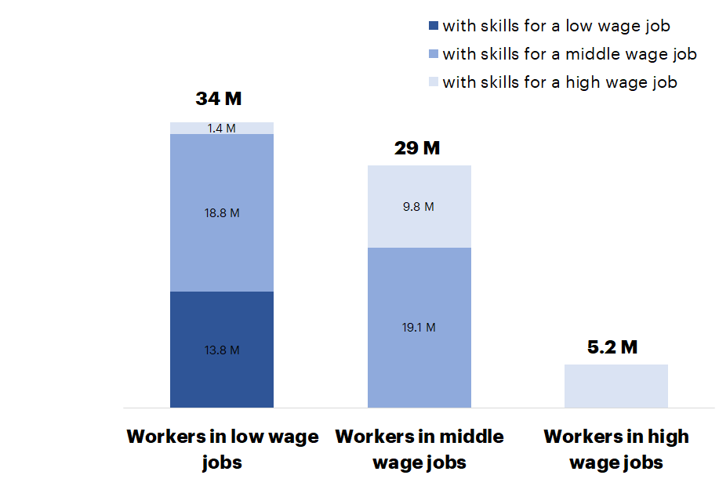
Figure 2: Non-college educated workers by wage group and skill similarity to workers in higher wage groups - In Millions Note: It excludes workers without a high school degree. See ‘Data and Methods’ section for wage ranges and skill similarity definitions.

Dividing the earnings distribution into three groups, we define (1) “Shining Stars” as non-college educated workers already earning > twice the median wages in state-cohort earnings distribution, (2) “Rising Stars” as non-college educated workers with skills to transition into middle to high-wage occupations where average earnings exceed the median wages in their state-cohort earnings distribution, and (3) “Forming Stars” as non-college educated workers with skills to transition into higher wage occupations with in their current earnings category. As shown in Figure 1, of the total non-college educated workers active in the in the US labor force 5% fit our categorization of Shining Stars, 30% “Rising STARs” and 33% are “Forming STARS.” There is significant and meaningful variation across this pool of workers. STARs in high-wage roles today are disproportionately white men, whereas STARs in low-wage roles with few transition opportunities see a disproportionate volume of underrepresented groups of women.
Indeed, there are a host of other attributes of the jobs that are unobserved to the econometrician which may also explain differences in wages. Many of these we will not be able to account for with the skill distance. With this caveat in mind, we view what we do in this paper as a descriptive exercise that lays the foundation for our forthcoming work which hones in on causal mechanisms. This does not, however, reduce the utility of identifying which jobs are close in the “skill space” to each other but are far apart in terms of earnings potential. Sub-setting the data into a sample of workers who are STARs if done with enough granularity and if sufficiently informative has the potential to generate a separating equilibrium among non-BA workers that enables both the firms and workers to identify potentially fruitful job matches. Moreover, since the separation would only require knowing the skill distance between the job of original and the job of destination, there is no need for additional (costly) investment in education on the part of workers without college degrees to signal skills. In short, providing this information should make the job market (weakly) more efficient, to the extent that firms and workers are rationally inattentive.
Impetus for Focus on Workers Without College Degrees
If the signaling failure described above is pervasive, it could well underlie the three dominant trends in the labor market today, which are stagnant median real wages, rising inequality, and declining labor force participation. These overall trends are most pronounced for non-college workers. Indeed, as a corollary, these poor outcomes may continue to worsen absent efforts to address this particular market failure facing non-college workers.
As noted above, the majority of US workers do not hold a 4-year college degree (62 percent of workers age 25 and older in 2016-2017). Starting with wages, Figure 2 shows real wage levels and growth by educational attainment from 1979 to 2016. For college graduates, real median wages have increased, whereas for non-BA workers, they have fallen substantially. Thus, overall stagnant median real wages are largely driven by the experience of non-college workers. And, since wages for college-educated workers have increased, stagnant wages for non-college workers contributes substantially to rising wage inequality in the US. In addition, males without college degrees have seen their labor force participation decline dramatically, much more than the decline for those with BA degrees, as shown in figure 3. It is reasonable to think that earnings stagnation and declining participation are at least partially related. That is, poor earnings prospects should reduce the propensity of non-BA men to enter or stay in the labor force.
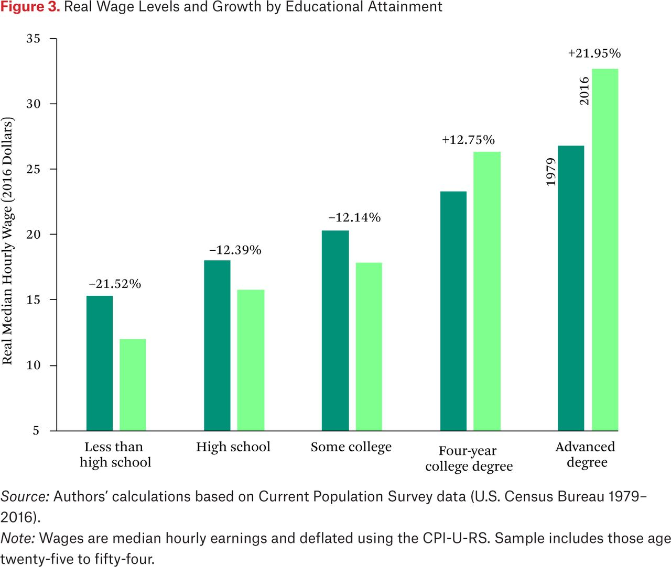
Figure 2.
Source: Reproduced from Groshen, Erica L. and Harry J. Holzer (2019a). “Improving Employment and Earnings in Twenty-First Century Labor Markets: An Introduction,” RSF: The Russell Sage Foundation Journal of the Social Sciences December 2019, 5 (5) 1-19; DOI: https://doi.org/10.7758/RSF.2019.5.5.0
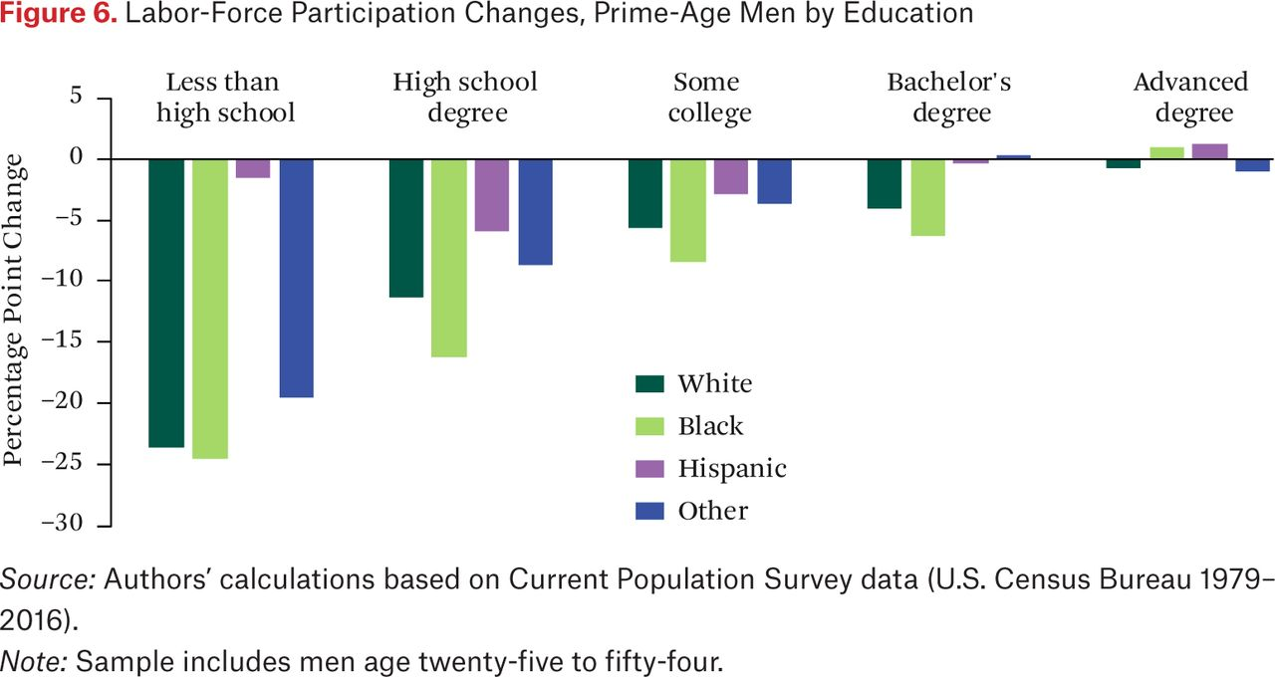
Figure 3.
Source: Reproduced from Groshen, Erica L. and Harry J. Holzer (2019a). “Improving Employment and Earnings in Twenty-First Century Labor Markets: An Introduction,” RSF: The Russell Sage Foundation Journal of the Social Sciences December 2019, 5 (5) 1-19; DOI: https://doi.org/10.7758/RSF.2019.5.5.01
In a recent Russell Sage Foundation volume, 24 prominent researchers examine the three long-run trends from many angles and agree that the forces behind these poor outcomes are unlikely to abate in the coming decades. The multiplicity of causes of the trends suggest that no single “silver bullet” policy is likely to be able to reverse these trends alone. Moreover, the nature of the problem suggests that a key focus of research targeting these issues will center on job opportunities for non-BA workers.
Going forward, what do overall supply and demand conditions look like for non-BA workers? The pattern of occupational job creation during the most recent decade reinforces concern. It bodes poorly for workers without a 4-year college degree in the future—and for the many employers hoping to staff many positions with college graduates. Figure 4 compares four key numbers: supply and demand measures of stocks and flows by BA attainment or not. The top bar shows the stock of demand for BA workers, that is, the share of jobs that typically require a 4-year college degree for entry-level positions (26 percent). Just below is the supply of workers for those jobs: the share of the workforce with a BA or more, which is 38 percent. Interestingly, measured this way, the supply (38 percent) is greater than the demand at the moment (26 percent)—shown in the top bar. This difference suggests that at least eight percent of workers are college degree holders with jobs in occupations that typically do not require a college degree for entry. Indeed, the true percentage of “underemployed” college graduates is certainly higher because the unemployed are less likely to hold a college degree and (as we show below) some college jobs are held by STARs. The reasons college graduates hold non-college jobs include preferences, a local scarcity of appropriate college jobs, family or physical constraints, and occupations where college education is not strictly required but may increase success.

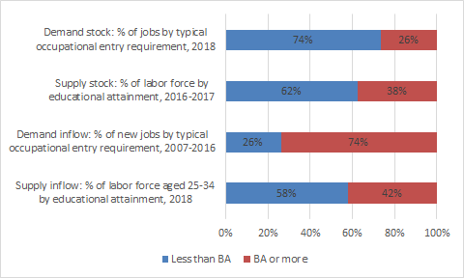
Figure 4. Supply of college-educated workers compared to requirements for jobs, recent stocks and inflows
Note: The typical entry-level education requirements assigned to each occupation are based on research by the BLS Employment Projections program and may differ from the educational level of workers in the occupation and from the education that particular employers require for individual jobs in the occupation.
Most strikingly for this study is the reversed and much larger gap between the inflows of demand and supply for college-educated workers, shown in the lower two bars of figure 4. The Bureau of Labor Statistics reports that from 2007 to 2016, 74 percent of new jobs were in occupations where employers that typically require a 4-year college degree, double the share in ongoing jobs. Compared to the stocks above, we see clear evidence that employers’ need for workers in skilled occupations expanded strongly in the last decade. Filtered through their common hiring practices, this need for upskilling dramatically shifted the educational requirements for new jobs. Consider the implications of a persistence of this hiring trend into the next decade. If it continues as is, only 26 percent of new jobs will be available to the 58-62 percent of US workers without a college degree. Turning the same numbers around for the employer perspective, only 38-42 percent of workers will be eligible for 74 percent of new jobs. Simply put, these trends portend serious challenges for employers in the near term, along with worse outcomes for workers with low levels of formal education.
Can we catch up by increasing college attendance? No. It is unrealistic to expect that improving college attendance alone in the near term can close the skills gap for employers or reverse the deterioration in lives of less educated workers in the near future. The bottom bar of figure 3 shows that in 2018, 42 percent of 25-34 year-olds in the workforce had a BA or more. Focusing on the youngest cohort in the labor force is a way to gauge the rate of inflow of college-educated workers. This increment of about four percentage points higher than the college share of the workforce as a whole is not enough higher to move the needle quickly. Nor does the inflow come close to matching what new jobs look like--taking the 74 percent rate of college requirements in new jobs during the last decade as indicative. Over the past 27 years (1992 to 2019), the US has raised the share of US workers with 4-year college degrees by only 15 percentage points--an average pace of 0.56 percentage points per year. Even if policies to raise graduations were adopted now (via, say, dramatic increases in funding for public colleges) it would take many years for colleges to dramatically increase the inflow of college graduates into the labor market.
The near impossibility of creating enough ‘quality seats’ in college bachelor’s degree programs to keep up with projections of the U.S. labor market’s ‘degree requirements’ is alarming, The evidence we share in this paper suggests significant potential for STARs to successfully fill higher paid, in-demand job roles for which their experienced-based skills have prepared them. But what about new jobs roles - technology enabled with higher-than-average wages - ushered in by a range of new technologies and business methods? While some of these new occupations (e.g., data scientist) may require skills (e.g., statistical methods) which are typically acquired in advanced formal education, a large number (e.g., application developers and administrators for enterprise Software-as-a-Service platforms such as Salesforce, Workday, or ServiceNow) are learned not in formal education, but mostly on-the-job or in credentialed skill training designed by the SaaS companies themselves. While estimating STARs’ potential to fill skilled roles still emerging is beyond the scope of this paper, it would be reasonable to expect that employers’ rational ignorance or deprecation of experienced-based signals of STARs skills for existing jobs may similarly shape assumptions about the academic requirements for many new jobs. Thus, over the next decade, in addition to whatever needed changes we make to access to higher education, improving the efficacy with which existing cadres of experienced workers with strong labor market attachment but without college degrees can signal their skills for in-demand jobs in both existing and emerging occupational fields will be essential to avoid innovation-sapping labor market imbalances and to improve job transition outcomes for millions of Americans.
Data and Methods
The analysis is based on two main databases - O*NET of the U.S. Department of Labor and the Current Population Survey (CPS) of the Bureau of Labor Statistics. We use the O*NET database to compute our experience similarity measure. O*NET is one of the most comprehensive public data source for occupational information. It provides a periodically updated and standardized Content Model for 974 individual occupations categorized by a standard occupation code (SOC), assessing topics such as required education, abilities, experience, tasks and skills. O*NET database is maintained and updated regularly through its Data Collection Program, which conducts a survey to sampled workers, occupational experts. Most of the information is collected from those surveys, while occupational analysts provide the importance and level information regarding the abilities and skills pertaining to each occupation.
In this paper we use occupational skill requirements, taking them as a proxy for the skill possessed by each worker. The reason why we chose skills is because the O*NET Content Model considers them “work-related attributes acquired and/or developed through experience and education”, which is precisely what we want to proxy, whereas abilities, for example, relate to “enduring attributes of the individual that influence the work performance.” O*NET skill requirements measure the importance of 35 basic and cross-functional skills, in areas such as Content, Process, Social, Complex Problem Solving, Technical, System and Resource Management skills. Skill importance levels span from a minimum of 1 to a maximum of 5. To the extent that a worker wages capture the marginal product of labor, in a standard model of human capital high level of skills translate into wages.
We use the CPS to sample the worker population. The CPS is a monthly household survey providing one of the most important sources for labor force economic and social statistics. It is conducted by the US Census Bureau for the Bureau of Labor Statistics (BLS). From the 2018 Annual Social and Economic Supplement (ASEC) of the CPS we pull in data about the demographic information on individuals: earnings, race, gender, age, state of residence etc. We also exploit the panel structure of the CPS to measure job transitions across occupations within the overall active population of workers in the US. When we construct our experience similarity measure between occupations, we will use the existence of actual job-to-job transitions in the data as a proof-of-concept that the pathways to higher wage jobs for STARs that we describe are plausible.

For each worker in the CPS under the declared occupation we match the O*NET skill requirements for that same occupation to the worker. Note that the matching was done between CPS OCC Code and O*NET SOC code using the official crosswalk provided by IPUMS-CPS. O*NET provides skills for occupations at an 8-digit depth, while the CPS OCC Codes are equivalent in depth to 6-digit SOC Codes, so we first take the 6-digit skill averages from the O*NET Skill database. We then match those averages with the CPS Codes. Most of the occupations match at the 6-digit level (65%), but we leveraged 5-digit (23%) and 4-digit (12%) averages for the ones that didn’t match at the 6-digit level.
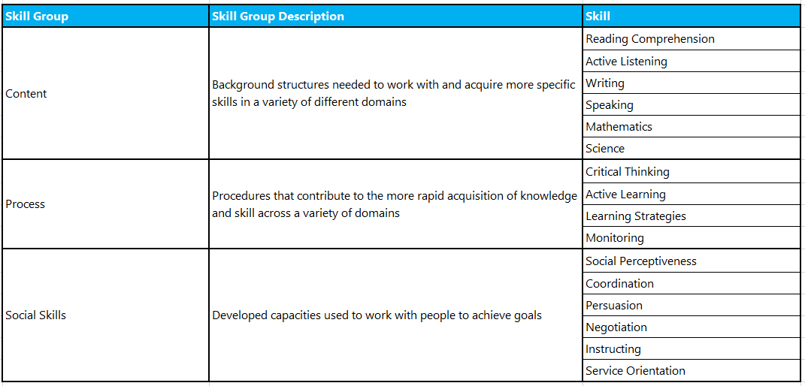
Table 1. Sample of O*NET skill requirements

Based on the skills of the current occupation, we calculate the Euclidean distance $d_{i,j}$between the skill vector of the of a worker’s current occupation $s_{i}=(s_{i,,1},...,s_{i,k}...,s_{i,35})$ (the origin occupation) and a potential destination occupation, $s_{j}=(s_{j,1},...,s_{j,k}...,s_{j,35})$, as follows:
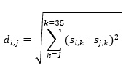
We considered other measures that are also used in the literature, most prominently the cosine similarity -- often used for text analysis -- but because the Euclidean distance allowed us to consider absolute magnitudes, while the cosine similarity weighs the relative importance of each element of the vector, we chose to deploy this method. Furthermore, one could also considered a weighted analog of our distance measure where the weights are determined by factors external to the O*Net database. These alternative measures are likely to be highly correlated and the reader can think about our proposed measure as a way of capturing the skill distance between occupations.
We focus our analysis on individuals who are active in the labor market and above the age of 25 with a high school diploma or equivalent and without a bachelor’s degree. We excluded workers who are not currently employed or did not have occupational data available in the Current Population Survey (CPS), since we cannot compute a skill distance measure based on current employment. These sample restrictions focus our study on a population of 68 million workers, which we call our Target Study Population (TSP). By comparison there are 60 million individuals who are active in the labor market in the same age range who possess a BA degree or higher.

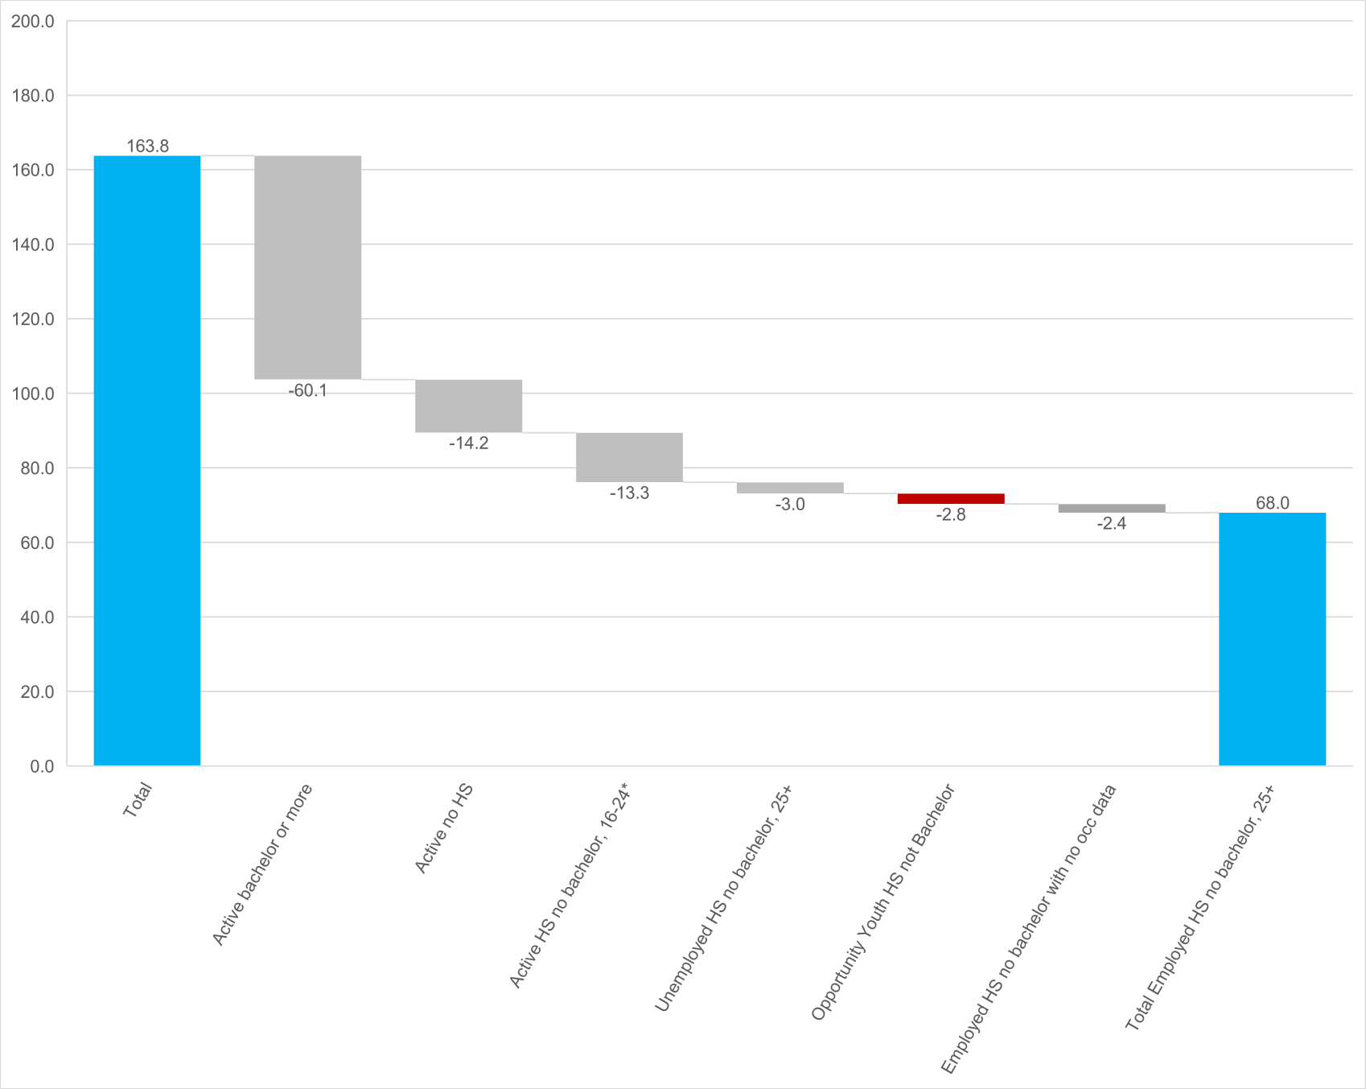
Figure 5. - Total Study Population

With our TSP defined, we split the population into three groups using a grouping based on median hourly wages, which were localized based on state, age and occupation. Specifically, we use the state level median wage to define the income thresholds: low, middle, and high. We calculate the median wages for each occupation, considering both state and age range (25-34, 35-44, 45-54, 55-64, 65+) using the following definitions:
● Low-wage: those in an occupation with median hourly wage (for that state and age cohort) below than the state median wage. As a reference, the national median is near $38,000/year, with a substantial degree of state-level variation (e.g. Mississippi $32,000/year, Colorado $42,000/year).

● Middle-wage: those in an occupation with median hourly wage above the state median wage and below than two times that measure. On average, this includes all occupations where the worker earns between $38,000 and $77,000. We use two times the median wage as a simple cut point between middle and high incomes.

● High-wage: those in an occupation with median hourly wage above than two times the state median wage. On average, this includes workers in occupations that earn above $77,000/year threshold.

Finally, we compare the occupation median wage (by state and age range) with the state median wage, to assign the workers to their relevant state-wage-cohort group and to characterize potential destination jobs. We use median wages instead of mean wages to reduce the prospect of outliers driving our wage definitions. Secondly, we use state level medians instead of the national ones to account for possible regional variation in wages and cost of living. Thirdly, when estimating the median wages we compute the medians separately by age cohort to reflect the fact that wages change over the life-cycle as experience increases.

In Table 2, we describe the characteristics of our TSP along the three wage groups. Even when the number of years of education is approximately the same across wage groups, age is higher as we move up in the wage categories, possibly reflecting the importance of experience as a driver of wages. Our measure of skill distance is also increasing in the wage categories which suggest that high wage jobs are further away in the skill space from other jobs. As we will see in the results section, this is linked to more opportunities to transition open to workers in occupations in low-wage groups relative to workers in high-wage occupations. Finally, workers in the low-wage group have a higher share of minorities relative to the middle and high-wage groups.

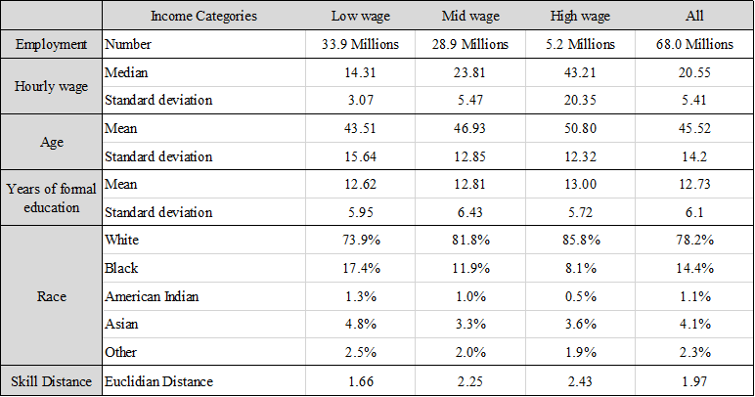
Table 2. Summary Statistics

Our first step in classifying STARs is to compute the skill distance between a worker’s current occupation and all other occupations. Next, we define several rules to determine if a destination occupation is a plausible job transition. The procedure is to look for the closest occupation in the skill distance that meets each of these transition rules. Overall, this approach is meant to impose more demanding criteria to potential transitions that may otherwise appear to be feasible if just skill distance were considered. For example, low-wage occupation ‘Automotive Body and Related Repairers’ [OCC code: 7150], based solely on skill similarity, would have as the second highest option the mid wage occupation ‘Telecommunications Line Installers and Repairers’ [OCC code: 7420]. However, after the filters are applied this option disappears and the first option becomes another mid wage occupation ‘Molders and Molding Machine Setters, Operators, and Tenders, Metal and Plastic [OCC code: 7150]’ which was previously ranked as the 11th in terms of skill similarity.

The rules and the order of operations we applied are the following:

● Wage increase: First, we sought a destination occupation that had a higher average wage than the origin occupation, i.e. from low- to middle- or high-wage, or from middle- to high-wage. If a destination occupation to a higher wage did not exist in the next wage category, we sought to understand if there was a different destination occupation within the income segment.
● Barriers to entry: Not all individuals in the destination occupation should have a college degree. This was to rule out transitions into roles where professional degrees are necessary (e.g. doctors). We used a 90% threshold, which means that at least 10% of people currently employed in that occupation do not have a college degree. We use the CPS microdata to build the college degree shares, but we also tried O*NET reported degree requirements, finding no significant differences in our results.

● Plausibility check: There is proof that this transition has occurred in the labor market. We study transitions in year-to-year CPS data to ensure that at least some individuals made a transition between our defined origin and destination occupation. To assess the transitions, we compared current and last year occupations for each individual, as declared in the CPS’s Annual Social and Economic Supplement (ASEC) during the last 4 years. We then ruled out the transitions with zero cases.

● Skill gap: Occupation similarity must be below a selected distance threshold: if the closest occupation matching the previously stated rules was too distance from the original occupation in skill distance, the transition is not valid. We ruled out transitions for destination occupations where the skill distance from the origin occupation exceeded 2.5. In practice 70% of all year-to-year CPS job-to-job transitions meet this bar (see Figure 6). Moreover this threshold is roughly one standard deviation above the average origin-destination distance weighted by the share of transitions occurring at that level.

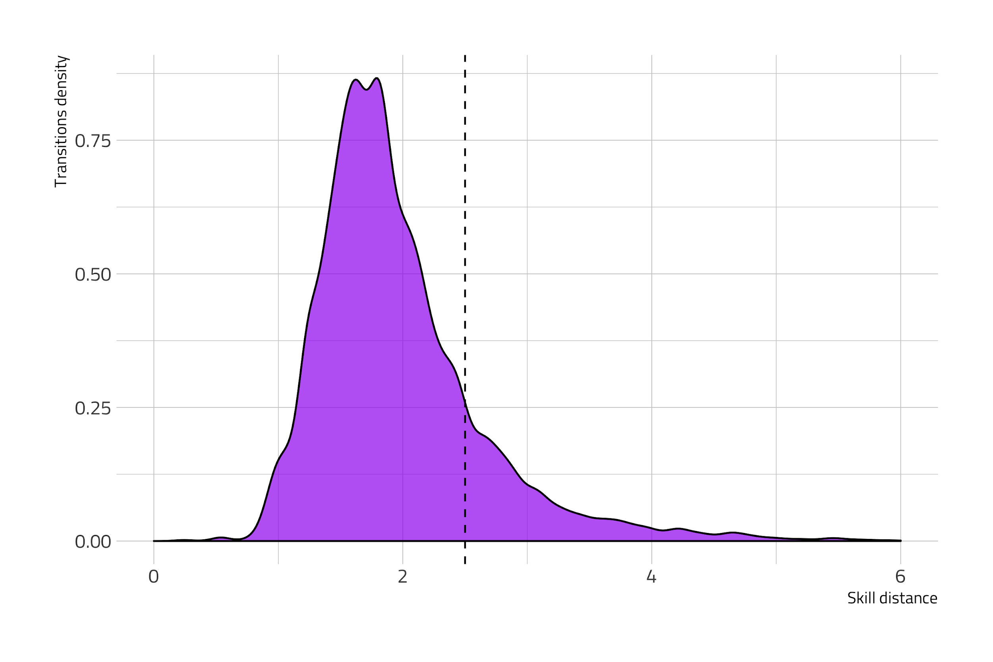
Figure 6. - Transition density by Skill Distance

The results in Table 2 are illustrative of transitions we predict. Here, we present data about two occupations in two different states, a Statistical Assistant, and a Childcare worker. The Statistical Assistant is responsible for compiling and computing data according to statistical formulas for use in statistical studies, according to the BLS description of the occupation, and include actuarial clerks. The skills this individual needs include mathematics, critical thinking and complex problem solving, among other skills. Statistical assistants are paid an average wage of $17.61/hour in California, and approximately 20% of people in this role have a Bachelor’s Degree today. Potential transitions from this origin occupation based on our skill distance score cutoff would be to the following destination occupations: Market Research Analysts and Marketing Specialists, Computer Occupations, Drafters, Compensation, Benefits, and Job Analysis Specialists and Financial Analysts. These destination jobs all pay higher wages in California than the Statistical Assistant. The second example illustrates potential transitions for a Childcare worker in New York. The average income for a Childcare worker is $10.29/hour in that state. This individual’s most important skills include Monitoring, Service Orientation and Social Perceptiveness. Potential destination occupations we find for this worker based on our criteria include Customer Service Representatives, Athletes, Coaches, Umpires, Teachers and Instructors, Cargo and Freight Agents and Bartenders. Each of these jobs pay wages that are two to four times the average wages of a childcare worker.

Occupation Code, Origin Occupation | Occupation Title, Origin Occupation | Starting Occupation Median Wage, $/hour | Starting Occupation BA+ Population share (%) | Occupation Code, Ending Occupation | Occupation Title, Destination Occupation | Ending Occupation Median Wage, $/hour | Destination Occupation, BA+ Population share (%) | Starting to Ending Skill Similarity (0 = Same Skills, >0 Skill distance).
In California
5920 | Statistical Assistants | 17.61 | 0.19 | 735 | Market Research Analysts & Specialists | 53.1 | 0.82 | 2.11
5920 | Statistical Assistants | 17.61 | 0.19 | 1107 | Computer Occupations, Other | 45.65 | 0.59 | 2.13
5920 | Statistical Assistants | 17.61 | 0.19 | 1540 | Drafters | 49.77 | 0.3 | 2.34
5920 | Statistical Assistants | 17.61 | 0.19 | 640 | Compensation, Benefits, & Job Analysis Specialists | 24.3 | 0.61 | 2.43
5920 | Statistical Assistants | 17.61 | 0.19 | 840 | Financial Analysts | 73.4 | 0.89 | 2.46
In New York
4600 | Childcare Workers | 10.29 | 0.15 | 5240 | Customer Service Representatives | 30.53 | 0.26 | 1.68
4600 | Childcare Workers | 10.29 | 0.15 | 2720 | Athletes, Coaches, Umpires, and Related Workers | 31.62 | 0.48 | 1.77
4600 | Childcare Workers | 10.29 | 0.15 | 2340 | Other Teachers and Instructors | 26.98 | 0.55 | 1.90
4600 | Childcare Workers | 10.29 | 0.15 | 5500 | Cargo and Freight Agents | 42.86 | 0.15 | 1.93
4600 | Childcare Workers | 10.29 | 0.15 | 4040 | Bartenders | 38.13 | 0.27 | 2.00
Table 3. Example of Predicted Transistions

Defining STARs

Equipped with the income groups definition and the potential transitions, we could quantify the workers in the target study population who have transitions available to destination occupations with higher wages. A meaningful way to segment this group of workers is by their skills-readiness for higher-wage work as measured by their experience similarity scores to destination occupations. We thus segment the 68 million STARs into the four categories below based on a worker’s ability to transition to higher wages based on their skills. The definition of each segment is below in Table 4.

Table 4. Definitions of STAR Segments
STAR  SEGMENT | CONCEPTUAL DEFINITION | QUANTITATIVE  OPERATIONALIZATION
SHINING | Workers without a four-year degree who are in high-wage roles today | Target Study Population (TSP) already working in high-wage occupations (above two median wages).
RISING | Workers without a four-year degree who have skillsets to transition to high or middle-wage work | TSP with high or middle-wages after transitions.  They are currently in low or middle income occupations, but have skills similar to the ones required by high income roles
FORMING STARS | Workers without a four-year degree in low or middle-wage roles who have skills to transition to a higher wage role in their wage category, but not to transition to the next wage group. Includes  Opportunity Youth who have finished high school. | TSP in low or middle income roles who do not have skills to transition to the next income threshold but who do have skills to transition to a higher wage.
Table 3.

Table 5: STARs Segments Origin to Destination Wages

 | Wage category of STARs’ destination job
WAGE SEGMENT | Low-wage Destination | Middle-wage  Destination | High-wage  Destination
Low-wage  Origin Job  34million | Forming STARs  13.8 million | Rising STARs  18.8 million | Rising STARs  1.4 million
Middle-wage  Origin Job  28.9million |  | Forming STARs  19.1 million | Rising STARs  9.8 million
High-wage  Origin Job  5.2 million |  |  | Shining STARs  5.2 million
Total potential: destination jobs  (O: 68.1M/D: 68.1M) | low-wage Destination  13.8 million | middle-wage  Destination  37.9 million | high-wage Destination  16.4million
Table 5. Counts by STARs Taxonomy

Table 5 above illustrates the potential transitions from origin to destination jobs based on the the experience similarity measure for STARs. Of the 34 million STARs in low-wage positions, 13.8 million do not have transition opportunities that move them outside the low-wage income group. We call them Forming STARs. There are 18.8 million low-wage workers who have skills to transition to middle-wage jobs, and 1.4 million who have the skills to transition to high-wage jobs. We call these combined 20.2 million workers Rising STARs. There are 28.9 million STARs in middle-wage jobs. Of these STARs, 19.1 million do not have skills to transition out of their wage category. As such, we refer to this group as Forming STARs as well. The STARs in middle-wage jobs who could transition to the high-wage group include 9.8 million STARs who are also Rising STARs. Finally, we find 5.2 million are Shining STARs: these are workers earning a high wage today.

Results/Description of Findings
There is meaningful variation across this segmentation, which we describe in this section. Figure 7 displays the average distance of the importance of skills across all low- and middle-wage jobs. Low-wage jobs have higher levels of import of the skills seen in the upper left part of the circle in Figure 7 and middle-wage jobs have a higher level of import of skills on the upper right part of the circle. Studying the average differences in importance of each skill, we find that low-wage jobs, on average, have higher import levels of Service Orientation, Operations and Control, Troubleshooting, Social Perceptiveness and Monitoring. The skills for which low-wage jobs have gaps compared to middle-wage jobs are in skills that tend to be more technical in nature: Operations Analysis, Science, Systems Analysis, Systems Evaluation, Management of Financial Resources, Management of Personnel Resources, and Programming.

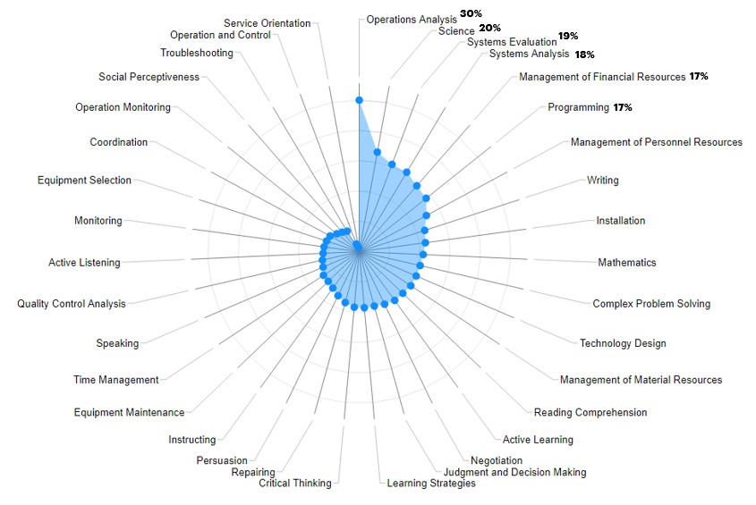
Figure 7. Differences in Skill Importance Across Low and middle-wage Jobs

The differences in importance of skills across two occupations is one component of the skill distance between two occupations. We use the skill distance to understand if a STAR has the skills to earn higher wages based on the skill content of their current job and how proximate it is to a higher earning, potential destination job. The transitions we predict from each STAR’s origin job to his destination job is defined by the skill distance score and other parameters we define in the Methods section. These transitions are illustrated at the 2-digit SOC code level in Figure 8. The Y-axis of Figure 8 represents the origin major job group for each STAR, and the Y-axis represents the destination occupation for each STAR.
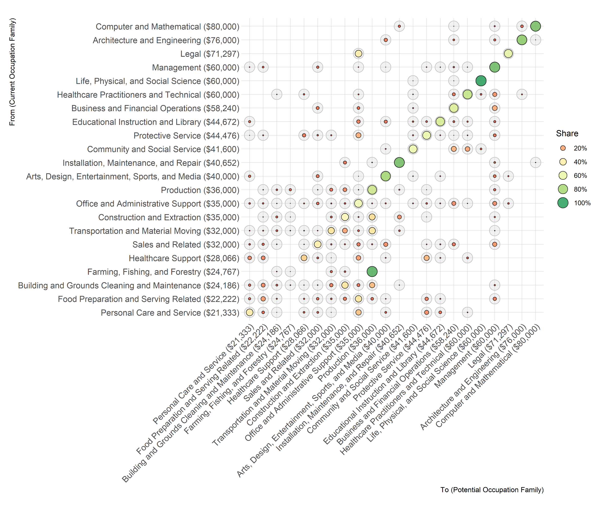
Figure 8. Predicted Transitions for STARs based on skill distance score

The transitions of workers starting at the higher end of the wage distribution on the Y-axis are to other roles within the same major job group. This is expected: the skills required in occupations that belong to the major job group frequently share the same area of knowledge and require the worker to perform similar tasks. We do find opportunities to transition to other major job groups, especially at the lower end of the wage distribution on the Y-axis. The data supports the finding that the skills developed on the job by these workers are compatible with requirements of higher paid jobs. For instance, for approximately 40% of occupations in the Personal Care and Service major occupation group - the job group with the lowest national median income - the predicted transitions based on the skill distance score are to other roles within that major job group. However, some roles within that major job group have greater upward mobility: 20% of the transitions we predict for workers in roles in the Personal Care and Service major job group are to jobs in the Educational Instruction major job group or Office and Administrative support major job group. Both of these job families have a higher average median wage than the Personal Care and Service major job group.

Other predicted transitions move STARs out of their major job group: for instance, many roles within the Farming, Fishing and Forestry major job group have many skills similar to the skills required of roles within the Production major job group. Another notable major job group on this chart is the Sales and Related group: our approach suggests potential transitions for workers from origin jobs in this category to destination jobs in the Office and Administrative Support group, the Arts, Designs, Entertainment and Media group and Business and Financial Operations group. Most of these transitions - which are outside the immediate major job group - are to higher-wage positions for the worker.

STARs’ transition opportunities vary based on their skills, which we illustrate through a segmentation based on STARs’ skills-readiness for higher wage work. We present the distribution of the 68 million STARs across 3 main segments in Figure 9. There are 5.2 million STARs in high-wage roles today, STARs we call Shining STARs. As displayed in Figure 10 below, Shining STARs are most commonly in roles in the Computer and Mathematics, and Management job families.

Rising STARs are STARs who have skill distance scores from their origin occupation to a destination occupation that could move them to [at least] the next wage group. There are 30 million Rising STARs, 9.8 million of which are middle-wage roles, and 20.2 million of which are in low-wage roles. The most common job families for middle-wage Rising STARs include Sales, Management and Office Administrative roles; for low-wage Rising STARs, the most common job families are in Office Administration, Transportation and Sales roles.

Finally, there are 32.9 million Forming STARs, currently in middle-wage and low-wage roles. While these workers have skills to transition to higher wages - each could experience at least a 10% increase in wages based on this predicted transition - they will not experience wage gains to the next wage category based on their current skills. There are 19.1 million middle-wage Forming STARs. They most commonly occupy roles in the Personal Care and Support major job group.

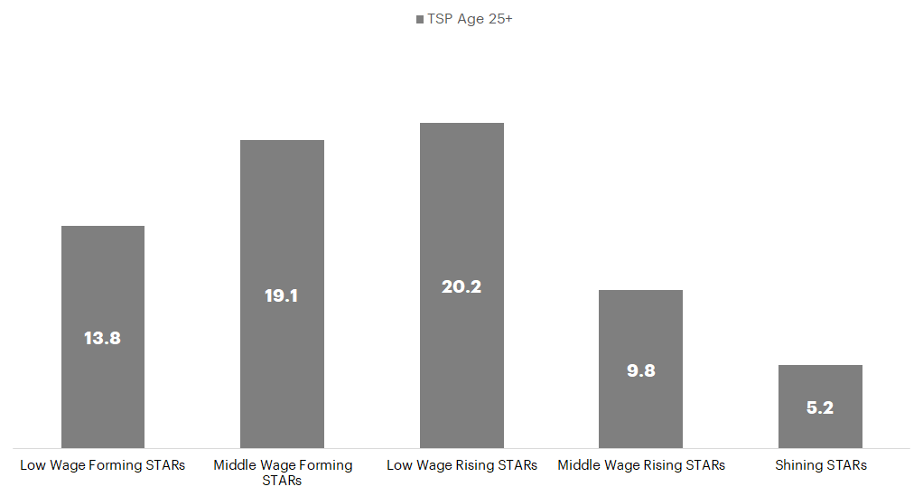
Figure 9. Distribution of STARs by Segment

In Figure 10, we illustrate the distribution of STARs current occupations by segment. The X-axis details the major job group and median wages (at the 2-digit SOC level) ranging from the lowest-wage major job group of Personal Care (median wage of $10/hr.) to the highest-wage major job group of Computer and Mathematics (median wage of $35/hr.). The Y-axis illustrates the STAR segment. Each green circle illustrates the proportion of STARs in that major job group. For instance, as illustrated by the green circles on the bottom left, we see a higher proportion of low-wage STARs - across both the Forming and Rising categories - in the lower-wage occupations of Personal Care and Services, Food Preparation and Building and Grounds Cleaning. And as illustrated by the green circles at the top right of the chart, we observe a higher proportion of Shining STARs in roles that are higher wage, such as Computer and Mathematical and Management job families.

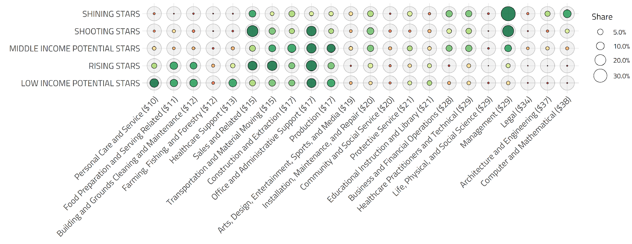
Figure 10. Predicted Transitions for STAR Segments Within and Across Job Families

The data illustrates that STARs are in almost all job families, but that STARs occupy a higher proportion of some job families than others. Further, there is a high volume of STARs across the STARs segment spectrum in the Office and Administrative Support major job group.

We detail the Potential Wage increases in Figure 11. Potential wage increases that result from these predicted transitions vary across segments. First, all STARs have transition opportunities to roles that pay 10% more in wages in their state. For Forming STARs, many transition opportunities do not lead to significant wage gains. For instance, while a taxi driver in our analysis could transition to a truck driver, that destination occupation pays little more than 10% more of his current wages. For Rising STARs, transition opportunities are significantly higher: the potential average increase in wages is almost 75%.

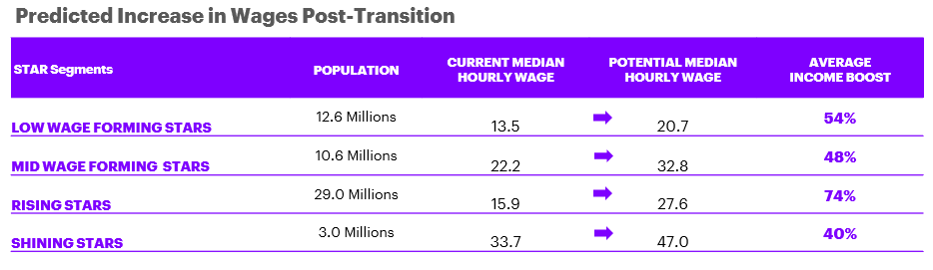
Figure 11.

There is meaningful variation in the age, gender, race and ethnicity and educational attainment across the STARs segments, as shown in Figure 12. Though we calculated median wages by state and age group when estimating wages for STARs and find important differences across the groups. Shining STARs, those in high-wage jobs, are older than low-wage STARs (both Forming and Rising). Whereas 70% of Shining STARs are over the age of 45, more than 50% of low-wage STARs are between the ages of 25-44. Almost 70% of Shining STARs, and almost 60% of middle-wage workers - in both the Rising and Forming segments - are men. However, looking at the low-wage workers, the distribution across gender is closer to an even split, with women comprising 56% of low-wage Forming STARs. It is important to recognize social, historical and market factors that drive pay bands for some professions. For instance, the major job groups that pay less also have a higher proportion of women than men, and even within that major job group, occupations pay different wages to men than women. For instance, the median earnings of janitors (usually men) is 22 percent higher than maids and house cleaners (usually women).,

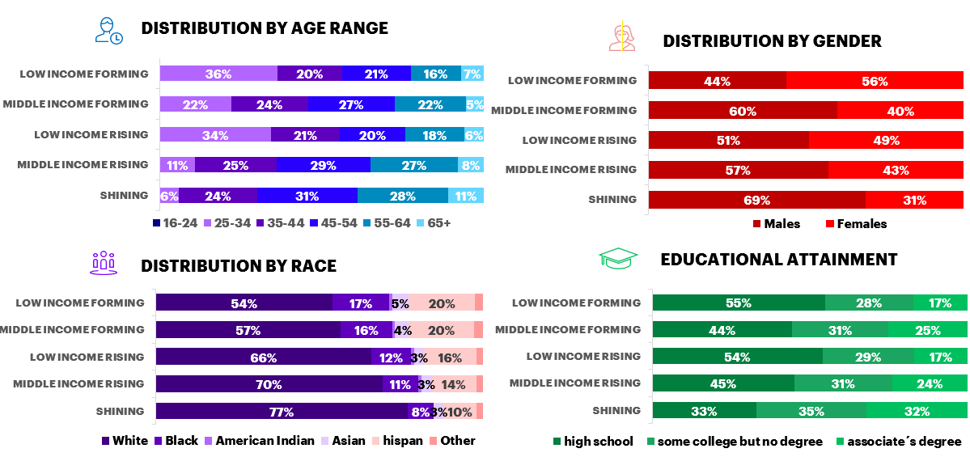
Figure 12. Demographics of STARs by Segment

There are differences in the racial and ethnic diversity across these segments as well. Whereas more than three-quarters of Shining STARs are white, less than 60% of low-wage Forming and Rising STARs are white. Within the Forming STAR category, 20% of workers are non-white Hispanic, and almost 16% are black. Finally, the educational attainment of workers varies across these groups. Whereas ⅔ of Shining STARs have some college or an associates degree, fewer than half of low-wage STARs have an educational attainment beyond high school.

Figure 13 illustrates the proportion of STARs to the active working population in each state: yellow indicates that STARs make up a higher proportion of working adults, while purple indicates they represent a smaller proportion of working adults. The data shows that STARs make up 50% or less of the active working population in DC, as well as Colorado, California and several other states on the east coast: Massachusetts, New Jersey, Maryland, New York, Connecticut and Virginia. They make up more than 65% of the active working populations in Mississippi, West Virginia and Wyoming.

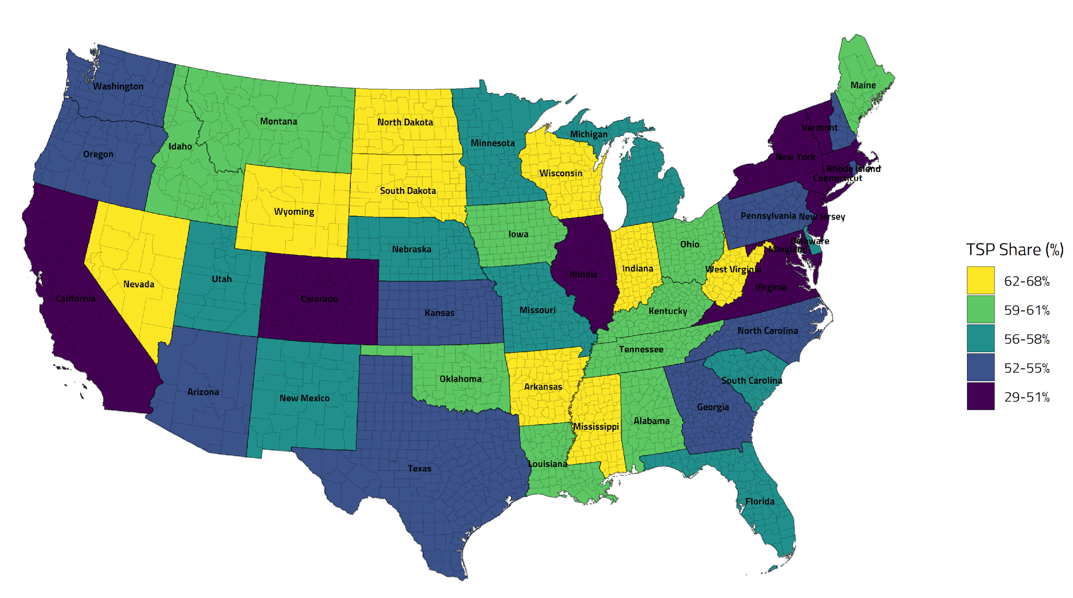
Figure 13. Geographic Distribution of STARs

Conclusion
To study the market for skills faced by workers without BA degrees, we borrow from the International Trade and IO literatures the insight that distances matter for describing the shape of economic activity. Using a readily available dataset on the skill requirements of occupations, we construct the Euclidean distance between the skill content of a worker’s origin job and the skill content of all other destination jobs in the dataset. To describe potential pathways to higher wage destination jobs, we look for destination jobs that: 1) are close in the skill space to the origin job, 2) currently employ some workers without BA degrees, 3) in the recent past have welcomed workers from the origin job who did not possess a BA degree and 4) pay higher average state-cohort median wages than the origin job.
To characterize these potentially plausible transitions we develop a taxonomy the STARs, i.e. workers without BA degrees who based on the skill content of their current occupations are skilled through alternative routes as compared to the traditional BA job market signal. Based on our measure of plausible job transitions, of the 68 million workers without BA degrees in the US, 30 million are “Rising STARs” whose skills are compatible with working in destination jobs with average earnings that are higher by $11/hour. Another 33 million are Forming STARs whose skills are compatible with working in destination jobs with average earnings that are higher by $7\hour. The presence of 5 million “Shining STARs,” who are workers without BA degrees earning greater than twice the median state-cohort in their current origin jobs is consistent with the proposition that high wage work exists for workers without BA degrees.
One potential concern of opening up career paths to more STARs is that they will crowd out workers with college degrees, lowering their wages. Or, put another way: Are there good jobs for all these STARs without damaging prospects for college grads? Hiring patterns from 2007 to 2016, which were influenced by ongoing forces in the labor market (including technological change, trade and institutions) suggest very strong demand for more skilled workers compared to the inflow of college-educated labor. Thus, there is reason to believe that there are indeed many opportunities for STARs to move up without displacing BA-holding workers.

References
Altonji, Joseph G., and Charles R. Pierret. 2001. “Employer Learning and Statistical Discrimination.” The Quarterly Journal of Economics 116 (1): 313–50.
Arrow, Kenneth J. 1986. “Rationality of Self and Others in an Economic System.” The Journal of Business 59 (4): S385–99.
Autor, David. 2019. “Work of the Past, Work of the Future.” AEA Papers and Proceedings 109: 1–32.
Autor, David H. 2014. “Skills, Education, and the Rise of Earnings Inequality among the ‘Other 99 Percent.’” Science 344 (6186): 843–51.
Autor, David H., Claudia Dale Goldin, and Lawrence F. Katz. 2020. “Extending the Race Between Education and Technology.”
Autor, David H., Lawrence F. Katz, and Melissa S. Kearney. 2006. “The Polarization of the U.S. Labor Market.” American Economic Review 96 (2): 189–94.
———. 2008. “Trends in U.S. Wage Inequality: Revising the Revisionists.” The Review of Economics and Statistics 90 (2): 300–323.
Bergstrand, Jeffrey H. 1985. “The Gravity Equation in International Trade: Some Microeconomic Foundations and Empirical Evidence.” The Review of Economics and Statistics 67 (3): 474–81.
Caplin, Andrew, and Mark Dean. 2015. “Revealed Preference, Rational Inattention, and Costly Information Acquisition.” American Economic Review 105 (7): 2183–2203.
Coate, Stephen, and Glenn C. Loury. 1993. “Will Affirmative-Action Policies Eliminate Negative Stereotypes?” The American Economic Review 83 (5): 1220–40.
Donaldson, Dave. 2018. “Railroads of the Raj: Estimating the Impact of Transportation Infrastructure.” American Economic Review 108 (4–5): 899–934.
Gabaix, Xavier. 2014. “A Sparsity-Based Model of Bounded Rationality.” The Quarterly Journal of Economics 129 (4): 1661–1710.
Gandhi, Amit, and Jean-Francois Houde. n.d. “Measuring Substitution Patterns in Differentiated Product Industries.”
Goos, Maarten, and Alan Manning. 2007. “Lousy and Lovely Jobs: The Rising Polarization of Work in Britain.” The Review of Economics and Statistics 89 (1): 118–33.
Goos, Maarten, Alan Manning, and Anna Salomons. 2014. “Explaining Job Polarization: Routine-Biased Technological Change and Offshoring.” American Economic Review 104 (8): 2509–26.
Katz, Lawrence F., and Kevin M. Murphy. 1992. “Changes in Relative Wages, 1963-1987: Supply and Demand Factors.” The Quarterly Journal of Economics 107 (1): 35–78.
Laibson, David. 1997. “Golden Eggs and Hyperbolic Discounting.” The Quarterly Journal of Economics 112 (2): 443–78.
Spence, Michael. 1973. “Job Market Signaling.” The Quarterly Journal of Economics 87 (3): 355–74.
Tinbergen, Jan. 1974. “Substitution of Graduate by Other Labour*.” Kyklos 27 (2): 217–26.

We thank Jennifer Brodie, Sean Burke, Amy Mortimer, and Martin Evelyn for their valued partnership in this research. The views expressed herein are those of the authors and do not necessarily reflect the views of the National Bureau of Economic Research. Further, the statements, findings, conclusions, views, and opinions contained and expressed here are not necessarily those of Accenture or any of its affiliated or subsidiary entities.
Bureau of Labor Statistics, U.S. Department of Labor, Employment Projections, Table 5.3 “Educational attainment for workers 25 years and older by detailed occupation, 2016-2017.” https://data.bls.gov/projections/occupationProj.
Groshen, Erica L. and Harry J. Holzer (2019b), eds. “Improving Employment and Earnings in Twenty-First Century Labor Markets,” RSF: The Russell Sage Foundation Journal of the Social Sciences, December 2019, 5(5); DOI: https://www.rsfjournal.org/content/5/5.
Examples of occupations where a degree is not required but may improve success include elected officials, computer programmers, artists, and sales jobs aimed at sophisticated clienteles.
Share of jobs by typical occupational entry requirement: Bureau of Labor Statistics, U.S. Department of Labor, Employment Projections, Table 1.7 Occupational projections, 2018-28, and worker characteristics, 2018. https://data.bls.gov/projections/occupationProj (visited February 21, 2020); Share of labor force by educational attainment, 2016-2017: Bureau of Labor Statistics, U.S. Department of Labor, Employment Projections, Table 5.3 Educational attainment for workers 25 years and older by detailed occupation, 2016-17, https://data.bls.gov/projections/occupationProj (visited February 21, 2020); Share of new jobs by typical occupational entry requirement, 2018-2028: Bureau of Labor Statistics, U.S. Department of Labor, The Economics Daily, Occupations typically requiring high school for entry lost 1.3 million jobs, May 2007–16 on the Internet at https://www.bls.gov/opub/ted/2017/occupations-typically-requiring-high-school-for-entry-lost-1-3-million-jobs-may-2007-16.htm (visited February 21, 2020); Share of labor force aged 25-34 by educational attainment, 2018: U.S. Census Bureau, Current Population Survey, Annual Social and Economic Supplement, 2018. https://www.census.gov/cps/data/cpstablecreator.html (visited February 28, 2020)
Note that BLS employment projections for 2018-2028 suggest a weaker bias toward jobs that require a college degree during the next decade than seen during the last decade. They project that 42% of new jobs will require a BA. Even that conservative rate implies that occupations requiring a college degree will grow by 8.2 percent--double the 4.1 percent growth expected for jobs typically requiring less than a college degree. The BLS projection model is bound by both demographic projections for educational attainment of the labor force and the assumption of fixed occupational education attainment requirements. This paper presents evidence that, in practice, relaxing many current occupational education requirements for a college degree may be another, preferable way to match demand with supply over the coming decade. https://www.bls.gov/emp/tables/education-summary.htm
Questionnaires are available online at the O*NET Data Collection Site: https://onet.rti.org/pdf/index.cfm.
Previous version of the database collected both skills and abilities importance from job incumbents, but recent research suggests that trained occupational analysts understand the skill constructs better than incumbents. Detailed methodology available at: https://www.onetcenter.org/dl_files/AOSkills_ProcUpdate.pdf
Other elements of the Content Model might also prove useful in future research. For example, the Generalized Work Activities, which outline the activities performed in each role. We preferred using skills in the analysis that we describe below, since we want to understand transition possibilities between occupations. So even if the involved activities may prove to be different in each occupation, the required skills to perform them might be similar anyway. Thus, a worker possessing those skills may be able to move from one role to the other, even when the implied activities will differ.
The Annual Social and Economic (ASEC) Supplement provides the usual monthly labor force data, but in addition, provides supplemental data on work experience, income, noncash benefits, and migration. We prefer the ASEC over the monthly CPS data for demographics as it provides better income coverage. We used the 2018 CPS-ASEC for demographics as this was the latest edition at the moment of writing, but tested the main aggregates against the 2019 monthly data finding no relevant differences.
As explained later, to explore the job-to-job transitions we used not only the latest available CPS-ASEC (2018) but the latest 4 at the moment of writing (2015-2018) in order to improve the amount of sampled transitions. Other sources for demographic data also exist, the American Community Survey (ACS) being one of the most common in similar studies. We cross checked some of our intermediate results with the ACS, such as the earnings by occupation, educational attainment shares, population distribution between MSAs and States, arriving at similar values. The ACS has a better geographical coverage, providing a bigger sample, but has a lower sampling frequency (1, 3 or 5 years) and does not provide information about occupational transitions, which was critical information for our study.
For literature covering similarity and proximity measures readers can be referred to "Data Mining: Concepts and Techniques" (Han, Kamber, Pei, 2011) for an introductory treatment.
Future analyses must be done to understand the skills of the population of workers without a high school diploma.
These figures correspond to the expanded CPS according to the reported weights on each individual in the sample.
We do not have occupational data about Opportunity Youth, but given the significant investment in ensuring this population acquires skills for meaningful career pathways, we included them in our STARs population estimate.
We also explored the possibility of using MIT Living Wages to build the three income groups, which could also provide a reasonable threshold for living standards across different US regions. We favored using hourly wage medians since they are more often used in labor economics literature, convey similar information, and allowed us to keep the analysis simple, without the need to refer to additional methodologies.
At a national level, wages above two times the median represent approximately the highest 20%. Pew Research Center uses a similar upper limit to define the American “middle class”. Specifically, they define “middle-income” Americans are adults whose annual household income is two-thirds to double the national median, after incomes have been adjusted for household size.
Metropolitan statistical area (MSA) level could also have been used towards that end, but the CPS data does not have enough granularity to allow for both MSA and occupation level estimates.
We are conditioning on the existence of a higher wage job, as such we ignore downside jobs that are similar. That is an area for further discovery in the future.
We used a 4 year pool of the CPS-ASEC (2015-2018, the latest four years available at the moment of writing), looking at the reported current and last year occupation for each individual in the sample. Using the standard CPS person weights we then constructed a transition matrix, by averaging the transitions recorded during those four years. Thus, the matrix reflects the observed destination occupation shares for each possible starting occupation. We allow any transition with non-zero share in the reality check. Even this way the transition matrix is notably sparse, and interesting clear clustering patterns emerge, which we leave for future analysis. We also tried the monthly CPS transitions, constructing a panel by pooling the latest 5 years of monthly data (2015-2019), and matching the occupation reported by the same individuals with a one-year difference, but the low retention rate of the sample made us prefer the CPS-ASEC approach.
Real transitions were taken from the ASEC current vs. last year occupations, as in the reality check step, and then matched with the skill Euclidean distances, to build the transition/distance density.
The Bureau of Labor Statistics classifies all workers into the Standard Occupational Classification (SOC) system, which is used by all federal agencies. The SOC includes 867 detailed occupations, which can be combined into 459 broad occupations, 98 minor groups, or 23 major (“2-digit”) groups. For more information, see https://www.bls.gov/soc/. We illustrate the 23 major job groups in this chart.
We predict transitions for 1.4 million STARs from the low-wage to high-wage category..
Levanon, Asaf, “Occupational Feminization and Pay: Assessing Causal Dynamics Using 1950–2000 U.S. Census Data” December 2009 https://academic.oup.com/sf/article-abstract/88/2/865/2235342
Miller, Claire Cain. “As Women Take Over a Male Dominated Field, The Pay Drops. ” March 2016 https://www.nytimes.com/2016/03/20/upshot/as-women-take-over-a-male-dominated-field-the-pay-drops.html

