Appendix A1. Other High-Skilled Visas
The H-1B visa is not the only visa option for multinational firms that wish to hire high-skilled foreign-born workers. If other high-skilled visas are easily substitutable for the H-1B visa, then H-1B visa restrictions will not actually constrain multinational firms’ ability to hire skilled foreign-born workers. Hunt (2011) provides an extensive discussion of all different types of visa categories, but here I focus on those relevant to skilled workers. The TN visa was created under the North American Free Trade Agreement and allows Canadian and Mexican citizens to come to the United States only if they already have a job offer with a firm and are in a certain set of occupations typically requiring a bachelor’s degree. The O visa is for workers of extraordinary ability. Figure A1-1 illustrates that the TN and O visas are used far less frequently than the H-1B visa.
Of particular relevance for multinational firms is the L-1 visa. The L-1 visa is used to permit overseas branches or subsidiaries of MNCs to transfer foreign workers within the company. To be eligible, the employee must have worked abroad for one continuous year in the last three years in a related business entity in a managerial/executive position (L1A) or in a specialized knowledge staff capacity (L1B). The former has a duration of three years and is extendable up to seven years, while the latter has a duration of two years and is extendable by two years. Like the H-1B, the employer files for the L-1 visa with the USCIS on behalf of the worker using the I-129 petition. Unlike H-1B visas, L-1 visas are not capped and do not require employers to pay the prevailing wage; no labor certification is needed. The degree to which multinationals have substituted L-1 (or other) visas for H-1B visas as H-1B visas have become more difficult to attain is unknown – this is a question for future research.
However, the evidence suggests that the two visas are not close substitutes; Figure A1-2 demonstrates the aggregate number of L-1 visa petitions have flattened in recent years. Interviews with multinational firms also suggest that they are not easily substitutable and are used for different categories of people: “we use both…but they’re just different…so if we have someone…already with the firm, they’re in a different category…than someone who may be just out of school or in an F1 that’s transitioning to an H”. Furthermore, while L-1 visas are not officially capped, L-1 denial rates have grown substantially over the last ten years, growing from about 5% in 2006 to nearly 70% in 2018. As another interviewee commented, “you can’t have certainty with either the H or the L”.
There is one other program that skilled immigrants can use to work in the US: the OPT program. Unlike the other visas described above, the OPT program is not a visa but instead allows temporary employment under the F-1 student visa. Only foreign students on an F-1 visa with a higher education degree from a US college or university are eligible for the OPT program, and foreign students do not require employer sponsorship to apply for the OPT. Furthermore, there is no cap on the number of approvals under the OPT program. However, the program is also shorter than the visas described above: the standard program allows up to 12 months of OPT employment. The program is longer for students in STEM fields. In 2008, an OPT extension was granted for up to twenty-nine months of work authorization for F-1 nonimmigrant students with STEM degrees, and in 2016, this was extended even further to thirty-six months. The OPT program is a popular pathway that foreign students on F-1 visas use to remain in the US for longer, in particular because it gives students more time to apply multiple times for H-1B visas. The STEM extension of the OPT program in 2008 likely helped loosen the constraints US multinational companies faced, and may have been another margin that firms adjusted on. The degree to which firms and students substituted the OPT program for H-1B visas – in addition to substituting between foreign workers at home and abroad – is unknown and is a question for future research, but current data sources on usage of the OPT program make this question difficult to answer.

Figure A1-1: Number of High-Skilled Visas Issued in FY2016

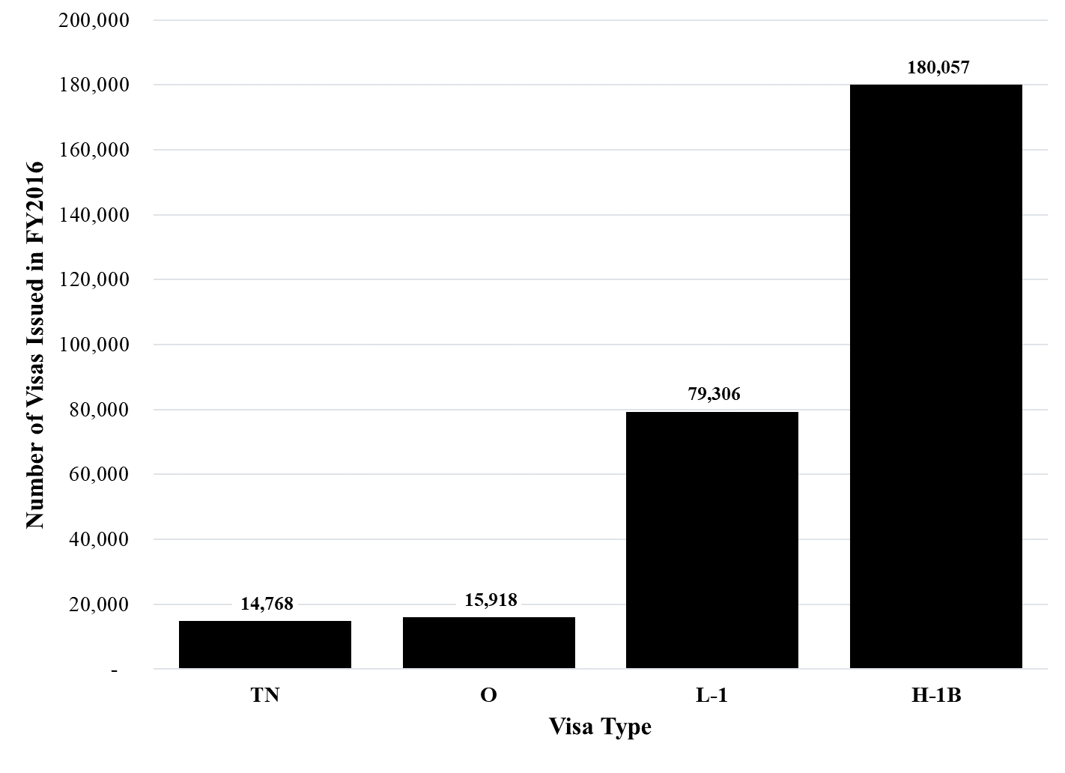
Notes: The graph shows that H-1B are by far the most commonly used visa for high-skilled workers. The TN visa is for Canadian and Mexican citizens only under the North American Free Trade Agreement. The O visa is for “the individual who possesses extraordinary ability in the sciences, arts, education, business, or athletics, or who has a demonstrated record of extraordinary achievement in the motion picture or television industry and has been recognized nationally or internationally for those achievements.” The L-1 visa is for intracompany transfers of foreign workers in the managerial, executive, or specialized knowledge categories to the U.S. The data is sourced from the State Department’s Annual Reports on Nonimmigrant Visa Statistics, Table XVI: Nonimmigrant Visas Issued by Classification.

Figure A1-2: Number of L-1 Visas Issued Over Time

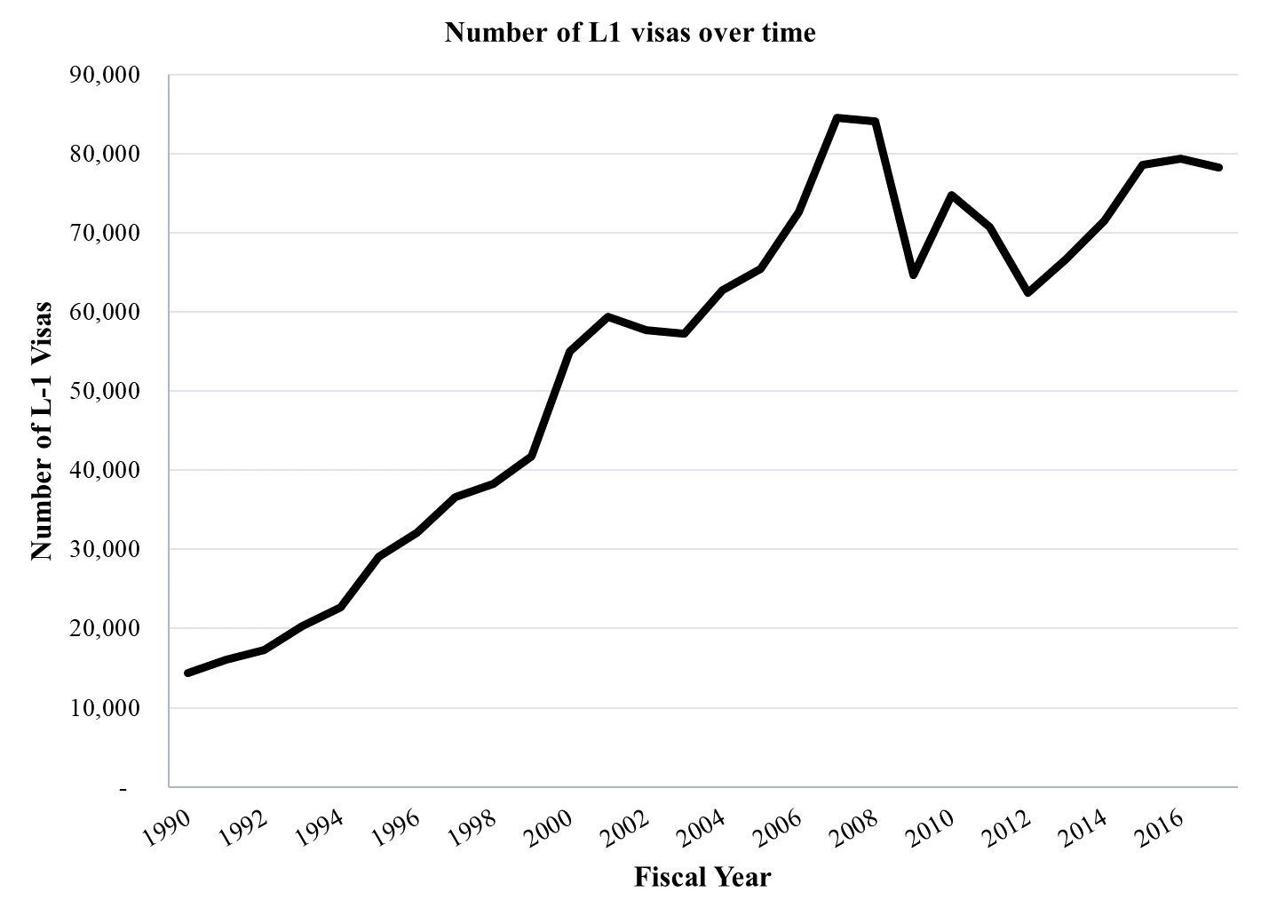
Notes: The graph shows that the time trend of aggregate L-1 visa petitions from FY 1990 through FY 2017. It shows that the aggregate number of L-1 visa petitions have not increased since the H-1B policies started to become more restrictive, suggesting that the two visas are not close substitutes. The 1990-2003 data is from Kirkegaard (2005), while the 2004-2017 data is from the State Department’s Annual Reports on Nonimmigrant Visa Statistics, Table XVI: Nonimmigrant Visas Issued by Classification. The decline in the number of issued L-1 visas in recent years is consistent with the opinion of the immigration lawyer the author spoke to that there has been a significant informal crackdown on L-1 visa petitions in parallel to tightening H-1B restrictions.

Appendix A2. More Detail on the Matching Procedure
There are no numerical identifiers that exist across all datasets, so I matched each database into the BEA data using firm names. For each match, I conducted several rounds of fuzzy matching between BEA multinationals and the firms in each of the other datasets (patent assignees/H-1B petitioners) using the “reclink2” Stata command at a 0.8 level, followed by manual verification to ensure the generated matches were correct. If a firm appeared in the BEA data but not in the patent data in a given year, I assumed that it did not apply for any patents in that year. Similarly, if a firm appeared in the BEA data but not in the I129 or LCA data in a given year, I assumed the firm did not apply for any visas in that year. Finally, I restrict the sample to the fifty countries with the most foreign affiliate activity to reduce noise, and to the multinationals who existed by 2001. Without this second restriction, multinationals who had zero H-1B applications in 2001 – because they did not exist yet – would be falsely classified as non-H-1B dependent.

Appendix A3. Quotes from Conversations with US Multinationals and an Immigration Lawyer

“The site [in India]…was set up in response to…growing restrictions on H-1B visas. HQ decided that if we could not bring the talent to the US, then [we] would go where the talent was.”

“this project we want to be staffed by these five people…one is in France and one is in the Czech Republic and one is in India, and we can’t bring them here on visas with the H-1B or L-1B, so we are going to house our own internal project in Prague instead of Chicago, and we’ll send [the team] to Prague instead of to Chicago.”

“we’re not going to be the destination location if we can’t figure out ways to move people in and out”

“…an Irish company had a particular proprietary software that was useful to municipalities…and they started getting a lot of contracts in the United States for various local governments…they were recruiting at US campuses and not all of the people they were hiring were US citizens and they couldn’t use the H-1B successfully…[because of the cap]…so they did set up operations in Canada specifically so they could do [the work] close at hand”

Appendix A4. Estimates on US-based Employment
In the main body of this paper, I find that restrictions on high-skilled immigration caused US multinational firms to hire additional foreign workers abroad at their foreign affiliates. I therefore argue that US multinational firms substitute between hiring foreign skilled workers in the US and hiring foreign workers abroad at their foreign affiliates.
To further support this argument, one ideally would be able to observe a corresponding decline in the hiring of foreign skilled workers in the US. However, the data do not allow me to isolate out foreign US-based skilled workers; I only observe total US-based workers. Since I cannot separate out foreign and native employees of US parents, the effect is hard to isolate, as displayed in Table A4-1 below, which shows the estimates resulting from regressing the effect of skilled immigration restrictions on total US-based employment:
$$Δ\ln\left({US_emp}_{i,t-2001}\right)=α_{j}+β_{1}{\left(\frac{LCAapps}{US_emp}\right)}_{i}^{2001}+Δϵ_{i,t-2001}$$
where i indexes the firm, j indexes the industry, and t is a post-policy year. There are two main differences between this regression and the earlier baseline regression: the dependent variable is now US_emp, or US-based employment (native and foreign) by firm i, and the regression is now at the firm-year level rather than at the firm-country-year level. One would expect$β_{1}$to be negative, but perhaps not statistically significant, if there were a decline in foreign US-based skilled workers; foreign US-based skilled workers make up a small fraction of total US-based employment by US multinational companies. Table A4-1 shows exactly that: a negative, but very noisy, effect on US-based employment, likely due to the difficulty of isolating the effect on foreign workers employed in the US.

Table A4-1: Effect on Growth in US-based Employment for All Firms, 2001 Base Year
 | (1) | (2) | (3) | (4) | (5) | (6) | (7) | (8) | (9) | (10) | (11) | (12)
 | 2002 | 2003 | 2004 | 2005 | 2006 | 2007 | 2008 | 2009 | 2010 | 2011 | 2012 | 2013
Ratio of LCAs to US-based Employment in 2001 in percentage point units | 0.00436 | 0.00594 | -0.0275** | -0.0157 | -0.00276 | -0.0192 | -0.0154 | -0.0168 | 0.00122 | -0.0212 | -0.0199 | -0.00736
 | (0.00880) | (0.0106) | (0.0127) | (0.0159) | (0.0200) | (0.0221) | (0.0254) | (0.0289) | (0.0319) | (0.0296) | (0.0332) | (0.0366)
Industry FE | Yes | Yes | Yes | Yes | Yes | Yes | Yes | Yes | Yes | Yes | Yes | Yes
Observations | 1198 | 1120 | 960 | 944 | 921 | 866 | 832 | 893 | 804 | 749 | 702 | 669
R² | 0.138 | 0.145 | 0.195 | 0.160 | 0.154 | 0.217 | 0.224 | 0.254 | 0.234 | 0.219 | 0.230 | 0.228
Adjusted R² | 0.026 | 0.025 | 0.065 | 0.025 | 0.018 | 0.079 | 0.086 | 0.127 | 0.095 | 0.075 | 0.076 | 0.072
F | 0.246 | 0.316 | 4.715 | 0.979 | 0.0191 | 0.756 | 0.369 | 0.337 | 0.00146 | 0.514 | 0.359 | 0.0404
Firm-clustered standard errors in parentheses
* p < 0.1, ** p < 0.05, *** p < 0.01

Notes: Each column represents a long difference in logged US-based employment between 2001 and a later year. We would expect null results in 2002-2003 (pre-policy change), and negative (but potentially noisy) results in 2005-2014 (post-policy change), and this is exactly what we see. The key independent variable is my measure of H-1B dependency, defined as the total number of LCA applications for a given multinational divided by that multinational’s US employment in 2001. The fixed effects account for industry (NAICS 4-digit level) time trends. The results are unable to detect a statistically significant change in US-based employment in response to the policy change, but this is likely due to the data’s inability to parse out foreign US-based employment from native US-based employment in the US.

Appendix A5. Additional Robustness Checks

Table A5-1: Effect on Foreign Affiliate Employment for All Firms, 1994-2014, where H-1B dependency is measured using H-1B petitions to USCIS in 2001 rather than LCA applications to DOL in 2001
 | (1)
 | ln(FA emp)
year=2004 # Continuous Treatment using H-1B petitions | 0.00240
 | (0.0304)
year=2005 # Continuous Treatment using H-1B petitions | 0.0322
 | (0.0289)
year=2006 # Continuous Treatment using H-1B petitions | 0.0283
 | (0.0357)
year=2007 # Continuous Treatment using H-1B petitions | 0.0508*
 | (0.0273)
year=2008 # Continuous Treatment using H-1B petitions | 0.0944***
 | (0.0295)
year=2009 # Continuous Treatment using H-1B petitions | 0.0876**
 | (0.0406)
year=2010 # Continuous Treatment using H-1B petitions | 0.0382
 | (0.0410)
year=2011 # Continuous Treatment using H-1B petitions | 0.0636
 | (0.0534)
year=2012 # Continuous Treatment using H-1B petitions | 0.102**
 | (0.0482)
year=2013 # Continuous Treatment using H-1B petitions | 0.137***
 | (0.0479)
year=2014 # Continuous Treatment using H-1B petitions | 0.158***
 | (0.0506)
Country FE | Yes
Firm FE | Yes
Year FE | Yes
Observations | 137459
R² | 0.429
F | 3.629
Firm-clustered standard errors in parentheses
* p < 0.1, ** p < 0.05, *** p < 0.01
Notes: This table shows the results of the baseline differences-in-differences approach shown in Table 3 and 4, but measures continuous treatment differently. As before, a measure of H-1B dependency is multiplied by a dummy variable equal to zero prior to 2004 and one after. But in this table, H-1B dependency is measured using H-1B petitions to USCIS rather than LCAs to DOL. As before, the timeframe is 1994-2014, the dependent variable is ln(foreign affiliate employment), and I control for country, firm, and year fixed effects.

Table A5-2: Effect on Foreign Affiliate Employment for All Firms, 1994-2014, DV is inverse hyperbolic sine of foreign affiliate employment
 | (1)
 | IHS(FA emp)
year=2004 # Continuous Treatment | 0.0817*
 | (0.0460)
year=2005 # Continuous Treatment | 0.0889***
 | (0.0301)
year=2006 # Continuous Treatment | 0.0853***
 | (0.0311)
year=2007 # Continuous Treatment | 0.142***
 | (0.0494)
year=2008 # Continuous Treatment | 0.0720*
 | (0.0427)
year=2009 # Continuous Treatment | 0.167**
 | (0.0666)
year=2010 # Continuous Treatment | 0.0987*
 | (0.0569)
year=2011 # Continuous Treatment | 0.155**
 | (0.0629)
year=2012 # Continuous Treatment | 0.152**
 | (0.0693)
year=2013 # Continuous Treatment | 0.177**
 | (0.0704)
year=2014 # Continuous Treatment | -0.00922
 | (0.113)
Country FE | Yes
Firm FE | Yes
Year FE | Yes
Observations | 409794
R² | 0.285
F | 1.491
Firm-clustered standard errors in parentheses
* p < 0.1, ** p < 0.05, *** p < 0.01

Notes: This table shows the results of the baseline differences-in-differences approach shown in Table 3 and 4, but shows both the extensive and intensive margin at once by using the inverse hyperbolic sine of foreign affiliate employment as the dependent variable rather than the natural log. The advantage of the inverse hyperbolic sine is that it provides a similar transformation as natural log but does not drop observations equal to zero. As before, the timeframe is 1994-2014, the independent variable is H-1B dependency multiplied by a dummy that equals one after 2004 and zero prior to then, and I control for country, firm, and year fixed effects.

Table A5-3: Effect on Growth in Foreign Affiliate Employment for All Firms, 2005 Base Year
 | (1) | (2) | (3) | (4) | (5)
 | 2010 | 2011 | 2012 | 2013 | 2014
Adjusted Excess Demand in 2007 | 0.106* | 0.205** | 0.172* | 0.203** | 0.119
Adjusted Excess Demand in 2007 | (0.0600) | (0.0871) | (0.0962) | (0.103) | (0.0921)
Number of LCAs in 2007 | -0.000132 | -0.000279** | -0.000140 | -0.000241 | -0.000143
Number of LCAs in 2007 | (0.000114) | (0.000129) | (0.000156) | (0.000157) | (0.000154)
Industry FE | Yes | Yes | Yes | Yes | Yes
Country FE | Yes | Yes | Yes | Yes | Yes
Observations | 4308 | 4029 | 3776 | 3685 | 3834
R² | 0.140 | 0.161 | 0.172 | 0.189 | 0.178
F | 1.548 | 2.903 | 1.739 | 1.939 | 0.845
Standard errors in parentheses
Standard errors clustered at the firm level
* p < 0.1, ** p < 0.05, *** p < 0.01

Notes: Each column represents a long difference in logged foreign affiliate employment between 2005 and a post-lottery year (2010-2014). The key independent variable is my measure of adjusted excess demand, defined as the total number of cap-subject LCA applications minus cap-subject H-1B petitions issued for a given multinational in 2007, divided by that multinational’s US employment in 2007. This number is multiplied by 100 for purposes of interpretation. The regression also includes a control for the number of LCA applications, since lottery randomization is at the petition, not firm, level. The fixed effects account for industry (NAICS 4-digit level) and country time trends. The results show that a random negative shock to H-1B supply equal to one percentage point of initial employment caused an increase in the foreign affiliate growth rate of between 10 and 20%. The table differs from Table 10 in that it only includes variation from the 2007 lottery, in an effort to address the concern that some firms anticipated the lottery.

Appendix A6. Additional Information about H-1B Applicants

Figure A6-1: H-1B Petitions Filed in FY2007-2017, by Beneficiary Country of Birth
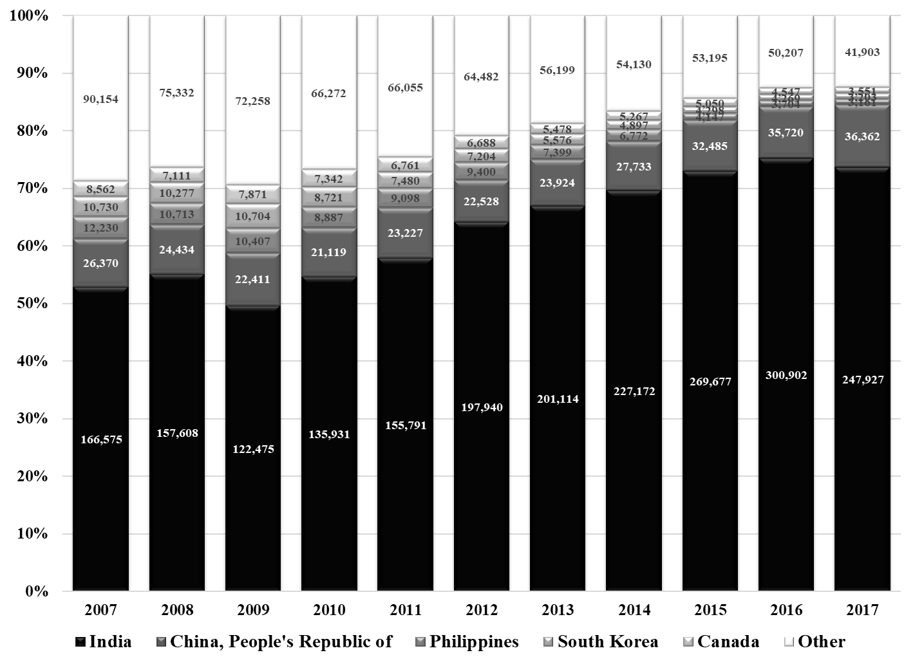
Notes: This figure shows the country breakdowns of H-1B petition filings between FY 2007 and 2017. It illustrates that the distribution of countries of origin is increasingly skewed; by 2017, 85% of H-1B petition filings were for workers from India or China. Note that these are petitions filed not petitions approved. Petition counts include both cap-subject and cap-exempt, initial and continuing employment. The data are publicly available from USCIS.

Figure A6-2: H-1B Petitions Filed in FY 2017, by Beneficiary Occupation Category
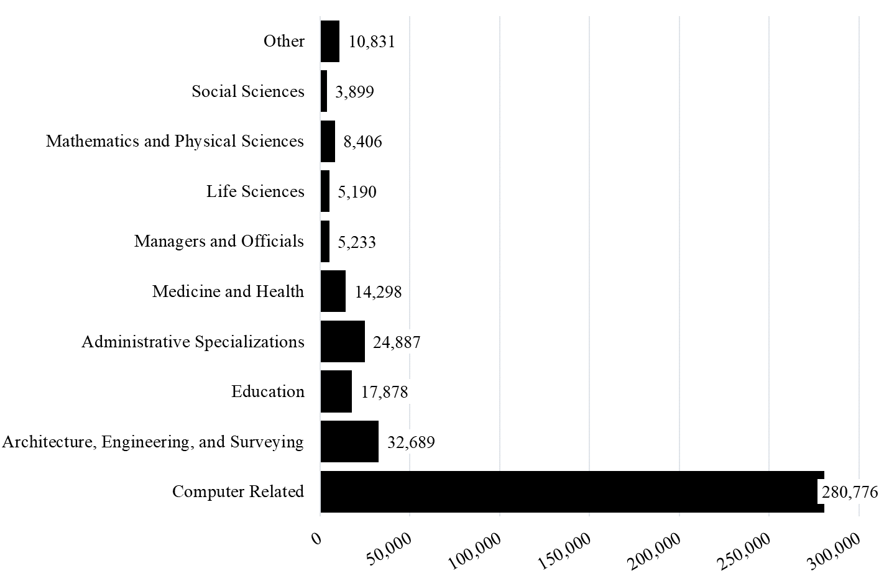
Notes: This figure shows the industry breakdowns of H-1B petition filings in 2017. It illustrates that the distribution of occupations is highly skewed; computer-related occupations accounted for 69% of H-1B petition filings in 2017. Note that these are petitions filed not petitions approved. Petition counts include both cap-subject and cap-exempt, initial and continuing employment. The data are publicly available from USCIS.

Figure A6-3: Total Number of H-1B Approved Petitions in FY 2016, for the Top 30 Firms
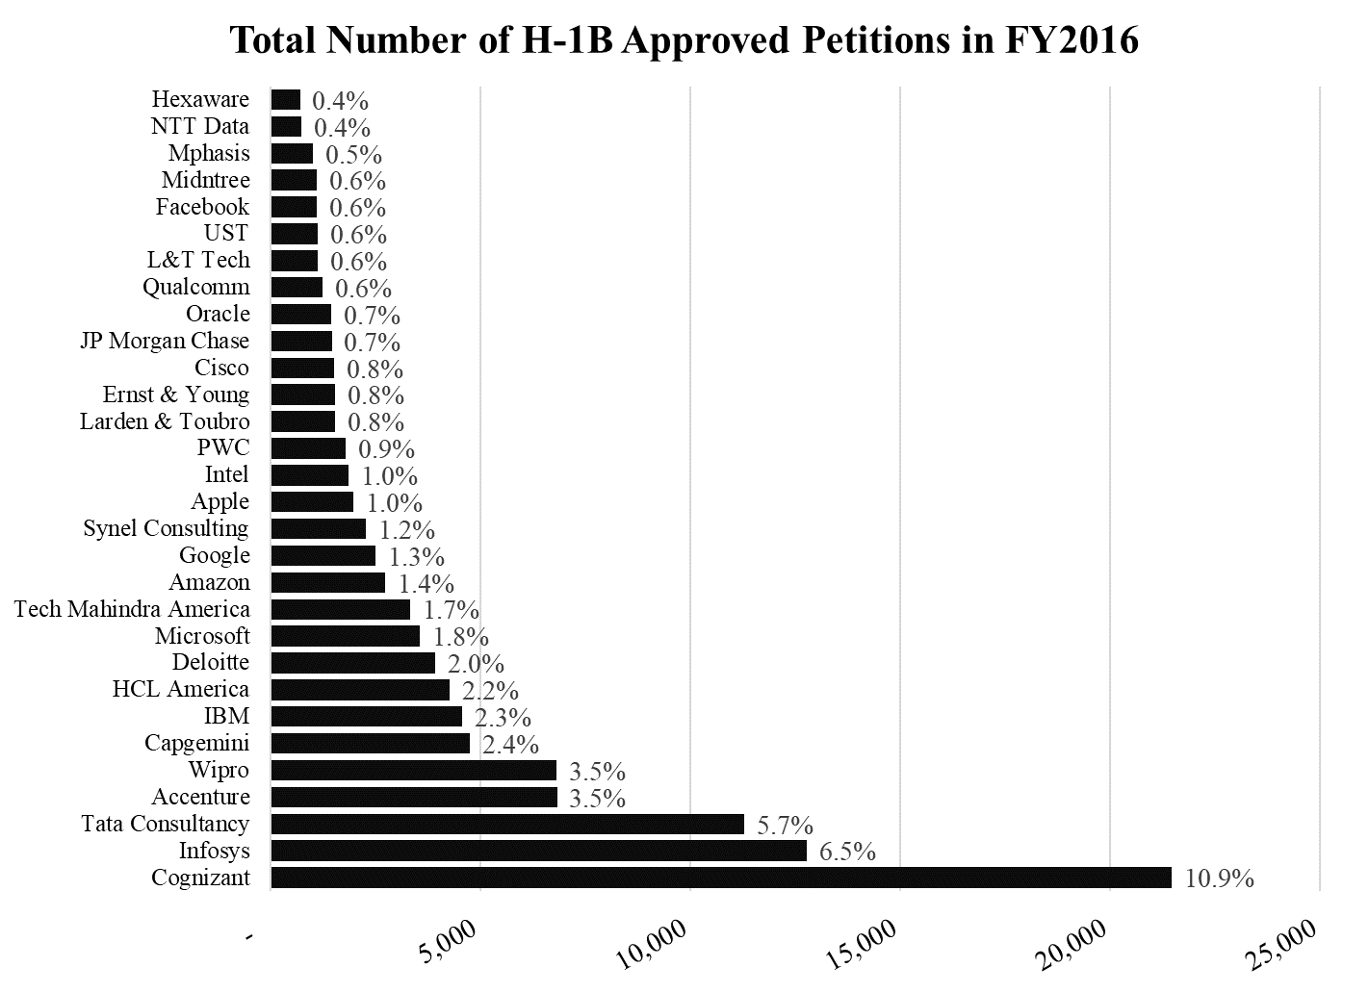
Notes: This figure shows the number of approved H-1B petitions for the top 30 firms in fiscal year 2016. All data are based on approved petitions during the fiscal year. Total number of beneficiaries includes initial, renewal, cap-subject, and cap-exempt petitions. This figure is constructed from publicly available data, which means that these may be underestimates in some cases; while some company names may appear multiple times, USCIS does not combine companies even where the names are the same because in all cases the employer tax identification numbers are different. In the confidential data used in the paper, this is not the case. The figure illustrates that there is also significant skewness in H-1B visas across firms. Note that these are not all multinationals and therefore are not equivalent to the BEA sample of firms used in this paper’s data; the sample of firms in my analysis is somewhat different.

Figure A6-4: Median Salary of H-1B Visa Holders at Top 20 H-1B Hiring Firms in 2018
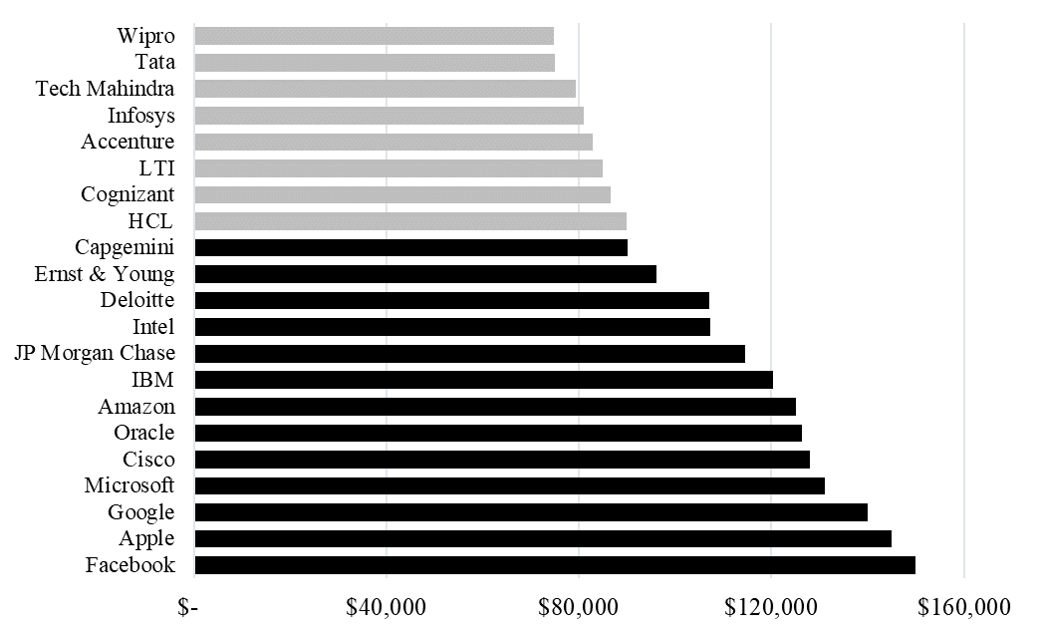
Notes: This figure shows the median salary of H-1B visa holders hired by the top 20 H-1B hiring firms in 2018. The light grey bars show Indian outsourcing companies, while the black bars show American firms. The companies shown in black bars are closer to the sample of firms used in this paper.

Appendix A7.
I use Table 10 to estimate that about 0.3 foreign affiliate jobs were created for every unfilled H-1B position. To calculate this number, I divided excess demand among US multinationals during the two relevant lottery years by the predicted change in foreign affiliate employment. To estimate the predicted change in foreign affiliate employment, I multiplied each firm’s normalized excess demand by the coefficients identified in Table 10. I then multiplied this value by logged foreign affiliate employment in 2005 and took the exponential to calculate the predicted change in foreign affiliate employment for each firm. I did this for each firm and then summed across firms. Table A7-1 displays these figures for US multinationals in aggregate. Column 1 shows excess demand. Column 2 shows the predicted increase in foreign affiliate employment. The final column displays the number of offshored jobs lost per unfilled H-1B position.
The 0.31 estimate of substitution should be treated with caution and as a lower bound for the true number of foreign affiliate jobs added per rejected H-1B visa for several reasons. First, it relies on calculations on the intensive margin and does not consider increased foreign affiliate employment on the extensive margin. Second, there are likely at least some firms that did not submit their petition(s) in time to be considered for the lottery, which means that their behavior is not captured in the analysis. Third, this estimate only captures how existing firms modified their strategy; new firms born into the visa-restrictive world may have incorporated offshoring into their strategy from the beginning. Finally, the estimate does not include foreign multinational company behavior, and one would expect that foreign MNCs would be even more likely to substitute foreign-born US-based skilled workers for foreign-born skilled workers at headquarters or other foreign affiliates. This suggests that, if anything, the regression estimates are smaller than the true effects – and so is the estimate of substitution.

Table A7-1: Estimating Offshored Jobs per unit of Excess Demand
Total Excess Demand Among US MNCs in April 2007-08 | Predicted Change in Foreign Affiliate Employment, 2005-2014 | Foreign Affiliate Jobs per Unit of Excess Demand
14,218 | 4,449 | 0.31

https://travel.state.gov/content/travel/en/legal/visa-law0/visa-statistics/nonimmigrant-visa-statistics.html
https://travel.state.gov/content/travel/en/legal/visa-law0/visa-statistics/nonimmigrant-visa-statistics.html

