Appendices for “Is Healthcare Employment Resilient and “Recession Proof”?

Appendix A: State Level Relationships

In Appendix A, we present the relationship between the share in health care and the unemployment rate at the state level. The coefficients are from a series of fixed effect regressions of the health care shares on the unemployment rate, controlling for state fixed effects, median income of households, poverty rate and working population size.

Appendix Figure A. Share in Health Care Employment and Graduates vs. Unemployment Rate
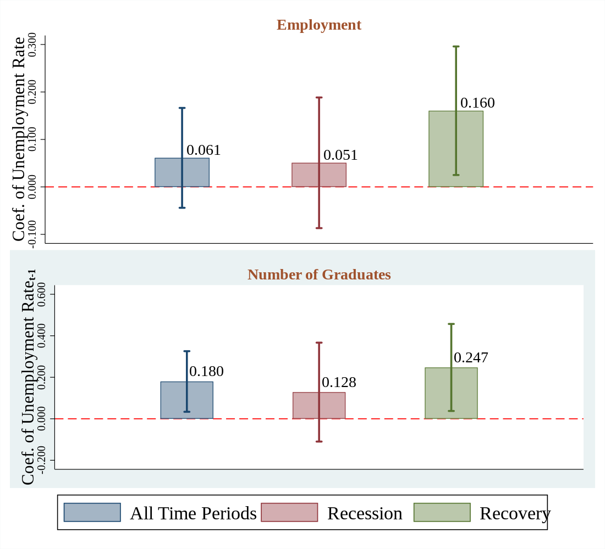
Source: QCEW 2005-2017,IPEDS 2005-2017, and BLS LAUS (2005-2017). Notes: Figure shows coefficients and confidence intervals of the unemployment rate. For employment, unemployment rate is at time t. For number of graduates, unemployment rate is at time t-1. Regressions control for state and year fixed effects. Regressions are weighted by population counts. Economic condition controls include state median household income, poverty rate and working age population. Recession refers to 2007-2009. Recovery refers to 2010-2017. 95% confidence intervals are obtained from heteroskedasticity robust standard errors clustered at the state level. Health care employment from QCEW refers to county establishments in NAICS 3-digit code 621, 622, 623.

Appendix B: Full Results for Fixed Effect Regressions

In Appendix B, we present a county fixed effects regression examining the relationship between health care’s share in employment and graduates, and the unemployment rate. Our analysis regresses the health care share on the unemployment rate controlling for county fixed effects, median income of households, poverty rate and working population. We also present the regression results for selected industries based on NAICS codes and selected education fields based on CIP codes.

Appendix Table B1. Regression Results: Health Care Share of Employment vs. Unemployment Rate
Dependent Variable: Share of Employment | (1) | (2) | (3) | (4) | (5)
Dependent Variable: Share of Employment | Un-weighted | No Controls | With Controls | Recession | Recovery
Dependent Variable: Share of Employment | Panel A. Health Care and Social Assistance
Unemployment Rate | 0.162*** | 0.056 | 0.072 | 0.163*** | -0.065
 | (0.051) | (0.084) | (0.088) | (0.040) | (0.146)
Mean | 14.62 | 14.62 | 14.62 | 13.38 | 15.40
Number of Obs. | 80,166 | 80,132 | 80,132 | 30,784 | 49,348
 | Panel B. Health Care
Unemployment Rate | 0.164*** | 0.127*** | 0.140*** | 0.166*** | 0.122**
 | (0.031) | (0.028) | (0.029) | (0.037) | (0.047)
Mean | 11.76 | 11.76 | 11.76 | 10.99 | 12.24
Number of Obs. | 39,920 | 39,904 | 39,904 | 15,328 | 24,567
County Fixed Effects | Yes | Yes | Yes | Yes | Yes
Year Fixed Effects | Yes | Yes | Yes | Yes | Yes
Economic Conditions | Yes | No | Yes | Yes | Yes
Weighted | No | Yes | Yes | Yes | Yes
Source: QCEW 2005-2017 and BLS LAUS (2005-2017). Economic conditions include median household income, poverty rate and working age population. Panel A includes county establishments in NAICS 2-digit code 62. Panel B includes NAICS 2 digit code 62 except 4-digit 6241, 6242, 6243, 6244. Regressions are weighted by population when indicated. Standard errors, heteroscedasticity-robust and clustered by state, are in parentheses. * p<0.10 ** p<0.05 *** p<0.01

Appendix Table B2. Regression Results: Health Care Share of Employment vs. Unemployment Rate- Selected Subsectors
Dependent Variable: Share of Employment | (1) | (2) | (3) | (4) | (5)
Dependent Variable: Share of Employment | Un-weighted | With Controls | No Controls | Recession | Recovery
Dependent Variable: Share of Employment | Panel A. Nursing Care Facilities
Unemployment Rate | 0.031** | 0.022*** | 0.024*** | 0.041*** | 0.011
 | (0.014) | (0.008) | (0.008) | (0.008) | (0.013)
Mean | 1.75 | 1.75 | 1.75 | 1.76 | 1.75
Number of Obs. | 34,805 | 34,805 | 34,805 | 13,353 | 21,423
 | Panel B. Home Health Care Services
Unemployment Rate | 0.017 | 0.003 | 0.001 | 0.007 | -0.015
 | (0.028) | (0.008) | (0.009) | (0.010) | (0.022)
Mean | 1.28 | 1.28 | 1.28 | 1.09 | 1.39
Number of Obs. | 29,742 | 29,726 | 29,726 | 11,035 | 18,584
 | Panel C. Offices of Physicians excl. Mental
Unemployment Rate | 0.071*** | 0.049*** | 0.053*** | 0.038*** | 0.045***
 | (0.010) | (0.008) | (0.007) | (0.009) | (0.010)
Mean | 2.59 | 2.59 | 2.59 | 2.49 | 2.65
Number of Obs. | 37,467 | 37,451 | 37,451 | 14,486 | 22,931
 | Panel D. Health General Medical & Surgical Hospitals
Unemployment Rate | 0.038** | 0.020 | 0.024 | 0.043 | 0.051
 | (0.014) | (0.026) | (0.025) | (0.032) | (0.040)
Mean | 2.24 | 2.24 | 2.24 | 2.21 | 2.26
Number of Obs. | 24,575 | 24,575 | 24,575 | 9,235 | 15,302
County Fixed Effects | Yes | Yes | Yes | Yes | Yes
Year Fixed Effects | Yes | Yes | Yes | Yes | Yes
Economic Conditions | Yes | Yes | No | Yes | Yes
Weighted | No | Yes | Yes | Yes | Yes
Source: QCEW 2005-2017 and BLS LAUS (2005-2017). Economic conditions include median household income, poverty rate and working age population. Panel A. includes establishments in NAICS of 6231, Panel B in NAICS 6216, Panel C in NAICS 6211, and Panel D in 6221. Regressions are weighted by population. Standard errors, heteroscedasticity-robust and clustered by state, are in parentheses. * p<0.10 ** p<0.05 *** p<0.01

Appendix Table B3. Regression Results: Health Care Share of Graduates vs. Unemployment Rate
Dependent Variable: Share of Health Care Graduates | (1) | (2) | (3) | (4) | (5)
Dependent Variable: Share of Health Care Graduates | Un-weighted | With Controls | No Controls | Recession | Recovery
Dependent Variable: Share of Health Care Graduates | Panel A. All Degree
Unemployment Rate_{t-1} | 0.051 | 0.178** | 0.183** | 0.128 | 0.247**
 | (0.055) | (0.070) | (0.076) | (0.119) | (0.104)
Mean | 12.22 | 12.22 | 12.22 | 12.36 | 12.13
Number of Obs. | 13,555 | 13,555 | 13,555 | 4,738 | 8,803
 | Panel B. Top 4 Professions
Unemployment Rate_{t-1} | 0.023 | 0.101 | 0.116* | 0.072 | 0.142
 | (0.058) | (0.066) | (0.066) | (0.115) | (0.091)
Mean | 9.33 | 9.33 | 9.33 | 9.57 | 9.18
Number of Obs. | 12,686 | 12,686 | 12,686 | 4,416 | 8,252
 | Panel C. Less than 1 year Degree
Unemployment Rate_{t-1} | 0.080 | 0.108 | 0.103 | 0.062 | 0.209**
 | (0.062) | (0.084) | (0.077) | (0.072) | (0.102)
Mean | 4.63 | 4.63 | 4.63 | 5.15 | 4.34
Number of Obs. | 7,985 | 7,985 | 7,985 | 2,510 | 5,419
 | Panel D. For Profit Institution
Unemployment Rate_{t-1} | -0.041 | 0.000 | 0.003 | 0.013 | 0.000
 | (0.052) | (0.035) | (0.029) | (0.053) | (0.043)
Mean | 4.05 | 4.05 | 4.05 | 3.62 | 3.62
Number of Obs. | 5,415 | 5,415 | 5,415 | 1,727 | 3,675
County Fixed Effect | Yes | Yes | Yes | Yes | Yes
Year Fixed Effect | Yes | Yes | Yes | Yes | Yes
Economic Condition | Yes | Yes | No | Yes | Yes
Weighted | No | Yes | Yes | Yes | Yes
Source: IPEDS 2005-2017 and BLS LAUS (2005-2017). Economic conditions include median household income, poverty rate and working age population. Sample includes graduates in the health care sector (CIP code 51) (Panel A), graduates in CIP codes 51.38, 51.07, 51.08, 51.39 (Panel B), graduates with award level equal to 1 (Panel C), and includes graduates in institutions with sector codes 3, 6, or 9 (Panel D). Unemployment rate is from Bureau of Labor Statistics-BLS). Regressions are weighted by population. Standard errors, heteroscedasticity-robust and clustered by state, are in parentheses. * p<0.10 ** p<0.05 *** p<0.01

Appendix Table B4. Regression Results: Health Care Share of Graduates vs. Unemployment Rate in Selected CIP Codes
Dependent Variable: Share of Health Care Graduates | (1) | (2) | (3) | (4) | (5)
Dependent Variable: Share of Health Care Graduates | Un-weighted | With Controls | No Controls | Recession | Recovery
Dependent Variable: Share of Health Care Graduates | Panel A. Registered, Practical Nursing, Nursing Admin & Research
Unemployment Rate | -0.040 | 0.013 | -0.002 | -0.046 | 0.029
 | (0.040) | (0.031) | (0.028) | (0.043) | (0.044)
Mean | 6.99 | 6.99 | 6.99 | 7.25 | 6.85
Number of Obs. | 11,957 | 11,957 | 11,957 | 4,099 | 7,840
 | Panel B. Allied Health and Medical Assisting Services
Unemployment Rate | 0.064 | 0.080 | 0.095 | 0.105 | 0.082
 | (0.060) | (0.063) | (0.058) | (0.085) | (0.069)
Mean | 2.58 | 2.58 | 2.58 | 2.76 | 2.76
Number of Obs. | 8,077 | 8,077 | 8,077 | 2,536 | 5,506
 | Panel C. Health and Medical Administrative Services
Unemployment Rate | 0.029 | 0.023 | 0.038 | 0.089 | 0.029
 | (0.020) | (0.024) | (0.026) | (0.055) | (0.034)
Mean | 1.52 | 1.52 | 1.52 | 1.68 | 1.44
Number of Obs. | 9,087 | 9,087 | 9,087 | 2,945 | 6,100
County Fixed Effect | Yes | Yes | Yes | Yes | Yes
Year Fixed Effect | Yes | Yes | Yes | Yes | Yes
Economic Condition | Yes | Yes | No | Yes | Yes
Weighted | No | Yes | Yes | Yes | Yes
Source: IPEDS 2010-2017 and BLS LAUS (2010-2017). Economic conditions include median household income, poverty rate and working age population. Sample includes graduates in CIPCODE 51.38 and 51.39 after 2010 and 51.16 before 2010 (Panel. A), graduates in CIPCODE 51.07 (Panel B) and graduates in CIPCODE 51.08 (Panel C). Regressions are weighted by population. 95% confidence intervals are obtained using state clustered heteroskedasticity robust standard errors

