Predicting the Oil Market:

Supplementary Appendix

Charles W. Calomiris, Nida Çakır Melek, and Harry Mamaysky
September 2021

This Online Appendix contains details on our futures return calculation as well as additional appendix figures and tables referred to in the main body of the paper.

Construction of cumulative weekly futures returns
If on a given Friday, the front-month futures contract will not expire before the next Friday, the weekly return is defined as
$$R\left(t+1\right)=\frac{F1\left(t+1\right)- F1\left(t\right)}{F1(t)}$$
where F1(t+1) is the price of the front-month futures in one week's time and F1(t) is the price of the same futures today. If on a given Friday, the front-month futures will expire before the next Friday, we switch to the second-month futures contract and define the weekly return as
$$R\left(t+1\right)= \frac{F1\left(t+1\right)-F2\left(t\right)}{F2(t)}$$
where F2(t) is the price of the second-month futures contract today. Then, we obtain n-week ahead weekly cumulative returns as
$$\left(1+R\left(t+1\right)\right)× \left(1+R\left(t+2\right)\right)×⋯×\left(1+R\left(t+n+1\right)\right)×100.$$

Constructing weekly returns series
We use weekly (Friday, end-of-period (EOP)) values for the front-month and second-month contracts. To figure out when the front-month expires and the second-month becomes the front-month, we follow the following steps.
- Find range of dates for Fridays with a new contract
The CME Group describes termination of trading for these contracts as: “Trading terminates 3 business day prior to the twenty-fifth calendar day of the month prior to the contract month. If the twenty-fifth calendar day is not a business day, trading terminates 3 business days prior to the business day preceding the twenty-fifth calendar day.” Based on this information, we can find Fridays signaling the start of a new contract.

Assume 25th falls on a | Trading ends | Trading ends  (assuming 1-day holiday) | Friday with new contract | Friday with  new contract  (if 1-day holiday)
Saturday | 21st (Tues.) | 20th (Mon.) | 24th | -
Sunday | 20th (Tues.) | 19th (Mon.) | 23rd | -
Monday | 20th (Wed.) | 19th (Tues.) | 22nd | -
Tuesday | 20th (Thurs.) | 19th (Wed.) | 21st | -
Wednesday | 20th (Fri.) | 19th (Thurs.) | 27th | 20th
Thursday | 22nd (Mon.) | 19th (Fri.) | 26th | -
Friday | 22nd (Tues.) | 21st (Mon.) | 25th | -

- Identify market holidays that might fall on Friday 20th - Wednesday 25th of a month
Based on the first step, the only time a holiday would change the Friday on which the front-month contract rolls over is when the 25th falls on a Wednesday. Thus, we need to inspect observations falling on the 27th to see if there’s a holiday that would lead to the 20th being the Friday with the new contract.
We want to see if a holiday fell on Friday 20th – Wednesday 25th of a month for 1998-2020.

Holiday | Check based on timing? | When would it need to fall for the new contract to begin on the 20th as opposed to the 27th?
New Years Day | N | -
Martin Luther King, Jr. Day | Y | Always on a Monday, would need to fall on Monday 23rd, but the latest it’s fallen on is Monday 21st  Friday 27th still when new contract begins
Washington’s Birthday | Y | Always on a Monday, would need to fall on Monday 23rd, but the latest it’s fallen on is Monday 21st  Friday 27th still when new contract begins
Good Friday | Y | Always on a Friday, would need to fall on Friday 20th, which it doesn’t for 1998-2019  Friday 27th still when new contract begins
Memorial Day | Y | Always on a Monday, would need to fall on Monday 23rd, but the earliest it’s fallen on is Monday 25th  Friday 27th still when new contract begins
Independence Day | N | -
Labor Day | N | -
Thanksgiving Day | Y | Always on a Thursday, more than 3 business days before the 25th of a month, therefore we do not need to consider this holiday’s effect if the 25th fell on a Wednesday
Christmas | Y | Always on the 25th, would need to fall on a Wednesday for the new contract to start on Friday 20th as opposed to Friday 27th. This was the case in 2002 and 2013, and will be the case in 2019. Thus, in December of 2002 and 2013, the new contract will begin on Friday 20th instead of the 27th

- Construct dummy for when to calculate returns using F2, based on steps 1 and 2
Using step one, create a dummy that equals to 1 if the day is between 21 and 27, inclusive; zero otherwise. Using step two:
If day = 27, month = 12, and (year = 2002 or 2013), change dummy back to 0
If day = 20, month = 12, and (year = 2002 or 2013), change dummy to 1
Using this dummy, we can compute returns using F1 and F2 such that, if dummy = 0,
$$R_{t}= \frac{{F1}_{t}-{F1}_{t-1}}{{F1}_{t-1}};$$
and if dummy = 1,
$$R_{t}= \frac{{F2}_{t}-{F2}_{t-1}}{{F2}_{t-1}},$$
all in one series. Here, F1 refers only to the front-month series (CL1), and F2 only to the second-month series (CL2), unlike in the definition section where we change notation when referring to the same series in equation above.
To fill in missing Friday observations, we rely on Thursday prices. If Thursday prices are missing, we use Wednesday prices. We only have to go as far back as Wednesday to eliminate all missing observations. We adapt the methodology above to Thursday and Wednesday prices.

Timing convention for variable construction
Unless explicitly noted, all days refer to week t.
Variables | Timing Convention
Variables | Prices Regressions | Physical Regressions
Dependent Variables
FutRet | Friday | -
DSpot | Friday | -
DOilVol | Friday | -
xomRet | Friday | -
bpRet | Friday | -
rdsaRet | Monday of week t+1 | -
DInv | - | Wednesday
DProd | - | Wednesday
Independent Variables
FutRet | Friday | Tuesday
DSpot | Friday | Tuesday
DOilVol | Thursday | Tuesday
xomRet | Thursday | Tuesday
bpRet | Thursday | Tuesday
rdsaRet | Friday | Tuesday
StkIdx | Thursday & Friday | Tuesday
DInv | Wednesday | Wednesday
DProd | Wednesday | Wednesday
OilVol | Thursday | Tuesday
VIX | Thursday | Tuesday
vix_diff | Thursday | Tuesday
ovx_diff | Thursday | Tuesday
sdf_fullSample | Thursday | Tuesday
DFX | Thursday | Tuesday
tnote_10y | Thursday | Tuesday
sp500Ret | Thursday | Tuesday
basis | Friday | Tuesday
WIPI | Monthly | Monthly
trend | Monthly | Monthly
BE/ME | Monthly | Monthly
Mom | Monthly | Monthly
BasMom | Monthly | Monthly
InflaBeta | Monthly | Monthly
DolBeta | Monthly | Monthly
HedgPres | Friday of week t-1 | Friday of week t-1
OpenInt | Thursday | Tuesday
liquidity | Thursday | Tuesday
f[Topic] | Friday | Tuesday
s[Topic] | Friday | Tuesday
artcount | Friday | Tuesday
entropy | Friday | Tuesday
PCAsent | Friday | Tuesday
PCAfreq | Friday | Tuesday
PCAall | Friday | Tuesday
The general philosophy is to take a variable from day t-1 if it's not clear that it won't overlap with a day t variable, and to take it from day t if we are sure there is no look-ahead bias. For example, we calculate text-based series to end at 2:30pm on each day, so there is no overlap with these at either the 2:30pm energy futures market closes or the 4pm stock market closes. Some of the independent series are from the prior month.
We calculate Momentum (Mom) for month m as the cumulative return from months m-11 to m-1, to be consistent with standard practice. After construction, we use month m’s Mom value as a regressor for future four- or eight-week outcomes that start in month m+1.
The physical regressions use levels of industrial production and inventories that are reported on Wednesday at 10am. Therefore, the explanatory variables for these are from Tuesday or earlier. The oil production and inventory variables are occasionally reported on either Thursday or even Friday. For this reason, when we are forecasting price-based series that use the physical oil market variables as forecasting variables, we use Friday and forward market-based observations to make sure there is no overlap with the production or inventory series in that week.
For Oil Volatility (OilVol), it is not certain whether Bloomberg uses futures settlement price or last traded price for calculating OilVol. Therefore, we use its Thursday or Tuesday value as an independent variable. Accordingly, for the level difference of OilVol, i.e. DOilVol, we use its Thursday or Tuesday value as an independent variable and use its Friday value as a dependent variable.
For Exxon Mobil stock returns (xomRet) and British Petrol stock returns (bpRet), we use Thursday or Tuesday values as an independent variable and use their Friday value as a dependent variable. We use BP PLC American Depository Receipts (ADR) Stock Price for calculating bpRet. For Royal Dutch Shell class A stock returns (rdsaRet), we use its Friday or Tuesday value as an independent variable and use its Monday week t+1 value when it is a dependent variable because it trades in Europe and has a 10 or 11am NY close.
For Open Interest (OpenInt) calculation, we take logarithm of the product of: WTI spot price, quantity of WTI futures contracts outstanding, and WTI futures contract size. The data for open interest generally comes in around 18:00 EST but this may vary depending on the exact time the exchange sends data to Bloomberg. Hence, we use Thursday or Tuesday value as an independent variable.
For Hedging Pressure (HedgPres), we use its Friday value from the week t-1 as an independent variable for both prices and physical regressions. The Commodity Futures Trading Commission (CFTC) provides long and short hedge positions data for “CRUDE OIL, LIGHT SWEET - NEW YORK MERCANTILE EXCHANGE” on a weekly basis. The data for week t are as of Tuesday, and are released on Friday of week t at 3:30pm EST.

Figures and Tables
Figure A.1. Clustered Correlation Plot of all Independent Variable Series. All the series are detrended before covariance calculation. The clustering adopts ﻿hierarchy method, implemented by Python scipy.clustering.hierarchy method. This plot shows the covariance clusters of the independent variable series constructed every Friday. The color bar on the right indicates the magnitude and sign of the value.

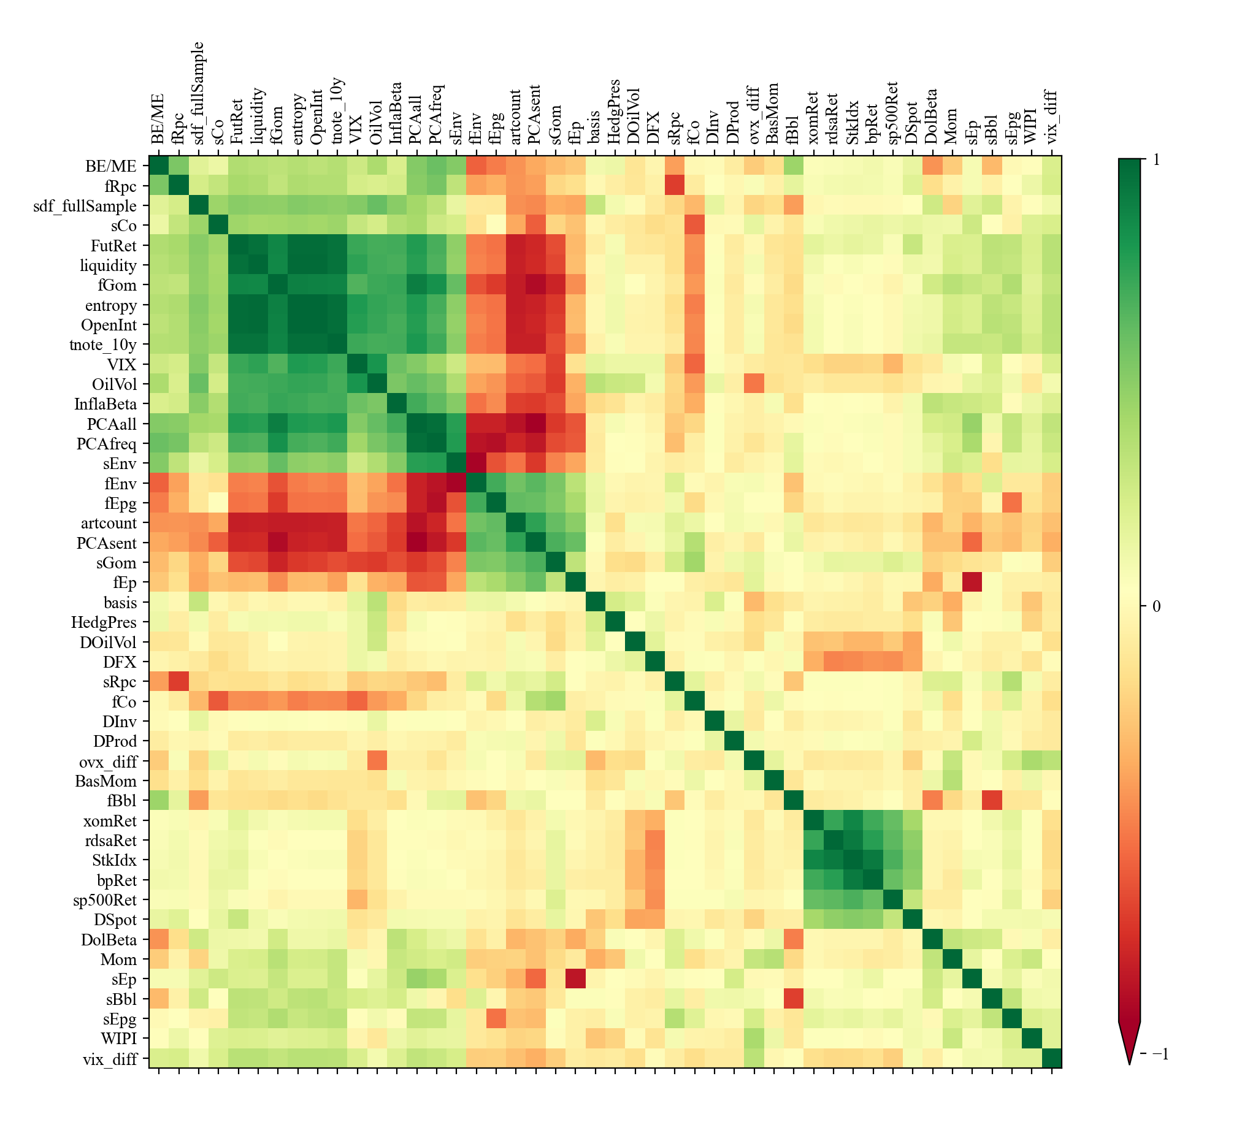

Figure A.2a. Time series plots of selected non-text variables in OOS 1-1 Lasso Model. Selected non-text variables in the Out-of-sample R² based 5-year Lasso updating model. This figure shows the time variation of the non-text variable composing the selected prediction model for FutRet, xomRet, bpRet, and rdsaRet in the whole data period. Y-axis lists the variables that at least enter the prediction model once during the whole selection process; x-axis denotes the time of each forecast point. A blue block indicates the corresponding variable is selected in that prediction window.

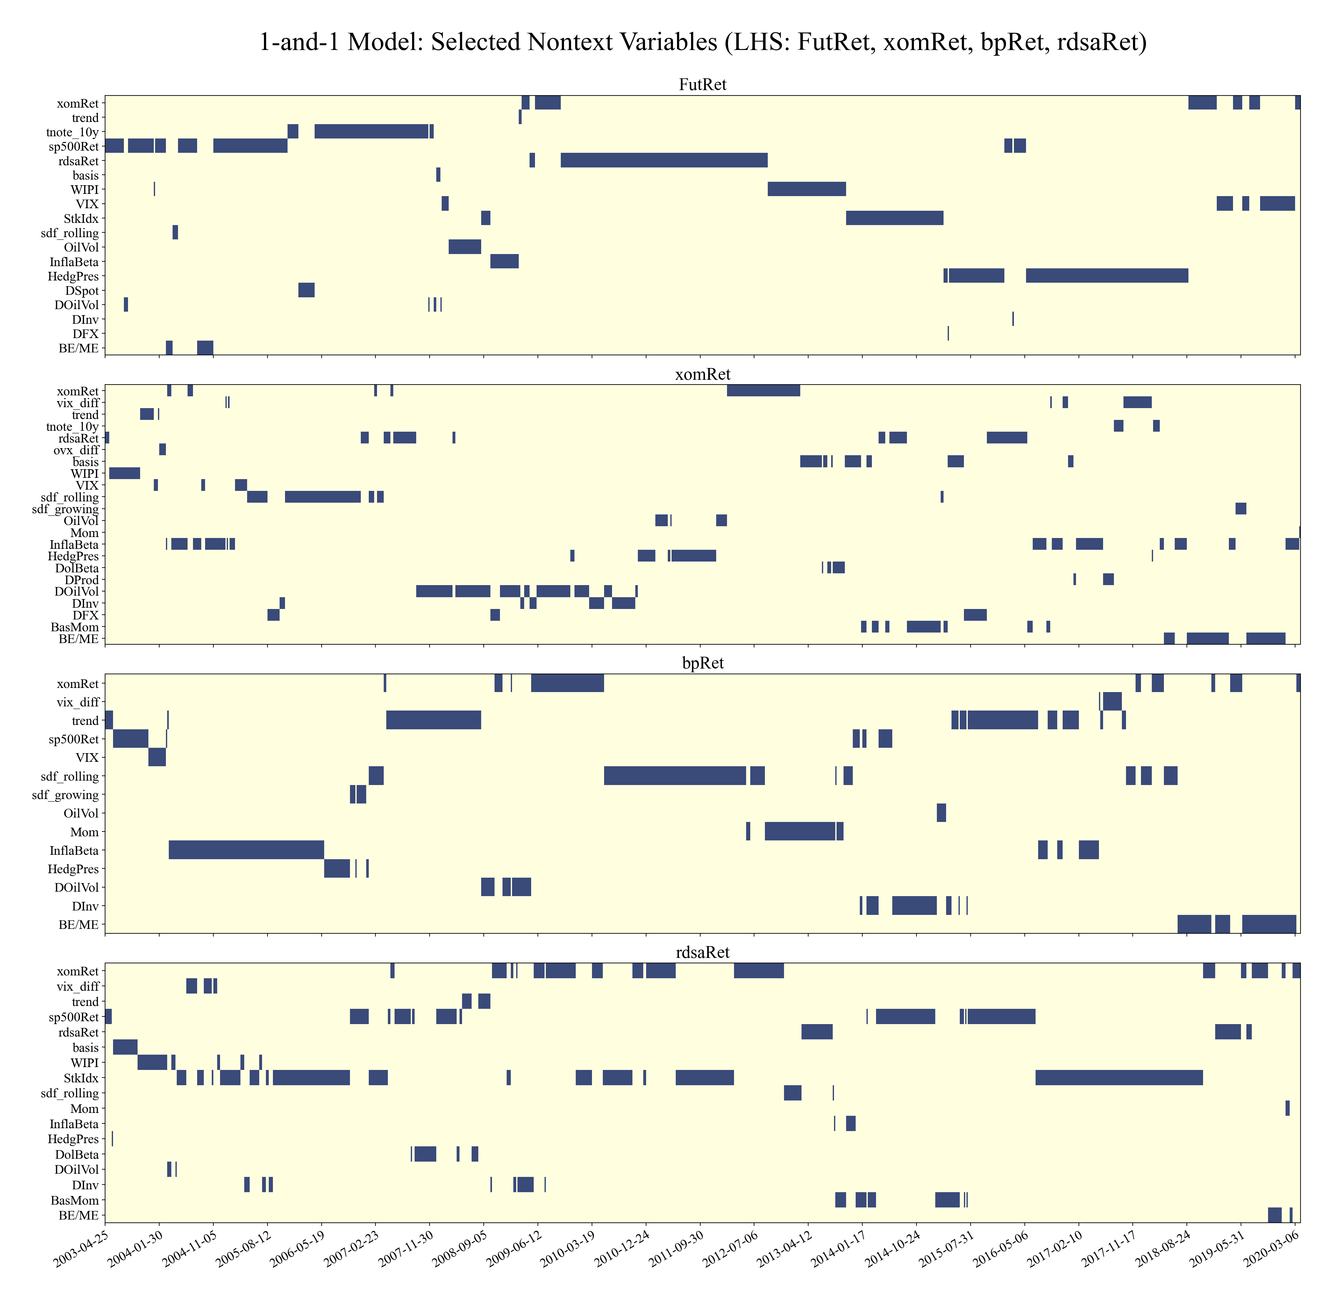

Figure A.2b. Time series plots of selected non-text variables in OOS 1-1 Lasso Model. Selected non-text variables in the Out-of-sample R² based 5-year Lasso updating model. This figure shows the time variation of the non-text variable composing the selected prediction model for DSpot, DOilVol, DInv, and DProd in the whole data period. Y-axis lists the variables that at least enter the prediction model once during the whole selection process; x-axis denotes the time of each forecast point. A blue block indicates the corresponding variable is selected in that prediction window.

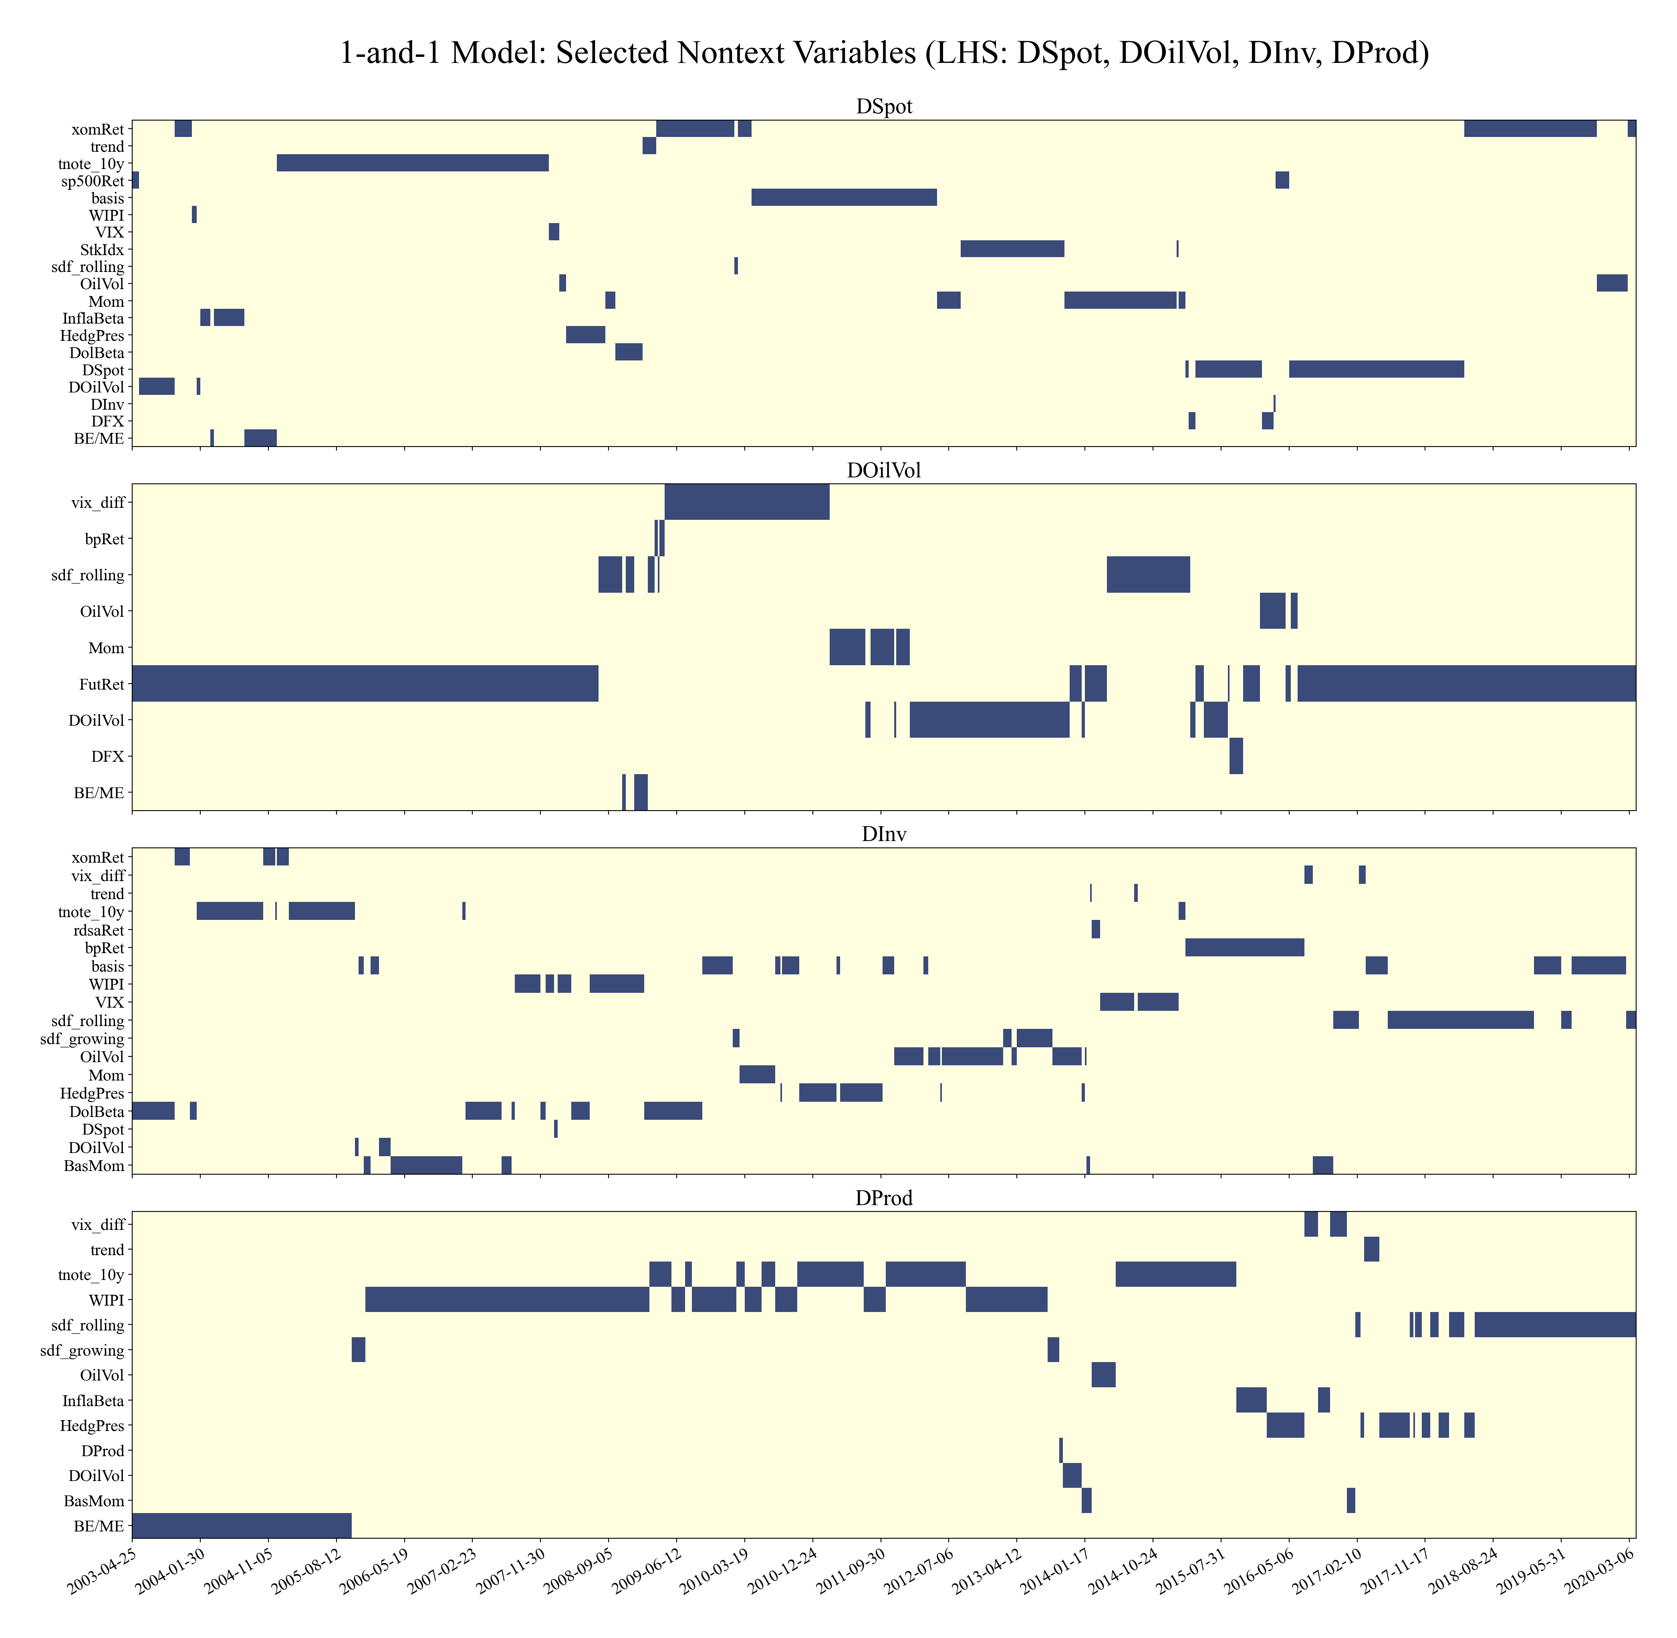

Figure A.2c. Time series plots of selected textual variables in OOS 1-1 Lasso Model. Selected text variables in the Out-of-sample R² based 5-year Lasso updating model. This figure shows the time variation of the text variable composing the selected prediction model for FutRet, xomRet, bpRet, and rdsaRet in the whole data period. Y-axis lists the variables that at least enter the prediction model once during the whole selection process; x-axis denotes the time of each forecast point. A blue block indicates the corresponding variable is selected in that prediction window.

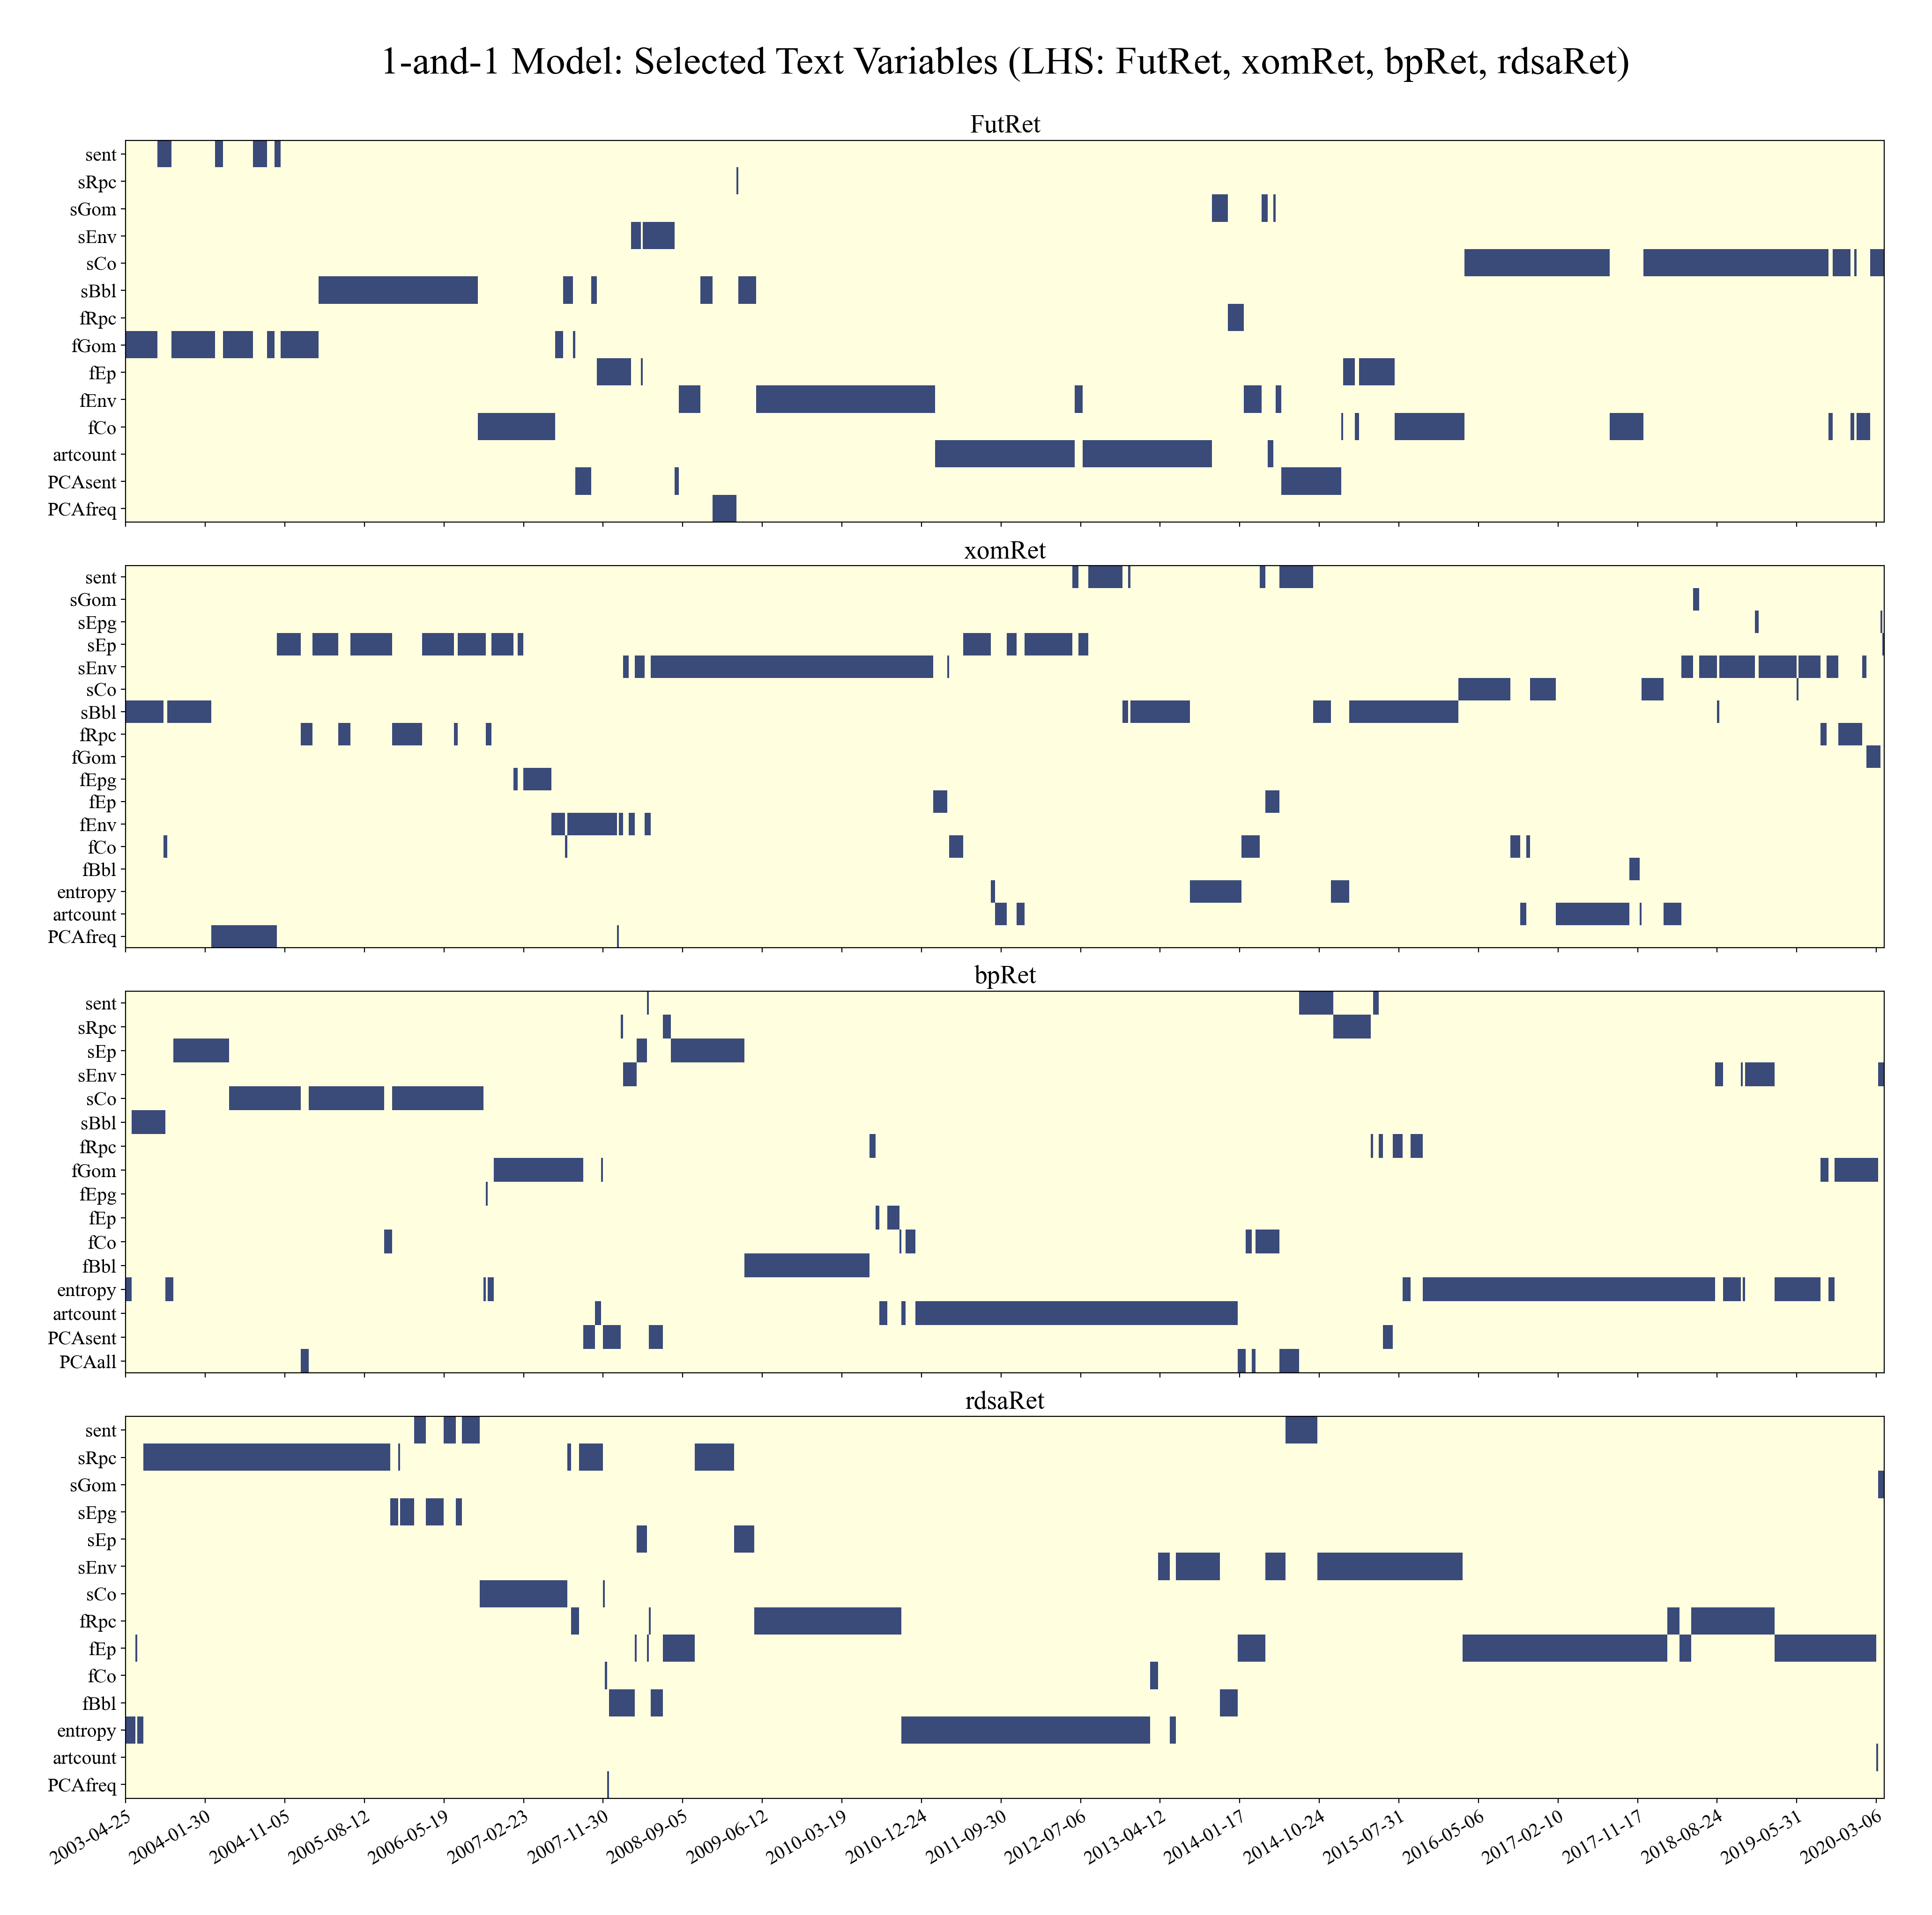

Figure A.2d. Time series plots of selected textual variables in OOS 1-1 Lasso Model. Selected text variables in the Out-of-sample R² based 5-year Lasso updating model. This figure shows the time variation of the text variable composing the selected prediction model for DSpot, DOilVol, DInv, and DProd in the whole data period. Y-axis lists the variables that at least enter the prediction model once during the whole selection process; x-axis denotes the time of each forecast point. A blue block indicates the corresponding variable is selected in that prediction window.

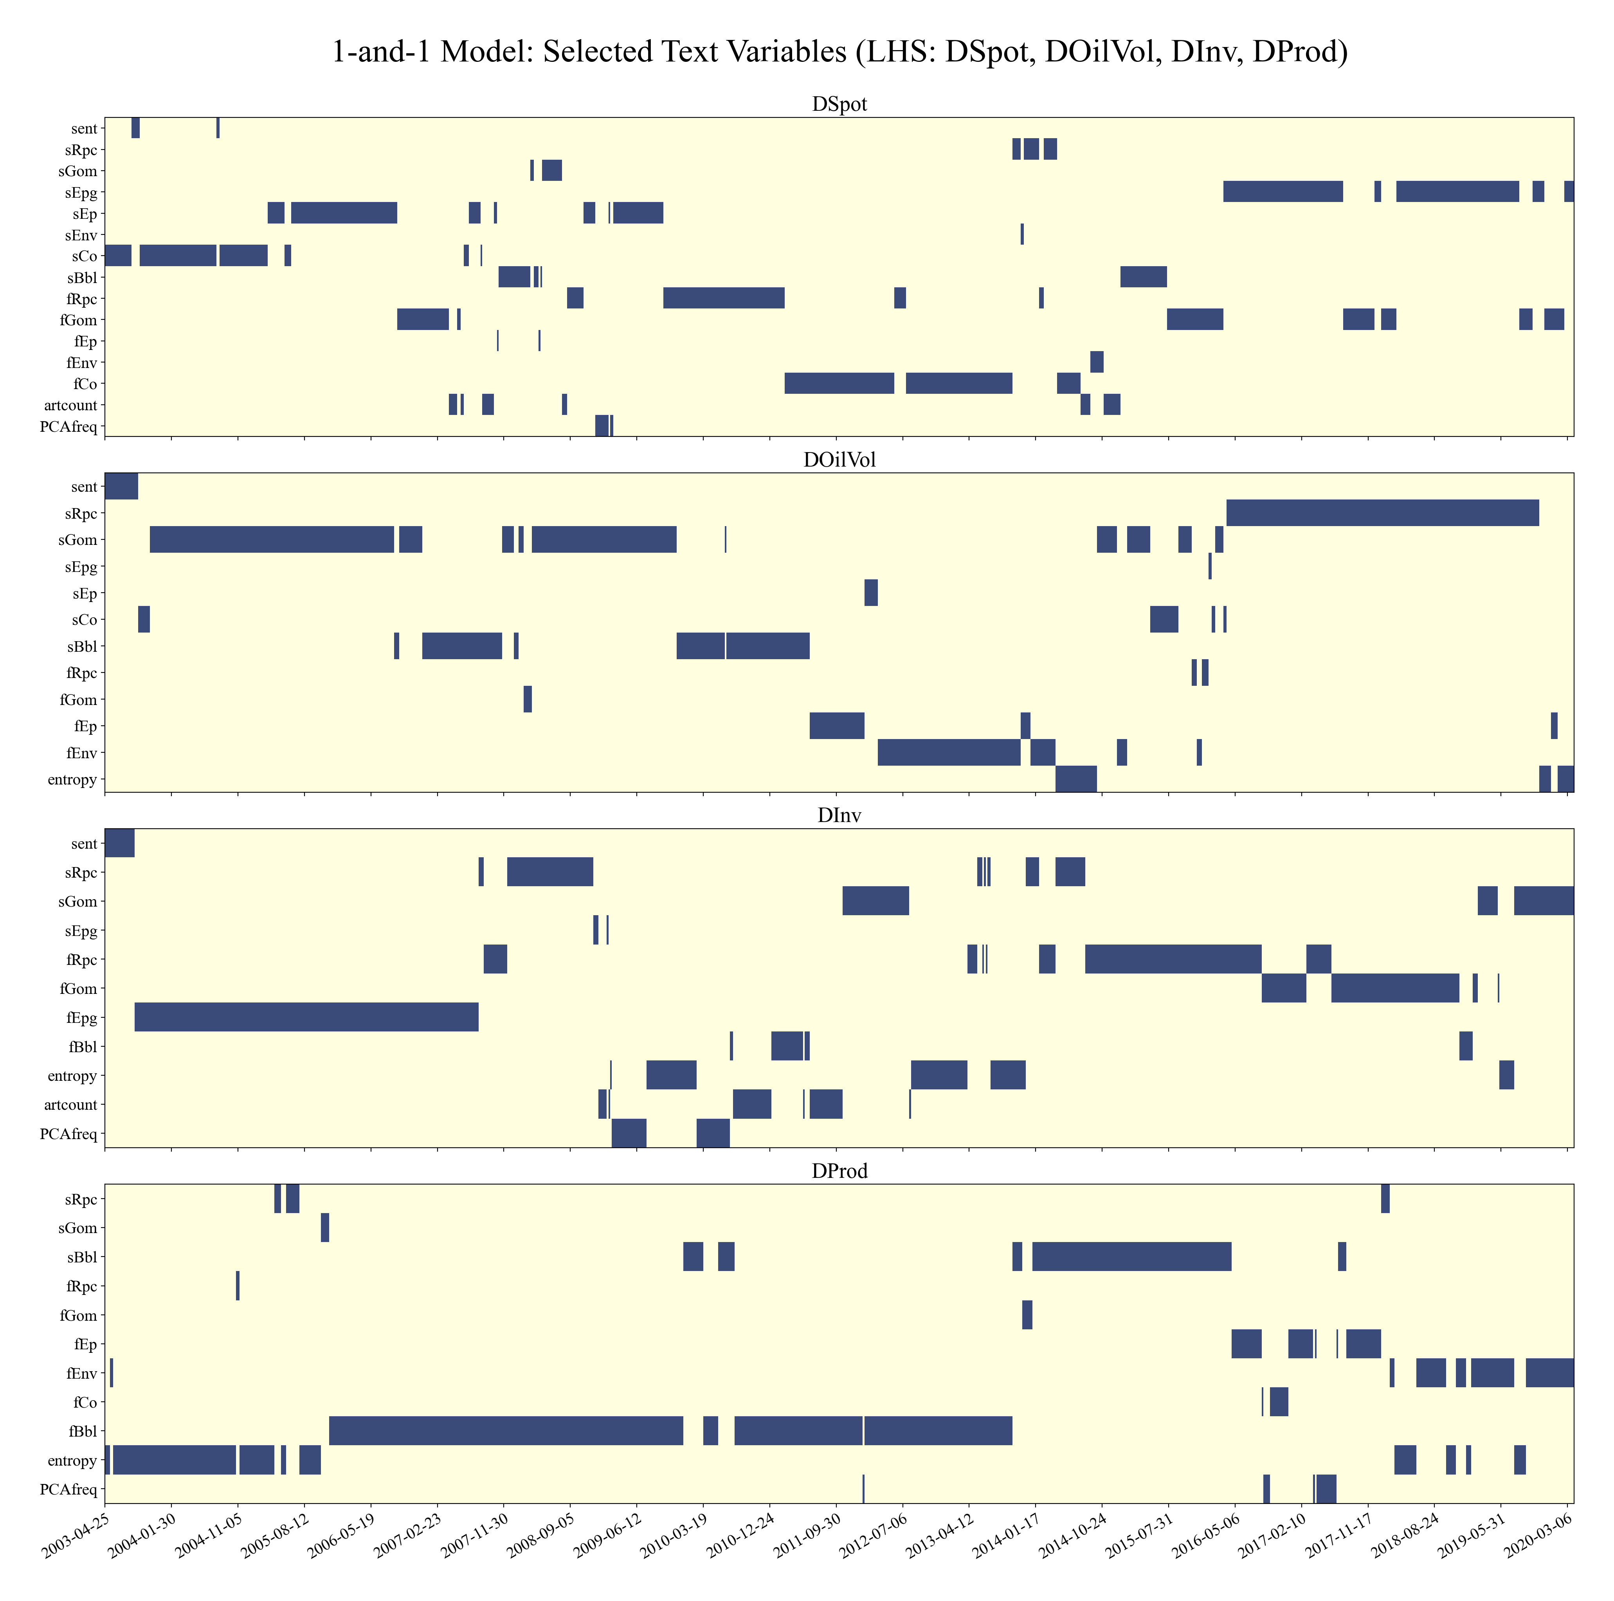

Figure A.3. Number of times that all possible 2-variable models outperform the constant model for out-of-sample forecasting. The figure shows the winning counts of the 2-variable fixed models against the constant model under MSE criterion in the prediction of the dependent variables. Each cell represents the number of left-hand side variables for which the corresponding fixed model, consisting of an explanatory variable from the indicated row and column of the matrix, beats the constant model. Darker color indicates greater number. The 2-variable fixed model fixes 2 predictors ex-ante and forecasts eight-week ahead weekly based on the update coefficients by applying Lasso regression on a 5-yr lookback window. All the possible combinations of 28 non-text and 20 textual variables are considered, rendering a model pool with 1128 (select 2 from 28+20 = 48) candidates for each predicted variable. The left and top edges display variable names starting by the 20 textual variables and then the 28 non-text variables. The matrix is symmetric and has zero diagonal by construction. The bottom and right edges show the sum of the labeling column or row respectively, and each number denotes the total time a variable enters the desired fixed models. Two boxes between the matrix and the color bar reveal the aggregated entry counts of textual and non-text variables accordingly.

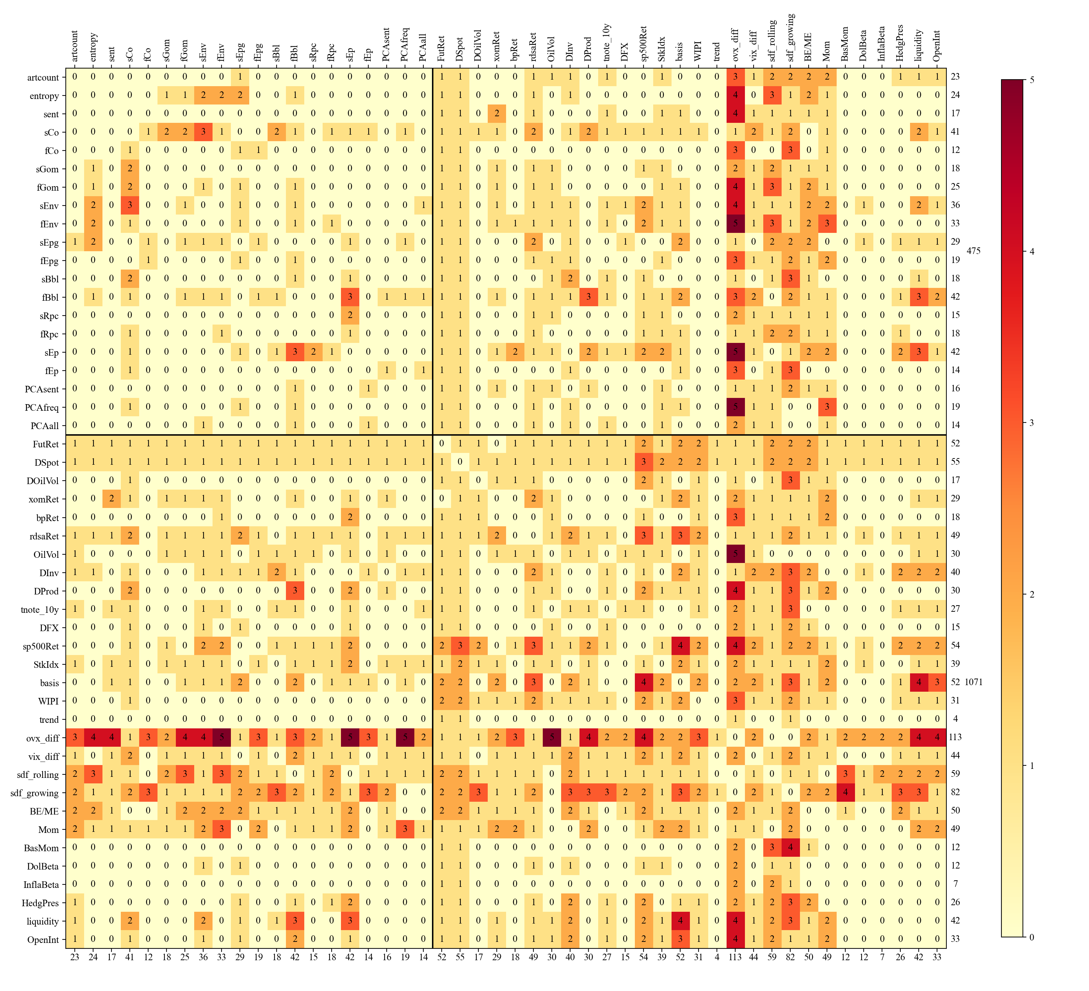

Figure A.4a: Transition Matrix for Out-of-Sample Fixed Models. This figure shows the transition matrix that captures consistency over time in successful fixed models (i.e., those with MSE ratios less than one) when predicted variable is DSpot or bpRet. A negative model outcome for a subperiod is defined as one where the MSE value is greater than that of the constant model. A positive model outcome for a subperiod is the opposite. Negative to Negative represents the probability of a negative model in period t continuing to be beaten by the constant model in period t+1; Negative to Positive represents the probability of a negative mode in period t beats the constant model in period t+1; Positive to Positive represents the probability of a positive mode in period t remains positive in period t+1; Positive to Negative represents the probability of a positive mode in period t turns negative in period t+1. There are 7 subperiods in total, the 3rd period is the NBER recession period and periods 4 to 7 are divided evenly in the subsequent samples after the 3rd one. The length of the 2nd period matches the ones after the 3rd and the first period contains data from the beginning of our sample till the start of the 2nd. There are 3 lines in each subplot, referring to Text models (models with at least 1 text variable), Non-text models (models without any text variable), and All models.
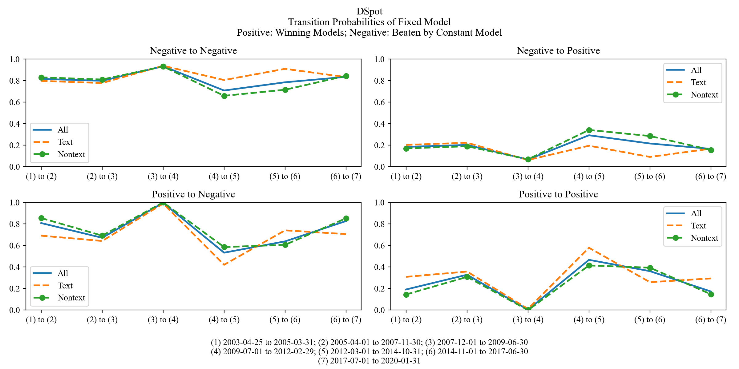
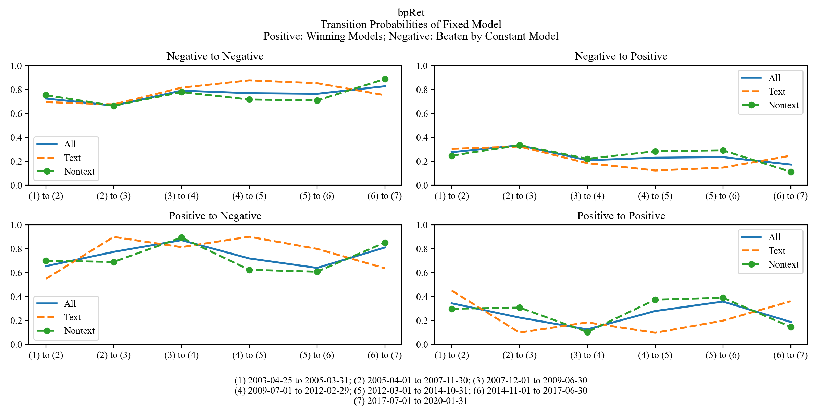

Figure A.4b: Transition Matrix for Out-of-Sample Fixed Models. This figure shows the transition matrix that captures consistency over time in successful fixed models (i.e., those with MSE ratios less than one) when predicted variable is xomRet or rdsaRet. A negative model outcome for a subperiod is defined as one where the MSE value is greater than that of the constant model. A positive model outcome for a subperiod is the opposite. Negative to Negative represents the probability of a negative model in period t continuing to be beaten by the constant model in period t+1; Negative to Positive represents the probability of a negative mode in period t beats the constant model in period t+1; Positive to Positive represents the probability of a positive mode in period t remains positive in period t+1; Positive to Negative represents the probability of a positive mode in period t turns negative in period t+1. There are 7 subperiods in total, the 3rd period is the NBER recession period and periods 4 to 7 are divided evenly in the subsequent samples after the 3rd one. The length of the 2nd period matches the ones after the 3rd and the first period contains data from the beginning of our sample till the start of the 2nd. There are 3 lines in each subplot, referring to Text models (models with at least 1 text variable), Non-text models (models without any text variable), and All models.
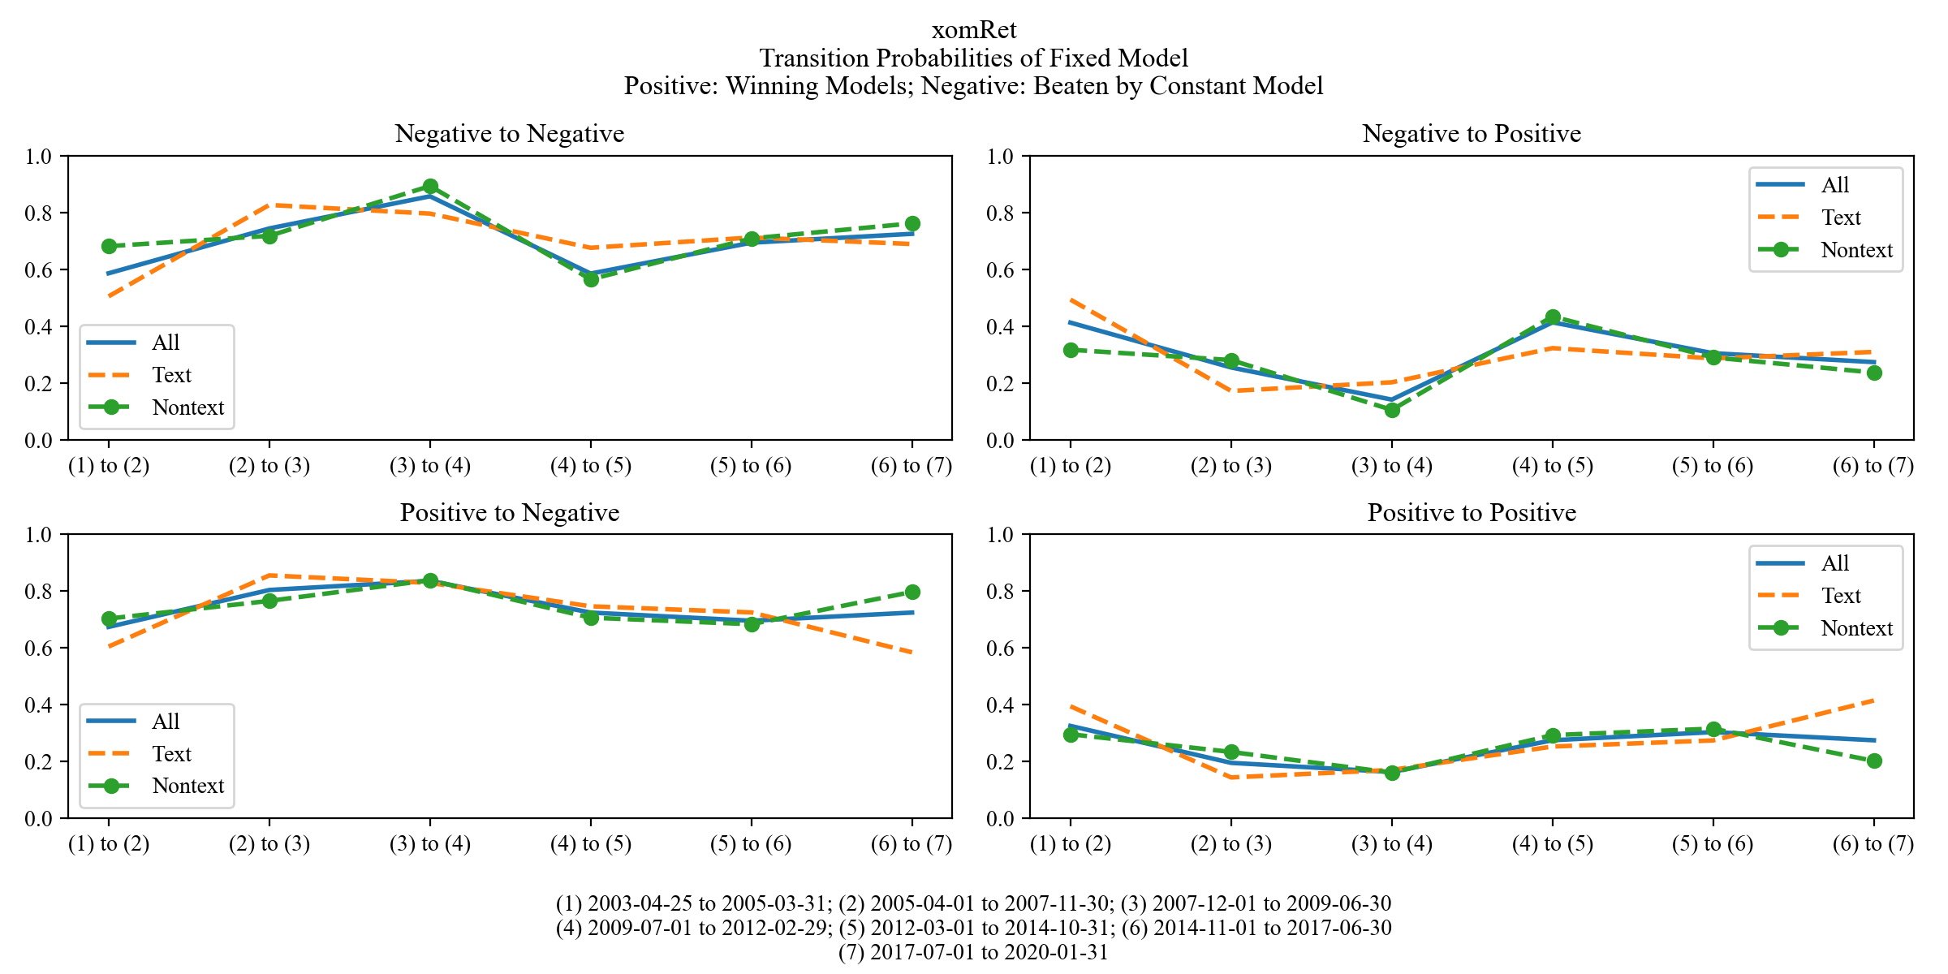
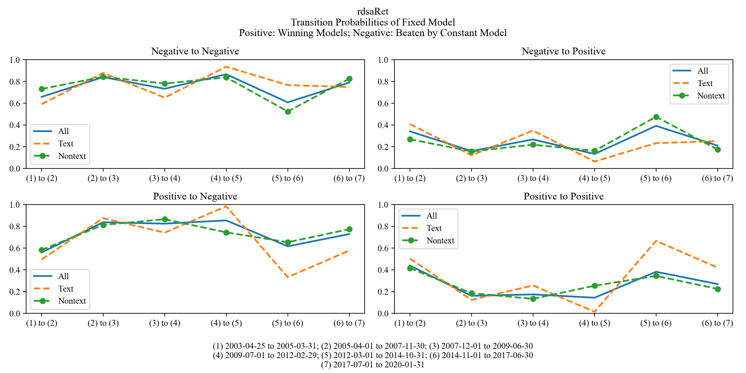

Figure A.4c: Transition Matrix for Out-of-Sample Fixed Models. This figure shows the transition matrix that captures consistency over time in successful fixed models (i.e., those with MSE ratios less than one) when predicted variable is DProd or DInv. A negative model outcome for a subperiod is defined as one where the MSE value is greater than that of the constant model. A positive model outcome for a subperiod is the opposite. Negative to Negative represents the probability of a negative model in period t continuing to be beaten by the constant model in period t+1; Negative to Positive represents the probability of a negative mode in period t beats the constant model in period t+1; Positive to Positive represents the probability of a positive mode in period t remains positive in period t+1; Positive to Negative represents the probability of a positive mode in period t turns negative in period t+1. There are 7 subperiods in total, the 3rd period is the NBER recession period and periods 4 to 7 are divided evenly in the subsequent samples after the 3rd one. The length of the 2nd period matches the ones after the 3rd and the first period contains data from the beginning of our sample till the start of the 2nd. There are 3 lines in each subplot, referring to Text models (models with at least 1 text variable), Non-text models (models without any text variable), and All models.

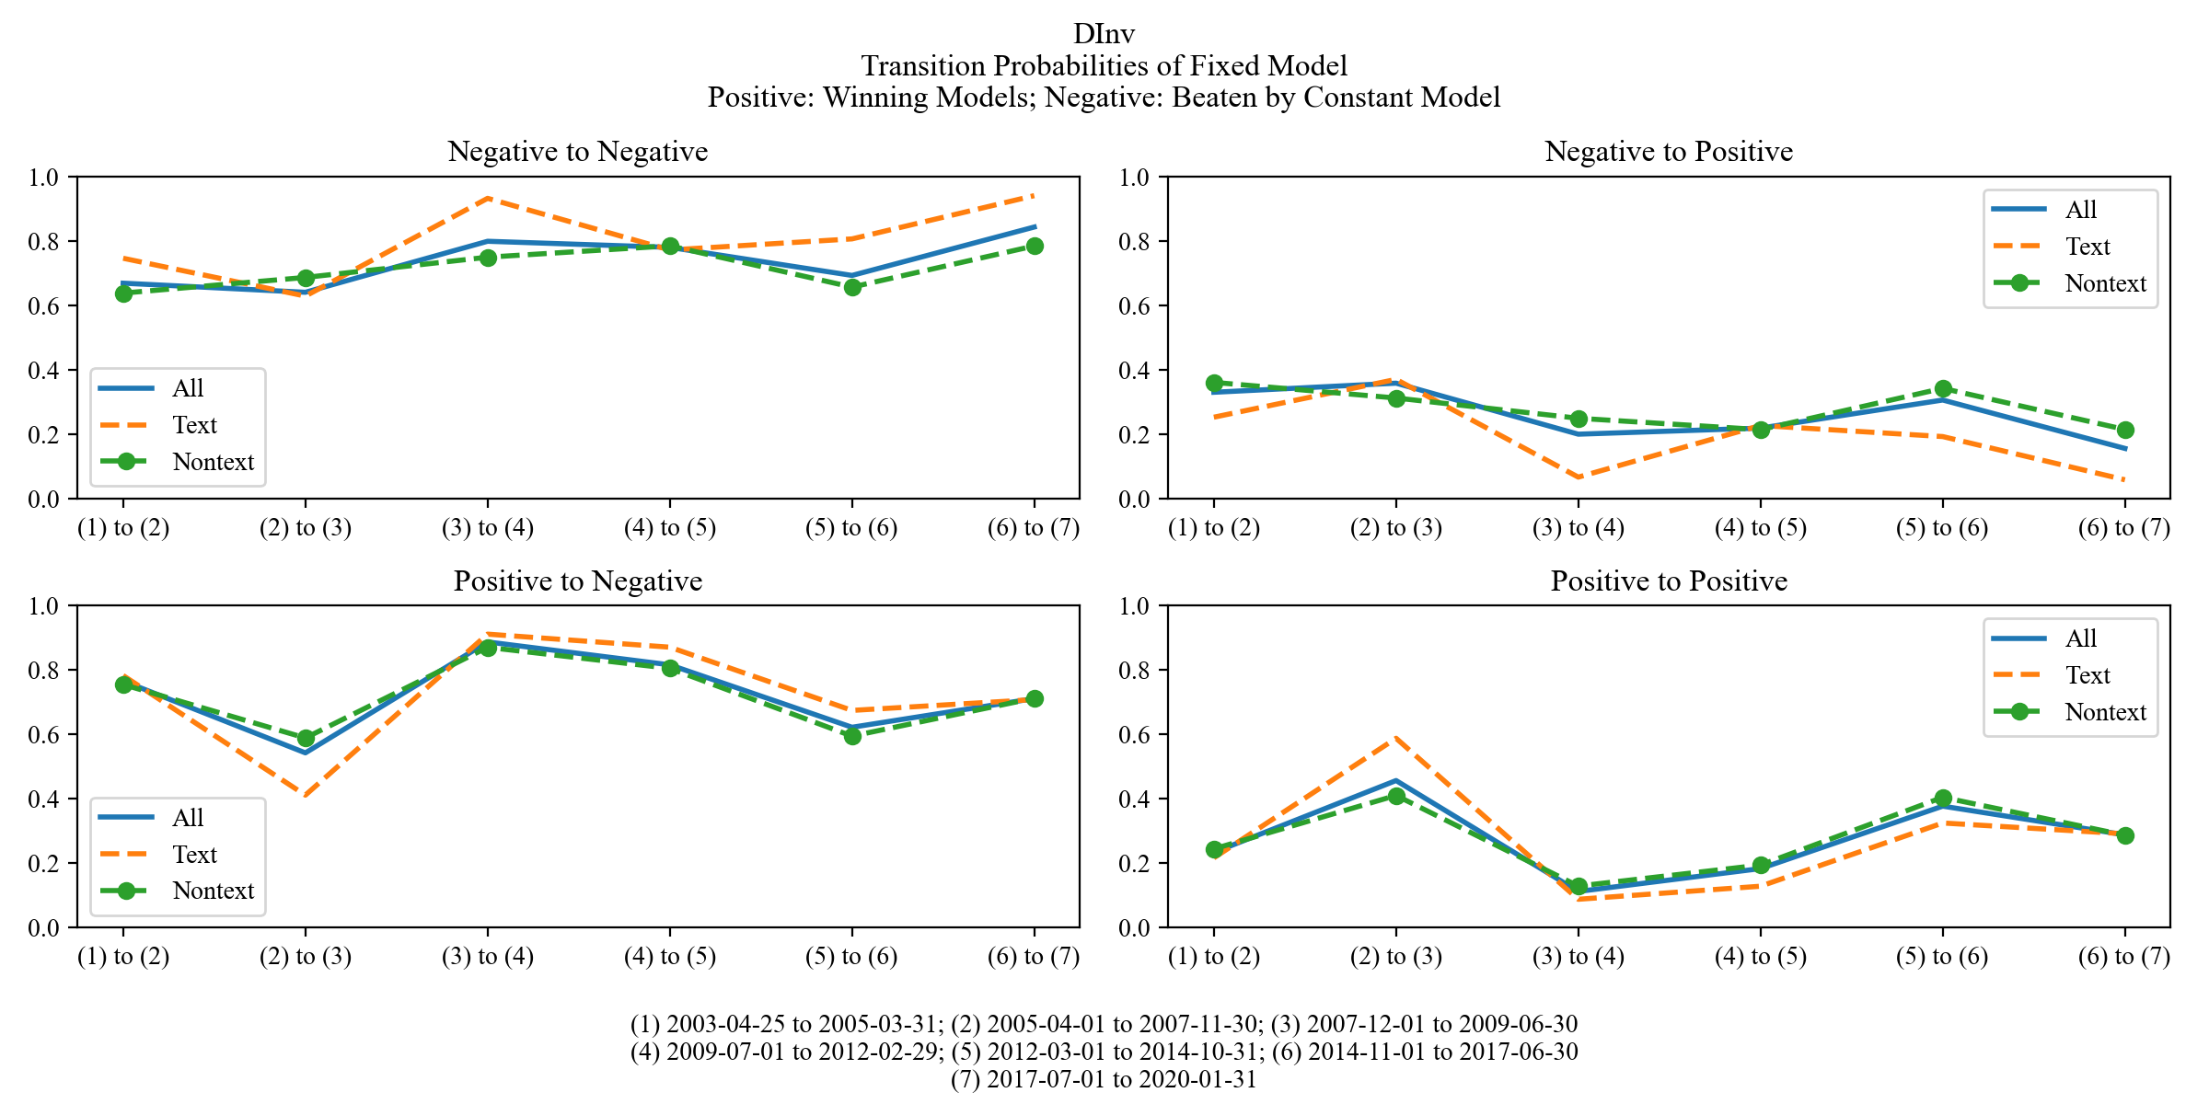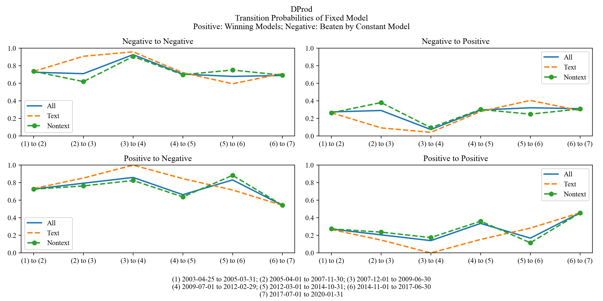

Table A.I
Reuters Topic Codes for Energy Related Article Selection
The table below shows the 98 Reuters Topic Codes we use in the article selection phase in constructing our corpus for textual analysis. We construct the list manually by checking whether the definition of each code captures energy-related news. The article selection is then accomplished by examining if any topic code assigned to a certain article is contained in the following list.
NRG |  | HOIL |  | RENE
CO2 |  | JET |  | RENQ
COA |  | PWR |  | RENF
COAPWR |  | COAPWR |  | ASIAE
NGS |  | GASPWR |  | NASIAE
PETC |  | NUCPWR |  | SEASIE
GASPWR |  | OILPWR |  | PACE
LNG |  | RNWPWR |  | SASIAE
NGL |  | RNW |  | AMERSE
SHL |  | BIOPWR |  | CAMERE
PLAS |  | GEOPWR |  | NAMERE
CRU |  | HYDPWR |  | ERCOT1
PROD |  | SOLPWR |  | FRCC1
OPEC |  | TWPWR |  | MRO1
AMCRU |  | WINPWR |  | NPCC1
ASCRU |  | BIOF |  | RFC1
EMACRU |  | BIODSL |  | SERC1
RUSCRU |  | BIOETH |  | SPP1
CANCRU |  | BIOMS |  | WECC1
LATCRU |  | BIOCEL |  | PADD1
USCRU |  | REF |  | PADD3
AUSCRU |  | PPL |  | PADD2
NASCRU |  | PWRL |  | PADD4
SEACRU |  | ENER |  | PADD5
AFRCRU |  | COAM |  | SAMERE
MECRU |  | OILG |  | EMEAE
NSCRU |  | OILI |  | CEEUE
RFO |  | EXPL |  | FSUE
MOG |  | REFI |  | NWEE
LPG1 |  | ENEQ |  | MEASTE
DISTLL |  | DRIL |  | OAFRE
NAP |  | OGTR |  | MEDNAE
BUN |  | OILQ

Table A.II
Word List of Louvain Clustered Topics
This table shows the top 20 tokens by frequency in each topical group.
Topic | Word List
global oil market (gom) | oil (4,136,780), barrel (1,226,580), brent (526,719), refin (411,872), crude.oil (409,276), opec (394,754), petroleum (293,525), heat (291,997), diesel (276,319), barg (194,018), ipe (175,841), distil (167,863), tanker (142,160), sulphur (140,039), gallon (136,243), eia (127,622), nwe (70,962), ara (62,293), energi.inform.administr (55,927), bunker (47,736)
energy/power generation (epg) | gas (2,082,748), energi (1,385,165), coal (510,535), outag (409,463), nuclear (381,919), electr (326,305), generat (225,899), equiti (184,324), mine (178,868), lead (165,664), lng (162,184), addit (142,116), reactor (125,164), renew (120,903), solar (101,509), case (91,068), miner (90,722), grid (79,484), hydro (69,220), power.generat (53,787)
company (co) | fuel (1,483,081), bp (369,851), shell (369,655), vitol (237,656), mrpl (220,506), hsfo (158,878), glencor (144,515), exxon (136,651), mop (121,139), hin.leong (113,240), ceypetco (102,883), chevron (96,915), bpcl (95,996), petrochina (93,576), bapco (92,908), essar (90,448), blend (88,597), pertamina (84,403), trafigura (83,198), forti (81,329)
crude oil physical (bbl) | pipelin (409,704), wti (321,512), lls (169,911), wts (117,949), gulf.coast (68,858), cush (53,943), west.texa.intermedi (35,191), bakken (31,987), heavi.louisiana.sweet (22,581), enbridg (18,568), midstream (17,634), permian (13,138), sunoco (12,958), heavi.crude (9,681), lighter (8,541), heavi.oil (8,333), eagl.ford (8,053), suncor.energi (7,419), occident.petroleum (5,411), permian.basin (5,366)
Environment (env) | emiss (189,038), carbon (176,792), climat (105,968), environ (61,429), green (49,666), climat.chang (46,992), pollut (45,532), biofuel (32,514), carbon.dioxid (24,075), epa (22,403), biodiesel (19,407), global.warm (19,067), fossil (18,012), valv (10,182), kyoto.protocol (9,235), environment.protect.agenc (8,036), methan (7,179), emiss.trade.scheme (6,951), alki (6,204), air.pollut (4,723)
exploration & production (ep) | explor (148,206), drill (137,958), offshor (123,543), rig (94,639), shale (58,500), gulf.mexico (52,649), spill (46,891), royal.dutch.shell (37,685), onshor (28,528), pemex (26,894), explor.product (23,701), upstream (23,476), downstream (21,409), baker.hugh (17,968), deepwat (17,860), extract (17,115), halliburton (11,329), texaco (10,093), frack (9,383), transocean (9,373)
refining & petrochemicals (rpc) | reform (110,766), petrochem (88,297), cement (22,637), lpg (20,345), feedstock (18,355), propan (18,259), crude.distil.unit (12,005), netback (7,888), butan (7,407), liquefi.petroleum.gas (6,682), octan (6,045), fluid.catalyt.cracker (5,842), ethan (5,737), visbreak (5,079), olefin (4,370), oxygen (3,418), benzen (2,738), tertiari (2,081), polym (2,075), urea (1,830)

Table A.III
Similarity of Topical Definitions for Louvain Clustering and Latent Dirichlet Allocation

This table displays the comparison of topic modeling on the energy corpus using LDA and Louvain Clustering methods. Panel A displays the document topic distribution of each Louvain topics. The probability distribution of a certain topic is calculated by ${\sum_{j}{x_{ij}}}/{\sum_{i}{\sum_{j}{x_{ij}}} }$, where $i=1,2,…,7$ indicates different topics, $j = 1,2, …,{ N}_{i}$ labels ${ N}_{i}$different words within topic $i$, and $x_{ij}$ represents the total occurrence of word ij in the whole corpus. Boldface indicates probability densities that are greater than 5%. Panel B displays the highest cosine similarity between a Louvain topic and the LDA topics within each trial of the LDA analysis. The cosine similarity is calculated by ${{(p}_{i}^{T}×q_{j})}/{(norm\left(p_{i}\right)×norm\left(q_{j}\right))},$ where $p_{i}$, $i=1,2,…,7$ is the probability distribution vector of a Louvain topic, and $q_{j}$, $j = 1,2, …,7$ is the probability distribution vector of a LDA topic in a certain trial. Each column corresponds to a Louvain topic, and each row per trial. The variation of cosine similarity results from the indeterminacy of the LDA outcomes, which allocate topics differently across trails. Cosine similarities greater than 80% are in boldface.

Panel III. 1: Document Topic Distribution of Louvain Topics
Topic | Co | Gom | Env | Epg | Bbl | Rpc | Ep
Distribution | 0.1911 | 0.3913 | 0.0331 | 0.2832 | 0.0489 | 0.0136 | 0.0388

Panel III. 2: Greatest Cosine Similarities between Louvain & LDA Topics (10 trials)
Topic  Trials | Co | Gom | Env | Epg | Bbl | Rpc | Ep
Trial 1 | 0.9037 | 0.9795 | 0.7078 | 0.7967 | 0.2610 | 0.1783 | 0.3354
Trial 2 | 0.7970 | 0.9864 | 0.5505 | 0.8744 | 0.2835 | 0.1346 | 0.4524
Trial 3 | 0.8952 | 0.9934 | 0.3637 | 0.8036 | 0.3697 | 0.1704 | 0.2601
Trial 4 | 0.8756 | 0.9876 | 0.1281 | 0.9299 | 0.6520 | 0.2642 | 0.4190
Trial 5 | 0.8769 | 0.9318 | 0.5228 | 0.8331 | 0.5097 | 0.0731 | 0.1024
Trial 6 | 0.9401 | 0.9719 | 0.6575 | 0.8346 | 0.3739 | 0.2868 | 0.1160
Trial 7 | 0.9019 | 0.9765 | 0.3547 | 0.8148 | 0.3310 | 0.0847 | 0.0815
Trial 8 | 0.9084 | 0.9774 | 0.5595 | 0.8242 | 0.3597 | 0.0506 | 0.1227
Trial 9 | 0.9014 | 0.9919 | 0.3500 | 0.8397 | 0.5550 | 0.0828 | 0.3745
Trial 10 | 0.8808 | 0.9894 | 0.3921 | 0.8042 | 0.2374 | 0.1094 | 0.1218
Average | 0.8881 | 0.9786 | 0.4587 | 0.8355 | 0.3933 | 0.1435 | 0.2386
Table A.IV
Count of Selected and Statistically Significant Variables of Forward Selection Model
This table displays in Panel A the count of text, non-text and all predictors that were selected in the stepwise forward selection at the eight-week horizon, and in Panel B the count of text, non-text and all predictors that were selected and statistically significant. The counts are based on the regression results shown in Table IV. The total numbers of text variables and non-text variables considered as regressors in the forward selection model in Table IV are 19 and 22, respectively.

Panel IV. 1: Count of selected variables
Specification | FutRet | DSpot | DOilVol | xomRet | bpRet | rdsaRet | DInv | DProd | All
Text | 4 | 4 | 3 | 4 | 3 | 4 | 5 | 3 | 30
Nontext | 3 | 3 | 4 | 3 | 4 | 3 | 2 | 4 | 26
All | 7 | 7 | 7 | 7 | 7 | 7 | 7 | 7 | 56

Panel IV. 2: Count of selected and significant Variables
Specification | FutRet | DSpot | DOilVol | xomRet | bpRet | rdsaRet | DInv | DProd | All
Text | 3 | 3 | 3 | 0 | 3 | 2 | 3 | 0 | 17
Nontext | 1 | 1 | 3 | 0 | 4 | 1 | 1 | 0 | 11
All | 4 | 4 | 6 | 0 | 7 | 3 | 4 | 0 | 28

Table A.V
F-test for the Eight-Week Stepwise Forward Selection
The table shows the F-statistics for the eight-week stepwise forward selection model. We test the joint significance of the text variables, the non-text variables, and all the (text + non-text) variables separately by conducting an F-test in the regressions. We regress each dependent variable on eight predictors with Newey-West standard errors allowing for a lag of up to six. Seven of the predictors are selected in the stepwise forward selection process, and the other independent variable is the four-week version of the lagged dependent variable. All predictors are lagged by eight weeks.

 | FutRet | DSpot | DOilVol | xomRet | bpRet | rdsaRet | DInv | DProd
text | 10.64*** | 7.54*** | 7.47*** | 2.15* | 12.42*** | 5.90*** | 9.26*** | 7.21***
non-text | 7.55*** | 5.70*** | 39.40*** | 2.28* | 5.82*** | 2.73** | 0.29 | 2.22*
all | 6.59*** | 5.43*** | 26.19*** | 2.06** | 7.32*** | 4.73*** | 6.68*** | 3.54***
* p<0.1 ** p<0.05 *** p<0.01

Table A.VI
Stepwise Forward Selection at the eight-week Horizon with Risk Premium Measures
The tables below show stepwise forward selection results per dependent variable from Table IV in the Baseline column, with the addition of each risk measure (VIX, vix_diff, ovx_diff, and sdf_fullSample) independently after the 7 variables were selected by forward selection. If one of VIX and vix_diff was picked up by forward selection, we leave the regression as is (which explains why in some cases the Baseline and one of the VIX or vix_diff columns match), and move on to add ovx_diff and sdf_fullSample separately since neither was a candidate variable in forward selection. We report Heteroskedasticity and Autocorrelation Consistent (HAC) standard errors.

Panel VI.1 Predicting eight-weeks ahead Oil Futures Returns (FutRet) |  |  |  |  |  |  | Panel VI.2 Predicting eight-weeks ahead Spot Price Changes (DSpot)
Predictors | Baseline | VIX | vix_diff | ovx_diff | sdf_full  Sample |  | Predictors | Baseline | VIX | vix_diff | ovx_diff | sdf_full  Sample
(Intercept) | 0.05 | -0.01 | -0.01 | 0.05 | -0.15 |  | (Intercept) | 0.10 | 0.10 | 0.04 | 0.20 | 0.04
BE/ME | 5.87 ** | 6.03 ** | 5.85 ** | 3.97 | 5.43 ** |  | basis | 9.97 *** | 9.97 *** | 9.78 *** | 10.88 *** | 11.38 ***
fBbl | -2.84 *** | -2.97 *** | -2.96 *** | -1.76 | -2.82 ** |  | fRpc | 0.80 | 0.80 | 0.78 | -0.87 | 1.43
entropy | 63.05 *** | 63.13 *** | 62.49 *** | 78.32 *** | 65.59 *** |  | entropy | 78.57 *** | 78.57 *** | 78.55 *** | 88.34 *** | 78.89 ***
sGom | 6.64 *** | 6.62 *** | 6.83 *** | 10.39 ** | 6.87 *** |  | VIX | -0.07 | -0.07 | -0.07 | -0.02 | -0.10
PCAall | 2.86 *** | 2.74 *** | 2.89 *** | 3.09 * | 2.85 *** |  | Mom | -0.07 | -0.07 | -0.07 | -0.09 | -0.08 *
Mom | -0.06 | -0.06 | -0.06 | -0.07 | -0.07 * |  | sGom | 6.24 *** | 6.24 *** | 6.45 *** | 11.59 *** | 5.86 ***
tnote_10y | -2.43 * | -2.59 * | -2.51 * | -3.65 * | -3.13 ** |  | PCAall | 3.06 *** | 3.06 *** | 3.08 *** | 3.64 ** | 2.62 **
VIX |  | -0.05 |  |  |  |  | vix_diff |  |  | -0.03
vix_diff |  |  | 0.02 |  |  |  | ovx_diff |  |  |  | -0.18
ovx_diff |  |  |  | -0.30 ** |  |  | sdf_fullSample |  |  |  |  | 0.96
sdf_fullSample |  |  |  |  | -6.60
Observations | 1122 | 1134 | 1134 | 665 | 1044 |  | Observations | 1122 | 1122 | 1134 | 665 | 1044
R² / R² adjusted | 0.172 / 0.167 | 0.173 / 0.167 | 0.172 / 0.167 | 0.216 / 0.206 | 0.187 / 0.181 |  | R² / R² adjusted | 0.176 / 0.171 | 0.176 / 0.171 | 0.173 / 0.168 | 0.224 / 0.215 | 0.195 / 0.189
* p<0.1 ** p<0.05 *** p<0.01 |  |  |  |  |  |  | * p<0.1 ** p<0.05 *** p<0.01

Panel VI.3 Predicting eight-weeks ahead Oil Volatility Changes (DOilVol) |  |  |  |  |  |  | Panel VI.4 Predicting eight-weeks ahead Exxon Stock Returns (xomRet)
Predictors | Baseline | VIX | vix_diff | ovx_diff | sdf_full  Sample |  | Predictors | Baseline | VIX | vix_diff | ovx_diff | sdf_full  Sample
(Intercept) | 0.01 | 0.01 | 0.10 | 0.72 | 0.19 |  | (Intercept) | -0.03 | -0.01 | -0.01 | -0.21 | -0.02
OilVol | -0.67 *** | -0.67 *** | -0.66 *** | -0.40 *** | -0.62 *** |  | fBbl | -1.26 | -1.26 | -1.26 | -0.68 | -1.78 *
DSpot | -0.35 *** | -0.35 *** | -0.37 *** | -0.42 *** | -0.36 *** |  | DInv | 0.71 * | 0.68 * | 0.64 | 0.60 | 0.65
VIX | 0.51 *** | 0.51 *** | 0.49 *** | 0.22 | 0.53 *** |  | sEp | -0.68 | -0.64 | -0.67 | -0.98 | -0.58
fGom | 10.48 *** | 10.48 *** | 10.11 *** | 12.37 ** | 10.40 *** |  | sEpg | 1.18 *** | 1.28 ** | 1.28 *** | 0.67 | 0.96 **
entropy | -77.76 ** | -77.76 ** | -78.67 ** | -76.05 ** | -81.61 ** |  | entropy | 20.29 ** | 19.65 | 20.44 * | 22.68 | 17.81 *
WIPI | -2.91 ** | -2.91 ** | -3.02 ** | -3.85 *** | -2.36 * |  | BE/ME | 1.99 | 2.09 | 2.20 | 2.79 ** | 2.63 *
fCo | -2.44 | -2.44 | -2.50 | -2.38 | -2.50 |  | HedgPres | 15.69 | 14.32 | 12.86 | 16.50 | 13.51
vix_diff |  |  | -0.05 |  |  |  | VIX |  | 0.02
ovx_diff |  |  |  | 0.53 *** |  |  | vix_diff |  |  | -0.11
sdf_fullSample |  |  |  |  | -32.21 |  | ovx_diff |  |  |  | -0.00
 |  |  |  |  |  |  | sdf_fullSample |  |  |  |  | -25.57 **
Observations | 1122 | 1122 | 1134 | 665 | 1044 |  | Observations | 1120 | 1132 | 1132 | 665 | 1042
R² / R² adjusted | 0.361 / 0.357 | 0.361 / 0.357 | 0.356 / 0.352 | 0.425 / 0.418 | 0.354 / 0.349 |  | R² / R² adjusted | 0.074 / 0.068 | 0.072 / 0.066 | 0.075 / 0.069 | 0.082 / 0.071 | 0.081 / 0.074
* p<0.1 ** p<0.05 *** p<0.01 |  |  |  |  |  |  | * p<0.1 ** p<0.05 *** p<0.01

Panel VI.5 Predicting eight-weeks ahead BP Stock Returns (bpRet) |  |  |  |  |  |  | Panel VI.6 Predicting eight-weeks ahead Royal Dutch Shell Stock Returns (rdsaRet)
Predictors | Baseline | VIX | vix_diff | ovx_diff | sdf_full  Sample |  | Predictors | Baseline | VIX | vix_diff | ovx_diff | sdf_full  Sample
(Intercept) | -0.03 | 0.01 | -0.03 | -0.27 | 0.03 |  | (Intercept) | -0.01 | 0.01 | 0.00 | -0.28 | 0.24
Mom | -0.09 *** | -0.09 *** | -0.09 *** | -0.12 *** | -0.08 ** |  | entropy | 68.01 ** | 70.98 ** | 69.81 ** | 68.19 * | 67.03 **
sEnv | 2.76 *** | 2.90 *** | 2.76 *** | 2.54 *** | 2.62 *** |  | sGom | 2.72 ** | 3.25 *** | 2.96 *** | 4.98 *** | 2.37 **
entropy | 35.09 ** | 33.08 ** | 35.09 ** | 42.35 ** | 33.22 ** |  | fCo | 1.79 | 2.46 | 1.88 | 1.25 | 1.84
sGom | 3.26 *** | 3.45 ** | 3.26 *** | 4.43 * | 3.03 ** |  | Mom | -0.04 | -0.03 | -0.04 | -0.07 *** | -0.02
vix_diff | -0.31 ** | -0.29 * | -0.31 ** | -0.42 *** | -0.29 * |  | DInv | 0.98 ** | 0.97 ** | 0.88 ** | 0.52 | 0.80
basis | -4.92 ** | -5.23 ** | -4.92 ** | -6.74 ** | -4.56 ** |  | sEnv | 1.50 | 1.80 * | 1.61 * | 1.98 * | 1.61
tnote_10y | -2.11 *** | -1.99 *** | -2.11 *** | -1.98 * | -1.97 *** |  | InflaBeta | -0.35 | -0.38 | -0.35 | -0.60 | -0.52 *
VIX |  | 0.06 |  |  |  |  | VIX |  | 0.17 **
ovx_diff |  |  |  | -0.10 |  |  | vix_diff |  |  | -0.19 **
sdf_fullSample |  |  |  |  | 9.94 |  | ovx_diff |  |  |  | -0.09
 |  |  |  |  |  |  | sdf_fullSample |  |  |  |  | 29.16
Observations | 1120 | 1133 | 1120 | 665 | 1043 |  | Observations | 1122 | 1134 | 1134 | 665 | 1044
R² / R² adjusted | 0.149 / 0.144 | 0.150 / 0.144 | 0.149 / 0.144 | 0.198 / 0.188 | 0.127 / 0.120 |  | R² / R² adjusted | 0.130 / 0.125 | 0.142 / 0.136 | 0.135 / 0.129 | 0.179 / 0.169 | 0.133 / 0.126
* p<0.1 ** p<0.05 *** p<0.01 |  |  |  |  |  |  | * p<0.1 ** p<0.05 *** p<0.01

Panel VI.7 Predicting eight-weeks ahead Oil Inventory Changes (DInv) |  |  |  |  |  |  | Panel VI.8 Predicting eight-weeks ahead Oil Production Changes (DProd)
Predictors | Baseline | VIX | vix_diff | ovx_diff | sdf_full  Sample |  | Predictors | Baseline | VIX | vix_diff | ovx_diff | sdf_full  Sample
(Intercept) | -0.00 | 0.01 | 0.01 | 0.05 | 0.06 |  | (Intercept) | 0.02 | 0.02 | 0.01 | -0.22 | 0.01
entropy | -8.08 *** | -8.21 *** | -8.21 *** | -12.13 *** | -9.82 *** |  | VIX | 0.05 | 0.05 | 0.05 | 0.09 * | 0.05
fRpc | -0.48 *** | -0.46 *** | -0.47 *** | -0.36 ** | -0.45 *** |  | fGom | -1.02 | -1.02 | -1.02 | -3.16 ** | -1.04
sGom | -0.26 | -0.24 | -0.28 | -0.81 ** | -0.29 |  | DSpot | -0.02 | -0.02 | -0.02 | -0.01 | -0.02
sEp | -0.63 *** | -0.61 *** | -0.61 *** | -0.62 *** | -0.59 *** |  | InflaBeta | 0.08 * | 0.08 * | 0.08 * | 0.15 | 0.06
fEp | -0.66 *** | -0.66 *** | -0.64 *** | -0.49 * | -0.57 *** |  | sRpc | 0.22 | 0.22 | 0.20 | 0.01 | 0.24
tnote_10y | -0.35 ** | -0.32 * | -0.34 * | -0.23 | -0.26 |  | fBbl | 0.48 *** | 0.48 *** | 0.47 *** | 0.72 *** | 0.45 ***
HedgPres | -4.85 * | -4.11 | -3.87 | -15.74 *** | -7.78 ** |  | BE/ME | -0.84 ** | -0.84 ** | -0.84 ** | -0.46 | -0.72
VIX |  | 0.01 |  |  |  |  | vix_diff |  |  | -0.00
vix_diff |  |  | 0.02 |  |  |  | ovx_diff |  |  |  | -0.02
ovx_diff |  |  |  | -0.00 |  |  | sdf_fullSample |  |  |  |  | -1.54
sdf_fullSample |  |  |  |  | 2.81
Observations | 1117 | 1134 | 1134 | 664 | 1044 |  | Observations | 1117 | 1117 | 1132 | 664 | 1045
R² / R² adjusted | 0.186 / 0.181 | 0.184 / 0.179 | 0.184 / 0.178 | 0.249 / 0.240 | 0.192 / 0.185 |  | R² / R² adjusted | 0.068 / 0.062 | 0.068 / 0.062 | 0.067 / 0.060 | 0.185 / 0.175 | 0.069 / 0.061
* p<0.1 ** p<0.05 *** p<0.01 |  |  |  |  |  |  | * p<0.1 ** p<0.05 *** p<0.01

Table A. VII
Subperiod stepwise forward selection at the eight-week horizon
The table shows the subperiod regression results for all eight dependent variables at the eight-week horizon using stepwise forward selection to choose 7 of all the variables described in Table I, except ovx_diff and sdf_fullSample. Only predictors that were chosen are included in this table and are listed in order of priority in forward selection. Coefficients are standardized using the ratios of the standard errors of the dependent and predicting variables. There are nine subperiods: 1998-04-01 – 1999-11-30, 1999-12-01 – 2002-07-31, 2002-08-01 – 2005-03-31, 2005-04-01 – 2007-11-30, 2007-12-01 – 2009-06-30, 2009-07-01 – 2012-02-29, 2012-03-01 – 2014-10-31, 2014-11-01 – 2017-06-30, and 2017-07-01 – 2020-03-31, defined as follows. We used NBER recession dating for the period 2007-12-01 to 2009-06-30; then we define post-crisis subperiods of roughly equal (32-month) length. The three pre-crisis subperiods that precede the crisis are also of 32-month length, while the initial (residual) subperiod is 20 months.

Panel VII. 1: Predicting 8-weeks ahead Oil Futures Returns (FutRet)

Subperiod 1: 1998-04-01 – 1999-11-30 |  | Subperiod 2: 1999-12-01 – 2002-07-31 |  | Subperiod 3: 2002-08-01 – 2005-03-31 |  | Subperiod 4: 2005-04-01 – 2007-11-30 |  | Subperiod 5: 2007-12-01 – 2009-06-30
Predictors | Estimates | Predictors | Estimates | Predictors | Estimates | Predictors | Estimates | Predictors | Estimates
HedgPres | 0.3 *** | BE/ME | 0.22 ** | PCAfreq | 0.71 *** | sCo | 0.31 *** | BE/ME | 0.59 ***
DFX | 0.25 *** | sRpc | -0.24 *** | HedgPres | 0.11 * | fEp | 0.24 *** | fBbl | -0.24 ***
BE/ME | 0.2 *** | sEpg | -0.28 *** | fEpg | 0.38 *** | InflaBeta | 0.22 *** | fEnv | -0.22 ***
PCAsent | -0.44 *** | sGom | 0.27 *** | OilVol | 0.3 *** | BE/ME | 0.18 *** | sGom | 0.56 ***
DolBeta | -0.44 *** | WIPI | 0.2 *** | liquidity | -0.19 *** | HedgPres | 0.33 *** | sEpg | -0.27 ***
DOilVol | -0.28 *** | VIX | -0.23 *** | Mom | -0.45 *** | entropy | 0.34 *** | tnote_10y | -0.13 **
entropy | 0.2 ** | InflaBeta | -0.22 *** | InflaBeta | -0.34 *** | fBbl | -0.3 *** | DOilVol | 0.11 **
Observations | 70 | Observations | 127 | Observations | 131 | Observations | 132 | Observations | 74
R²/ R² adjusted | 0.81/0.79 | R²/ R² adjusted | 0.56/0.54 | R²/ R² adjusted | 0.6/0.58 | R²/ R² adjusted | 0.65/0.63 | R²/ R² adjusted | 0.91/0.9
* p<0.1 ** p<0.05 *** p<0.01

Subperiod 6: 2009-07-01 – 2012-02-29 |  | Subperiod 7: 2012-03-01 – 2014-10-31 |  | Subperiod 8: 2014-11-01 – 2017-06-30 |  | Subperiod 9: 2017-07-01 – 2020-03-31
Predictors | Estimates | Predictors | Estimates | Predictors | Estimates | Predictors | Estimates
fBbl | 0.39 *** | HedgPres | 0.22 *** | OilVol | 0.67 *** | Mom | -0.2 ***
BE/ME | 0.54 *** | sRpc | -0.43 *** | fEnv | -0.59 *** | sCo | -0.23 ***
OilVol | 0.23 *** | basis | 0.42 *** | DOilVol | -0.38 *** | fEpg | 0.15 **
fGom | 0.27 *** | VIX | 0.26 *** | DSpot | -0.17 *** | DolBeta | -0.39 ***
WIPI | 0.18 *** | BE/ME | 0.39 *** | sBbl | 0.28 *** | OilVol | 0.59 ***
DFX | 0.21 *** | fEpg | 0.26 *** | entropy | 0.14 *** | sRpc | -0.25 ***
InflaBeta | 0.22 *** | DInv | -0.25 *** | vix_diff | 0.12 *** | DOilVol | -0.33 ***
Observations | 129 | Observations | 132 | Observations | 129 | Observations | 135
R²/ R² adjusted | 0.55/0.5² | R²/ R² adjusted | 0.61/0.59 | R²/ R² adjusted | 0.82/0.81 | R²/ R² adjusted | 0.7/0.68
* p<0.1 ** p<0.05 *** p<0.01

Table A. VII—Continued

Panel VII.2: Predicting 8-weeks ahead Spot Price Changes (DSpot)

Subperiod 1: 1998-04-01 – 1999-11-30 |  | Subperiod 2: 1999-12-01 – 2002-07-31 |  | Subperiod 3: 2002-08-01 – 2005-03-31 |  | Subperiod 4: 2005-04-01 – 2007-11-30 |  | Subperiod 5: 2007-12-01 – 2009-06-30
Predictors | Estimates | Predictors | Estimates | Predictors | Estimates | Predictors | Estimates | Predictors | Estimates
HedgPres | 0.24 *** | BE/ME | 0.33 *** | fRpc | 0.51 *** | sCo | 0.34 *** | BE/ME | 0.37 ***
DFX | 0.36 *** | sEpg | -0.27 *** | OilVol | 0.31 *** | fEp | 0.22 *** | sEp | 0.04
DProd | -0.32 *** | sRpc | -0.28 *** | artcount | -0.12 * | InflaBeta | 0.22 *** | tnote_10y | -0.39 ***
sBbl | 0.27 *** | DOilVol | -0.16 *** | InflaBeta | -0.6 *** | HedgPres | 0.35 *** | sGom | 0.32 ***
DOilVol | -0.29 *** | VIX | -0.24 *** | Mom | -0.45 *** | fBbl | -0.4 *** | fBbl | -0.27 ***
OilVol | 0.24 ** | DInv | 0.25 *** | DolBeta | 0.24 *** | entropy | 0.38 *** | fEpg | 0.2 ***
OpenInt | -0.14 ** | InflaBeta | -0.22 *** | StkIdx | 0.17 *** | BasMom | -0.16 *** | FutRet | -0.13 ***
Observations | 70 | Observations | 127 | Observations | 131 | Observations | 132 | Observations | 74
R²/ R² adjusted | 0.81/0.79 | R²/ R² adjusted | 0.58/0.55 | R²/ R² adjusted | 0.63/0.61 | R²/ R² adjusted | 0.69/0.67 | R²/ R² adjusted | 0.91/0.9
* p<0.1 ** p<0.05 *** p<0.01

Subperiod 6: 2009-07-01 – 2012-02-29 |  | Subperiod 7: 2012-03-01 – 2014-10-31 |  | Subperiod 8: 2014-11-01 – 2017-06-30 |  | Subperiod 9: 2017-07-01 – 2020-03-31
Predictors | Estimates | Predictors | Estimates | Predictors | Estimates | Predictors | Estimates
fBbl | 0.25 *** | HedgPres | 0.2 *** | OilVol | 0.69 *** | DolBeta | -0.49 ***
BE/ME | 0.49 *** | sRpc | -0.43 *** | fEnv | -0.57 *** | OilVol | 0.63 ***
DOilVol | 0.35 *** | basis | 0.41 *** | DOilVol | -0.37 *** | sRpc | -0.31 ***
DFX | 0.27 *** | BE/ME | 0.44 *** | sBbl | 0.29 *** | DOilVol | -0.39 ***
InflaBeta | 0.37 *** | VIX | 0.25 *** | FutRet | 0.16 *** | sCo | -0.19 ***
artcount | -0.37 *** | fEpg | 0.27 *** | vix_diff | 0.13 *** | DFX | 0.15 ***
basis | 0.17 ** | DInv | -0.25 *** | entropy | 0.14 *** | tnote_10y | -0.11 *
Observations | 129 | Observations | 132 | Observations | 129 | Observations | 135
R²/ R² adjusted | 0.58/0.55 | R²/ R² adjusted | 0.62/0.6 | R²/ R² adjusted | 0.82/0.81 | R²/ R² adjusted | 0.67/0.65
* p<0.1 ** p<0.05 *** p<0.01

Table A. VII—Continued

Panel VII. 3: Predicting 8-weeks ahead Oil Volatility Changes (DOilVol)

Subperiod 1: 1998-04-01 – 1999-11-30 |  | Subperiod 2: 1999-12-01 – 2002-07-31 |  | Subperiod 3: 2002-08-01 – 2005-03-31 |  | Subperiod 4: 2005-04-01 – 2007-11-30 |  | Subperiod 5: 2007-12-01 – 2009-06-30
Predictors | Estimates | Predictors | Estimates | Predictors | Estimates | Predictors | Estimates | Predictors | Estimates
OilVol | -0.95 *** | sEpg | 0.61 *** | OilVol | -0.83 *** | OilVol | -0.89 *** | BE/ME | -0.82 ***
fEpg | 0.23 *** | OilVol | -0.45 *** | Mom | 0.48 *** | tnote_10y | -0.18 ** | fCo | -0.35 ***
VIX | -0.26 *** | entropy | -0.23 *** | basis | -0.21 *** | entropy | -0.32 *** | fEnv | -0.25 ***
StkIdx | -0.21 *** | fRpc | -0.43 *** | sCo | 0.2 *** | DolBeta | -0.42 *** | artcount | 0.16 **
basis | -0.19 *** | BE/ME | 0.33 *** | entropy | 0.27 *** | sCo | -0.41 *** | tnote_10y | 0.17 **
vix_diff | 0.24 *** | vix_diff | -0.21 *** | sEpg | 0.31 *** | sBbl | 0.24 *** | basis | 0.12 *
sp500Ret | 0.18 *** | VIX | 0.13 ** | PCAfreq | -0.19 *** | WIPI | 0.17 *** | OilVol | -0.09
Observations | 70 | Observations | 127 | Observations | 131 | Observations | 132 | Observations | 74
R²/ R² adjusted | 0.88/0.87 | R²/ R² adjusted | 0.64/0.62 | R²/ R² adjusted | 0.86/0.85 | R²/ R² adjusted | 0.56/0.53 | R²/ R² adjusted | 0.87/0.85
* p<0.1 ** p<0.05 *** p<0.01

Subperiod 6: 2009-07-01 – 2012-02-29 |  | Subperiod 7: 2012-03-01 – 2014-10-31 |  | Subperiod 8: 2014-11-01 – 2017-06-30 |  | Subperiod 9: 2017-07-01 – 2020-03-31
Predictors | Estimates | Predictors | Estimates | Predictors | Estimates | Predictors | Estimates
tnote_10y | 0.27 *** | OilVol | -0.6 *** | OilVol | -0.76 *** | OilVol | -0.61 ***
OilVol | -0.78 *** | DSpot | -0.35 *** | BasMom | 0.33 *** | DSpot | -0.22 ***
sEpg | -0.26 *** | PCAsent | 0.25 *** | DFX | 0.11 ** | DolBeta | 0.3 ***
DInv | -0.21 *** | basis | -0.28 *** | tnote_10y | -0.17 *** | fGom | 0.14 **
entropy | 0.37 *** | DFX | 0.23 *** | entropy | -0.46 *** | sCo | 0.14 **
PCAsent | -0.34 *** | fBbl | 0.25 *** | sCo | 0.26 *** | sRpc | 0.24 ***
VIX | 0.19 ** | sEpg | 0.2 *** | sGom | -0.2 *** | HedgPres | 0.17 **
Observations | 129 | Observations | 132 | Observations | 129 | Observations | 135
R²/ R² adjusted | 0.71/0.7 | R²/ R² adjusted | 0.7/0.68 | R²/ R² adjusted | 0.76/0.75 | R²/ R² adjusted | 0.64/0.62
* p<0.1 ** p<0.05 *** p<0.01

Table A. VII—Continued

Panel VII. 4: Predicting 8-weeks ahead Exxon Stock Returns (xomRet)
Subperiod 1: 1998-04-01 – 1999-11-30 |  | Subperiod 2: 1999-12-01 – 2002-07-31 |  | Subperiod 3: 2002-08-01 – 2005-03-31 |  | Subperiod 4: 2005-04-01 – 2007-11-30 |  | Subperiod 5: 2007-12-01 – 2009-06-30
Predictors | Estimates | Predictors | Estimates | Predictors | Estimates | Predictors | Estimates | Predictors | Estimates
DProd | -0.55 *** | basis | 0.28 *** | fEpg | 0.42 *** | sGom | 0.52 *** | VIX | 1.05 ***
fBbl | 0.2 ** | entropy | 0.43 *** | OilVol | 0.45 *** | artcount | 0.34 *** | WIPI | 0.12
PCAfreq | -0.48 *** | sGom | 0.23 *** | DFX | 0.35 *** | DolBeta | 0.55 *** | DInv | 0.35 ***
sEpg | 0.32 *** | OilVol | 0.27 *** | artcount | -0.26 *** | tnote_10y | -0.36 *** | OilVol | -0.88 ***
fEnv | -0.16 | fEp | 0.46 *** | sRpc | 0.29 *** | fBbl | -0.34 *** | DFX | -0.21 **
FutRet | 0.16 * | BE/ME | 0.34 *** | sBbl | -0.16 ** | DFX | 0.22 *** | DOilVol | 0.53 ***
WIPI | 0.13 * | fEnv | -0.24 *** | VIX | -0.16 * | entropy | 0.17 ** | BE/ME | 0.35 ***
Observations | 70 | Observations | 125 | Observations | 131 | Observations | 132 | Observations | 74
R²/ R² adjusted | 0.75/0.72 | R²/ R² adjusted | 0.52/0.49 | R²/ R² adjusted | 0.39/0.35 | R²/ R² adjusted | 0.54/0.52 | R²/ R² adjusted | 0.68/0.64
* p<0.1 ** p<0.05 *** p<0.01

Subperiod 6: 2009-07-01 – 2012-02-29 |  | Subperiod 7: 2012-03-01 – 2014-10-31 |  | Subperiod 8: 2014-11-01 – 2017-06-30 |  | Subperiod 9: 2017-07-01 – 2020-03-31
Predictors | Estimates | Predictors | Estimates | Predictors | Estimates | Predictors | Estimates
BE/ME | 0.5 *** | DInv | 0.35 *** | sGom | -0.62 *** | DolBeta | -0.39 ***
tnote_10y | -0.29 *** | StkIdx | 0.33 *** | BE/ME | 0.26 *** | OilVol | 0.5 ***
entropy | -0.18 *** | VIX | 0.32 *** | VIX | 0.34 *** | sCo | -0.29 ***
fRpc | -0.21 *** | BasMom | 0.43 *** | artcount | 0.34 *** | sEpg | -0.17 ***
DOilVol | 0.27 *** | tnote_10y | -0.44 *** | InflaBeta | 0.34 *** | DFX | 0.24 ***
artcount | -0.24 *** | entropy | 0.23 *** | fEpg | 0.8 *** | DOilVol | -0.29 ***
Mom | -0.17 ** | sBbl | 0.16 ** | fCo | 0.71 *** | sRpc | -0.21 ***
Observations | 129 | Observations | 132 | Observations | 129 | Observations | 135
R²/ R² adjusted | 0.61/0.58 | R²/ R² adjusted | 0.56/0.53 | R²/ R² adjusted | 0.63/0.61 | R²/ R² adjusted | 0.63/0.61
* p<0.1 ** p<0.05 *** p<0.01

Table A. VII—Continued

Panel VII. 5: Predicting 8-weeks ahead BP Stock Returns (bpRet)
Subperiod 1: 1998-04-01 – 1999-11-30 |  | Subperiod 2: 1999-12-01 – 2002-07-31 |  | Subperiod 3: 2002-08-01 – 2005-03-31 |  | Subperiod 4: 2005-04-01 – 2007-11-30 |  | Subperiod 5: 2007-12-01 – 2009-06-30
Predictors | Estimates | Predictors | Estimates | Predictors | Estimates | Predictors | Estimates | Predictors | Estimates
BE/ME | 0.32 *** | HedgPres | 0.29 *** | BE/ME | -0.32 *** | tnote_10y | -0.68 *** | BE/ME | 0.12
fEp | 0.37 *** | sGom | 0.5 *** | sGom | -0.52 *** | fBbl | -0.42 *** | VIX | 0.67 ***
HedgPres | 0.17 ** | entropy | 0.59 *** | fGom | -0.7 *** | entropy | 0.58 *** | sGom | 0.87 ***
StkIdx | -0.22 *** | PCAsent | -0.21 *** | VIX | -0.4 *** | HedgPres | 0.16 ** | vix_diff | -0.44 ***
sEpg | 0.31 *** | BE/ME | 0.37 *** | DolBeta | 0.1 | fGom | -0.41 *** | FutRet | 0.34 ***
DolBeta | -0.29 *** | VIX | 0.25 *** | fCo | -0.36 *** | DInv | 0.28 *** | DInv | 0.32 ***
FutRet | 0.23 *** | fBbl | 0.17 * | PCAfreq | 0.32 *** | DFX | 0.22 *** | DOilVol | 0.23 **
Observations | 70 | Observations | 125 | Observations | 131 | Observations | 132 | Observations | 74
R²/ R² adjusted | 0.77/0.75 | R²/ R² adjusted | 0.56/0.53 | R²/ R² adjusted | 0.51/0.49 | R²/ R² adjusted | 0.61/0.59 | R²/ R² adjusted | 0.7/0.67
* p<0.1 ** p<0.05 *** p<0.01

Subperiod 6: 2009-07-01 – 2012-02-29 |  | Subperiod 7: 2012-03-01 – 2014-10-31 |  | Subperiod 8: 2014-11-01 – 2017-06-30 |  | Subperiod 9: 2017-07-01 – 2020-03-31
Predictors | Estimates | Predictors | Estimates | Predictors | Estimates | Predictors | Estimates
tnote_10y | -0.27 *** | VIX | 0.29 *** | sGom | -0.44 *** | DolBeta | -0.31 ***
fRpc | -0.57 *** | sBbl | 0.56 *** | BasMom | -0.29 *** | OilVol | 0.33 ***
sRpc | -0.46 *** | sEpg | -0.18 * | DInv | 0.25 *** | fGom | -0.23 ***
PCAsent | 0.45 *** | fGom | -0.54 *** | FutRet | 0.24 *** | BE/ME | 0.49 ***
InflaBeta | 0.53 *** | BasMom | 0.22 *** | PCAsent | -0.34 *** | sCo | -0.27 ***
entropy | -0.28 *** | sRpc | -0.22 *** | PCAfreq | -0.22 *** | artcount | 0.38 ***
DolBeta | -0.33 *** | sGom | -0.33 *** | VIX | 0.2 *** | sRpc | -0.23 ***
Observations | 129 | Observations | 132 | Observations | 129 | Observations | 135
R²/ R² adjusted | 0.65/0.63 | R²/ R² adjusted | 0.59/0.56 | R²/ R² adjusted | 0.72/0.7 | R²/ R² adjusted | 0.62/0.6
* p<0.1 ** p<0.05 *** p<0.01

Table A. VII—Continued
Panel VII. 6: Predicting 8-weeks ahead Royal Dutch Shell Stock Returns (rdsaRet)
Subperiod 1: 1998-04-01 – 1999-11-30 |  | Subperiod 2: 1999-12-01 – 2002-07-31 |  | Subperiod 3: 2002-08-01 – 2005-03-31 |  | Subperiod 4: 2005-04-01 – 2007-11-30 |  | Subperiod 5: 2007-12-01 – 2009-06-30
Predictors | Estimates | Predictors | Estimates | Predictors | Estimates | Predictors | Estimates | Predictors | Estimates
BE/ME | 0.36 *** | DInv | 0.52 *** | PCAall | -0.51 *** | fRpc | 0.37 *** | DInv | 0.38 ***
sEpg | 0.63 *** | sEp | 0.38 *** | entropy | 0.48 *** | InflaBeta | 0.42 *** | fRpc | 0.08
fGom | -0.54 *** | BasMom | -0.26 *** | BE/ME | -0.31 *** | FutRet | -0.22 *** | BasMom | 0.33 ***
HedgPres | 0.16 *** | fBbl | -0.33 *** | StkIdx | -0.23 *** | DInv | 0.35 *** | FutRet | 1.6 ***
FutRet | 0.39 *** | fEp | 0.37 *** | DOilVol | -0.23 *** | VIX | 0.4 *** | DSpot | -1.23 ***
sGom | -0.21 *** | BE/ME | 0.25 ** | DFX | 0.23 *** | fCo | 0.43 *** | Mom | -0.36 ***
fBbl | -0.19 ** | tnote_10y | -0.2 ** | sp500Ret | 0.22 *** | sEp | -0.31 *** | vix_diff | -0.23 **
Observations | 70 | Observations | 127 | Observations | 131 | Observations | 132 | Observations | 74
R²/ R² adjusted | 0.82/0.8 | R²/ R² adjusted | 0.42/0.39 | R²/ R² adjusted | 0.53/0.5 | R²/ R² adjusted | 0.48/0.46 | R²/ R² adjusted | 0.68/0.64
* p<0.1 ** p<0.05 *** p<0.01

Subperiod 6: 2009-07-01 – 2012-02-29 |  | Subperiod 7: 2012-03-01 – 2014-10-31 |  | Subperiod 8: 2014-11-01 – 2017-06-30 |  | Subperiod 9: 2017-07-01 – 2020-03-31
Predictors | Estimates | Predictors | Estimates | Predictors | Estimates | Predictors | Estimates
tnote_10y | -0.06 | sRpc | -0.39 *** | fEnv | 0.22 | DolBeta | -0.32 ***
fEnv | -0.06 | sEnv | 0.81 *** | VIX | 0.38 *** | OilVol | 0.14 **
DOilVol | 0.25 *** | artcount | 0.27 *** | sEnv | 0.89 *** | sCo | -0.4 ***
Mom | -0.85 *** | fEnv | 0.49 *** | HedgPres | 0.31 *** | sEpg | -0.4 ***
BasMom | 0.46 *** | VIX | 0.26 *** | tnote_10y | 0.35 *** | Mom | -0.29 ***
DolBeta | -0.32 *** | StkIdx | 0.18 ** | OilVol | 0.25 *** | sEp | 0.4 ***
sBbl | -0.22 *** | sGom | -0.21 ** | DOilVol | -0.14 * | fEp | 0.29 ***
Observations | 129 | Observations | 132 | Observations | 129 | Observations | 135
R²/ R² adjusted | 0.63/0.61 | R²/ R² adjusted | 0.54/0.52 | R²/ R² adjusted | 0.61/0.59 | R²/ R² adjusted | 0.66/0.64
* p<0.1 ** p<0.05 *** p<0.01

Table A. VII—Continued

Panel VII. 7: Predicting 8-weeks ahead Oil Inventory Changes (DInv)
Subperiod 1: 1998-04-01 – 1999-11-30 |  | Subperiod 2: 1999-12-01 – 2002-07-31 |  | Subperiod 3: 2002-08-01 – 2005-03-31 |  | Subperiod 4: 2005-04-01 – 2007-11-30 |  | Subperiod 5: 2007-12-01 – 2009-06-30
Predictors | Estimates | Predictors | Estimates | Predictors | Estimates | Predictors | Estimates | Predictors | Estimates
tnote_10y | -0.86 *** | InflaBeta | 0.62 *** | PCAfreq | -0.92 *** | basis | 0.38 *** | sEpg | -0.69 ***
entropy | 0.7 *** | DolBeta | 0.26 *** | InflaBeta | 0.52 *** | PCAsent | -0.02 | Mom | -0.69 ***
BasMom | -0.3 *** | fBbl | -0.38 *** | tnote_10y | -0.24 *** | artcount | -0.27 *** | BasMom | -0.31 ***
StkIdx | -0.31 *** | fEp | 0.38 *** | entropy | -0.34 *** | sEpg | -0.65 *** | DFX | -0.37 ***
PCAfreq | -0.56 *** | fRpc | -0.2 ** | PCAsent | -0.47 *** | fEpg | -0.82 *** | InflaBeta | -0.59 ***
fEnv | -0.26 *** | DOilVol | -0.41 *** | sEpg | -0.34 *** | fGom | -0.5 *** | sp500Ret | -0.21 *
sEpg | 0.17 ** | OilVol | 0.39 *** | fEpg | -0.31 *** | BE/ME | 0.22 *** | fEp | -0.2 *
Observations | 72 | Observations | 126 | Observations | 131 | Observations | 130 | Observations | 73
R²/ R² adjusted | 0.78/0.75 | R²/ R² adjusted | 0.52/0.49 | R²/ R² adjusted | 0.6/0.58 | R²/ R² adjusted | 0.51/0.48 | R²/ R² adjusted | 0.7/0.67
* p<0.1 ** p<0.05 *** p<0.01

Subperiod 6: 2009-07-01 – 2012-02-29 |  | Subperiod 7: 2012-03-01 – 2014-10-31 |  | Subperiod 8: 2014-11-01 – 2017-06-30 |  | Subperiod 9: 2017-07-01 – 2020-03-31
Predictors | Estimates | Predictors | Estimates | Predictors | Estimates | Predictors | Estimates
fGom | 0.4 *** | HedgPres | -0.04 | PCAall | 0.03 | fEnv | -0.45 ***
OilVol | -0.23 *** | fEpg | -0.61 *** | HedgPres | -0.34 *** | PCAall | -0.78 ***
fCo | 0.39 *** | tnote_10y | 0.57 *** | OilVol | 0.2 *** | InflaBeta | -0.4 ***
tnote_10y | 0.58 *** | InflaBeta | -1.12 *** | fGom | 0.41 *** | DFX | -0.33 ***
DProd | 0.27 *** | fRpc | -0.54 *** | fEpg | -0.59 *** | fEpg | -0.57 ***
sBbl | -0.32 *** | sBbl | 0.59 *** | sBbl | -0.42 *** | VIX | 0.2 ***
BE/ME | 0.26 *** | sEp | -0.44 *** | artcount | -0.27 *** | sGom | 0.22 ***
Observations | 131 | Observations | 129 | Observations | 129 | Observations | 132
R²/ R² adjusted | 0.59/0.57 | R²/ R² adjusted | 0.64/0.62 | R²/ R² adjusted | 0.73/0.71 | R²/ R² adjusted | 0.59/0.56
* p<0.1 ** p<0.05 *** p<0.01

Table A. VII—Continued
Panel VII. 8: Predicting 8-weeks ahead Oil Production Changes (DProd)
Subperiod 1: 1998-04-01 – 1999-11-30 |  | Subperiod 2: 1999-12-01 – 2002-07-31 |  | Subperiod 3: 2002-08-01 – 2005-03-31 |  | Subperiod 4: 2005-04-01 – 2007-11-30 |  | Subperiod 5: 2007-12-01 – 2009-06-30
Predictors | Estimates | Predictors | Estimates | Predictors | Estimates | Predictors | Estimates | Predictors | Estimates
BE/ME | -0.86 *** | fGom | 0.49 *** | Mom | 0.66 *** | PCAall | -0.33 *** | VIX | 0.64 ***
HedgPres | -0.25 *** | InflaBeta | -0.43 *** | DFX | -0.26 *** | sGom | 0.48 *** | FutRet | 0.09
fBbl | 0.31 *** | vix_diff | 0.23 *** | artcount | -0.41 *** | DSpot | -2.35 *** | BasMom | 0.48 ***
DolBeta | 0.55 *** | OilVol | 0.39 *** | DInv | 0.29 *** | BasMom | 0.48 *** | PCAsent | 0.57 ***
DFX | -0.31 *** | sBbl | -0.23 *** | fEp | 0.23 *** | DInv | 0.26 *** | BE/ME | 0.74 ***
DSpot | -0.22 *** | sEp | -0.23 *** | HedgPres | -0.17 *** | FutRet | 1.95 *** | entropy | -0.38 ***
Mom | -0.5 *** | DOilVol | -0.23 *** | tnote_10y | -0.13 ** | DolBeta | -0.27 *** | fBbl | -0.28 ***
Observations | 72 | Observations | 126 | Observations | 131 | Observations | 130 | Observations | 73
R²/ R² adjusted | 0.79/0.76 | R²/ R² adjusted | 0.65/0.63 | R²/ R² adjusted | 0.6/0.58 | R²/ R² adjusted | 0.61/0.59 | R²/ R² adjusted | 0.86/0.85
* p<0.1 ** p<0.05 *** p<0.01

Subperiod 6: 2009-07-01 – 2012-02-29 |  | Subperiod 7: 2012-03-01 – 2014-10-31 |  | Subperiod 8: 2014-11-01 – 2017-06-30 |  | Subperiod 9: 2017-07-01 – 2020-03-31
Predictors | Estimates | Predictors | Estimates | Predictors | Estimates | Predictors | Estimates
tnote_10y | -0.32 *** | fGom | -0.28 *** | HedgPres | -0.32 *** | sGom | 0.56 ***
InflaBeta | 0.57 *** | OilVol | -0.37 *** | fBbl | 0.24 *** | VIX | 0.5 ***
VIX | 0.38 *** | Mom | 0.36 *** | sGom | 0.68 *** | sRpc | 0.5 ***
StkIdx | 0.36 *** | PCAsent | 0.3 *** | PCAsent | -0.68 *** | fCo | 0.25 ***
Mom | 0.44 *** | WIPI | -0.19 *** | fEnv | 0.52 *** | DolBeta | -0.28 ***
liquidity | -0.17 ** | DInv | 0.22 *** | OilVol | 0.41 *** | sBbl | -0.25 ***
entropy | 0.12 | fEnv | -0.19 *** | Mom | 0.33 *** | fRpc | 0.22 **
Observations | 131 | Observations | 129 | Observations | 129 | Observations | 132
R²/ R² adjusted | 0.42/0.38 | R²/ R² adjusted | 0.62/0.59 | R²/ R² adjusted | 0.56/0.54 | R²/ R² adjusted | 0.62/0.6
* p<0.1 ** p<0.05 *** p<0.01

Table A. VIII
Stepwise forward selection at the four-week horizon
The table shows the forecasting regression results for seven dependent variables excluding DOilVol (which Bloomberg evaluates in 30-day windows and thus overlaps with predictors in terms of timing) at the four-week horizon using stepwise forward selection to choose seven regressors from all the variables described in Table I, except ovx_diff (which is only available after 2007) and sdf_fullSample (the values of which reflect future data). We also exclude three energy company stock returns (xomRet, bpRet, rdsaRet) from our regressors and instead include StkIdx (which is the average of the three stock returns). Only predictors that were chosen by at least one model are included in this table. Coefficients are standardized using the ratios of the standard errors of the dependent and predicting variables. Superscripts before coefficients indicate order in forward selection (1=chosen first). The p-values are obtained using Monte Carlo simulations that use an AR8 process to simulate the LHS variable, as well as forward selection to produce both adjusted R² and t-statistic simulations. The p-values refer to the minimum of the fraction of simulated t-statistics less than the empirical t-statistic, and 1 minus the fraction of simulated t-statistics less than the empirical t-statistic, where the comparison is relative to the order in which the variables were chosen. The bootstrap was repeated 1,000 times. The table also reports the mean of simulated adjusted R² resulting from the same bootstrap, as well as the corresponding CDF percentage, computed as the percent of adjusted R² simulations less than the empirical adjusted R². Statistically significance shown in bold.
Predictors | FutRet |  | Dspot |  | xomRet |  | bpRet |  | rdsaRet |  | DInv |  |  | DProd
Predictors | coef | pval | coef | pval | coef | pval | coef | pval | coef | pval | coef | pval | coef |  | pval
FutRet |  |  |  |  |  |  |  |  |  |  |  |  | ⁴-0.08 |  | 0.37
OilVol | ⁶0.12 | 0.07 |  |  |  |  |  |  |  |  | ⁶0.15 | 0.00
DInv |  |  |  |  |  |  |  |  | ⁵0.07 | 0.34 |  |  | ³0.09 |  | 0.31
DProd |  |  | ⁷0.08 | 0.04 | ⁵0.07 | 0.35
tnote_10y | ⁷-0.09 | 0.02 |  |  | ⁶-0.08 | 0.13 | ⁷-0.07 | 0.15 |  |  |  |  | ⁶0.07 |  | 0.38
sp500Ret |  |  |  |  | ⁴-0.10 | 0.16
basis |  |  | ¹0.13 | 0.20 |  |  | ²-0.12 | 0.21
HedgPres |  |  |  |  |  |  |  |  |  |  | ⁷-0.13 | 0.00
BE/ME | ¹0.25 | 0.00 | ⁴0.26 | 0.00 | ²0.14 | 0.19 |  |  | ²0.15 | 0.14
Mom |  |  |  |  |  |  | ¹-0.23 | 0.01
InflaBeta |  |  |  |  |  |  |  |  |  |  |  |  | ⁵0.07 |  | 0.43
OpenInt |  |  |  |  | ³0.09 | 0.30 | ³0.08 | 0.40
VIX | ⁵-0.18 | 0.00 | ²-0.14 | 0.07 |  |  |  |  | ⁷0.08 | 0.07 |  |  | ¹0.12 |  | 0.31
artcount |  |  |  |  |  |  |  |  |  |  | ⁴-0.17 | 0.01
entropy | ⁴0.20 | 0.00 | ³0.18 | 0.00 |  |  |  |  | ⁴0.19 | 0.01 | ¹-0.18 | 0.05
fCo |  |  |  |  |  |  |  |  | ⁶0.13 | 0.08
sGom | ³0.18 | 0.00 | ⁶0.12 | 0.01 | ⁷0.08 | 0.07 | ⁶0.09 | 0.09 | ³0.14 | 0.04 | ³-0.06 | 0.49
fGom |  |  |  |  |  |  |  |  |  |  |  |  | ²-0.17 |  | 0.13
sEnv |  |  |  |  |  |  | ⁴0.15 | 0.01
fEpg |  |  |  |  |  |  |  |  |  |  |  |  | ⁷-0.07 |  | 0.36
fBbl | ²-0.17 | 0.051 | ⁵-0.17 | 0.01 | ¹-0.13 | 0.29 | ⁵-0.08 | 0.29 | ¹-0.13 | 0.32
fRpc |  |  |  |  |  |  |  |  |  |  | ²-0.19 | 0.01
sEp |  |  |  |  |  |  |  |  |  |  | ⁵-0.14 | 0.01
Observations | 1126 |  | 1126 |  | 1125 |  | 1125 |  | 1126 |  | 1121 |  | 1121
R² / R² adjusted | 0.112 / 0.106 |  | 0.124 / 0.119 |  | 0.048 / 0.042 |  | 0.066 / 0.060 |  | 0.067 / 0.061 |  | 0.117 / 0.111 |  |  | 0.049 / 0.043
Mean of sim. Adj. R2 | 0.0436 |  | 0.0437 |  | 0.042 |  | 0.0435 |  | 0.0425 |  | 0.0458 |  | 0.0472
CDF (%) | 100 |  | 100 |  | 51 |  | 90.3 |  | 92.5 |  | 99.9 |  | 41.5

Table A.IX
Summary Statistics of the MSE ratios of the Successful Candidates
in the Out-of-Sample Fixed Models

This table shows the summary statistics of the distribution of the MSE ratios of the winning models against the constant model in the out-of-sample test for the fixed model. Fixed models maintain the same variable pairs throughout the forecasting period. There are 8 rows with each row corresponding to a dependent variable. The columns indicate the 5, 25, 50 (median), 75, 95 percentiles, mean, and standard deviations of the models with MSE ratios less than one. The column labeled N(Win) reports the total number of “winning” models (i.e., those with MSE ratios less than 1) for each dependent variable. N(Win<0.95) shows the number of winning models that have an MSE ratio of less than 0.95. N(Text) shows the number of winning models that contain at least one text variable, and N(Non-text) shows the number of winning models that contain at least one non-text variables. There are a total of 1081, 730 and 891 possible models of each type, as explained in the text. Each model selects a pair of variables to use for the entire sample. The predictions are made weekly by updating the coefficients using a rolling 5-year lookback Lasso regression, and the MSEs are calculated once all forecasts are done. The MSE ratios divides the MSE of the fixed model by that of the constant model, which predicts one-week ahead outcomes using the average of the dependent variable in rolling 5-year lookback windows.

Predicted Variables | Summary Statistics of MSE ratios for Successful Models
Predicted Variables | p5 | p10 | p25 | p50 | mean | std | N(Win) | N(Win, <0.95) | N(Text) | N(Nontext)
FutRet | 0.9538 | 0.975 | 0.9913 | 0.9954 | 0.9901 | 0.0141 | 26/1128 | 2/26 | 22/750 | 18/938
xomRet | 0.9741 | 0.9799 | 0.9881 | 0.9934 | 0.9912 | 0.008 | 125/1128 | 0/125 | 37/750 | 122/938
bpRet | 0.9859 | 0.9879 | 0.9911 | 0.9956 | 0.9943 | 0.0048 | 37/1128 | 0/37 | 24/750 | 31/938
rdsaRet | 0.9846 | 0.9872 | 0.9923 | 0.9960 | 0.9944 | 0.0050 | 67/1128 | 0/67 | 34/750 | 60/938
DSpot | 0.9600 | 0.9740 | 0.9854 | 0.9925 | 0.9875 | 0.0127 | 39/1128 | 2/39 | 30/750 | 31/938
DOilVol | 0.6832 | 0.6926 | 0.9285 | 0.9719 | 0.923 | 0.1058 | 279/1128 | 121/279 | 142/750 | 257/938
DInv | 0.9593 | 0.9761 | 0.9847 | 0.9938 | 0.9887 | 0.0118 | 96/1128 | 0/96 | 64/750 | 77/938
DProd | 0.9351 | 0.9421 | 0.9554 | 0.9737 | 0.9713 | 0.0216 | 104/1128 | 22/104 | 55/750 | 87/938

Table A.X
Summary Statistics of the MSE ratios of the Successful Candidates
in the Out-of-Sample Fixed Models

This table shows for each subperiod the summary statistics of the distribution of the MSE ratios of the winning models against the constant model in the out-of-sample test for the fixed model. Fixed models maintain the same variable pairs throughout the forecasting period. There are 8 rows with each row corresponding to a dependent variable. The columns indicate the 5, 25, 50 (median), 75, 95 percentiles, mean, and standard deviations of the models with MSE ratios less than one. The column labeled N(Win) reports the total number of “winning” models (i.e., those with MSE ratios less than 1) for each dependent variable. N(Win<0.95) shows the number of winning models that have an MSE ratio of less than 0.95. N(Text) shows the number of winning models that contain at least one text variable, and N(Nontext) shows the number of winning models that contain at least one nontext variables. There are a total of 25 nontext and 20 text variables before April 2007 (sdf_rolling, sdf_growing are not available before April 2002, and ovx_diff series are not available before May 2007, but we need a 5 year lookback window ), hence there are 990, 690 and 800 possible candidates of each type of the model for Panel A and B. After April 2007, sdf_rolling and sdf_growing enter the nontext variable list, and hence there are 1081, 730 and 891 possible candidates of each type of the model for Panel C, D and E. Then ovx_diff becomes available after May 2012, and there are 1128, 750 and 938 possible candidates of each type of the model for Panel F and G. The predictions are made weekly by updating the coefficients using a rolling 5-year lookback Lasso regression, and the MSEs are calculated once all forecasts are done. The MSE ratios divides the MSE of the fixed model by that of the constant model, which predicts one-week ahead outcomes using the average of the dependent variable in rolling 5-year lookback windows.

Panel X. 1: 2003-04-25 to 2005-03-31

Predicted Variables | Summary Statistics of MSE ratios for Successful Models
Predicted Variables | p5 | p10 | p25 | p50 | mean | std | N(Win) | N(Win, <0.95) | N(Text) | N(Nontext)
FutRet | 0.7575 | 0.792 | 0.9407 | 0.9804 | 0.9469 | 0.0772 | 264/990 | 85/264 | 181/690 | 197/800
xomRet | 0.8217 | 0.8395 | 0.8954 | 0.9309 | 0.9259 | 0.0576 | 672/990 | 420/672 | 454/690 | 501/800
bpRet | 0.9089 | 0.9243 | 0.9535 | 0.9763 | 0.9674 | 0.0319 | 377/990 | 82/377 | 273/690 | 284/800
rdsaRet | 0.8379 | 0.8646 | 0.9075 | 0.9683 | 0.9441 | 0.0541 | 516/990 | 196/516 | 355/690 | 385/800
DSpot | 0.7295 | 0.769 | 0.932 | 0.9726 | 0.9362 | 0.086 | 240/990 | 91/240 | 167/690 | 183/800
DOilVol | 0.5266 | 0.5281 | 0.9549 | 0.9891 | 0.8895 | 0.1848 | 200/990 | 45/200 | 115/690 | 179/800
DInv | 0.8545 | 0.877 | 0.9178 | 0.9602 | 0.9471 | 0.0457 | 325/990 | 132/325 | 198/690 | 275/800
DProd | 0.9455 | 0.9669 | 0.9845 | 0.9944 | 0.987 | 0.0203 | 165/990 | 10/165 | 135/690 | 123/800

Panel X. 2: 2005-04-01 to 2007-11-30

Predicted Variables | Summary Statistics of MSE ratios for Successful Models
Predicted Variables | p5 | p10 | p25 | p50 | mean | std | N(Win) | N(Win, <0.95) | N(Text) | N(Nontext)
FutRet | 0.9204 | 0.9596 | 0.9792 | 0.989 | 0.9807 | 0.0261 | 109/990 | 9/109 | 73/690 | 75/800
xomRet | 0.8633 | 0.8921 | 0.9222 | 0.967 | 0.9522 | 0.0434 | 388/990 | 151/388 | 214/690 | 332/800
bpRet | 0.9146 | 0.9348 | 0.9493 | 0.9777 | 0.97 | 0.0264 | 324/990 | 83/324 | 178/690 | 266/800
rdsaRet | 0.9102 | 0.9229 | 0.9454 | 0.9736 | 0.9655 | 0.0303 | 420/990 | 113/420 | 249/690 | 343/800
DSpot | 0.9244 | 0.9429 | 0.9697 | 0.9855 | 0.9761 | 0.027 | 201/990 | 26/201 | 118/690 | 157/800
DOilVol | 0.8621 | 0.8835 | 0.9754 | 0.9888 | 0.9682 | 0.0502 | 477/990 | 85/477 | 339/690 | 345/800
DInv | 0.9485 | 0.9593 | 0.9811 | 0.9902 | 0.9845 | 0.018 | 326/990 | 18/326 | 217/690 | 242/800
DProd | 0.9746 | 0.9768 | 0.9828 | 0.9979 | 0.9914 | 0.0105 | 296/990 | 2/296 | 194/690 | 238/800

Panel X. 3: 2007-12-01 to 2009-06-30

Predicted Variables | Summary Statistics of MSE ratios for Successful Models
Predicted Variables | p5 | p10 | p25 | p50 | mean | std | N(Win) | N(Win, <0.95) | N(Text) | N(Nontext)
FutRet | 0.8569 | 0.8744 | 0.9148 | 0.9536 | 0.9447 | 0.0425 | 227/1081 | 106/227 | 132/730 | 195/891
xomRet | 0.8818 | 0.8953 | 0.9308 | 0.965 | 0.954 | 0.0406 | 299/1081 | 117/299 | 215/730 | 224/891
bpRet | 0.8799 | 0.9004 | 0.9423 | 0.979 | 0.9629 | 0.0396 | 354/1081 | 105/354 | 241/730 | 279/891
rdsaRet | 0.9017 | 0.9217 | 0.955 | 0.9866 | 0.9717 | 0.0316 | 200/1081 | 46/200 | 142/730 | 163/891
DSpot | 0.8696 | 0.8806 | 0.9136 | 0.957 | 0.9455 | 0.0436 | 246/1081 | 113/246 | 152/730 | 210/891
DOilVol | 0.7786 | 0.7846 | 0.8702 | 0.9804 | 0.9358 | 0.0841 | 299/1081 | 89/299 | 169/730 | 274/891
DInv | 0.6833 | 0.7364 | 0.8626 | 0.9554 | 0.9125 | 0.1063 | 470/1081 | 220/470 | 277/730 | 394/891
DProd | 0.9056 | 0.9063 | 0.957 | 0.9969 | 0.9764 | 0.0354 | 356/1081 | 84/356 | 257/730 | 244/891

Panel X. 4: 2009-07-01 to 2012-02-29

Predicted Variables | Summary Statistics of MSE ratios for Successful Models
Predicted Variables | p5 | p10 | p25 | p50 | mean | std | N(Win) | N(Win, <0.95) | N(Text) | N(Nontext)
FutRet | 0.972 | 0.9825 | 0.9923 | 0.997 | 0.9913 | 0.0219 | 73/1081 | 1/73 | 55/730 | 59/891
xomRet | 0.9498 | 0.9512 | 0.9687 | 0.9936 | 0.9835 | 0.0187 | 167/1081 | 9/167 | 87/730 | 145/891
bpRet | 0.8929 | 0.9007 | 0.9782 | 0.9913 | 0.9758 | 0.0372 | 207/1081 | 36/207 | 127/730 | 164/891
rdsaRet | 0.925 | 0.9377 | 0.9647 | 0.986 | 0.9764 | 0.0267 | 283/1081 | 47/283 | 143/730 | 240/891
DSpot | 0.928 | 0.9705 | 0.9774 | 0.9945 | 0.9833 | 0.034 | 60/1081 | 4/60 | 41/730 | 46/891
DOilVol | 0.8608 | 0.8822 | 0.957 | 0.9956 | 0.9678 | 0.0517 | 190/1081 | 41/190 | 121/730 | 135/891
DInv | 0.938 | 0.9548 | 0.9789 | 0.9954 | 0.984 | 0.0231 | 185/1081 | 14/185 | 143/730 | 110/891
DProd | 0.9342 | 0.9543 | 0.9863 | 0.9926 | 0.9846 | 0.0219 | 107/1081 | 11/107 | 84/730 | 66/891

Panel X. 5: 2012-03-01 to 2014-10-31

Predicted Variables | Summary Statistics of MSE ratios for Successful Models
Predicted Variables | p5 | p10 | p25 | p50 | mean | std | N(Win) | N(Win, <0.95) | N(Text) | N(Nontext)
FutRet | 0.8995 | 0.9267 | 0.9702 | 0.9865 | 0.9738 | 0.0338 | 336/1081 | 50/336 | 218/730 | 248/891
xomRet | 0.9433 | 0.96 | 0.9776 | 0.9925 | 0.9844 | 0.0214 | 444/1081 | 27/444 | 301/730 | 340/891
bpRet | 0.9822 | 0.988 | 0.9932 | 0.998 | 0.9953 | 0.0066 | 270/1081 | 0/270 | 198/730 | 179/891
rdsaRet | 0.9482 | 0.9585 | 0.9822 | 0.9949 | 0.9869 | 0.0177 | 154/1081 | 9/154 | 114/730 | 106/891
DSpot | 0.9185 | 0.9371 | 0.9639 | 0.9827 | 0.9728 | 0.0314 | 340/1081 | 54/340 | 226/730 | 252/891
DOilVol | 0.8951 | 0.9047 | 0.9609 | 0.9943 | 0.9723 | 0.0392 | 470/1081 | 103/470 | 308/730 | 359/891
DInv | 0.9779 | 0.9825 | 0.9962 | 0.9989 | 0.9956 | 0.0081 | 241/1081 | 1/241 | 141/730 | 192/891
DProd | 0.9152 | 0.9427 | 0.978 | 0.991 | 0.9812 | 0.0249 | 338/1081 | 37/338 | 223/730 | 277/891

Panel X. 6: 2014-11-01 to 2017-06-30

Predicted Variables | Summary Statistics of MSE ratios for Successful Models
Predicted Variables | p5 | p10 | p25 | p50 | mean | std | N(Win) | N(Win, <0.95) | N(Text) | N(Nontext)
FutRet | 0.8786 | 0.8944 | 0.9384 | 0.9745 | 0.9596 | 0.0397 | 293/1128 | 93/293 | 219/750 | 209/938
xomRet | 0.9517 | 0.9644 | 0.981 | 0.9918 | 0.986 | 0.0168 | 345/1128 | 16/345 | 234/750 | 275/938
bpRet | 0.9202 | 0.9292 | 0.9593 | 0.9822 | 0.9734 | 0.0271 | 302/1128 | 48/302 | 226/750 | 218/938
rdsaRet | 0.908 | 0.9239 | 0.95 | 0.972 | 0.9665 | 0.0298 | 448/1128 | 112/448 | 320/750 | 331/938
DSpot | 0.878 | 0.8903 | 0.9482 | 0.9791 | 0.9625 | 0.0398 | 295/1128 | 77/295 | 225/750 | 211/938
DOilVol | 0.6975 | 0.7807 | 0.8357 | 0.945 | 0.9051 | 0.0973 | 419/1128 | 214/419 | 241/750 | 363/938
DInv | 0.8372 | 0.8615 | 0.9626 | 0.9874 | 0.9652 | 0.053 | 364/1128 | 68/364 | 249/750 | 258/938
DProd | 0.7577 | 0.7982 | 0.8471 | 0.9306 | 0.9087 | 0.0802 | 311/1128 | 185/311 | 167/750 | 273/938

Panel X. 7: 2017-07-01 to 2020-01-31

Predicted Variables | Summary Statistics of MSE ratios for Successful Models
Predicted Variables | p5 | p10 | p25 | p50 | mean | std | N(Win) | N(Win, <0.95) | N(Text) | N(Nontext)
FutRet | 0.8574 | 0.8759 | 0.9277 | 0.982 | 0.9602 | 0.0475 | 255/1128 | 77/255 | 173/750 | 200/938
xomRet | 0.9384 | 0.9481 | 0.961 | 0.9842 | 0.9769 | 0.0208 | 323/1128 | 36/323 | 182/750 | 285/938
bpRet | 0.9365 | 0.9449 | 0.9729 | 0.9894 | 0.9803 | 0.0208 | 208/1128 | 28/208 | 99/750 | 190/938
rdsaRet | 0.9272 | 0.9414 | 0.9734 | 0.9862 | 0.979 | 0.0241 | 274/1128 | 37/274 | 148/750 | 234/938
DSpot | 0.8668 | 0.8776 | 0.9287 | 0.9745 | 0.955 | 0.0465 | 197/1128 | 72/197 | 122/750 | 168/938
DOilVol | 0.7836 | 0.8137 | 0.9211 | 0.959 | 0.9391 | 0.0693 | 520/1128 | 217/520 | 311/750 | 440/938
DInv | 0.8804 | 0.9039 | 0.9456 | 0.9725 | 0.9623 | 0.0372 | 232/1128 | 71/232 | 172/750 | 164/938
DProd | 0.9149 | 0.928 | 0.9667 | 0.9887 | 0.9766 | 0.0303 | 411/1128 | 70/411 | 252/750 | 344/938

Columbia Business School and NBER, cc374@gsb.columbia.edu, Federal Reserve Bank of Kansas City, nida.cakirmelek@kc.frb.org, and Columbia Business School, hm2646@columbia.edu, respectively. Authors are listed in alphabetical order. The views expressed herein are solely those of the authors and do not necessarily reflect the views of the Federal Reserve Bank of Kansas City, or the Federal Reserve System.
For more information, see https://www.cmegroup.com/trading/energy/crude-oil/light-sweet-crude_contract_specifications.html
Refers to NYSE holidays: https://www.nyse.com/markets/hours-calendars.

