Appendix A: Regression Discontinuity Design Validity

We conduct a range of empirical tests to examine the validity of our regression discontinuity design. First, we present histograms of our sorting variable for the 2018-19 and 2019-20 RD models in Figures A.1 and A.2, respectively. These figures illustrate no evidence of manipulation around either treatment cutoff. This makes sense given schools were unaware of the program or the decision to use a weighted historical fill-rate variable as the assignment mechanism until after the incentive schools were announced. Using historical data in the sorting process ensured that schools could not manipulate their position on either side of the cutoff. We perform formal nonparametric density tests to ensure school assignment above or below the cutoff was not manipulated following Cattaneo et al. (2020). We pass these formal tests (p=0.18 in 2018-19 and p=0.93 in 2019-20) and display the results in Figures A.3 and A.4.
We also test for discontinuities in school characteristics across each year’s treatment threshold. These tests are intended to validate the integrity of the foundational assumption of pseudo-random selection into treatment and comparison groups close to the treatment cutoff. We show the distribution of these characteristics across the 2018-19 and 2019-20 sorting variables in Figures A.5 and A.6. In Table A.1 we present the point estimates of discontinuities at the threshold for several covariates by using these variables as outcomes in our 2018-19 and 2019-20 RD models. We find small and statistically insignificant effects across the ten covariates we test for both our 2018-19 and 2019-20 RD models with the exception of a 4 percentage-point difference in concentration of special education students across the 2019-20 125th school cutoff. We interpret these overall findings as evidence for the validity of the pseudo-random assignment of schools across the treatment cutoff.
To ensure the robustness of our results to model specification, we examine the sensitivity of our main results to our selection of bandwidth and functional form in Table A.2. We use a single bandwidth across outcomes in our main tables to allow for a stable sample. We selected the maximum of the mean-square-error minimizing bandwidth from Calonico et al., (2017; 2020) calculated for each outcome, which fell in the range of 6 to 12 percentage points in our 2018-19 model, rounded to the nearest hundredth. In Tables A.2 and A.3, below, we present RD estimates for our key outcomes across both years with bandwidths of +/- 6, 8, 10, and 12 percentage points across linear, quadratic, and cubic functional forms. We also graphically illustrate the stability of our estimates for 2018-19 across bandwidths as in Lee & Lemieux (2010) for fill rates in Figures A.7 and A.8. Similar to Fan & Gijbels (1996) and Ludwig & Miller (2007), we find that the choice of kernel does not materially impact our results, as shown in Tables A.4, A.5, A.6, and A.7 where we report estimate from models using a triangular kernel weight.

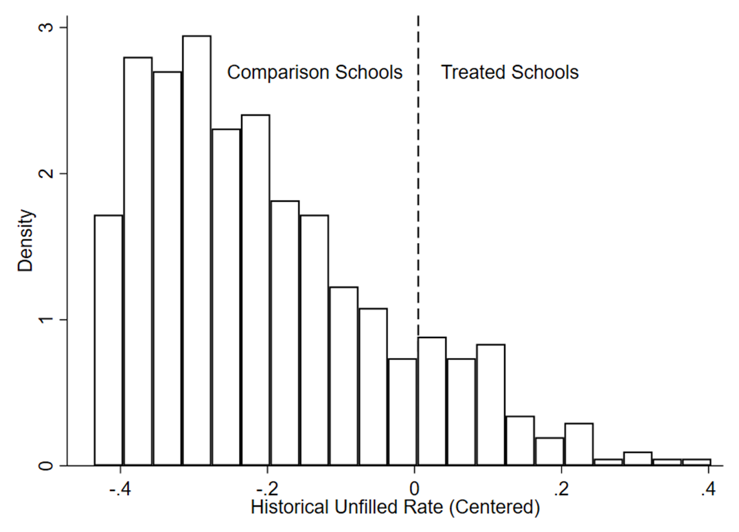

Figure A.1 Sorting variable density 2018-19

Notes: Histogram of schools along the 2018-19 sorting variable; bin width is 4 percentage points.

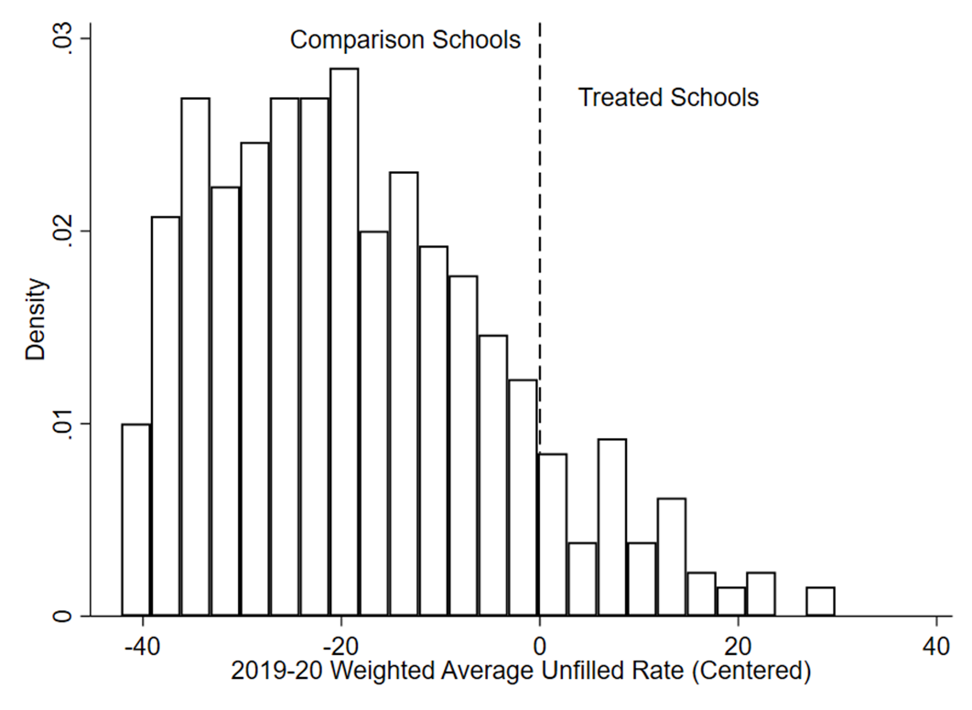

Figure A.2 Sorting variable density 2019-20

Notes: Histogram of schools along the 2019-20 sorting variable; bin width is 3 percentage points. Schools sorted into treatment in 2017-18 are omitted.
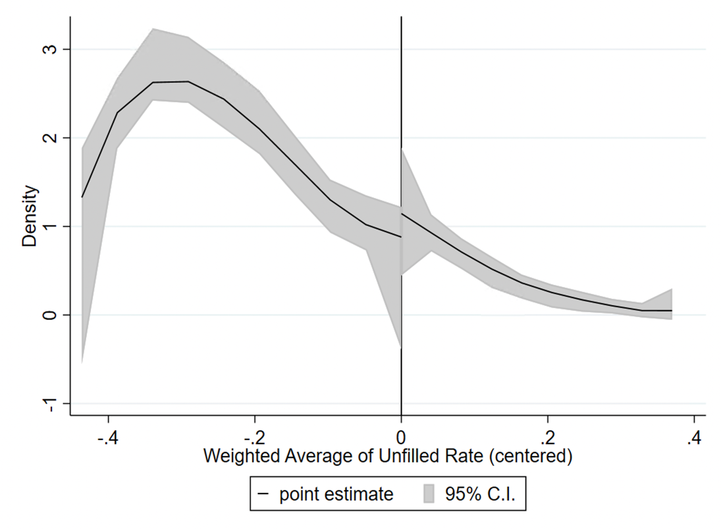
Figure A.3 Sorting variable density test 2018-19
Notes: Visual results from the nonparametric density test (Cattaneo, Jansson, and Ma 2018) for the sorting variable used to determine treatment in the 2018-19 school year.

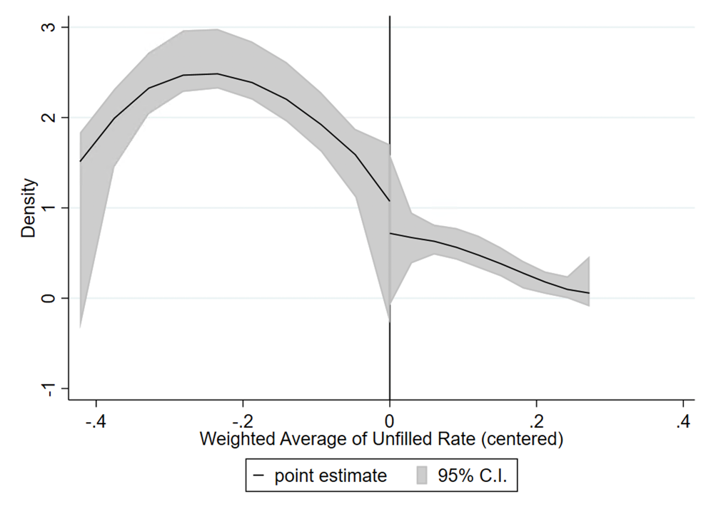
Figure A.4 Sorting variable density test 2019-20
Notes: Visual results from the nonparametric density test (Cattaneo, Jansson, and Ma 2018) for the sorting variable used to determine treatment in the 2019-20 school year. We exclude schools treated in 2018-19.

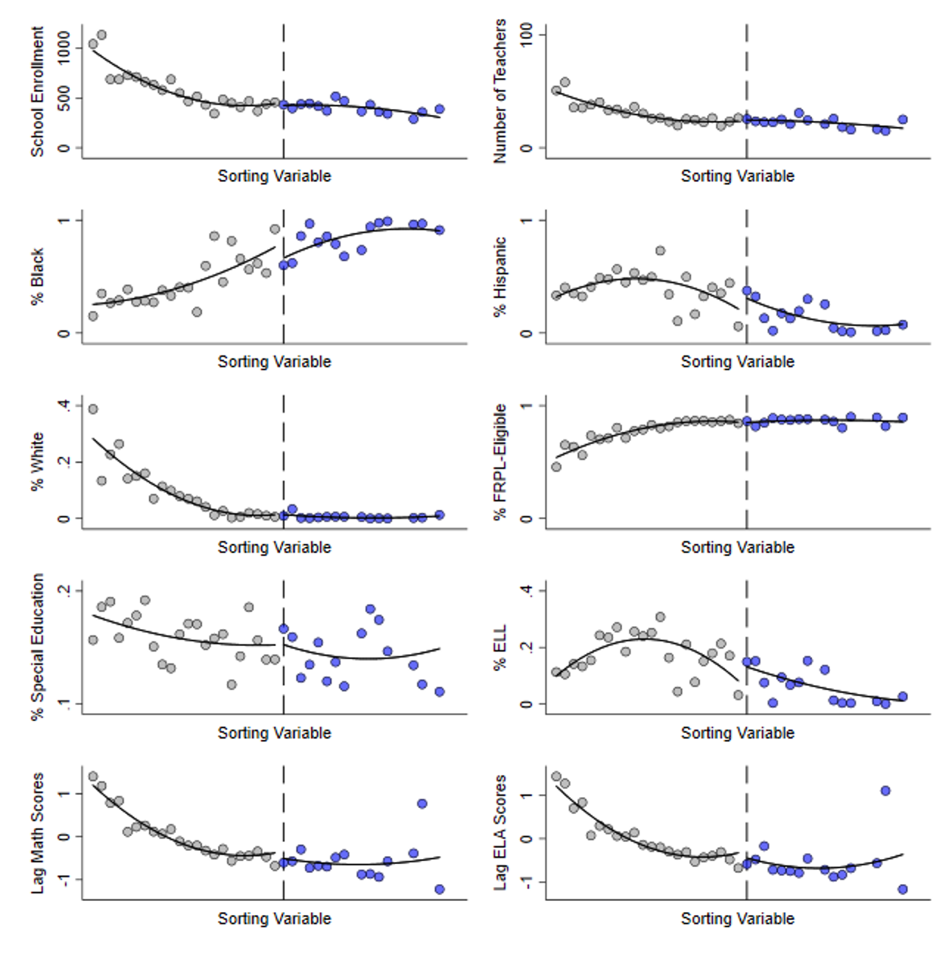

Figure A.5 Covariate balance 2018-19 forcing variable

Notes: Each covariate plot is a scatter of bin averages across the district; bin width is 2 percentage points. Treated schools are on the right of each vertical dashed line. Each covariate is a school-level measure for the 2018-19 school year.

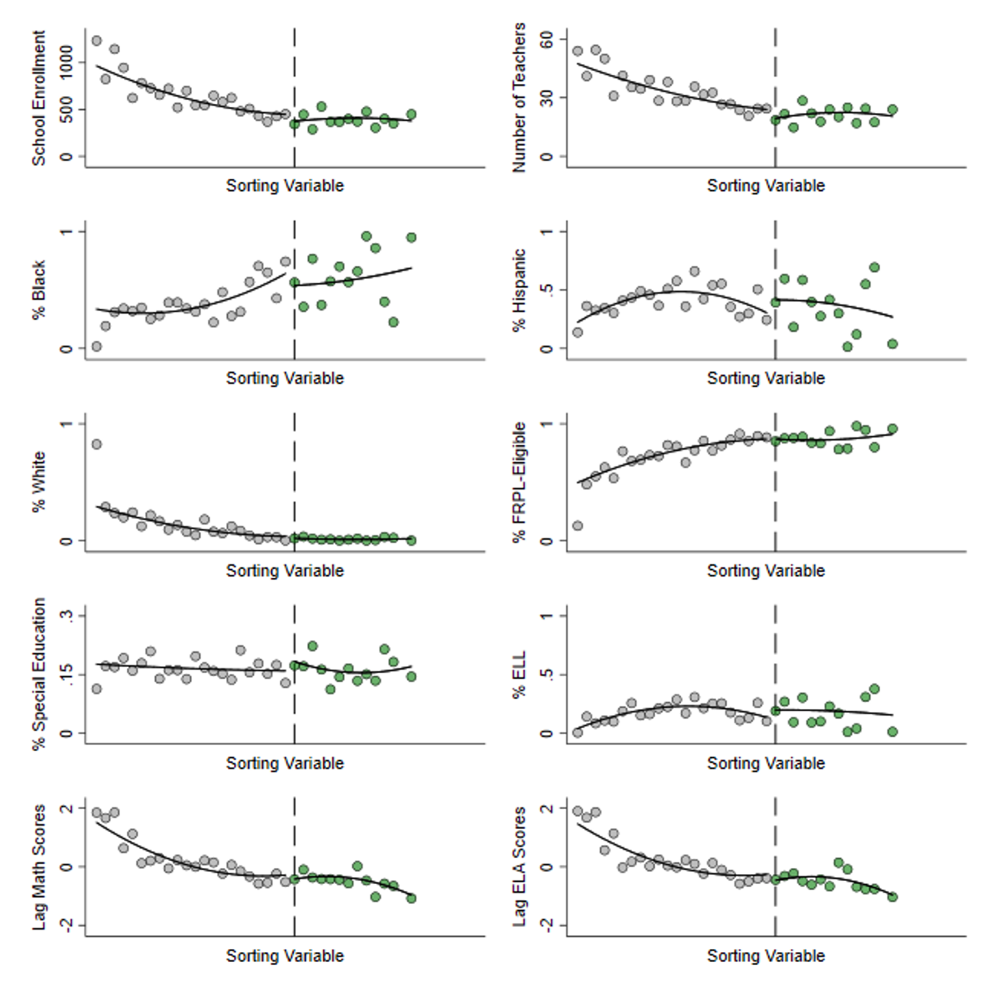

Figure A.6 Covariate Balance 2019-20 forcing variable

Notes: Each covariate plot is a scatter of bin averages across the district; bin width is 2 percentage points. Treated schools are on the right of each vertical dashed line. Each covariate is a school-level measure for the 2019-20 school year. The initial 75 treated schools are omitted.

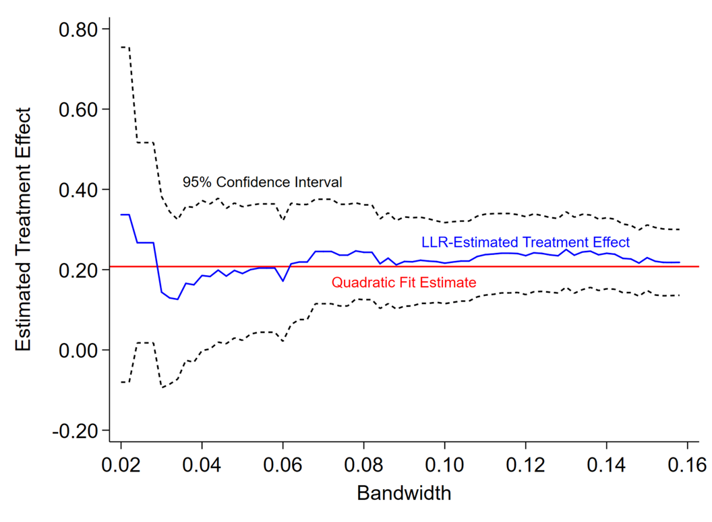

Figure A.7 Stability of fill rate results across bandwidths, 2018-19

Notes: Quadratic fit estimate uses an optimized bandwidth calculated according to Calonico et al., (2017). Local linear regression (LLR) estimates on fill rates are for the bandwidth indicated on the x axis. 95% confidence intervals are for corresponding LLR-estimated effect.

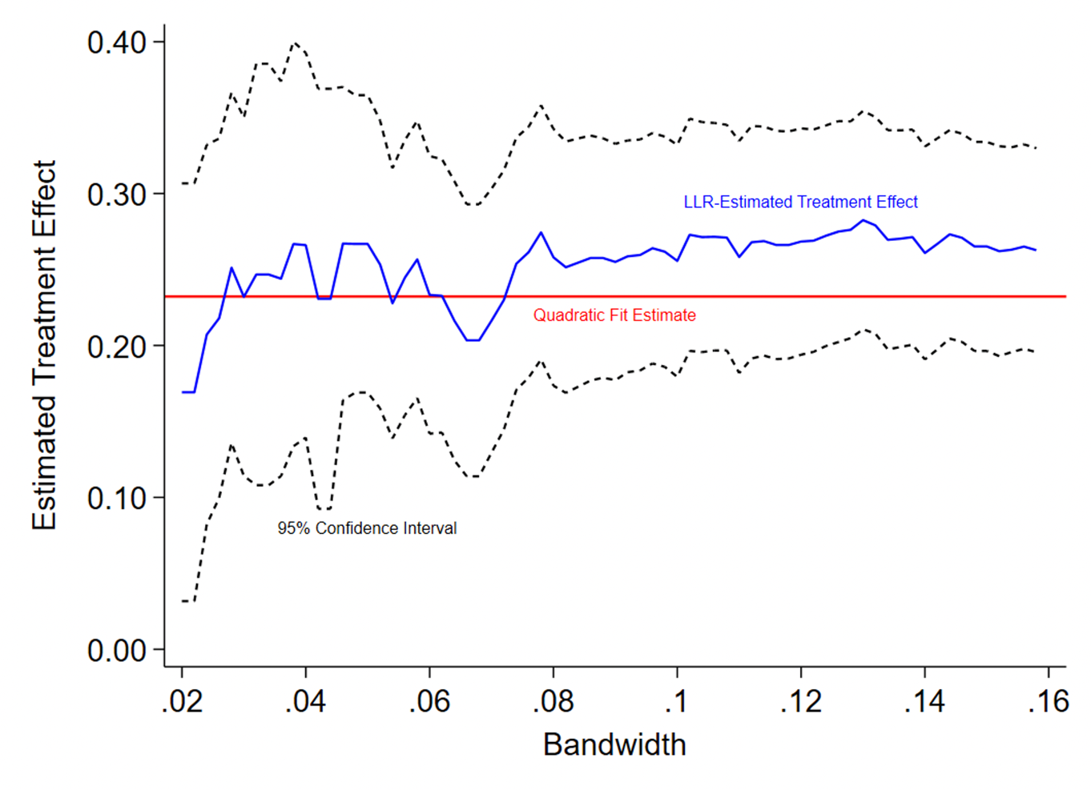

Figure A.8 Stability of fill rate results across bandwidths, 2019-20

Notes: Quadratic fit estimate uses an optimized bandwidth calculated according to Calonico et al., (2017). Local linear regression (LLR) estimates on fill rates are for the bandwidth indicated on the x axis. 95% confidence intervals are for corresponding LLR-estimated effect. The 75 schools in the 2018-19 treated cohort are omitted from all estimates.

Table A.1: Covariate Balance across Treatment Thresholds for Main Specifications
 |  | 2018-19 75th School Cutoff |  | 2019-20 125th School Cutoff
Outcome |  | (1) |  | (2)
Enrollment |  | 26.41 |  | -71.70
 |  | (62.40) |  | (75.52)
Number of teachers |  | 2.00 |  | -5.86
 |  | (3.89) |  | (4.14)
Black % |  | -0.00 |  | -0.00
 |  | (0.00) |  | (0.01)
Hispanic % |  | -0.08 |  | -0.00
 |  | (0.14) |  | (0.18)
White % |  | 0.08 |  | -0.02
 |  | (0.13) |  | (0.17)
FRPL eligible % |  | 0.00 |  | 0.02
 |  | (0.01) |  | (0.01)
Special education % |  | -0.01 |  | -0.04
 |  | (0.02) |  | (0.04)
ELL % |  | 0.00 |  | 0.04
 |  | (0.02) |  | (0.02)
Lagged Math |  | 0.01 |  | -0.02
 |  | (0.07) |  | (0.08)
Lagged ELA |  | -0.02 |  | 0.03
 |  | (0.22) |  | (0.28)
Bandwidth |  | 0.12 |  | 0.10
n |  | 111 |  | 93
Notes: Heteroskedasticity-robust standard errors are reported in parentheses (* p<.10, ** p<.05, *** p<.01). All models include schooling-level fixed effects and weight observations with a uniform kernel.

Table A.2: Stability of Results to Bandwidth and Functional Form Choice 2018-19
Bandwidth |  |  | 0.06 | 0.08 | 0.10 | 0.12
 | Panel A. Substitute behavior measures
Substitute request fill rate | Linear |  | 0.223*** | 0.252*** | 0.213*** | 0.226***
 | Quadratic |  | 0.310*** | 0.241** | 0.228*** | 0.246***
Number of unique substitutes at a school | Linear |  | 21.990*** | 17.677** | 12.190** | 13.020***
Number of unique substitutes at a school | Quadratic |  | 29.558*** | 30.084*** | 21.618** | 17.075**
Average substitutes' total days worked at a school | Linear |  | 0.358 | 1.088 | 1.523 | 1.572
Average substitutes' total days worked at a school | Quadratic |  | -0.182 | -1.289 | 1.439 | 3.015
 | Panel B. Teacher outcomes
Total absences | Linear |  | 2.033 | 0.454 | 1.233 | 1.477
 | Quadratic |  | 5.133** | 3.478* | -0.005 | 0.100
School retention | Linear |  | 0.032 | 0.030 | 0.029 | 0.022
 | Quadratic |  | 0.033 | 0.044 | 0.044 | 0.047
Transfers | Linear |  | -0.063 | -0.041 | -0.028 | -0.030
 | Quadratic |  | -0.105* | -0.105** | -0.077 | -0.066
Exits | Linear |  | 0.031 | 0.012 | -0.001 | 0.009
 | Quadratic |  | 0.073** | 0.060** | 0.033 | 0.019
 | Panel C. Student outcomes
Index math | Linear |  | 0.089*** | 0.093** | 0.032 | 0.044
 | Quadratic |  | 0.004 | 0.027 | 0.067 | 0.036
Index ELA | Linear |  | 0.109*** | 0.113*** | 0.072*** | 0.046*
 | Quadratic |  | 0.054* | 0.055* | 0.053* | 0.082***
Notes: Heteroskedasticity-robust standard errors are reported in parentheses and clustered by school for teacher- and student-level models (* p<.10, ** p<.05, *** p<.01). We include schooling-level fixed effects and our school covariate vector in all models. Teacher- and student-level models also include individual-level control vectors. Observations within the bandwidth indicated are weighted by a uniform kernel.

Table A.3: Stability of Results to Bandwidth and Functional Form Choice 2019-20
Bandwidth |  |  | 0.06 | 0.08 | 0.10 | 0.12
 | Panel A. Substitute behavior measures
Substitute request fill rate | Linear |  | 0.157*** | 0.155*** | 0.213*** | 0.237***
 | Quadratic |  | 0.171*** | 0.130** | 0.149*** | 0.208***
Number of unique substitutes at a school | Linear |  | 37.214*** | 33.814*** | 34.908*** | 32.783***
Number of unique substitutes at a school | Quadratic |  | 24.554** | 36.051*** | 37.754*** | 38.401***
Average substitutes' total days worked at a school | Linear |  | -1.764 | -3.043** | -1.875 | -2.010*
Average substitutes' total days worked at a school | Quadratic |  | 1.432 | -0.369 | -0.472 | -0.871
 | Panel B. Teacher outcomes
Total absences | Linear |  | 4.986*** | 3.000** | 3.502** | 2.571*
 | Quadratic |  | 6.989*** | 5.354** | 4.208* | 4.590**
School retention | Linear |  | -0.055 | -0.052 | -0.053 | -0.053
 | Quadratic |  | -0.174** | -0.122** | -0.145** | -0.050
Transfers | Linear |  | 0.062 | 0.033 | 0.038 | 0.037
 | Quadratic |  | 0.095 | 0.060 | 0.079 | 0.033
Exits | Linear |  | -0.008 | 0.018 | 0.016 | 0.016
 | Quadratic |  | 0.079*** | 0.062** | 0.066** | 0.017
Notes: Heteroskedasticity-robust standard errors are reported in parentheses and clustered by school for teacher- and student-level models (* p<.10, ** p<.05, *** p<.01). We include schooling-level fixed effects and our school covariate vector in all models. Teacher- and student-level models also include individual-level control vectors. Observations within the bandwidth indicated are weighted by a uniform kernel.

Table A.4: Effects of Targeted Incentives on Substitute Labor Supply 2018-19 Triangular Kernel
 | Incentive school mean 2017-18 |  | (1) | (2)
Panel A. Substitute behavior measures
Substitute request fill rate | 0.47 |  | 0.21*** | 0.23***
Substitute request fill rate |  |  | (0.05) | (0.05)
Number of unique substitutes at a school | 50.40 |  | 21.88*** | 15.19***
Number of unique substitutes at a school |  |  | (8.05) | (5.09)
Average substitutes' total days worked at a school | 4.65 |  | 0.81 | 1.62
Average substitutes' total days worked at a school |  |  | (1.62) | (1.35)
Panel B. Number of unique substitutes in 2018-19 by prior work history
Prior work in treated schools only | 0.73 |  | 0.01 | 0.11
Prior work in treated schools only |  |  | (0.23) | (0.22)
Prior work in comparison schools only | 5.47 |  | 4.14** | 0.93
Prior work in comparison schools only |  |  | (1.77) | (0.98)
Prior work in both treated & comparison schools | 27.73 |  | 16.68*** | 15.44***
Prior work in both treated & comparison schools |  |  | (4.71) | (3.48)
New to the substitute roster in 2018-19 | 13.11 |  | 0.50 | -1.23
New to the substitute roster in 2018-19 |  |  | (2.04) | (1.49)
Lapsed substitutes | 3.36 |  | 0.57 | -0.07
 |  |  | (0.73) | (0.54)
School covariate vector |  |  | No | Yes
n |  |  | 111 | 111
Notes: Heteroskedasticity-robust standard errors are reported in parentheses (* p<.10, ** p<.05, *** p<.01). Panel B disaggregates unique substitutes at a school in 2018-19 by where they worked in the prior year. Lapsed substitutes have been on the roster but did not take any substituting jobs in the year prior. We include schooling-level fixed effects in all models. Our school covariate vector includes controls for student body race demographics, free/reduced price lunch eligibility, special education status, English as a second language status, total enrollment, and school-level lagged achievement in math and English. All models use a bandwidth of +/- 0.12 and are weighted by a triangular kernel.

Table A.5: Heterogeneous Effects of Targeted Incentives on Substitute Labor Supply 2018-19 Triangular Kernel
 | Incentive school mean 2017-18 |  | (1) | (2)
Panel A. Substitute localness
Number of substitutes commuting <10min | 9.05 |  | 2.10 | 1.54
Number of substitutes commuting <10min |  |  | (1.76) | (1.39)
Number of substitutes commuting 10-20min | 17.52 |  | 9.44*** | 10.34***
Number of substitutes commuting 10-20min |  |  | (3.30) | (2.49)
Number of substitutes commuting >20min | 22.29 |  | 10.33*** | 5.04***
Number of substitutes commuting >20min |  |  | (3.13) | (1.81)
Panel B. Number of unique substitutes in 2018-19 by demographic groups
Asian | 0.64 |  | 0.35 | -0.38
 |  |  | (0.48) | (0.28)
Black | 30.96 |  | 5.61 | 11.91**
 |  |  | (7.11) | (4.66)
Hispanic | 3.95 |  | 5.22*** | 2.16**
 |  |  | (1.78) | (0.90)
White | 9.81 |  | 8.38** | -0.09
 |  |  | (3.59) | (1.57)
Female | 37.23 |  | 15.67** | 13.71***
 |  |  | (6.17) | (3.93)
Male | 13.17 |  | 6.21** | 1.48
 |  |  | (2.95) | (1.79)
School covariate vector |  |  | No | Yes
n |  |  | 111 | 111
Notes: Heteroskedasticity-robust standard errors are reported in parentheses (* p<.10, ** p<.05, *** p<.01). We include schooling-level fixed effects in all models. Our school covariate vector includes controls for student body race demographics, free/reduced price lunch eligibility, special education status, English as a second language status, total enrollment, and school-level lagged achievement in math and English. All models use a bandwidth of +/- 0.12 and are weighted by a triangular kernel.

Table A.6: Effects of Targeted Incentives on Teacher and Student Outcomes 2018-19 Triangular Kernel
 | Incentive school mean 2017-18 |  | (1) | (2)
Panel A. Teacher-level measures
Total absences | 11.701 |  | 2.744* | 1.188
 |  |  | (1.546) | (1.263)
 |  |  | n = 2,609
Retained | 0.780 |  | 0.055 | 0.026
 |  |  | (0.036) | (0.034)
 |  |  | n = 2,609
Transferred | 0.115 |  | 0.055 | 0.026
 |  |  | (0.036) | (0.034)
 |  |  | n = 2,609
Left district | 0.104 |  | -0.001 | 0.014
 |  |  | (0.025) | (0.020)
 |  |  | n = 2,609
Panel B. Student-level measures
Index math achievement | -0.406 |  | 0.142 | 0.046
 |  |  | (0.120) | (0.029)
 |  |  | n = 28,046
Index ELA achievement | -0.378 |  | 0.152 | 0.074***
 |  |  | (0.134) | (0.021)
 |  |  | n = 27,733
School covariate vector |  |  | No | Yes
Individual covariate vector |  |  | No | Yes
Notes: Heteroskedasticity-robust standard errors are clustered by school and reported in parentheses (* p<.10, ** p<.05, *** p<.01). Model (2) includes vectors of school covariates as well as individual covariates. For teachers, the individual covariate vector indicates race, gender, and binned tenure indicators (3-5, 6-10, 11-20, 21+ years, 0-2 years omitted). Student-level covariates include student race, gender, English as a second language status, free/reduced price lunch eligibility, special education status, and a lagged cubic of student-level achievement in both math and English. Student outcomes are modeled for the subsample of students with lagged outcomes to improve precision; this does not materially impact our estimates. Schooling-level fixed effects are included in all models. Observations within the bandwidth or +/- 0.12 are weighted by a triangular kernel.

Table A.7: Effects of Targeted Incentives on Substitute Labor Supply 2019-20 Triangular Kernel
 | Incentive school mean 2017-18 |  | (1) | (2)
Panel A. Substitute behavior measures
Substitute request fill rate | 0.66 |  | 0.24*** | 0.17***
Substitute request fill rate |  |  | (0.04) | (0.03)
Number of unique substitutes at a school | 63.12 |  | 34.20*** | 33.95***
Number of unique substitutes at a school |  |  | (9.05) | (6.89)
Average substitutes' total days worked at a school | 6.08 |  | -1.20 | -2.25**
Average substitutes' total days worked at a school |  |  | (1.22) | (1.03)
Panel B. Number of unique substitutes in 2019-20 by prior work history
Prior work in treated schools only | 0.26 |  | 1.80*** | 1.66***
Prior work in treated schools only |  |  | (0.48) | (0.34)
Prior work in comparison schools only | 10.44 |  | 5.04* | 3.97**
Prior work in comparison schools only |  |  | (2.82) | (1.98)
Prior work in both treated & comparison schools | 32.14 |  | 21.86*** | 22.78***
Prior work in both treated & comparison schools |  |  | (4.72) | (3.72)
New to the substitute roster in 2019-20 | 15.56 |  | 3.24* | 3.01*
New to the substitute roster in 2019-20 |  |  | (1.92) | (1.62)
Lapsed substitutes | 4.72 |  | 2.27** | 2.52***
 |  |  | (0.99) | (0.79)
School covariate vector |  |  | No | Yes
n |  |  | 93 | 93
Notes: Heteroskedasticity-robust standard errors are reported in parentheses (* p<.10, ** p<.05, *** p<.01). Panel B disaggregates unique substitutes at a school in 2019-20 by where they worked in the prior year. Lapsed substitutes have been on the roster but did not take any substituting jobs in the year prior. We include schooling-level fixed effects in all models. Our school covariate vector includes controls for student body race demographics, free/reduced price lunch eligibility, special education status, English as a second language status, total enrollment, and school-level lagged achievement in math and English. All models use a bandwidth of +/- 0.10 and are weighted by a triangular kernel.

Appendix B: Supplemental Figures and Tables

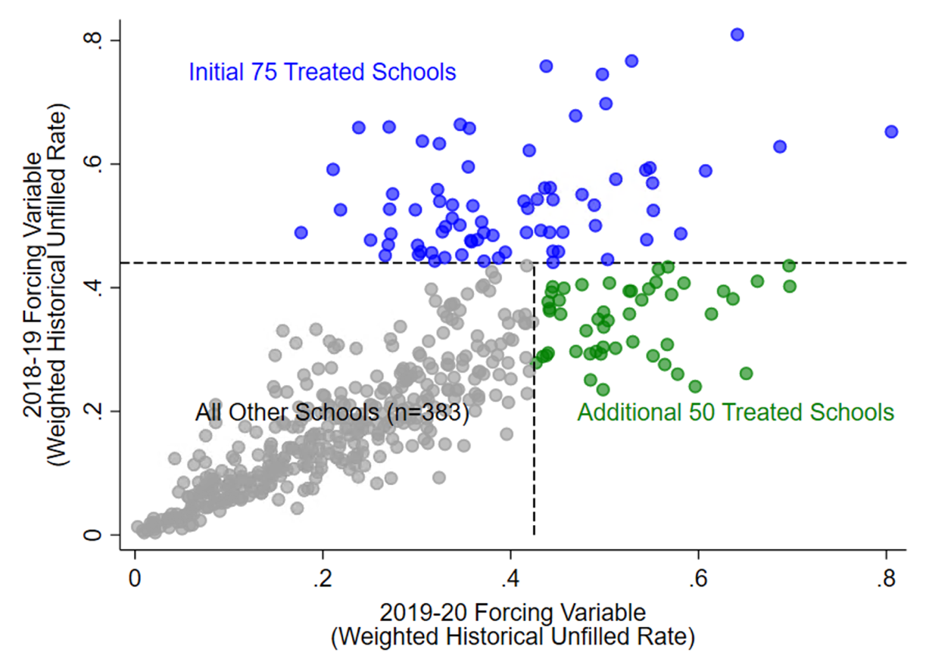

Figure B.1 District distribution across both treatment sorting variables

Notes: Demarcated regions indicate treatment status as determined by each year’s treatment cutoff. Both the initial 75 treated schools and additional 50 treated schools received treatment in 2019-20.

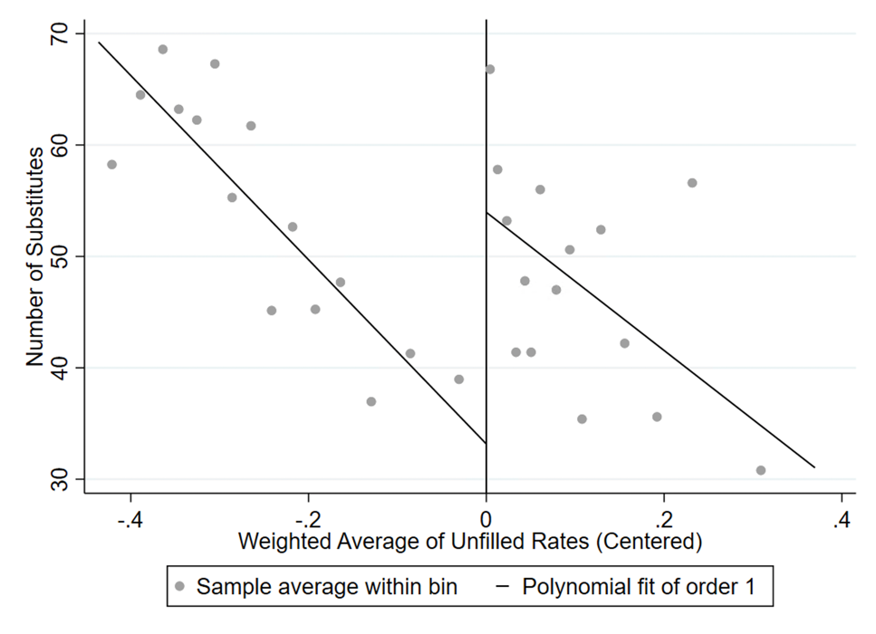
Figure B.2 Raw discontinuity in unique substitutes at each school, 2018-19
Notes: The independent variable is the forcing variable used to select schools for treatment, centered at the treatment cutoff. Treated schools are to the right of the cutoff. We follow Calonico et al. (2015) by selecting bin-width with the evenly-spaced mimicking variance method using spacings estimators.

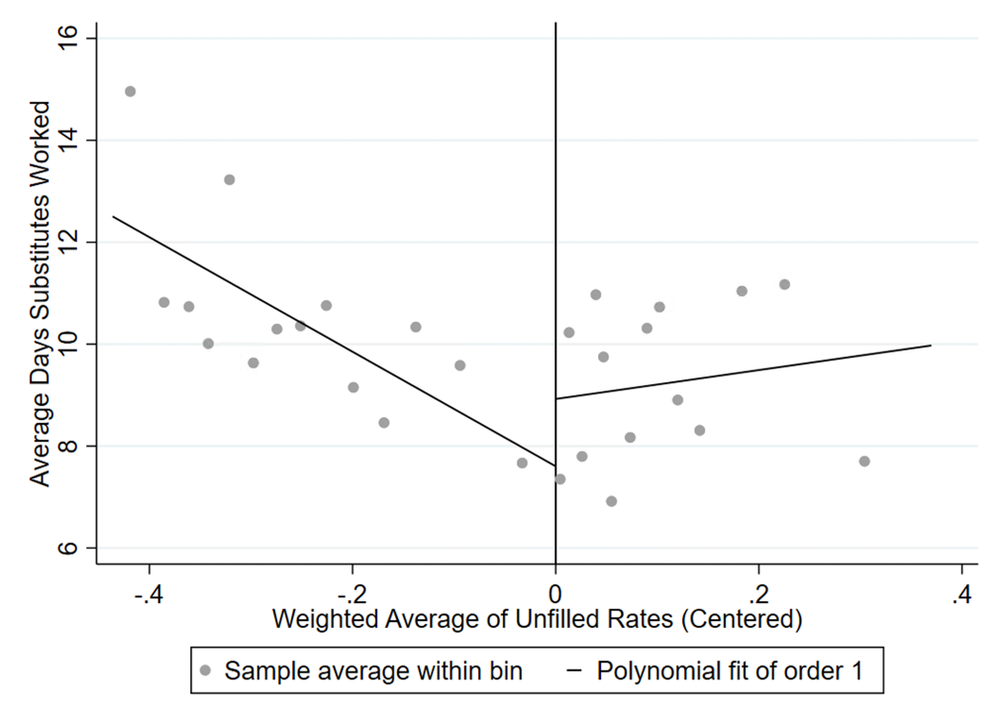
Figure B.3 Raw discontinuity in the average days substitutes worked at each school, 2018-19
Notes: The independent variable is the forcing variable used to select schools for treatment, centered at the treatment cutoff. Treated schools are to the right of the cutoff. We follow Calonico et al. (2015) by selecting bin-width with the evenly-spaced mimicking variance method using spacings estimators.

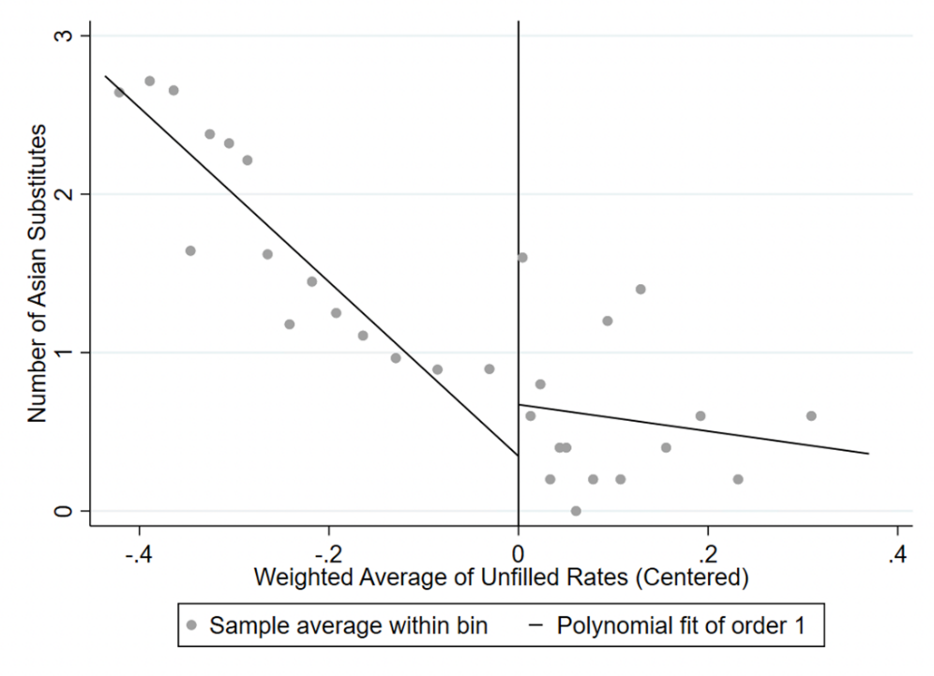
Figure B.4 Raw discontinuity in unique Asian substitutes at each school, 2018-19
Notes: The independent variable is the forcing variable used to select schools for treatment, centered at the treatment cutoff. Treated schools are to the right of the cutoff. We follow Calonico et al. (2015) by selecting bin-width with the evenly-spaced mimicking variance method using spacings estimators.

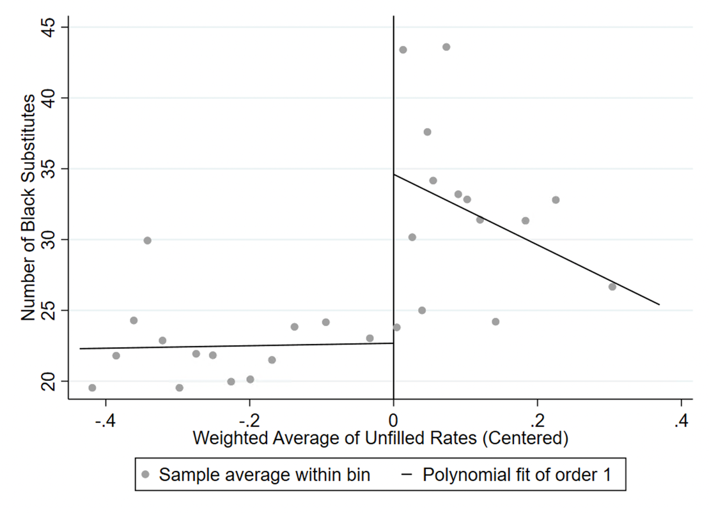
Figure B.5 Raw discontinuity in unique Black substitutes at each school, 2018-19
Notes: The independent variable is the forcing variable used to select schools for treatment, centered at the treatment cutoff. Treated schools are to the right of the cutoff. We follow Calonico et al. (2015) by selecting bin-width with the evenly-spaced mimicking variance method using spacings estimators.

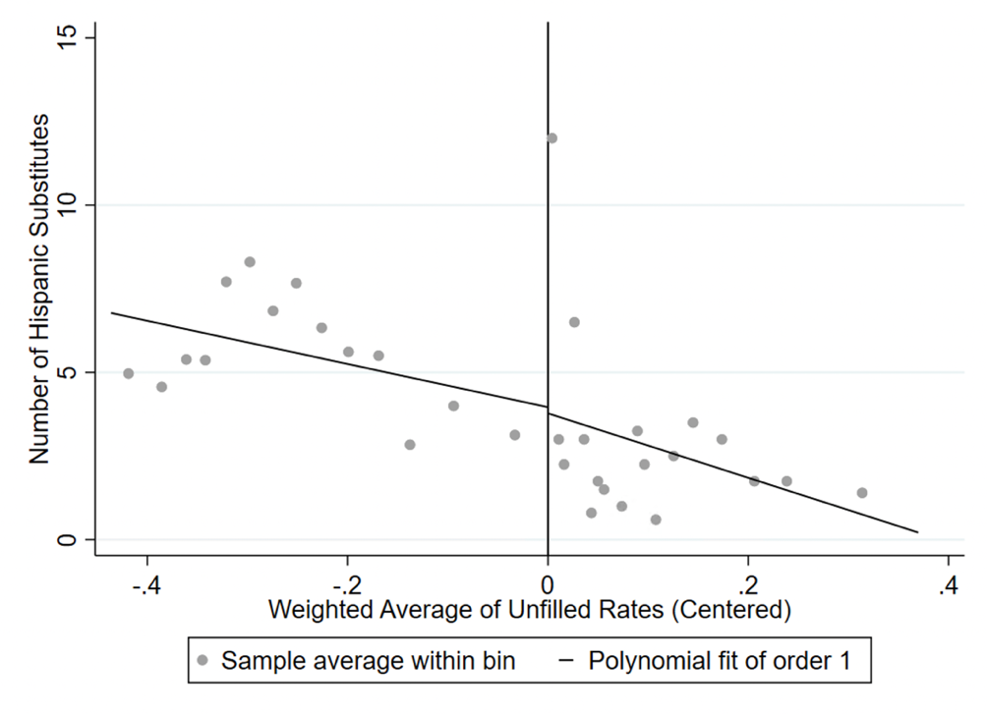
Figure B.6 Raw discontinuity in unique Hispanic substitutes at each school, 2018-19
Notes: The independent variable is the forcing variable used to select schools for treatment, centered at the treatment cutoff. Treated schools are to the right of the cutoff. We follow Calonico et al. (2015) by selecting bin-width with the evenly-spaced mimicking variance method using spacings estimators.

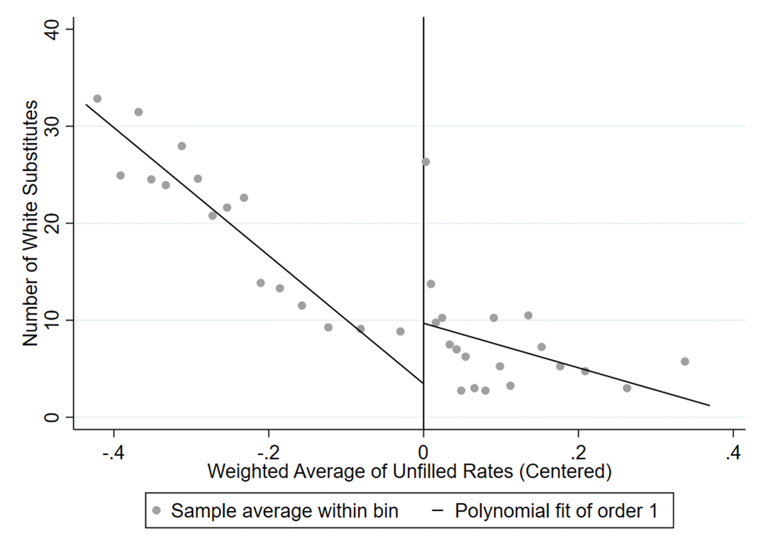
Figure B.7 Raw discontinuity in unique white substitutes at each school, 2018-19
Notes: The independent variable is the forcing variable used to select schools for treatment, centered at the treatment cutoff. Treated schools are to the right of the cutoff. We follow Calonico et al. (2015) by selecting bin-width with the evenly-spaced mimicking variance method using spacings estimators.

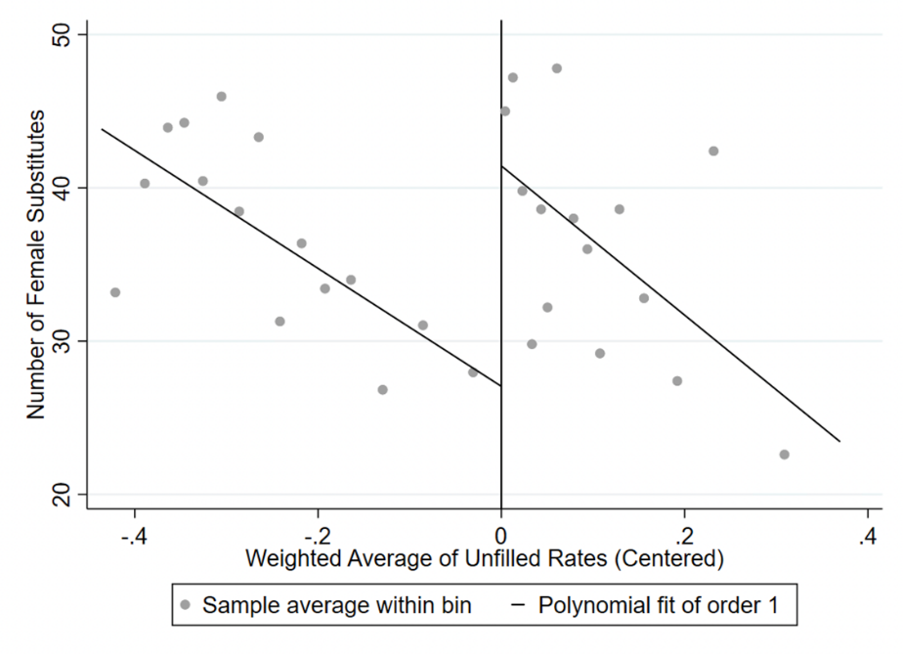
Figure B.8 Raw discontinuity in unique female substitutes at each school, 2018-19
Notes: The independent variable is the forcing variable used to select schools for treatment, centered at the treatment cutoff. Treated schools are to the right of the cutoff. We follow Calonico et al. (2015) by selecting bin-width with the evenly-spaced mimicking variance method using spacings estimators.

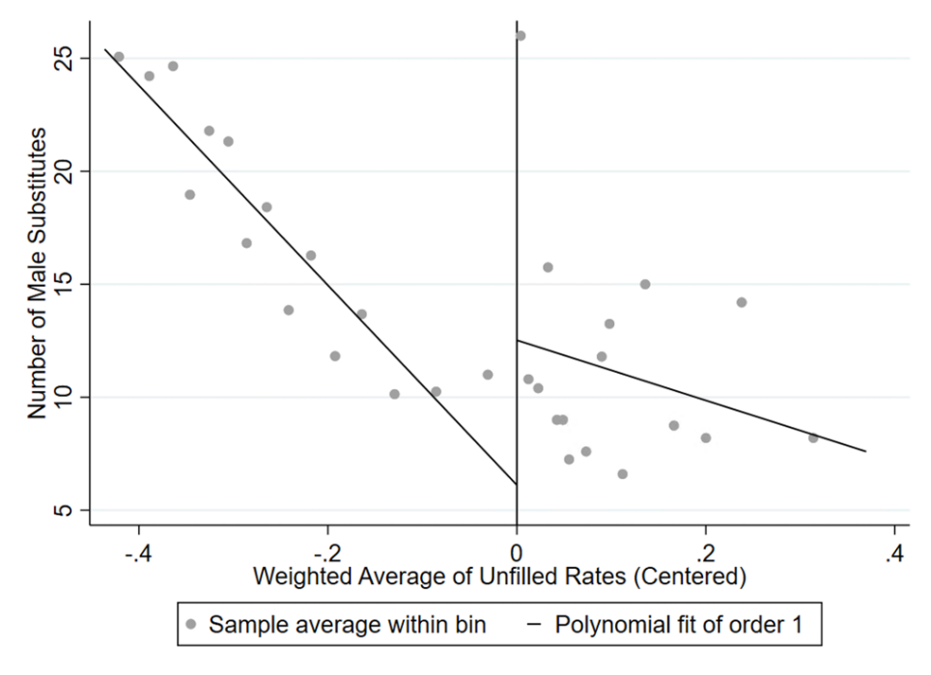
Figure B.9 Raw discontinuity in unique male substitutes at each school, 2018-19
Notes: The independent variable is the forcing variable used to select schools for treatment, centered at the treatment cutoff. Treated schools are to the right of the cutoff. We follow Calonico et al. (2015) by selecting bin-width with the evenly-spaced mimicking variance method using spacings estimators.

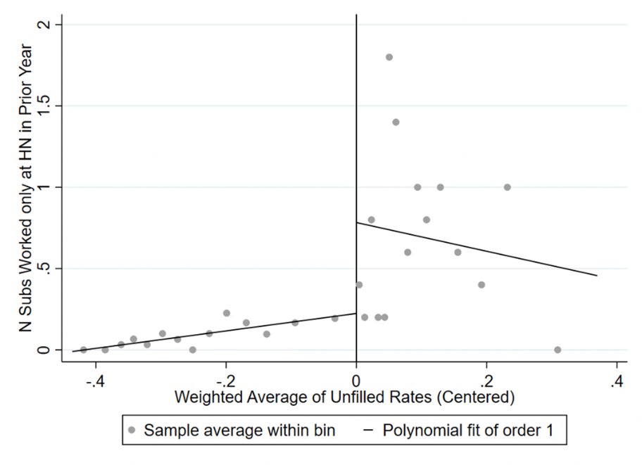
Figure B.10 Raw discontinuity in the number of unique substitutes in 2018-19 who worked only at incentive schools in the prior year
Notes: The independent variable is the forcing variable used to select schools for treatment, centered at the treatment cutoff. Treated schools are to the right of the cutoff. We follow Calonico et al. (2015) by selecting bin-width with the evenly-spaced mimicking variance method using spacings estimators.

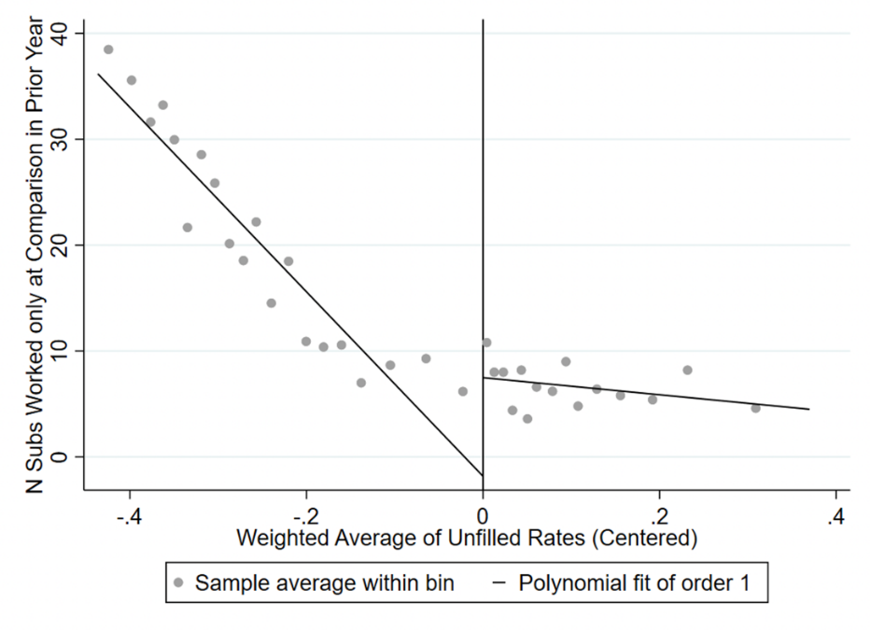
Figure B.11 Raw discontinuity in the number of unique substitutes in 2018-19 who worked only at non-incentive schools in the prior year
Notes: The independent variable is the forcing variable used to select schools for treatment, centered at the treatment cutoff. Treated schools are to the right of the cutoff. We follow Calonico et al. (2015) by selecting bin-width with the evenly-spaced mimicking variance method using spacings estimators.

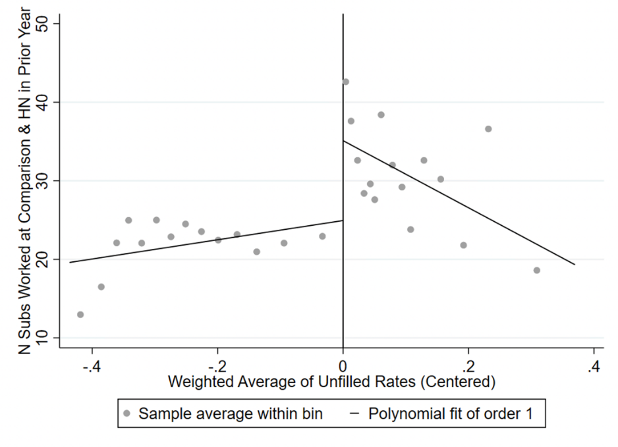
Figure B.12 Raw discontinuity in the number of unique substitutes in 2018-19 who worked only at both incentive and non-incentive schools in the prior year
Notes: The independent variable is the forcing variable used to select schools for treatment, centered at the treatment cutoff. Treated schools are to the right of the cutoff. We follow Calonico et al. (2015) by selecting bin-width with the evenly-spaced mimicking variance method using spacings estimators.

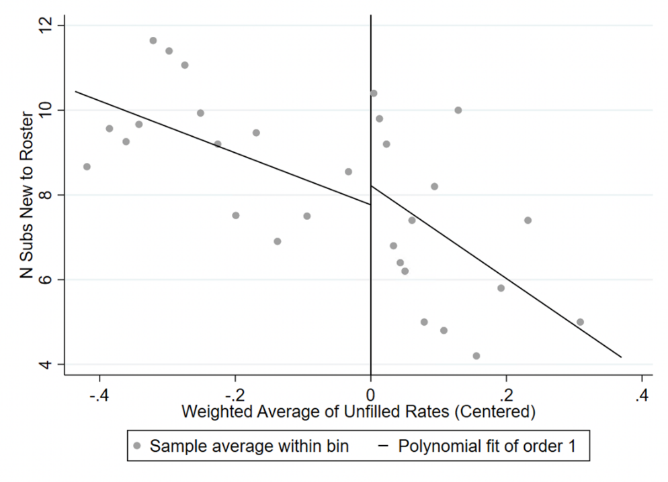
Figure B.13 Raw discontinuity in the number of unique substitutes new to the roster in 2018-19
Notes: The independent variable is the forcing variable used to select schools for treatment, centered at the treatment cutoff. Treated schools are to the right of the cutoff. We follow Calonico et al. (2015) by selecting bin-width with the evenly-spaced mimicking variance method using spacings estimators.

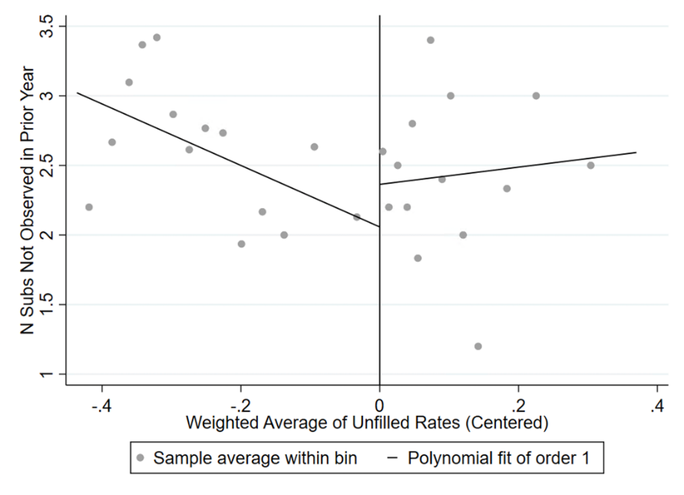
Figure B.14 Raw discontinuity in the number of unique substitutes in 2018-19 not observed in the prior year
Notes: The independent variable is the forcing variable used to select schools for treatment, centered at the treatment cutoff. Treated schools are to the right of the cutoff. We follow Calonico et al. (2015) by selecting bin-width with the evenly-spaced mimicking variance method using spacings estimators.

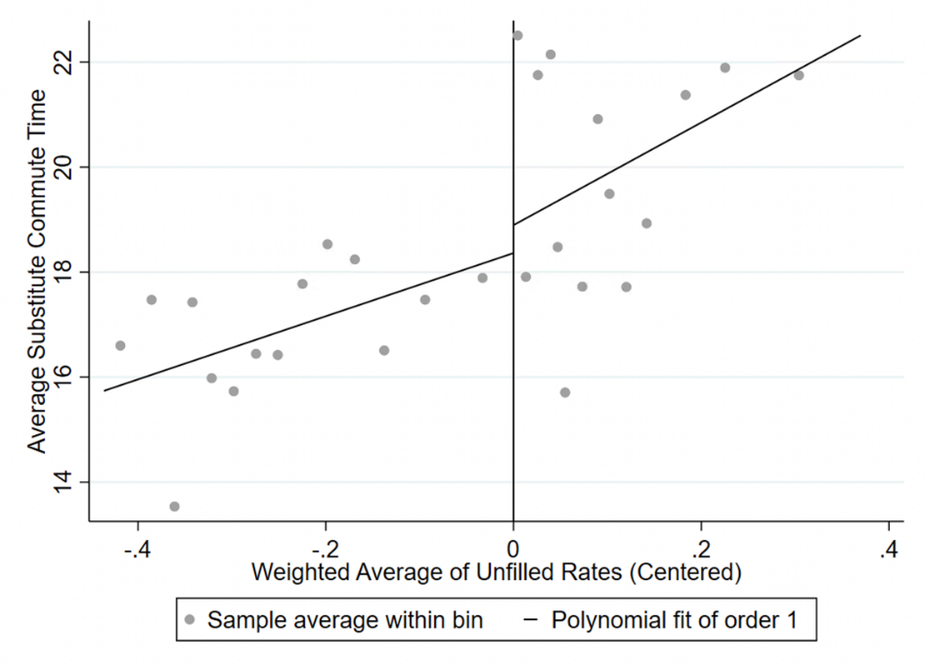
Figure B.15 Raw discontinuity in average substitute commute time 2018-19
Notes: The independent variable is the forcing variable used to select schools for treatment, centered at the treatment cutoff. Treated schools are to the right of the cutoff. We follow Calonico et al. (2015) by selecting bin-width with the evenly-spaced mimicking variance method using spacings estimators.

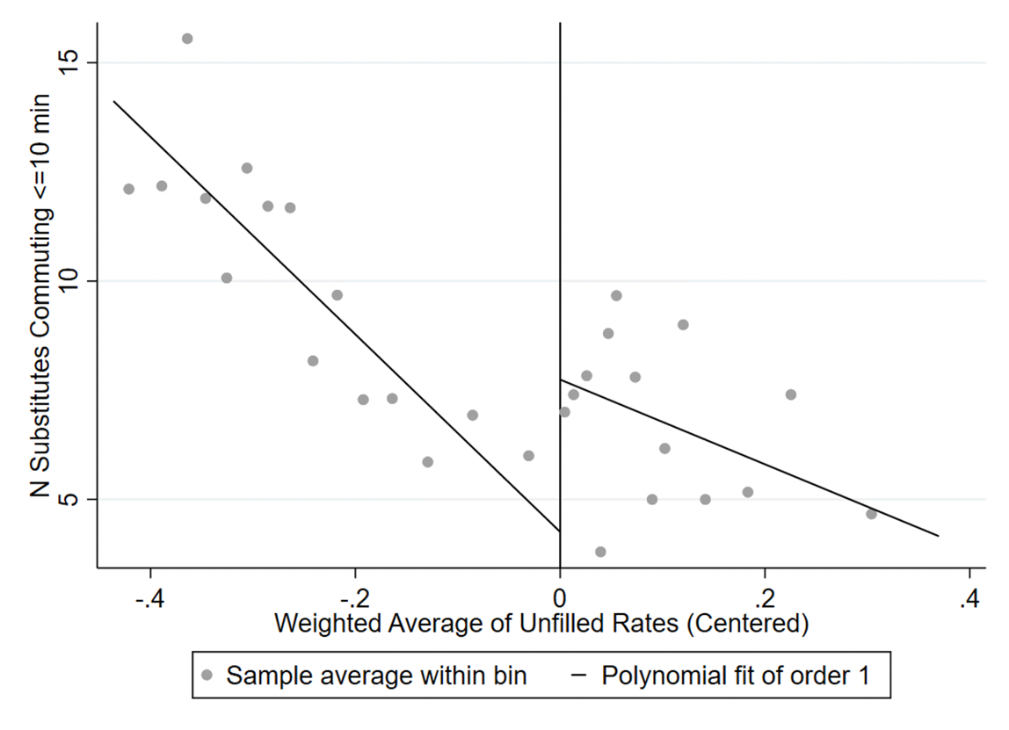
Figure B.16 Raw discontinuity in unique substitutes commuting less than ten minutes in 2018-19
Notes: The independent variable is the forcing variable used to select schools for treatment, centered at the treatment cutoff. Treated schools are to the right of the cutoff. We follow Calonico et al. (2015) by selecting bin-width with the evenly-spaced mimicking variance method using spacings estimators.

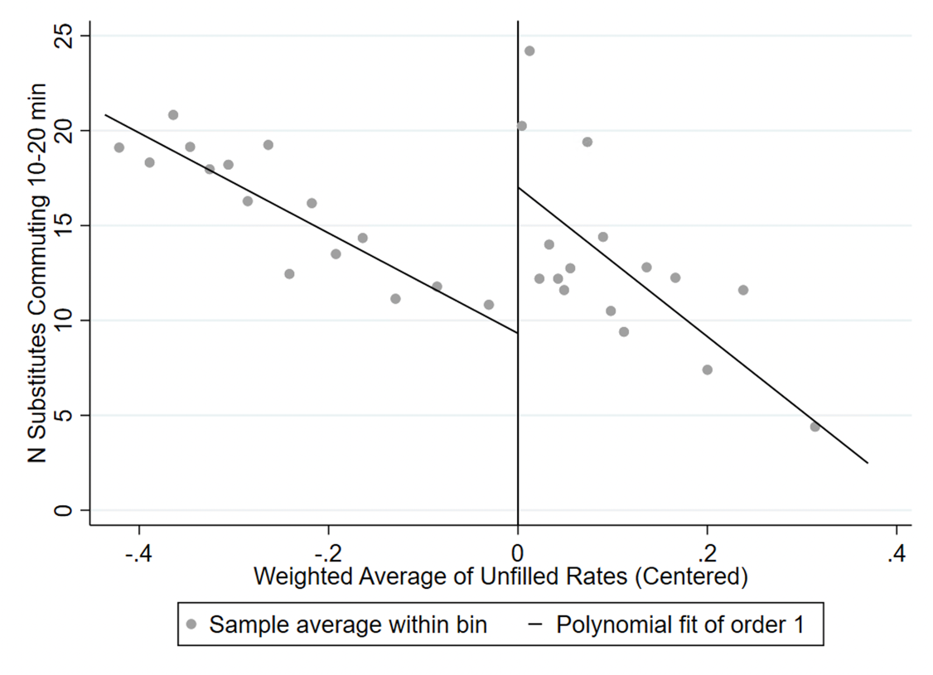
Figure B.17 Raw discontinuity in unique substitutes commuting 10 to 20 minutes in 2018-19
Notes: The independent variable is the forcing variable used to select schools for treatment, centered at the treatment cutoff. Treated schools are to the right of the cutoff. We follow Calonico et al. (2015) by selecting bin-width with the evenly-spaced mimicking variance method using spacings estimators.

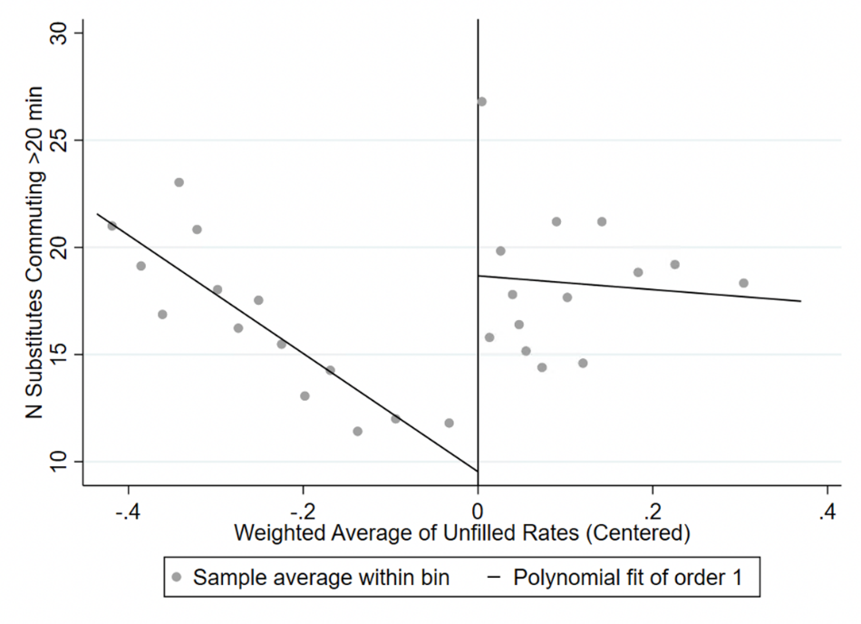
Figure B.18 Raw discontinuity in unique substitutes commuting >20 minutes in 2018-19
Notes: The independent variable is the forcing variable used to select schools for treatment, centered at the treatment cutoff. Treated schools are to the right of the cutoff. We follow Calonico et al. (2015) by selecting bin-width with the evenly-spaced mimicking variance method using spacings estimators.

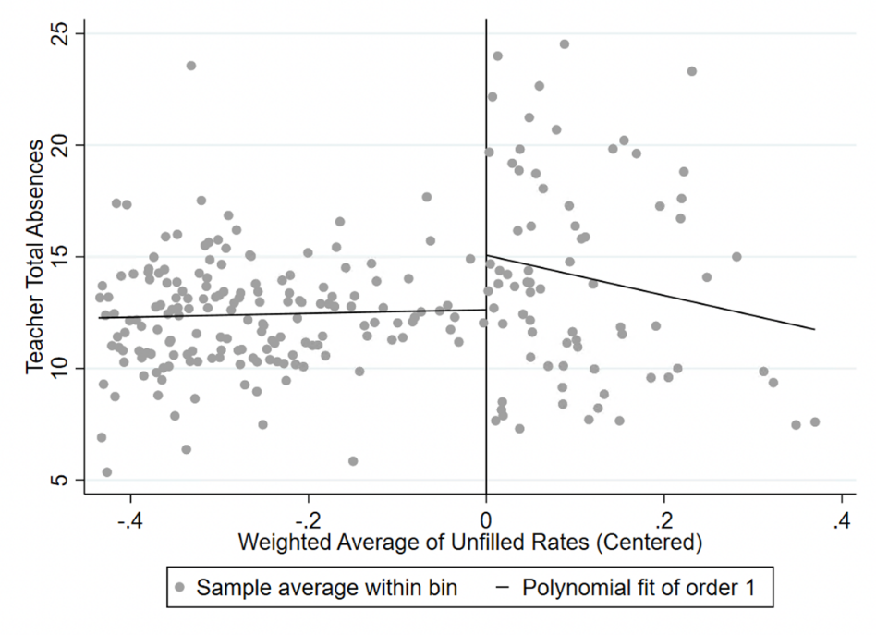
Figure B.19 Raw discontinuity in teacher-level absences in 2018-19
Notes: The independent variable is the forcing variable used to select schools for treatment, centered at the treatment cutoff. Teachers working in treated schools are to the right of the cutoff. We follow Calonico et al. (2015) by selecting bin-width with the evenly-spaced mimicking variance method using spacings estimators.

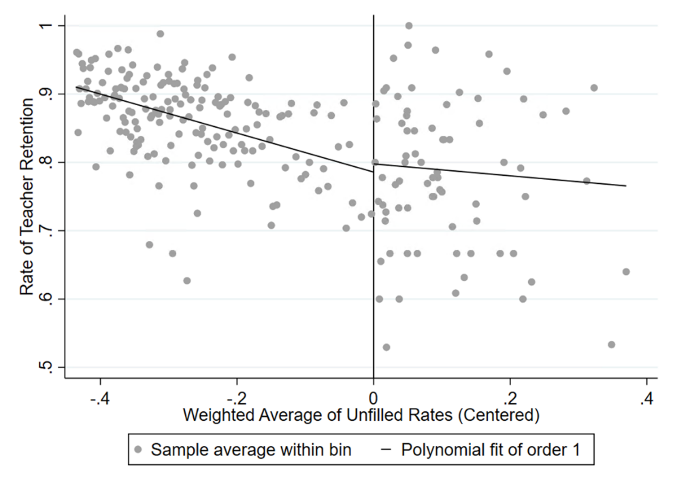
Figure B.20 Raw discontinuity in teacher-level retention in 2018-19
Notes: The independent variable is the forcing variable used to select schools for treatment, centered at the treatment cutoff. Teachers working in treated schools are to the right of the cutoff. We follow Calonico et al. (2015) by selecting bin-width with the evenly-spaced mimicking variance method using spacings estimators.

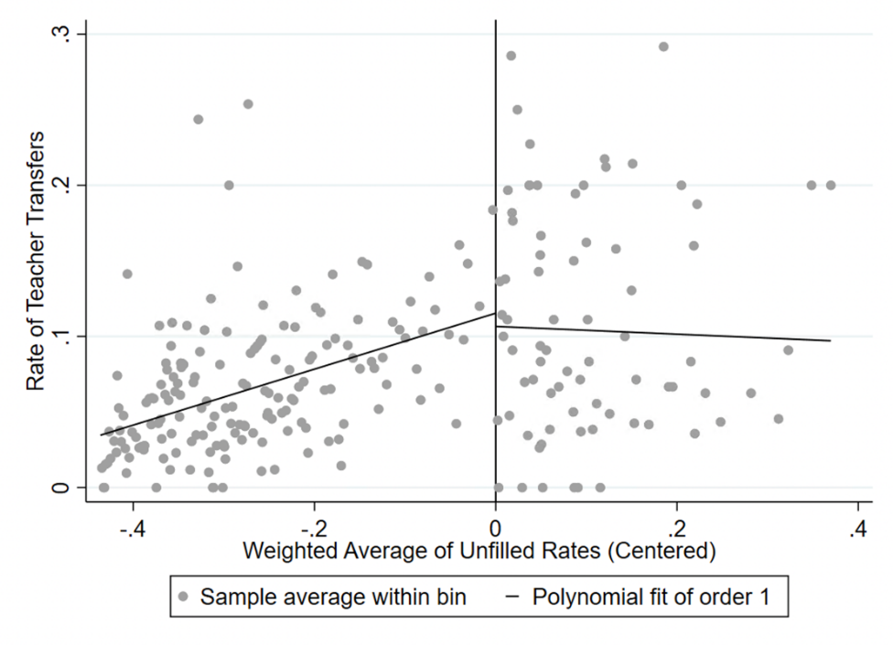
Figure B.21 Raw discontinuity in teacher-level transfers in 2018-19
Notes: The independent variable is the forcing variable used to select schools for treatment, centered at the treatment cutoff. Teachers working in treated schools are to the right of the cutoff. We follow Calonico et al. (2015) by selecting bin-width with the evenly-spaced mimicking variance method using spacings estimators.

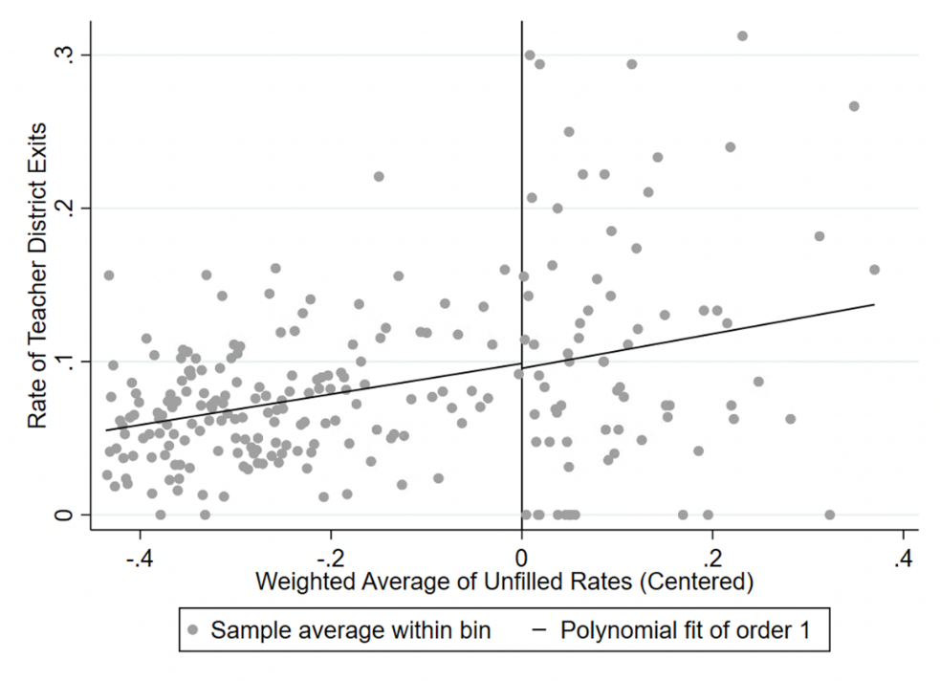
Figure B.22 Raw discontinuity in teacher-level district exits in 2018-19
Notes: The independent variable is the forcing variable used to select schools for treatment, centered at the treatment cutoff. Teachers working in treated schools are to the right of the cutoff. We follow Calonico et al. (2015) by selecting bin-width with the evenly-spaced mimicking variance method using spacings estimators.

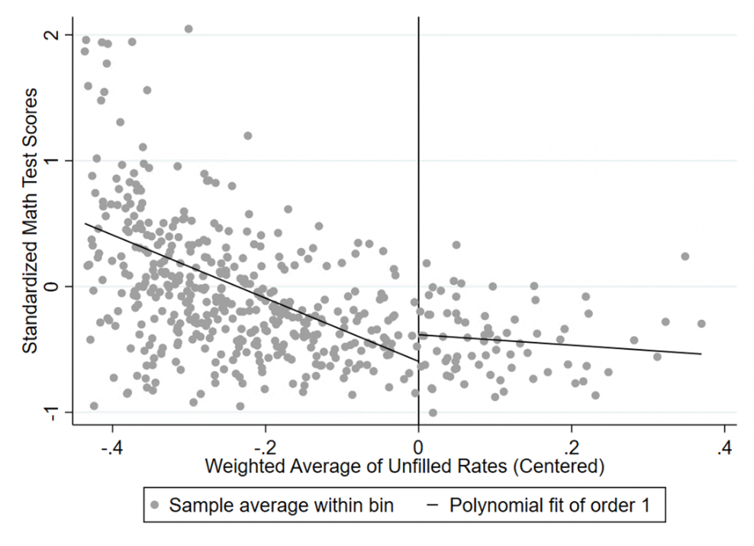
Figure B.22 Raw discontinuity in student-level math test scores in 2018-19
Notes: The independent variable is the forcing variable used to select schools for treatment, centered at the treatment cutoff. Students in treated schools are to the right of the cutoff. We follow Calonico et al. (2015) by selecting bin-width with the evenly-spaced mimicking variance method using spacings estimators.

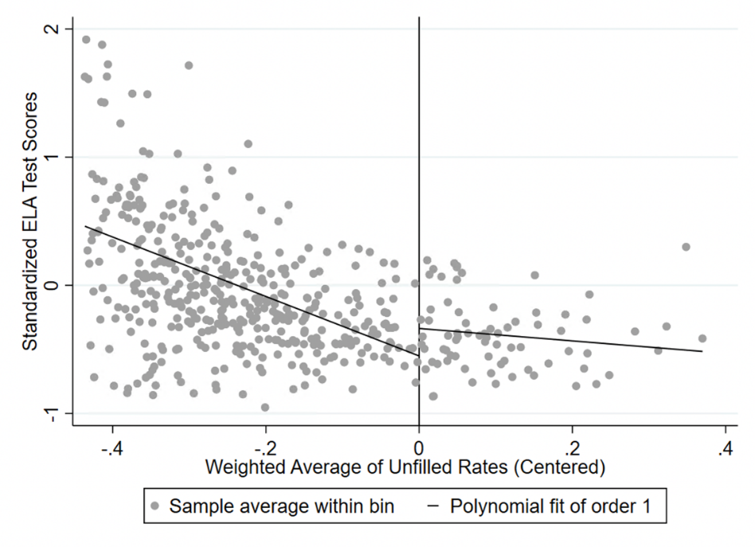
Figure B.23 Raw discontinuity in student-level ELA test scores in 2018-19
Notes: The independent variable is the forcing variable used to select schools for treatment, centered at the treatment cutoff. Students in treated schools are to the right of the cutoff. We follow Calonico et al. (2015) by selecting bin-width with the evenly-spaced mimicking variance method using spacings estimators.

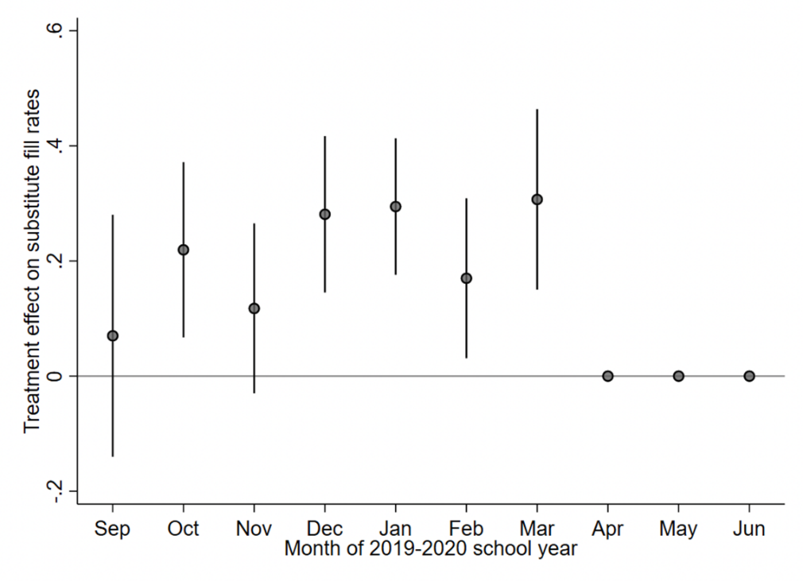
Figure B.24 Month-level regression discontinuity estimates, 2019-20
Notes: We plot average treatment effects at the 125th school cutoff from our RD model on fill-rates for specific months during the school year, controlling for school-level covariates. Vertical bars demarcate 95% confidence intervals for each estimate.
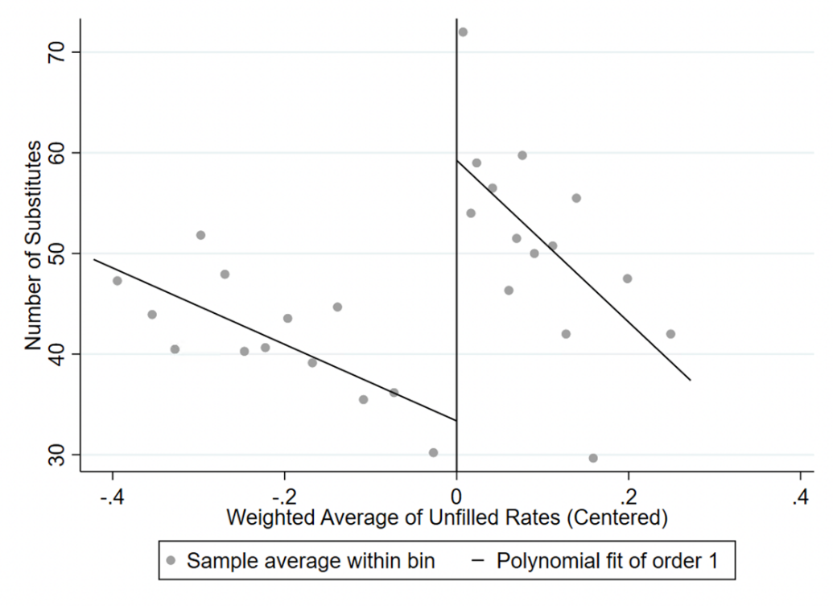
Figure B.25 Raw discontinuity in unique substitutes at each school, 2019-20
Notes: The independent variable was used to select schools for treatment in the second program year, centered at zero. Treated schools are to the right of the cutoff. We follow Calonico et al. (2015) by selecting bin-width with the evenly-spaced mimicking variance method using spacings estimators.

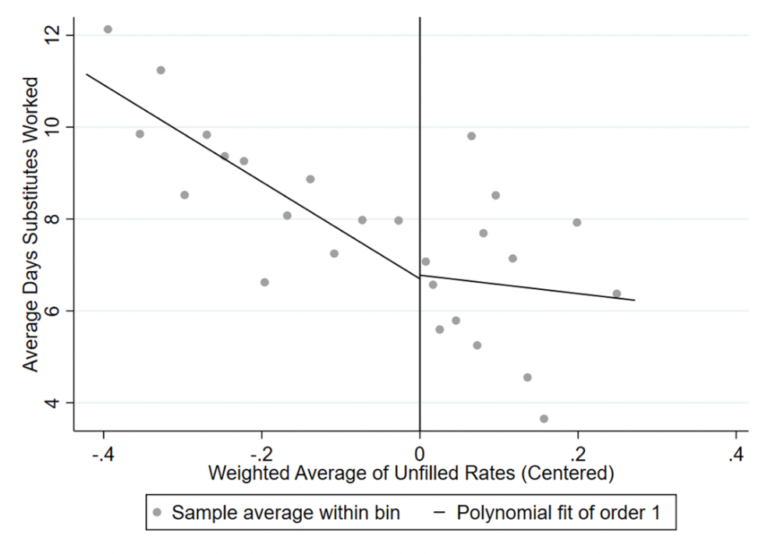
Figure B.26 Raw discontinuity in the average days substitutes worked at each school, 2019-20
Notes: The independent variable was used to select schools for treatment in the second program year, centered at zero. Treated schools are to the right of the cutoff. We follow Calonico et al. (2015) by selecting bin-width with the evenly-spaced mimicking variance method using spacings estimators.

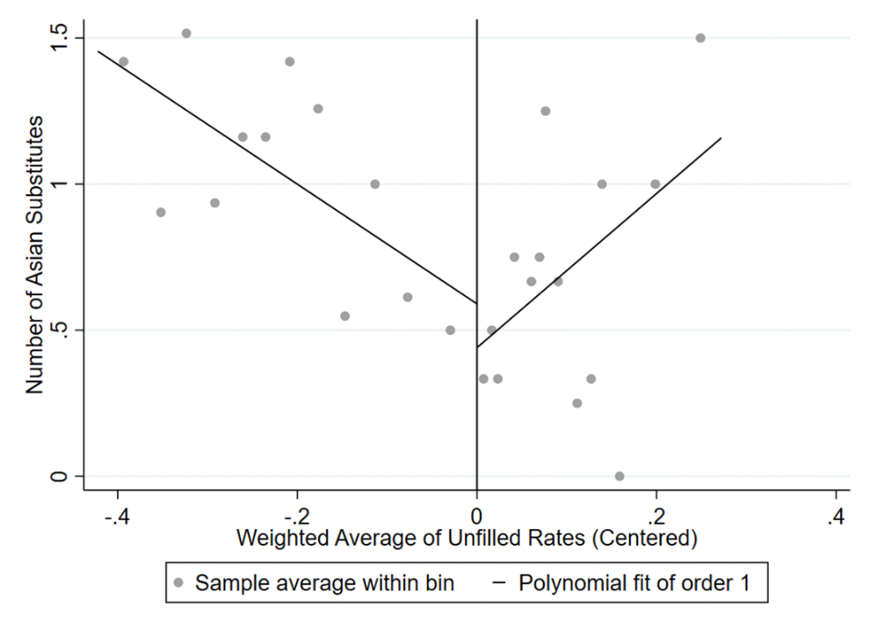
Figure B.27 Raw discontinuity in number of Asian substitutes at each school, 2019-20
Notes: The independent variable was used to select schools for treatment in the second program year, centered at zero. Treated schools are to the right of the cutoff. We follow Calonico et al. (2015) by selecting bin-width with the evenly-spaced mimicking variance method using spacings estimators.

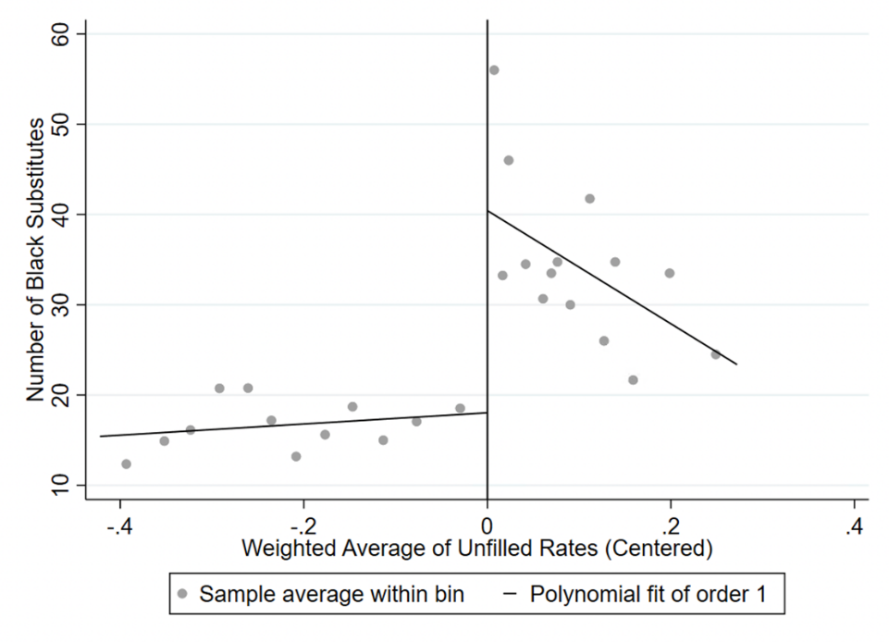
Figure B.28 Raw discontinuity in number of Black substitutes at each school, 2019-20
Notes: The independent variable was used to select schools for treatment in the second program year, centered at zero. Treated schools are to the right of the cutoff. We follow Calonico et al. (2015) by selecting bin-width with the evenly-spaced mimicking variance method using spacings estimators.

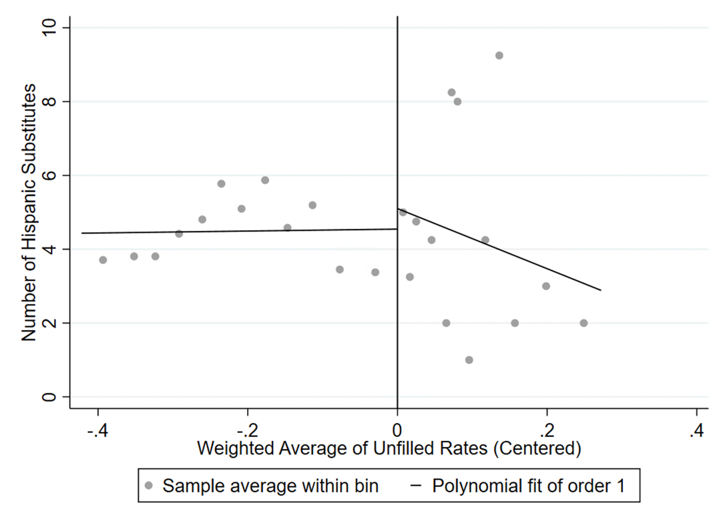
Figure B.29 Raw discontinuity in number of Hispanic substitutes at each school, 2019-20
Notes: The independent variable was used to select schools for treatment in the second program year, centered at zero. Treated schools are to the right of the cutoff. We follow Calonico et al. (2015) by selecting bin-width with the evenly-spaced mimicking variance method using spacings estimators.

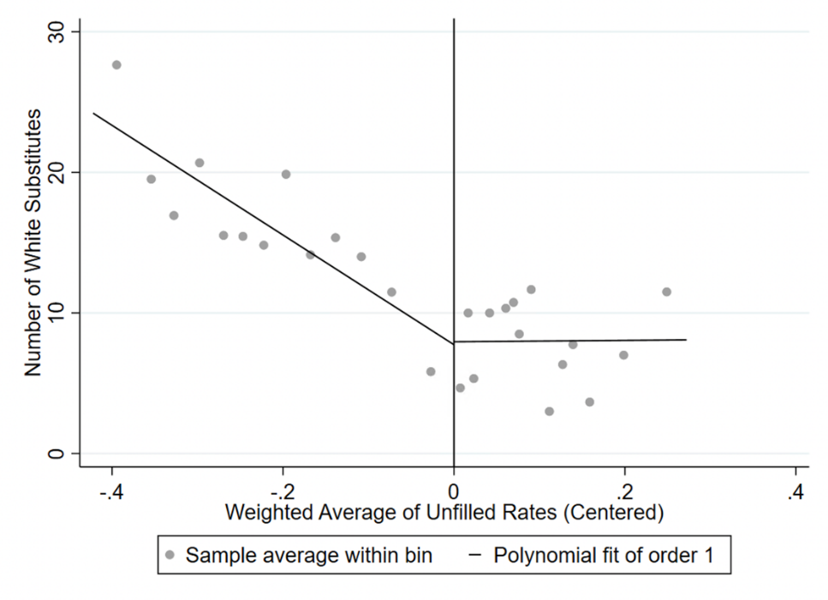
Figure B.30 Raw discontinuity in number of white substitutes at each school, 2019-20
Notes: The independent variable was used to select schools for treatment in the second program year, centered at zero. Treated schools are to the right of the cutoff. We follow Calonico et al. (2015) by selecting bin-width with the evenly-spaced mimicking variance method using spacings estimators.

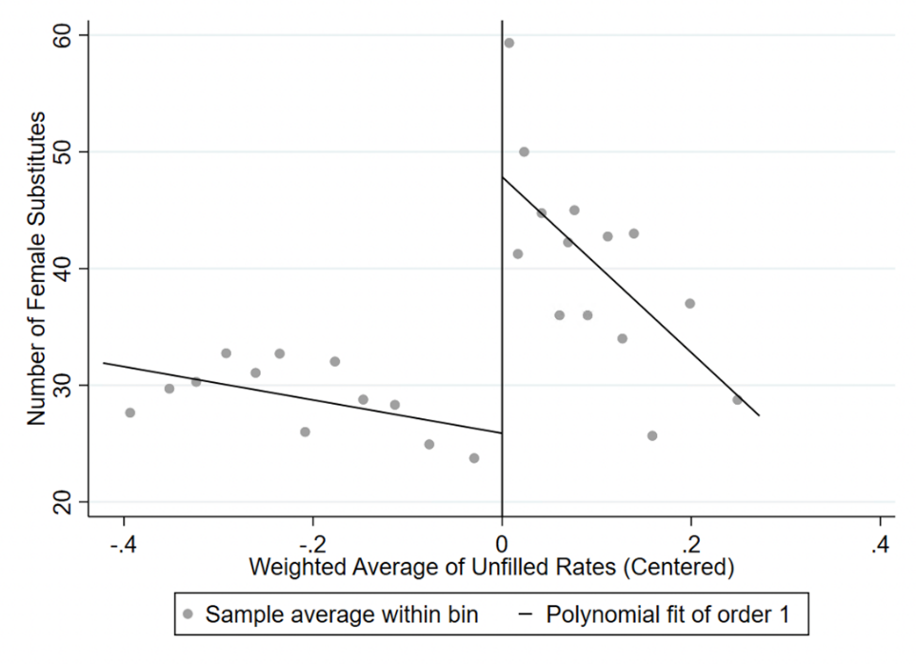
Figure B.31 Raw discontinuity in number of female substitutes at each school, 2019-20
Notes: The independent variable was used to select schools for treatment in the second program year, centered at zero. Treated schools are to the right of the cutoff. We follow Calonico et al. (2015) by selecting bin-width with the evenly-spaced mimicking variance method using spacings estimators.

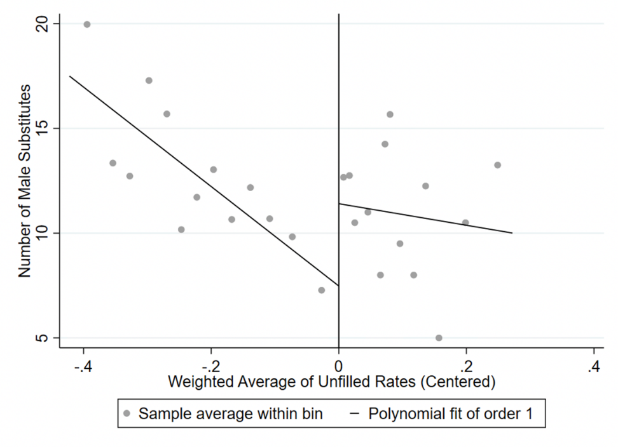
Figure B.32 Raw discontinuity in number of male substitutes at each school, 2019-20
Notes: The independent variable was used to select schools for treatment in the second program year, centered at zero. Treated schools are to the right of the cutoff. We follow Calonico et al. (2015) by selecting bin-width with the evenly-spaced mimicking variance method using spacings estimators.

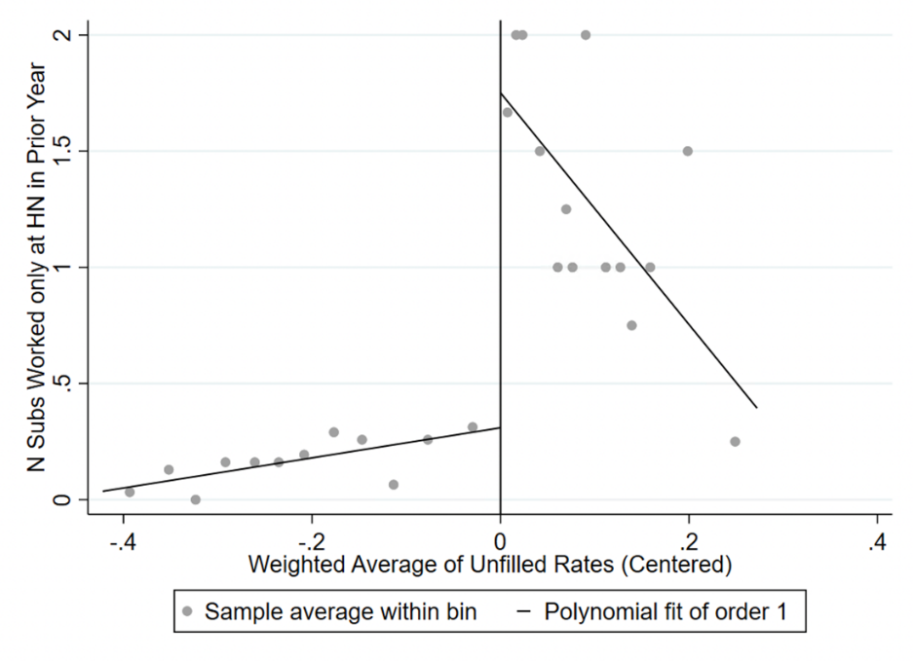
Figure B.33 Raw discontinuity in the number of unique substitutes in 2019-20 who worked only at incentive schools in the prior year
Notes: The independent variable was used to select schools for treatment in the second program year, centered at zero. Treated schools are to the right of the cutoff. We follow Calonico et al. (2015) by selecting bin-width with the evenly-spaced mimicking variance method using spacings estimators.

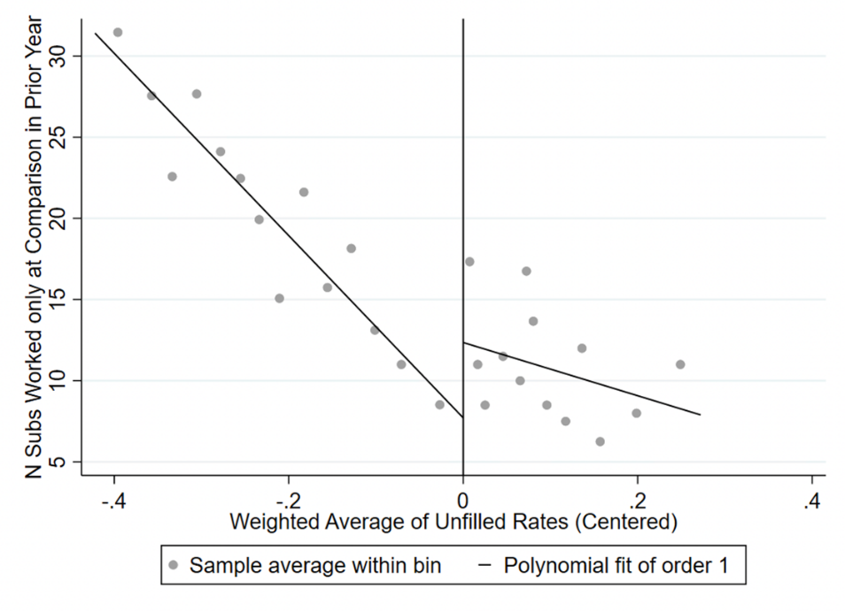
Figure B.34 Raw discontinuity in the number of unique substitutes in 2019-20 who worked only at non-incentive schools in the prior year
Notes: The independent variable was used to select schools for treatment in the second program year, centered at zero. Treated schools are to the right of the cutoff. We follow Calonico et al. (2015) by selecting bin-width with the evenly-spaced mimicking variance method using spacings estimators.

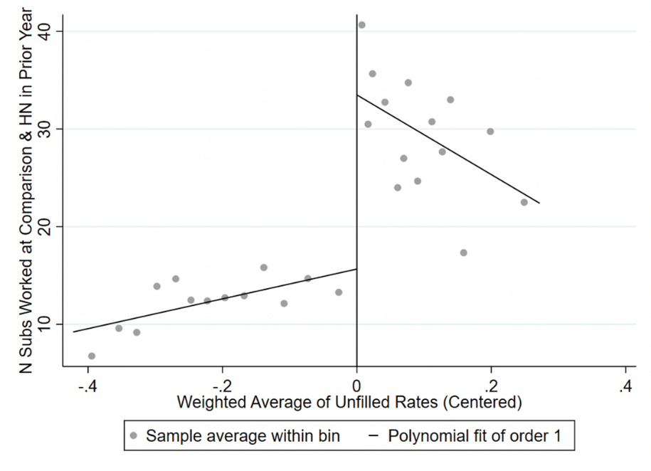
Figure B.35 Raw discontinuity in the number of unique substitutes in 2019-20 who worked only at both incentive and non-incentive schools in the prior year
Notes: The independent variable was used to select schools for treatment in the second program year, centered at zero. Treated schools are to the right of the cutoff. We follow Calonico et al. (2015) by selecting bin-width with the evenly-spaced mimicking variance method using spacings estimators.

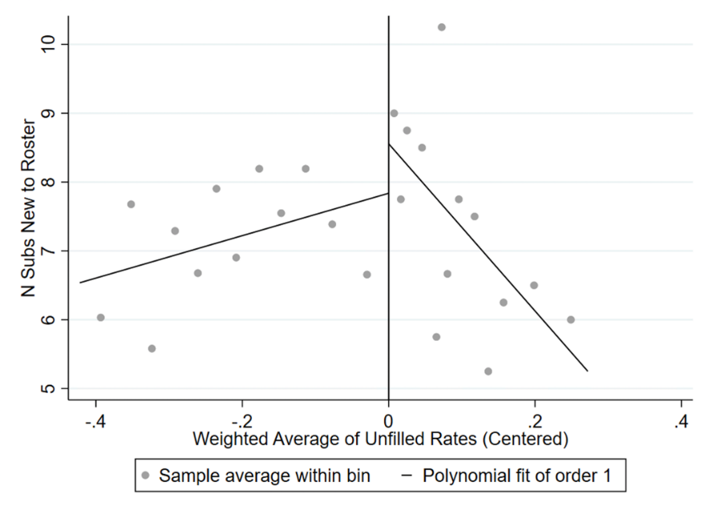
Figure B.36 Raw discontinuity in the number of unique substitutes new to the roster in 2019-20
Notes: The independent variable was used to select schools for treatment in the second program year, centered at zero. Treated schools are to the right of the cutoff. We follow Calonico et al. (2015) by selecting bin-width with the evenly-spaced mimicking variance method using spacings estimators.

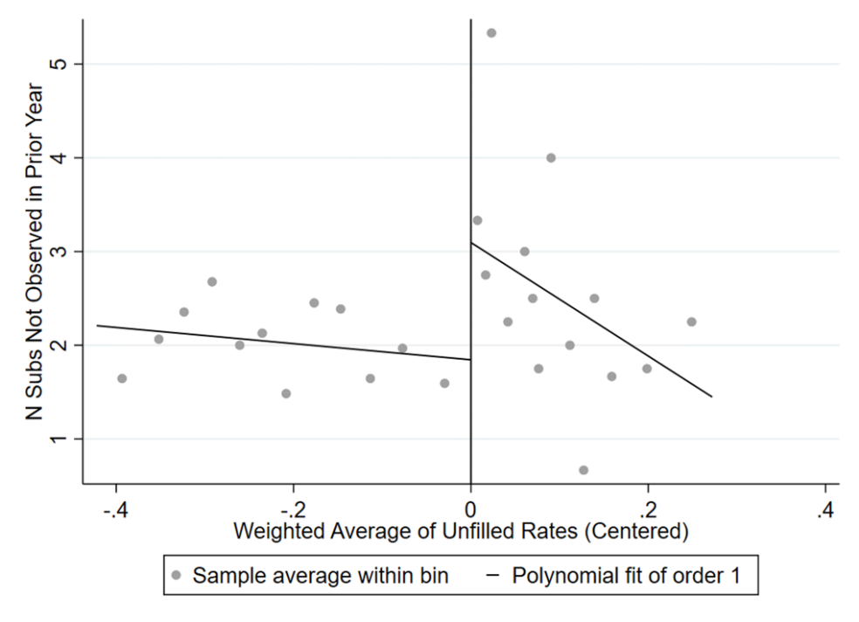
Figure B.37 Raw discontinuity in the number of unique substitutes in 2019-20 who worked only at incentive schools in the prior year
Notes: The independent variable was used to select schools for treatment in the second program year, centered at zero. Treated schools are to the right of the cutoff. We follow Calonico et al. (2015) by selecting bin-width with the evenly-spaced mimicking variance method using spacings estimators.

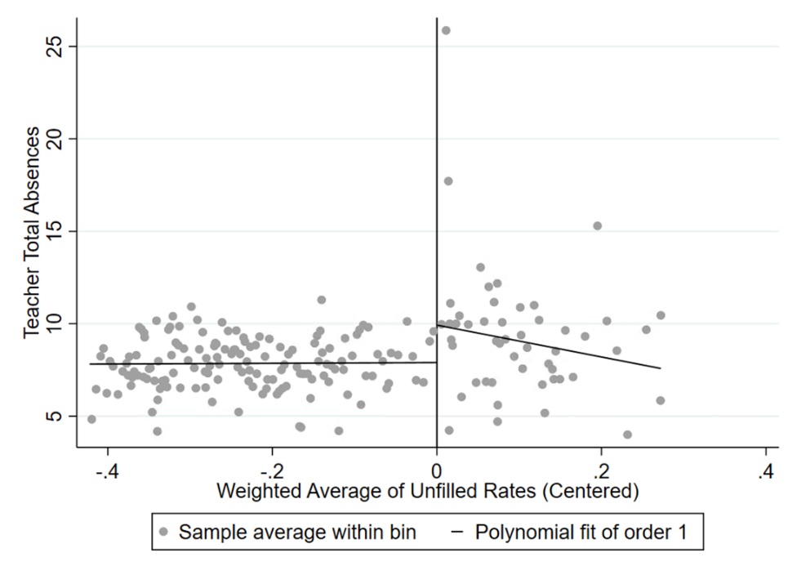
Figure B.38 Raw discontinuity in teacher-level total absences in 2019-20
Notes: The independent variable was used to select schools for treatment in the second program year, centered at zero. Teachers working in treated schools are to the right of the cutoff. We follow Calonico et al. (2015) by selecting bin-width with the evenly-spaced mimicking variance method using spacings estimators.

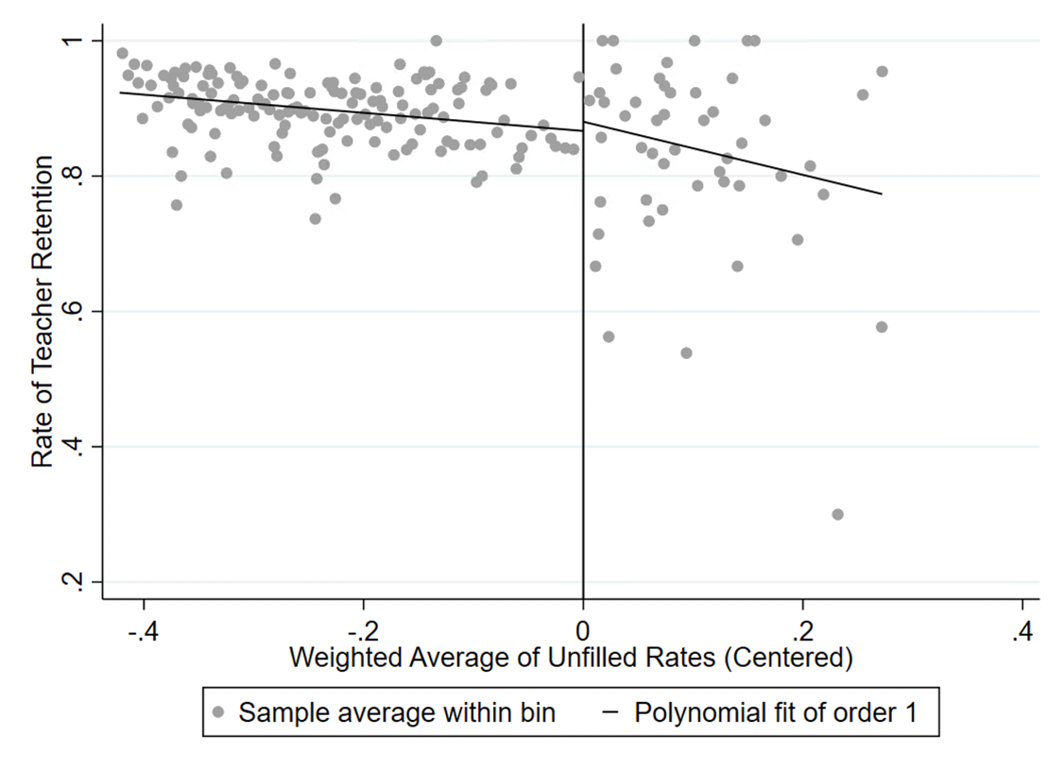
Figure B.39 Raw discontinuity in teacher-level retention in 2019-20
Notes: The independent variable was used to select schools for treatment in the second program year, centered at zero. Teachers working in treated schools are to the right of the cutoff. We follow Calonico et al. (2015) by selecting bin-width with the evenly-spaced mimicking variance method using spacings estimators.

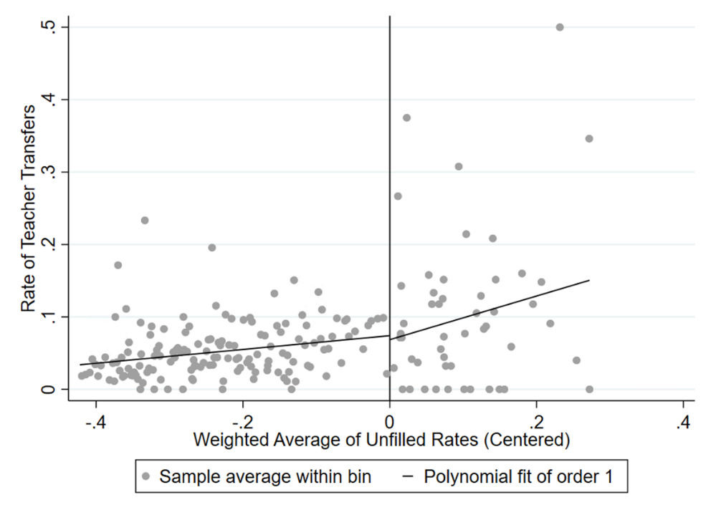
Figure B.40 Raw discontinuity in teacher-level transfers in 2019-20
Notes: The independent variable was used to select schools for treatment in the second program year, centered at zero. Teachers working in treated schools are to the right of the cutoff. We follow Calonico et al. (2015) by selecting bin-width with the evenly-spaced mimicking variance method using spacings estimators.

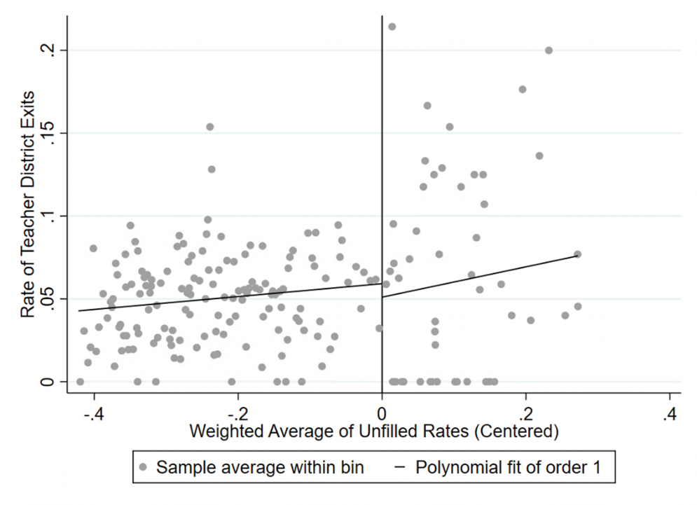
Figure B.41 Raw discontinuity in teacher-level exits in 2019-20
Notes: The independent variable was used to select schools for treatment in the second program year, centered at zero. Teachers working in treated schools are to the right of the cutoff. We follow Calonico et al. (2015) by selecting bin-width with the evenly-spaced mimicking variance method using spacings estimators.

Table B.1: Effects of Targeted Incentives on Substitute Labor Supply 2019-20 75th School Cutoff
 | Incentive school mean 2017-18 |  | (1) | (2)
Panel A. Substitute behavior measures
Substitute request fill rate | 0.47 |  | 0.22** | 0.21**
 |  |  | (0.10) | (0.09)
Number of unique substitutes at a school | 50.40 |  | 29.10*** | 27.81***
Number of unique substitutes at a school |  |  | (8.89) | (6.79)
Average substitutes' total days worked at a school | 4.65 |  | -2.57 | -1.49
Average substitutes' total days worked at a school |  |  | (2.39) | (2.48)
Panel B. Number of unique subs in 2019-20 by prior work history
Prior work in treated schools only | 0.73 |  | 1.70*** | 1.89***
Prior work in treated schools only |  |  | (0.42) | (0.33)
Prior work in comparison schools only | 5.47 |  | 1.10 | 0.08
Prior work in comparison schools only |  |  | (2.80) | (1.92)
Prior work in both treated & comparison schools | 27.73 |  | 22.62*** | 22.34***
Prior work in both treated & comparison schools |  |  | (4.76) | (4.01)
New to the substitute roster | 13.11 |  | 2.62 | 2.68*
New to the substitute roster |  |  | (2.07) | (1.52)
Lapsed substitutes | 3.36 |  | 1.05 | 0.81
 |  |  | (0.67) | (0.56)
School covariate vector |  |  | No | Yes
n |  |  | 75 | 75
Notes: Heteroskedasticity-robust standard errors are reported in parentheses (* p<.10, ** p<.05, *** p<.01). Models exclude schools sorted into treatment in 2019-20. Schooling-level fixed effects are included in all models. The school covariate vector includes controls for student body race demographics, representation of free/reduced price lunch eligibility, special education status, English as a second language status, total school enrollment, and lagged school-level math and ELA achievement. Observations within the bandwidth of +/- 0.11 are weighted by a uniform kernel. The pre-treatment mean reported is for the initial 75 treated schools.

Table B.2: Heterogeneous Effects of Targeted Incentives on Substitute Labor Supply 2019-20 75th School Cutoff
 | Incentive school mean 2017-18 |  | (1) | (2)
Panel A. Substitute localness
Number of substitutes commuting <10min | 9.05 |  | 2.80 | 2.25*
Number of substitutes commuting <10min |  |  | (1.76) | (1.25)
Number of substitutes commuting 10-20min | 17.52 |  | 7.64** | 7.37***
Number of substitutes commuting 10-20min |  |  | (3.06) | (2.43)
Number of substitutes commuting >20min | 22.29 |  | 7.69*** | 6.64***
Number of substitutes commuting >20min |  |  | (2.92) | (2.41)
Panel B. Number of unique substitutes in 2018-19 by demographic groups
Asian | 0.64 |  | 1.36** | 0.55
Asian |  |  | (0.58) | (0.40)
Black | 30.96 |  | 18.14** | 23.24***
Black |  |  | (7.13) | (6.06)
Latinx | 3.95 |  | 2.09 | 0.62
Latinx |  |  | (2.25) | (0.74)
White | 9.81 |  | 4.89 | 1.44
White |  |  | (3.10) | (1.77)
Female | 37.23 |  | 21.43*** | 21.44***
 |  |  | (7.33) | (5.43)
Male | 13.17 |  | 7.67*** | 6.36***
 |  |  | (2.40) | (1.85)
School covariate vector |  |  | No | Yes
n |  |  | 75 | 75
Notes: Heteroskedasticity-robust standard errors are reported in parentheses (* p<.10, ** p<.05, *** p<.01). Models exclude schools sorted into treatment in 2019-20. Schooling-level fixed effects are included in all models. The school covariate vector includes controls for student body race demographics, representation of free/reduced price lunch eligibility, special education status, English as a second language status, total school enrollment, and lagged school-level math and ELA achievement. Observations within the bandwidth of +/- 0.11 are weighted by a uniform kernel.

Table B.3: Effects of Targeted Incentives on Teacher Outcomes 2019-20 75th School Cutoff
 | Incentive school mean 2017-18 |  | (1) | (2)
Total absences | 11.700 |  | 1.739 | 2.506***
Total absences |  |  | (1.380) | (0.844)
Retained at school | 0.780 |  | -0.051 | -0.038
Retained at school |  |  | (0.053) | (0.040)
Transferred | 0.115 |  | 0.025 | 0.004
Transferred |  |  | (0.032) | (0.032)
Left district | 0.104 |  | 0.026 | 0.034
Left district |  |  | (0.037) | (0.027)
School covariate vector |  |  | No | Yes
Teacher covariate vector |  |  | No | Yes
n |  |  | 1,684 | 1,684
Notes: Heteroskedasticity-robust standard errors are reported in parentheses (* p<.10, ** p<.05, *** p<.01). Models exclude schools sorted into treatment in 2019-20. Schooling-level fixed effects are included in all models. The school covariate vector includes controls for student body race demographics, representation of free/reduced price lunch eligibility, special education status, English as a second language status, total school enrollment, and lagged school-level math and ELA achievement. The teacher covariate vector includes binned tenure indicators (3-5, 6-10, 11-20, 21+ years, with 0-2 years omitted), gender, and race / ethnicity indicators. Observations within the bandwidth of +/- 0.11 are weighted by a uniform kernel.

Table B.4: Regression discontinuity estimates for teacher absence types, 2019-20
 | Incentive school mean 2017-18 |  | (1) | (2)
Total Absences | 12.56 |  | 4.315** | 3.502**
Total Absences |  |  | (1.782) | (1.510)
Sick | 5.45 |  | -0.009 | -0.362
Sick |  |  | (0.482) | (0.397)
Personal day | 2.03 |  | 0.250* | 0.155
Personal day |  |  | (0.143) | (0.123)
Professional development | 2.49 |  | 2.903* | 2.884*
Professional development |  |  | (1.741) | (1.527)
Leave of absence | 1.42 |  | 0.162 | 0.033
 |  |  | (0.308) | (0.306)
School covariate vector |  |  | No | Yes
Individual covariate vector |  |  | No | Yes
n |  |  | 2174 | 2174
Notes: Heteroskedasticity-robust standard errors are reported in parentheses (* p<.10, ** p<.05, *** p<.01). Models exclude the 75 schools sorted into treatment in 2018-19. Schooling-level fixed effects are included in all models. The school covariate vector includes controls for student body race demographics, representation of free/reduced price lunch eligibility, special education status, English as a second language status, total school enrollment, and lagged school-level math and ELA achievement. Observations within the bandwidth of +/- 0.10 are weighted by a uniform kernel. The pre-treatment mean reported is at the teacher-level, for the 50 treated schools added to treatment in 2019-20.

Table B.5. Sensitivity Analysis for 2019-20 125th Cutoff Regression Discontinuity
 | (1) | (2)
Panel A. Exclude Top 25% of Schools by % of Substitutes Worked at Both Treatment and Comparison Schools Last Year
Substitute request fill rates | 0.25*** | 0.24***
 | (0.04) | (0.04)
 | n=61
Panel B. Exclude Top 50% of Schools by % of Substitutes Worked at Both Treatment and Comparison Schools Last Year
Substitute request fill rates | 0.16** | 0.25***
 | (0.07) | (0.05)
 | n=38
Panel C. Exclude Top 25% of Schools by Number of Treated Schools Within 3 Miles
Substitute request fill rates | 0.18*** | 0.18***
 | (0.04) | (0.04)
 | n=59
Panel D. Exclude Top 50% of Schools by Number of Treated Schools Within 3 Miles
Substitute request fill rates | 0.22*** | 0.18***
 | (0.04) | (0.04)
 | n=44
School covariate vector | No | Yes
Notes: Heteroskedasticity-robust standard errors are reported in parentheses (* p<.10, ** p<.05, *** p<.01). We include schooling-level fixed effects and our school covariate vector in all models. Observations are weighted by a uniform kernel. Estimation Bandwidth is 0.10 for all panels. All models exclude the initial 75 treated schools, focusing on the 125th treatment-school cutoff.

