Supplement Data and Supporting Results

This online supplement accompanies the manuscript entitled “Health Benefits and Health Care Savings from the United States National Hepatitis C Elimination Initiative.” The supplement provides data and supporting results, including those for model calibration and validation.

Table of Contents

Additional Details on the Estimating HCV Prevalence Overall and by Subpopulation 3
Assignment of Incident HCV Cases to Subpopulation 3
HCV Awareness and Diagnosis 3
eTable 8. Percentage of HCV-Infected People Aware of Their Disease Status, United States, 2015 3
HCV Treatment 4
DAA Treatment Strategies Under the Status Quo and National Elimination Initiative 4
eTable 9. The annual number of individuals receiving DAA treatment for HCV infection, United States, 2015 to 2020 5
eTable 10. The probability that a person is a candidate for HCV treatment without the national hepatitis C elimination initiative 5
eFigure 1. HEP-SIM calibration results, including (A) calibration to the prevalence of HCV, United States, 2015¹ and (B) calibration to the number of liver-related deaths, United States, 2015 to 2019.⁴⁰ 6
eFigure 2. Number of hepatitis C infected individuals receiving treatment by subpopulation under the status quo, United States, 2024 to 2028 7
eFigure 3. Number of hepatitis C infected individuals receiving treatment by subpopulation under the national hepatitis c elimination initiative, United States, 2024 to 2028 8
eFigure 4. Reduction in HCV-related hepatocellular carcinoma and deaths because of national hepatitis C initiative by calendar year (A, C) and cumulative over 5, 10, and 20 years (B, C) in the scenario with a decreasing HCV incidence over time 9
eTable 1. Proportion of HCV Infected Persons by Subpopulation, United States 10
eTable 2. HCV prevalence and breakdown by subpopulation, United States, 2015 10
eTable 3. Number of Estimated Acute HCV Cases by Year, United States, 2011 to 2020 and Extrapolated Incident HCV Cases by Year, United States, 2021 to 2050 10
eTable 4. Distribution of High-Risk Individuals (PWIDs) to Insurance Groups, United States 11
eTable 5. Discounted 10- and 20-year cost savings including extrahepatic conditions 12
eTable 6. Cost Savings Attributable to ALL Illnesses Averted Including the cost of non-HCV illnesses (diabetes and chronic kidney disease) 12
eTable 7. Non-discounted Cost Savings Attributable to All Illnesses Averted, Including the cost of non-HCV illnesses (diabetes and chronic kidney disease) in the Scenario with Decreasing Incidence Over Time 13
eTable 12. Rate of Uninsured People who Transition to Medicaid, United States, 2014 to 2018 13
eTable 13. SVR Rates by Treatment, Genotype, Treatment History, and Fibrosis State, United States 14
References 15

Additional Details on the Estimating HCV Prevalence Overall and by Subpopulation

We used state-level HCV prevalence estimates to initialize the model in 2015.¹ To account for under reporting of HCV prevalence in justice-involved population, we first subtracted the number of HCV persons in state prisons from the original state-level HCV prevalence to calculate the overall prevalence among non-justice-involved individuals. The number of HCV persons in non-justice settings was distributed across four subpopulations (Medicare, Medicaid, privately insured, and uninsured) based on a CDC analysis of state-level data on ambulatory, inpatient, and urgent care visits for HCV infection from 2012 through 2015 (eTable 1). These estimates incorporated evidence on the frequency of healthcare system usage among persons with HCV and those with an opioid dependence to estimate the number of persons with HCV in each insurance category.²⁻⁸ Individuals in the “other” subpopulation were redistributed among the four remaining categories. This model then combines these estimates with the previously calculated prevalence among justice-involved individuals to compute the number of currently HCV-infected persons within each subpopulation: Medicaid, Medicare, privately insured, uninsured, and incarcerated (eTable 2). After patients have been initially assigned to a subpopulation, the model permits limited mobility through two mechanisms. Specifically, the model assumes that non-incarcerated patients will join Medicare after turning 65 years old and also that there was Medicaid expansion at the rates in eTable 11 through 2018 that enabled some initially uninsured patients to join Medicaid.

Assignment of Incident HCV Cases to Subpopulation

The high-risk cases are assigned proportionally to subpopulations according to the estimated percentage of coverage type among people with opioid use disorder (eTable 4), with the incarcerated subpopulation being omitted in the high-risk case assignment process.⁹ Low-risk cases were distributed between Medicare and private insurance based on the proportion of HCV-infected individuals within each subpopulation. Lastly, the model assumes that all new chronic HCV cases will begin in the F0 state.

HCV Awareness and Diagnosis

The likelihood of HCV-infected persons to be aware of their infection is dependent on their age and insurance status. This information was extracted from published studies that evaluated NHANES data. For instance, in 2008, 49.7% of all HCV-infected persons, including 57.0% of those insured and 23.7% of those uninsured, were aware of their HCV status.¹⁰ We also accounted for differences in the awareness rates by age: 29% for age < 40, 57.6% for ages 40-49, 56% for ages 50-59, and 44.8% for ages above 60.
eTable 8 presents the HCV awareness rate by age and insurance used in HEP-SIM.

eTable 8. Percentage of HCV-Infected People Aware of Their Disease Status, United States, 2015
Age | Awareness Rate by Insurance Status¹⁰
Age | Insured | Uninsured
<40 | 17.63% | 5.81%
40-49 | 60.45% | 19.50%
50-59 | 54.59% | 16.29%
>60 | 34.94% | 5.77%

People unaware of their HCV infections can become aware because of one of the following screening strategies depending on the calendar year and simulated scenario.
- Provider-driven diagnostic and risk-based testing: This strategy is equivalent to diagnostic and risk-based testing for high-risk individuals, as defined in the CDC’s 1998 Recommendations, before birth cohort screening comes into place.¹¹ The estimated annual testing rate was approximately 1.6%.¹² Within that overall rate, individual probabilities for testing varied by disease stage (so, for example, we assume providers were more likely to initiate testing for individuals with symptoms of advanced liver disease).
- Birth cohort screening: This strategy is equivalent to risk-based testing (as outlined above, under the first screening strategy option) plus one-time screening for all individuals born between 1945 and1965 (i.e., Baby Boomers), as defined in the 2013 U.S. Preventive Services Task Force’s Hepatitis C Screening Recommendation.¹³ Based on analyses published by CDC, the estimated annual testing rate for birth-cohort screening is set to 9% for the insured and 0.99% for the uninsured.[REF]^{12,14,15} We assume that the birth cohort screening will be replaced by universal screening from 2021 onwards.
- Universal screening: This strategy assumes one-time screening, recommended for all adults 18 years and older, with repeat testing for those at high risk for infection from 2021 onwards.¹⁶ Under the status quo, the default screening rate is calibrated such that the number of people diagnosed with HCV aligns with the current literature on the HCV screening rate in the United States.¹⁷⁻²⁰ Because of an anticipated increase in the HCV screening rate over time, we assume the universal screening rate will be 5% per year from 2024 onwards. The national hepatitis C elimination scenario assumes an elevated screening rate of 18% annually from 2024 onwards. This screening rate was selected to align with the proposed national initiative under which at least 300,000 persons are aware of their HCV status (and thus are eligible for HCV treatment) each year between January 2024 and December 2024. We assumed that the annual screening rate changes to 5% once 90% of all HCV-infected persons get diagnosed. If the HCV diagnosis rate drops below 90%, the annual screening rate will rise to 18% again. The annual treatment volumes by subpopulation under the status quo and national hepatitis C elimination initiative are presented in eFigure 2 and eFigure 3, respectively.

HCV Treatment

Under the status quo, the annual treatment rate is capped at the 2020 treatment volume of 83,740 patients (eTable 9).²¹ In the national elimination scenario, it is assumed that 90% of all diagnosed patients in that year will receive treatment in the same year, and the remaining 10% will be eligible to receive treatment next year. Every year, under both scenarios, the number of treated patients is distributed across the different subpopulations according to the probability of being eligible for treatment (eTable 10).

DAA Treatment Strategies Under the Status Quo and National Elimination Initiative
Once diagnosed with an HCV infection, a patient becomes eligible to receive treatment with one of the direct-acting antiviral agents (DAAs). The type of DAA treatment depends on the year the person receives treatment (eTable 13). To align with current standards of care, treatment in 2024 is assumed to consist of all-oral DAA combinations for both treatment naïve and treatment-experienced patients (including those for whom initial DAA therapies did not work). The model varies the rate of sustained virologic response (SVR) by viral genotype, stage of fibrosis, treatment regimen, and treatment history (eTable 13).²²⁻³⁹
Annual treatment rate: This refers to the percentage of all diagnosed individuals within a given subpopulation(s) for whom the healthcare system can accommodate treatment each year. It thus attempts to quantify, in a single number, system-level considerations such as restrictions on who can provide treatment (e.g., specialists vs. primary care), as well as the availability and accessibility (e.g., are they accepting new patients, how many, etc.) of “allowed” treatment providers.
- National Hepatitis C Elimination Initiative: Under the hepatitis C elimination initiative, 90% of all eligible (screened and HCV-diagnosed) individuals will be treated each year.
- Previous Years (before 2024) and Status Quo: The annual number of individuals receiving treatment for HCV in the past and under the status quo is based on reported data (eTable 9). From 2020 onwards, the model assumes that the number of people receiving treatment remains constant at 83,740 for all years after 2020 under the status quo strategy.²¹

eTable 9. The annual number of individuals receiving DAA treatment for HCV infection, United States, 2015 to 2020
Year | Number of persons treated per year²¹
2015 | 164,247
2016 | 134,287
2017 | 114,419
2018 | 122,666
2019 | 114,893
2020 | 83,740
  - We allocate HCV treatment among different subpopulations (uninsured, Medicare, Medicaid, private insurance, and incarcerated) by first estimating the DAA treatment-eligible population size in each subpopulation by multiplying the probability that a person in each subpopulation is a candidate for DAA treatment, denoted at probability_{i}, (eTable 12) by the total eligible treatment volume, denoted by N_{it} (where $i$ indicates the subpopulation and $t$indicates the year). In total, for a given year (t), the proportion of individuals receiving treatment in a particular subpopulation is calculated by the following equation:
$$proportion_{i}=\frac{probability_{i}{×N}_{it}}{\sum_{i}{probability_{i}×N_{it}}}$$

eTable 10. The probability that a person is a candidate for HCV treatment without the national hepatitis C elimination initiative
Subpopulation | Probability
Uninsured | 0.1
Medicare | 0.25
Medicaid | 0.2
Private Insurance | 0.3
Incarcerated | 0.02
  - Finally, the proportion of persons receiving treatment in each subpopulation ($proportion_{i}$) is multiplied by the number of individuals receiving treatment in a given year, $M_{t},$ where $t$indicates the year (eTable 9), to estimate the number of individuals in each subpopulation who are receiving treatment in that year, denoted by $M_{it}$.
$$M_{it}=proportion_{i}×M_{t}$$

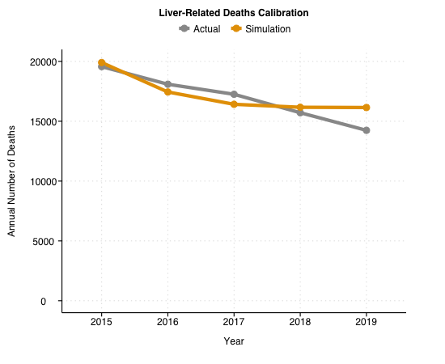
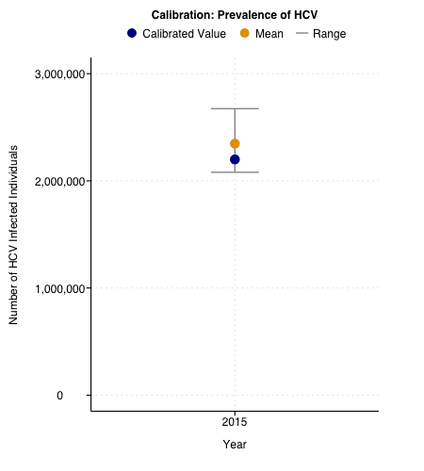

eFigure 1. HEP-SIM calibration results, including (A) calibration to the prevalence of HCV, United States, 2015¹ and (B) calibration to the number of liver-related deaths, United States, 2015 to 2019.⁴⁰

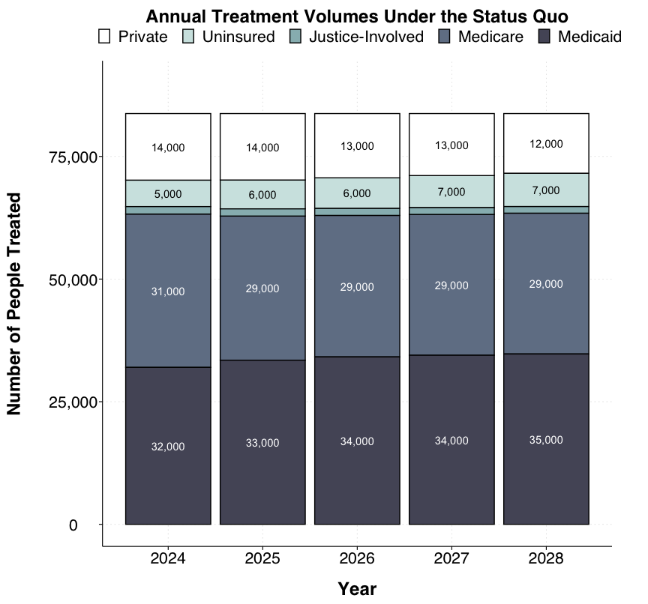

eFigure 2. Number of hepatitis C infected individuals receiving treatment by subpopulation under the status quo, United States, 2024 to 2028

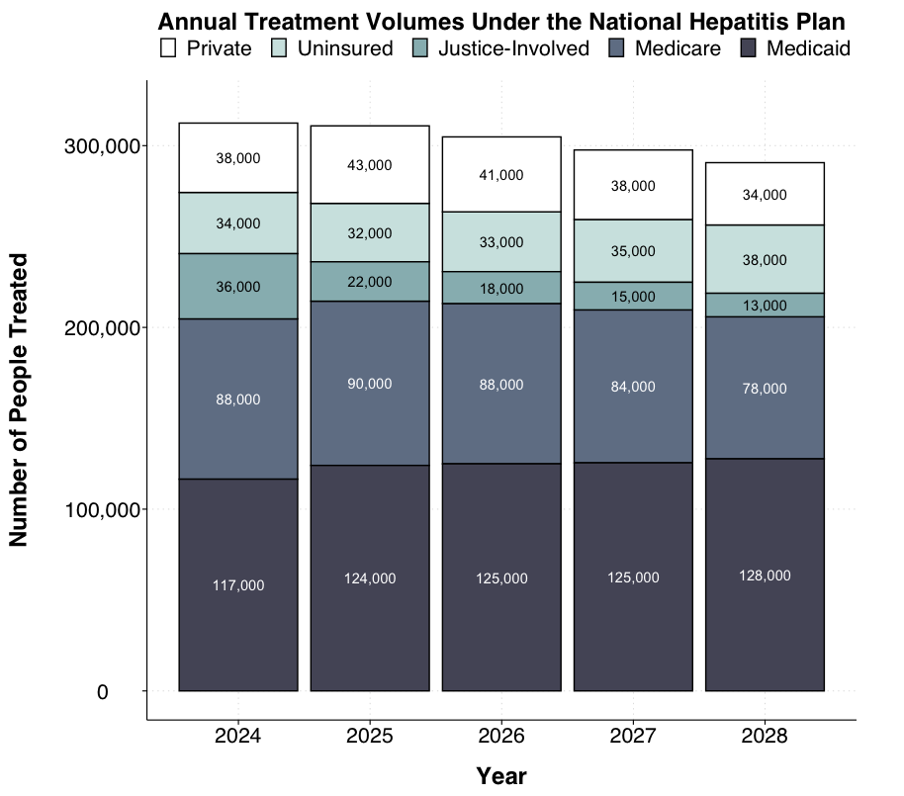

eFigure 3. Number of hepatitis C-infected individuals receiving treatment by subpopulation under the national hepatitis c elimination initiative, United States, 2024 to 2028

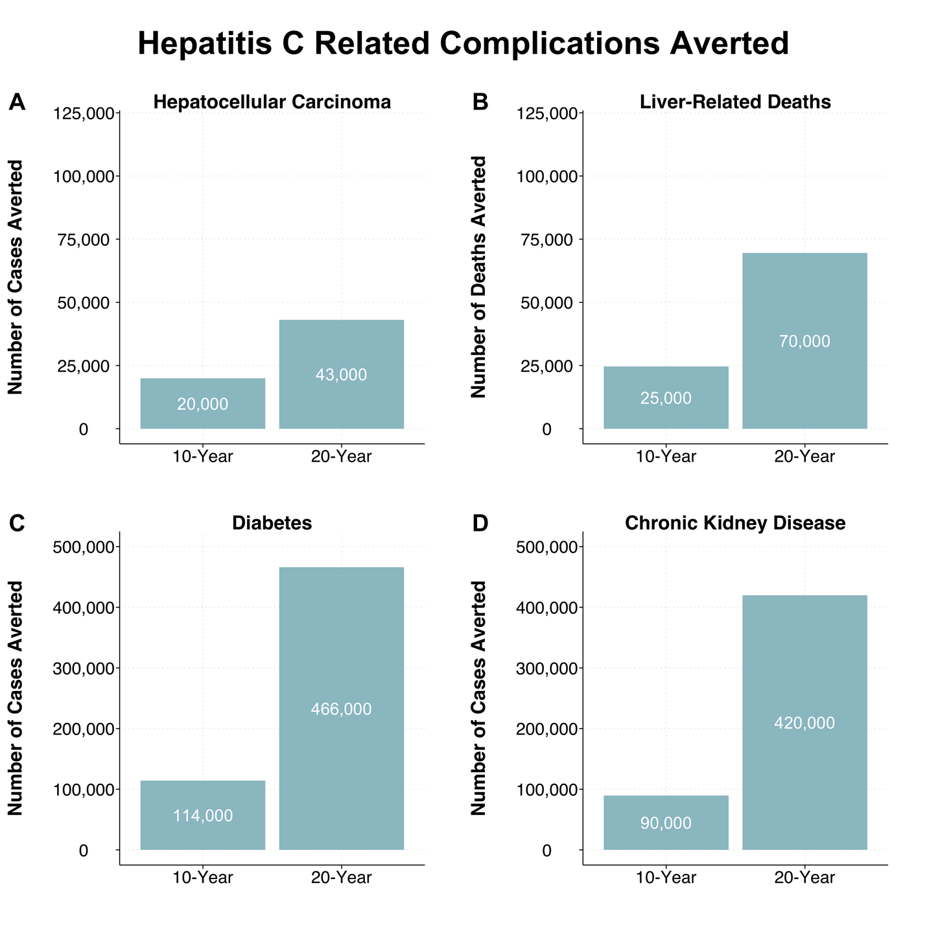

eFigure 4. Reduction in HCV-related hepatocellular carcinoma (A), deaths (B), diabetes (C), and chronic kidney disease (D) because of national hepatitis C initiative under the scenario with decreasing HCV incidence

eTable 1. Proportion of HCV Infected Persons by Subpopulation, United States

Insurance Status | Original Proportionª | Redistributed Proportion
Uninsured | 5% | 5.16%
Medicare | 28% | 28.87%
Medicaid | 50% | 52.54%
Private Insurance | 14% | 14.43%
Other | 2% | --

ª The original proportions are based on a recent CDC analysis that incorporates evidence on frequency of seeking medical care among persons with diagnosed HCV² and those with opioid abuse/dependence³ (a proxy for probable recent HCV infections) as well as state-level data for 2012–2015 from a variety of data sources⁴⁻⁸to estimate the number of patients with HCV in each insurance category.

eTable 2. HCV prevalence and breakdown by subpopulation, United States, 2015

State | HCV Prevalenceª | Breakdown by Subpopulation, % ^{b}
 | No. of Viremic People | Medicaid | Medicare | Private | Uninsured | Justice-Involved
United States | 2,346,990  Calibrated: 2,199,648 | 37% | 32% | 18% | 8% | 6%

ª Default estimates for HCV prevalence (for the year 2015) were obtained from a recently published work that leverages multiple data sources and advanced statistical models to estimate the prevalence of current HCV infection in each state.¹

^{b} Estimates for HCV prevalence in state prisons are obtained from the Hep Corrections website (www.HepCorrections.org). For the non-justice-involved population, estimates of the breakdown of HCV prevalence by insurance status were based eTable 1.

eTable 3. Number of Estimated Acute HCV Cases by Year, United States, 2011 to 2020 and Extrapolated Incident HCV Cases by Year, United States, 2021 to 2050

Year | Incident Casesª
2011 | 17,100
2012 | 24,700
2013 | 29,700
2014 | 30,500
2015 | 33,900
2016 | 41,200
2017 | 44,700
2018 | 50,300
2019 | 57,500
2020 | 66,700
2021 | 71,220
2022 | 77,600
2023 | 83,980
2024 | 90,360
2025 | 96,740
2026 | 103,120
2027 | 109,500
2028 | 115,880
2029 | 122,260
2030 | 128,640
2031 | 135,020
2032 | 141,400
2033 | 147,780
2034 | 154,160
2035 | 160,540
2036 | 166,920
2037 | 173,300
2038 | 179,680
2039 | 186,060
2040 | 192,440
2041 | 198,820
2042 | 205,200
2043 | 211,580
2044 | 217,960
2045 | 224,340
2046 | 230,720
2047 | 237,100
2048 | 243,480
2049 | 249,860
2050 | 256,240

ª Incident cases for the years from 2011 to 2020 are based on a published CDC estimate.⁴⁰ Future cases for the years 2021 through 2050 have been extrapolated using a linear trend from the previous years.

eTable 4. Distribution of High-Risk Individuals (PWIDs) to Insurance Groups, United States

Insurance Status | Proportion⁹
Uninsured | 26%
Medicare | 5.35%
Medicaid | 65.33%
Private Insurance | 3.33%

eTable 5. Discounted 10- and 20-year cost savings including extrahepatic conditions

Subpopulation | 10-Year Total Cost |  | 10-Year Cost Savings | 20-Year Total Cost |  | 20-Year Cost Savings
Subpopulation | Status Quo | National Hepatitis C Initiative | 10-Year Cost Savings | Status Quo | National Hepatitis C Initiative | 20-Year Cost Savings
Uninsured | $34.1 B | $32.9 B | $1.2 B | $68.7 B | $66.0 B | $2.7 B
Private | $61.3 B | $59.4 B | $1.9 B | $86.1 B | $81.9 B | $4.2 B
Medicare | $268.1 B | $263.4 B | $4.7 B | $511.3 B | $496.8 B | $14.5 B
Medicaid | $167.4 B | $163.3 B | $4.1 B | $279.7 B | $272.4 B | $7.3 B
Incarcerated | $26.8 B | $25.2 B | $1.6 B | $41.3 B | $38.9 B | $2.4 B
Total | $557.6 B | $544.2 B | $13.3 B | $987.0 B | $956.0 B | $31.0 B

eTable 6. Cost Savings Attributable to ALL Illnesses Averted Including the cost of non-HCV illnesses (diabetes and chronic kidney disease)

Subpopulation | 10-Year Total Cost |  | 10-Year Cost Savings | 20-Year Total Cost |  | 20-Year Cost Savings
Subpopulation | Status Quo | National Hepatitis C Initiative | 10-Year Cost Savings | Status Quo | National Hepatitis C Initiative | 20-Year Cost Savings
Uninsured | $46.2 B | $44.6 B | $1.6 B | $126.3 B | $121.4 B | $4.9 B
Private | $83.1 B | $80.5 B | $2.6 B | $158.3 B | $150.6 B | $7.7 B
Medicare | $363.5 B | $357.2 B | $6.3 B | $940.2 B | $913.5 B | $26.7 B
Medicaid | $227.0 B | $221.5 B | $5.5 B | $514.3 B | $500.8 B | $13.5 B
Incarcerated | $36.3 B | $34.2 B | $2.1 B | $75.9 B | $71.5 B | $4.4 B
Total | $756.1 B | $738.0 B | $18.1 B | $1,815.0 B | $1,758.0 B | $57.1 B

eTable 7. Non-discounted Cost Savings Attributable to All Illnesses Averted, Including the cost of non-HCV illnesses (diabetes and chronic kidney disease) in the Scenario with Decreasing Incidence Over Time

Subpopulation | 10-Year Total Cost |  | 10-Year Cost Savings | 20-Year Total Cost |  | 20-Year Cost Savings
Subpopulation | Status Quo | National Hepatitis C Initiative | 10-Year Cost Savings | Status Quo | National Hepatitis C Initiative | 20-Year Cost Savings
Uninsured | $46.2 B | $38.9 B | $7.3 B | $126.3 B | $81.6 B | $44.7 B
Private | $83.1 B | $79.7 B | $3.4 B | $158.3 B | $145.7 B | $12.6 B
Medicare | $363.5 B | $354.2 B | $9.3 B | $940.2 B | $878.4 B | $61.8 B
Medicaid | $227.0 B | $207.2 B | $19.8 B | $514.3 B | $404.4 B | $109.9 B
Incarcerated | $36.3 B | $34.2 B | $2.1 B | $75.9 B | $71.4 B | $4.5 B
Total | $756.1 B | $714.2 B | $41.9 B | $1,815.0 B | $1,581.4 B | $233.6 B

eTable 11. Age Distribution by Subpopulation, United States

 | Age Distribution by Subpopulation^{10,11}
Insurance Status | Age 20 ~ 44 | Age 45 ~ 64 | Age 65 and over
Incarceration | 0.74 | 0.245 | 0.015
Medicaid | 0.4413 | 0.5469 | 0.0118
Medicare | 0.1234 | 0.5016 | 0.375
Private Insurance | 0.3396 | 0.5891 | 0.0713
Uninsured | 0.5402 | 0.4272 | 0.0326

eTable 12. Rate of Uninsured People who Transition to Medicaid, United States, 2014 to 2018

Year | Expansion Rate⁴¹
2014 | 3.3%
2015 | 4.5%
2016 | 3.3%
2017 | 0.2%
2018 | 0.0%

eTable 13. SVR Rates by Treatment, Genotype, Treatment History, and Fibrosis State, United States

Treatment History and Fibrosis State | GT1 | GT2 | GT3 | GT4–6
DAA non-NS5A^{22-25*}
Treatment naïve
F0-F3 | 0.9 | 0.9 | 0.85 | 0.9
F4 | 0.8 | 0.8 | 0.6 | 0.8
Contraindicated with modifiable and non-modifiable reasons
F0-F3 | 0.9 | 0.9 | 0.9 | 0.9
F4 | 0.7 | 0.7 | 0.6 | 0.7
Failed PEG+RBV: relapse
F0-F3 | 0.9 | 0.9 | 0.85 | 0.9
F4 | 0.8 | 0.7 | 0.6 | 0.75
Failed PEG+RBV: partial and null response
F0-F3 | 0.9 | 0.9 | 0.85 | 0.9
F4 | 0.75 | 0.7 | 0.6 | 0.75
Failed first-generation PI
F0-F3 | 0.9 | - | - | -
F4 | 0.7 | - | - | -
Failed DAA NS5A (during 2015-2018)
F0-F3 | - | - | - | -
F4 | 0.8 | 0.8 | 0.6 | 0.8
DAA NS5A²⁶⁻³⁴**
Treatment naïve, contraindicated, failed PEG+RBV, failed BOC/TEL+PEG+RBV (GT1 only), failed DAA non-NS5A, failed DAA nonNS5A
F0-F3 | 0.95 | 0.99 | 0.95 | 0.99
F4 | 0.9 | 0.99 | 0.9 | 0.99
DAA NS5A-next generation^{35-39***}
All conditions
F0-F3 | 0.95 | 0.99 | 0.95 | 0.99
F4 | 0.9 | 0.99 | 0.9 | 0.99
*DAA1 non-NS5A includes the following drug combinations: SOF+IFN+/-RBV, SOF+/-RBV, SOF+SMV+/-RBV, and SMV+IFN+/-RBV.
**DAA1 NS5A includes the following drug combinations: SOF+LDV+/-RBV, SOF+DCV, DCV+IFN+/-RBV, OBV/PTV/r+DSV+/-RBV, OBV/PTV/r+/-RBV, EBR+GZR, and SOF+VEL.
***DAA2 NS5A includes the next wave of potential drug combinations such as SOF/VEL/VOX, grazoprevir/ruzasvir/uprifosbuvir, glecaprevir/pibrentasivr, and odalasvir+AL-335+/SMV

Abbreviations: GT, genotype; PEG, peginterferon; RBV, ribavirin; F0, no fibrosis; F1, portal fibrosis without septa; F2, portal fibrosis with few septa; F3, numerous septa without cirrhosis; F4, cirrhosis; BOC, boceprevir; TEL, telaprevir; DAA, direct-acting antiviral; NS5A, nonstructural protein 5A; PI, protease inhibitor; SOF, sofosbuvir; IFN, interferon; SMV, simeprevir; LDV, ledipasvir; DCV, daclatasvir; OBV, ombitasvir; PTV, paritaprevir; r, ritonavir; DSV, dasabuvir; EBR, elbasvir; GZR, grazoprevir; VEL, velpatasvir; VOX, voxilaprevir

References

1. Rosenberg ES, Rosenthal EM, Hall EW, et al. Prevalence of Hepatitis C Virus Infection in US States and the District of Columbia, 2013 to 2016. JAMA Network Open 2018;1(8):e186371-e186371.
2. Pham TT, Keast SL, Farmer KC, et al. Sustained Virologic Response and Costs Associated with Direct-Acting Antivirals for Chronic Hepatitis C Infection in Oklahoma Medicaid. Journal of managed care & specialty pharmacy 2018;24(7):664-676.
3. Rice JB, Kirson NY, Shei A, et al. Estimating the costs of opioid abuse and dependence from an employer perspective: a retrospective analysis using administrative claims data. Applied health economics and health policy 2014;12(4):435-446.
4. Ambulatory Health Care Data. National Center for Health Statistics. Centers for Disease Control; and Prevention, Atlanta, GA.; 1973-2015.
5. HCUPnet. Healthcare Cost and Utilization Project (HCUP). Agency for Healthcare Research and Quality, Rockville, MD.; 1990-2015.
6. HCUP National (Nationwide) Inpatient Sample (NIS). Healthcare Cost and Utilization Project (HCUP). Agency for Healthcare Research and Quality, Rockville, MD.; 1980-2015.
7. HCUP State Emergency Department Databases (SEDD). Healthcare Cost and Utilization Project (HCUP). Agency for Healthcare Research and Quality, Rockville, MD.; 2001-2015.
8. HCUP Nationwide Emergency Department Sample (NEDS). Healthcare Cost and Utilization Project (HCUP). Agency for Healthcare Research and Quality, Rockville, MD.; 2006-2015.
9. Krawczyk N, Williams AR, Saloner B, Cerdá M. Who stays in medication treatment for opioid use disorder? A national study of outpatient specialty treatment settings. Journal of Substance Abuse Treatment 2021;126. DOI: 10.1016/j.jsat.2021.108329.
10. Denniston MM, Klevens RM, McQuillan GM, Jiles RB. Awareness of infection, knowledge of hepatitis C, and medical follow-up among individuals testing positive for hepatitis C: National Health and Nutrition Examination Survey 2001-2008. Hepatology (Baltimore, Md) 2012;55(6):1652-1661. DOI: 10.1002/hep.25556.
11. Centers for Disease Control and Prevention. Recommendations for prevention and control of hepatitis C virus (HCV) infection and HCV-related chronic disease. MMWR 1998;47(RR-19):1-39.
12. Bian J, Schreiner AD. Population-based screening of hepatitis C virus in the United States. Curr Opin Gastroenterol 2019;35(3):177-182. (In eng). DOI: 10.1097/mog.0000000000000520.
13. Moyer VA. Screening for hepatitis C virus Infection in adults: U.S. Preventive Services Task Force Recommendation Statement. Annals of internal medicine 2013;159(5):349-357. DOI: 10.7326/0003-4819-159-5-201309030-00672.
14. Tsay CJ, Lim JK. Assessing the Effectiveness of Strategies in US Birth Cohort Screening for Hepatitis C Infection. J Clin Transl Hepatol 2020;8(1):25-41. (In eng). DOI: 10.14218/jcth.2019.00059.
15. Kasting ML, Giuliano AR, Reich RR, et al. Hepatitis C Virus Screening Trends: Serial Cross-Sectional Analysis of the National Health Interview Survey Population, 2013-2015. Cancer epidemiology, biomarkers & prevention : a publication of the American Association for Cancer Research, cosponsored by the American Society of Preventive Oncology 2018;27(4):503-513. (In eng). DOI: 10.1158/1055-9965.Epi-17-0855.
16. US Preventive Services Task Force. Screening for Hepatitis C Virus Infection in Adolescents and Adults: US Preventive Services Task Force Recommendation Statement. Jama 2020;323(10):970-975. DOI: 10.1001/jama.2020.1123.
17. Barocas JA, Tasillo A, Eftekhari Yazdi G, et al. Population-level Outcomes and Cost-Effectiveness of Expanding the Recommendation for Age-based Hepatitis C Testing in the United States. Clinical Infectious Diseases 2018;67(4):549-556. DOI: 10.1093/cid/ciy098.
18. Epstein RL, Wang J, White LF, et al. Medicaid Hepatitis C Virus Treatment Policies: Impact on Testing and Treatment in the Commercially Insured. American Journal of Preventive Medicine 2022;63(3):e87-e98. DOI: 10.1016/j.amepre.2022.03.010.
19. Sullivan JM, Soh J, Khan MA, Thompson WW, Nelson N. Trend analysis in hepatitis C virus testing among individuals covered by commercial insurance plans or Medicare Advantage, OptumLabs Data Warehouse, 2011–2017. International Society for Disease Surveillance (ISDS) conference, San Diego, CA, January 2019. 2019.
20. Soh JE, Khan MA, Thompson WW, Nelson N. Prevalence of self-reported hepatitis C virus testing among non-institutionalized individuals in the United States: National Health Interview Survey, 2013–2017. International Society for Disease Surveillance (ISDS) conference, San Diego, CA, January 2019. 2019.
21. Teshale EH, Roberts H, Gupta N, Jiles R. Characteristics of Persons Treated for Hepatitis C Using National Pharmacy Claims Data, United States, 2014–2020 Clinical Infectious Diseases 2022;75(6):1078-1080. DOI: 10.1093/cid/ciac139.
22. Lawitz E, Mangia A, Wyles D, et al. Sofosbuvir for previously untreated chronic hepatitis C infection. New England Journal of Medicine 2013;368(20):1878-1887. DOI: doi:10.1056/NEJMoa1214853.
23. Jacobson IM, Gordon SC, Kowdley KV, et al. Sofosbuvir for hepatitis C genotype 2 or 3 in patients without treatment options. New England Journal of Medicine 2013;368(20):1867-1877. DOI: doi:10.1056/NEJMoa1214854.
24. Lawitz E, Sulkowski MS, Ghalib R, et al. Simeprevir plus sofosbuvir, with or without ribavirin, to treat chronic infection with hepatitis C virus genotype 1 in non-responders to pegylated interferon and ribavirin and treatment-naive patients: the COSMOS randomised study. The Lancet 2014;384(9956):1756-1765.
25. Zeuzem S, Dusheiko GM, Salupere R, et al. Sofosbuvir and ribavirin in HCV genotypes 2 and 3. New England Journal of Medicine 2014;370(21):1993-2001.
26. Kowdley KV, Gordon SC, Reddy KR, et al. Ledipasvir and sofosbuvir for 8 or 12 weeks for chronic HCV without cirrhosis. New England Journal of Medicine 2014;370(20):1879-1888.
27. Sulkowski MS, Gardiner DF, Rodriguez-Torres M, et al. Daclatasvir plus sofosbuvir for previously treated or untreated chronic HCV infection. New England Journal of Medicine 2014;370(3):211-221.
28. Afdhal N, Reddy KR, Nelson DR, et al. Ledipasvir and sofosbuvir for previously treated HCV genotype 1 infection. The New England journal of medicine 2014;370(16):1483-93. (In eng). DOI: 10.1056/NEJMoa1316366.
29. Feld JJ, Kowdley KV, Coakley E, et al. Treatment of HCV with ABT-450/r-ombitasvir and dasabuvir with ribavirin. The New England journal of medicine 2014;370(17):1594-603. DOI: 10.1056/NEJMoa1315722.
30. Ferenci P, Bernstein D, Lalezari J, et al. ABT-450/r–Ombitasvir and Dasabuvir with or without Ribavirin for HCV. New England Journal of Medicine 2014;370(21):1983-1992. DOI: doi:10.1056/NEJMoa1402338.
31. Poordad F, Hezode C, Trinh R, et al. ABT-450/r-ombitasvir and dasabuvir with ribavirin for hepatitis C with cirrhosis. The New England journal of medicine 2014;370(21):1973-82. DOI: 10.1056/NEJMoa1402869.
32. Zeuzem S, Jacobson IM, Baykal T, et al. Retreatment of HCV with ABT-450/r-ombitasvir and dasabuvir with ribavirin. The New England journal of medicine 2014;370(17):1604-14. DOI: 10.1056/NEJMoa1401561.
33. Flisiak R, Janczewska E, Wawrzynowicz-Syczewska M, et al. Real-world effectiveness and safety of ombitasvir/paritaprevir/ritonavir +/- dasabuvir +/- ribavirin in hepatitis C: AMBER study. Alimentary pharmacology & therapeutics 2016;44(9):946-956. (In eng). DOI: 10.1111/apt.13790.
34. Feld JJ, Jacobson IM, Hézode C, et al. Sofosbuvir and Velpatasvir for HCV Genotype 1, 2, 4, 5, and 6 Infection. New England Journal of Medicine 2015;373(27):2599-2607. DOI: doi:10.1056/NEJMoa1512610.
35. Roth D, Nelson DR, Bruchfeld A, et al. Grazoprevir plus elbasvir in treatment-naive and treatment-experienced patients with hepatitis C virus genotype 1 infection and stage 4–5 chronic kidney disease (the C-SURFER study): a combination phase 3 study. The Lancet 2015;386(10003):1537-1545.
36. Forns X, Gordon SC, Zuckerman E, et al. Grazoprevir and elbasvir plus ribavirin for chronic HCV genotype-1 infection after failure of combination therapy containing a direct-acting antiviral agent. Journal of hepatology 2015;63(3):564-572.
37. Burstow NJ, Mohamed Z, Gomaa AI, et al. Hepatitis C treatment: where are we now? International Journal of General Medicine 2017;10:39-52. DOI: 10.2147/IJGM.S127689.
38. Bourlière M, Gordon SC, Flamm SL, et al. Sofosbuvir, Velpatasvir, and Voxilaprevir for Previously Treated HCV Infection. New England Journal of Medicine 2017;376(22):2134-2146. DOI: 10.1056/NEJMoa1613512.
39. Forns X, Lee SS, Valdes J, et al. Glecaprevir plus pibrentasvir for chronic hepatitis C virus genotype 1, 2, 4, 5, or 6 infection in adults with compensated cirrhosis (EXPEDITION-1): a single-arm, open-label, multicentre phase 3 trial. The Lancet Infectious Diseases 2017;17(10):1062-1068.
40. Viral Hepatitis Surveillance Report 2019. Viral Hepititis Surveillance - United States. Centers for Disease Control and Prevention, July 5, 2022 2021. (https://www.cdc.gov/hepatitis/statistics/2019surveillance/HepC.htm).
41. Congressional Budget Office. Updated Budget Projections: 2014 to 2024. Pub. No. 4928. April 2014 (retrieved from www.cbo.gov/publication/45229, last accessed: September 28, 2015). 2014.

