Appendix

Appendix Figure A1: Effects of Parent’s Medicaid Expansions on Two Parent Family’s Uniformity of Insurance
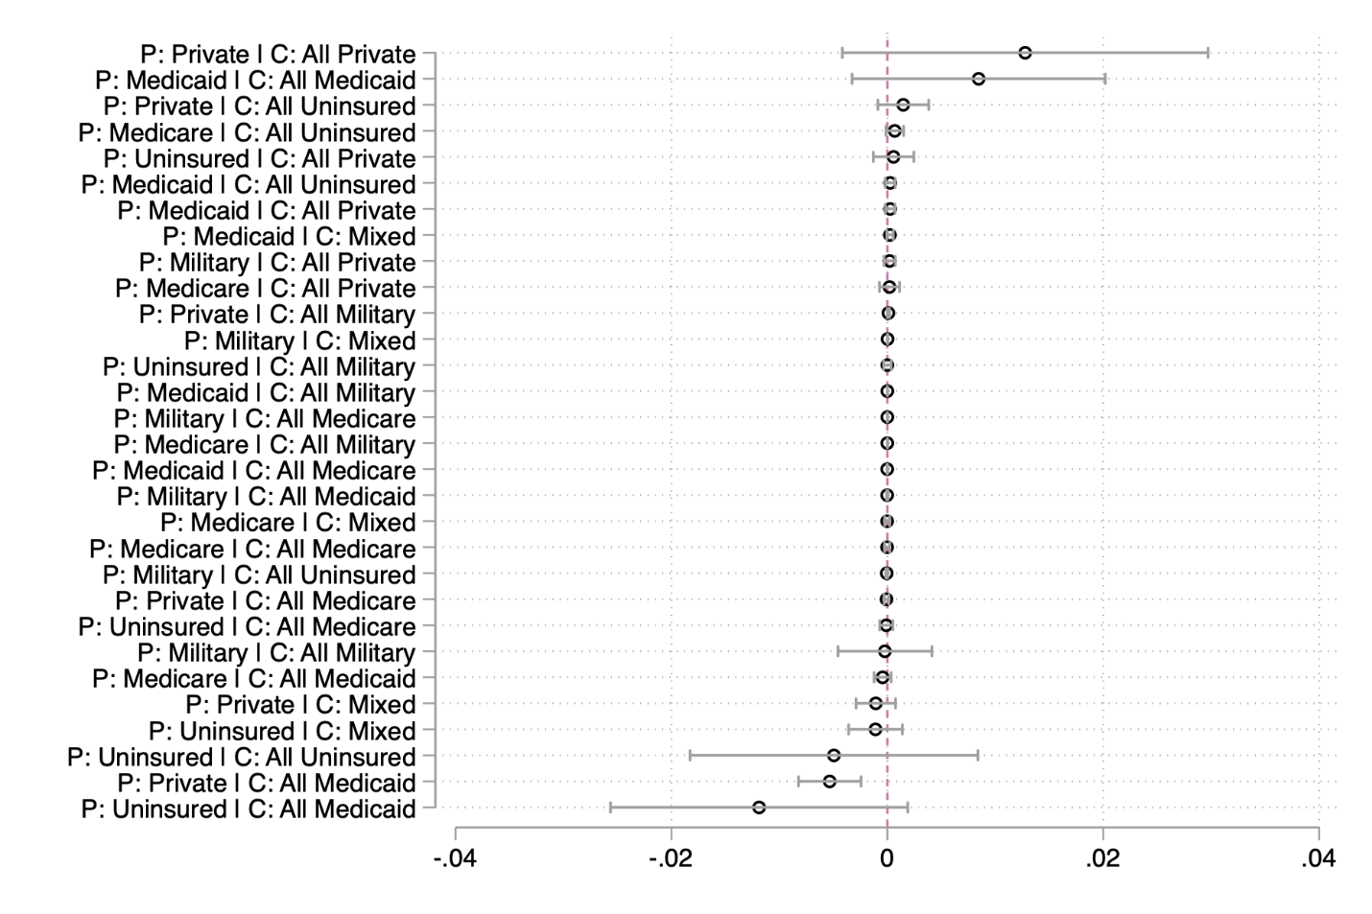

Appendix Figure A2: Effects of Parent’s Medicaid Expansions on Single Father Family’s Uniformity of Insurance
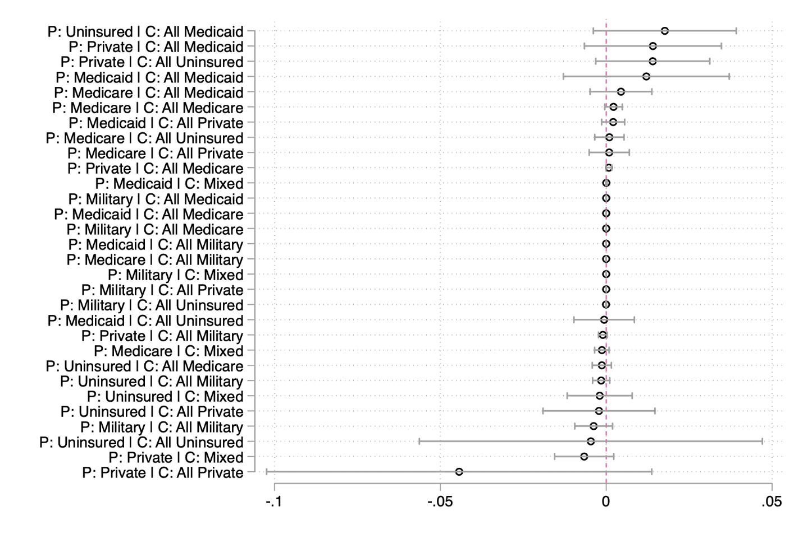

Appendix Figure A3: Uniform Insured Families Perform Better than Patchwork Insured Families

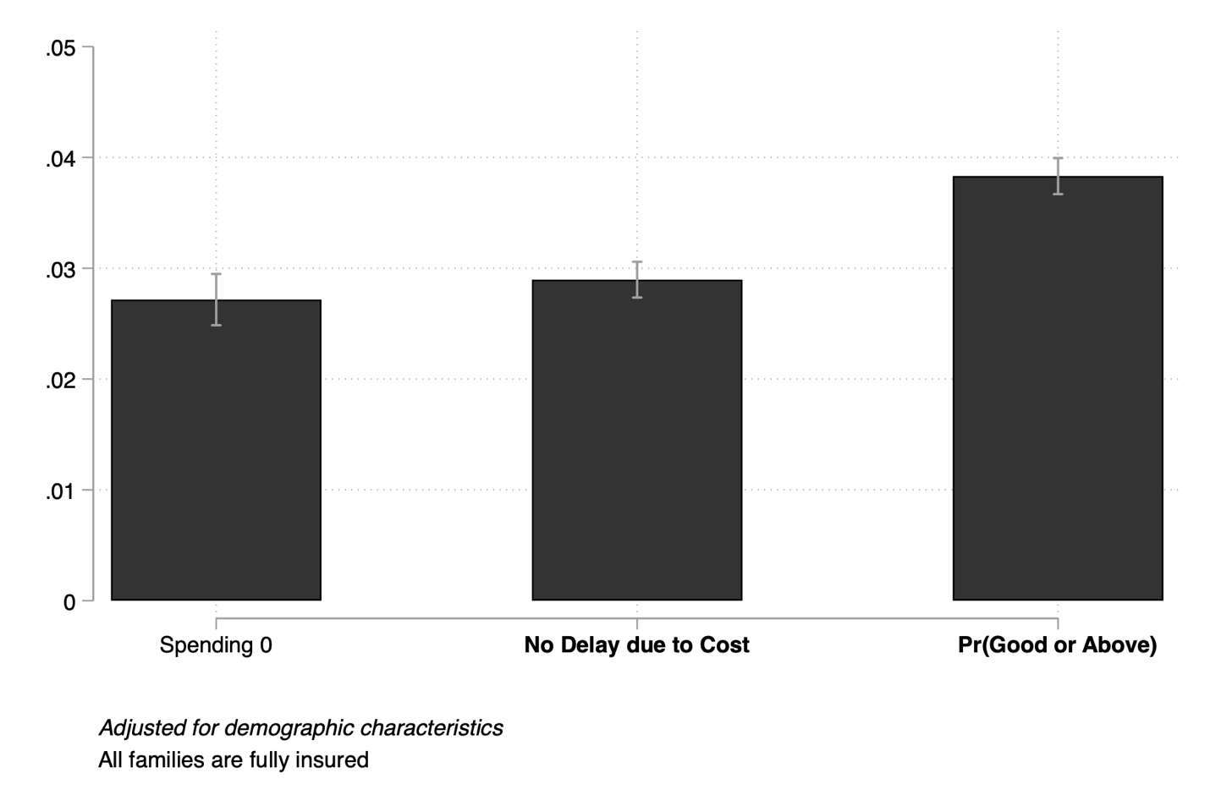

Appendix Figure A4: Covariates on the left-hand side
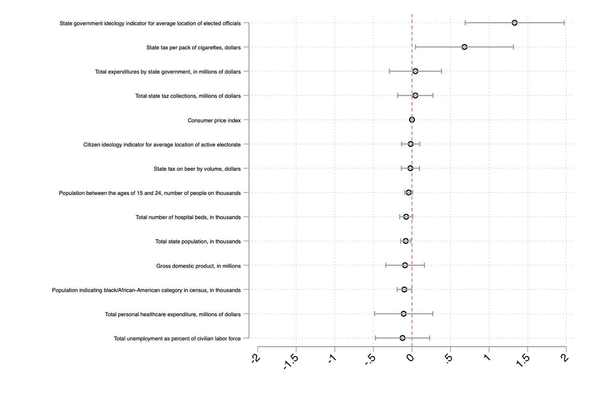

Appendix Table 1: Parental Expansion Effects (SIPP) with Alternative Time Spans
 | (1) | (2) | (3) | (4)
1996 panel only | Uniformly Insured | Patchwork Insured | Patchwork with gaps | Fully  Uninsured
Whole sample | 0.0294** | 0.0041 | -0.0194** | -0.0141
Single moms only | 0.0934*** | -0.0001 | -0.0529** | -0.0404*
1996 and 2001 panels
Whole sample | 0.0362*** | -0.0039 | -0.0218*** | -0.0104*
Single moms only | 0.0700*** | -0.0134 | -0.0476*** | -0.0090
1996, 2001, and 2004 panels
Whole sample | 0.0373*** | -0.0014 | -0.0276*** | -0.0083**
Single moms only | 0.0630*** | -0.0023 | -0.0456*** | -0.0151*

Appendix Table 2: Adding covariates to main specification
 | (1) | (2) | (3) | (4)
 | Uniformly Insured | Patchwork | Patchwork with Gaps | Fully Uninsured
Baseline | 0.0276 | -0.0051 | -0.0209 | -0.0016
 | (0.0139) | (0.0022) | (0.0076) | (0.0075)
 | [0.0470] | [0.0202] | [0.0060] | [0.8348]
Baseline with sample of controls but no controls | 0.0251 | -0.0028 | -0.0163 | -0.0060
 | (0.0129) | (0.0015) | (0.0065) | (0.0087)
 | [0.0510] | [0.0611] | [0.0121] | [0.4951]
Baseline with sample of controls but with controls | 0.0212 | -0.0006 | -0.0131 | -0.0076
 | (0.0110) | (0.0015) | (0.0060) | (0.0076)
 | [0.0538] | [0.6931] | [0.0305] | [0.3172]

