Online Appendix Figure 1: 2006 Survey Instrument
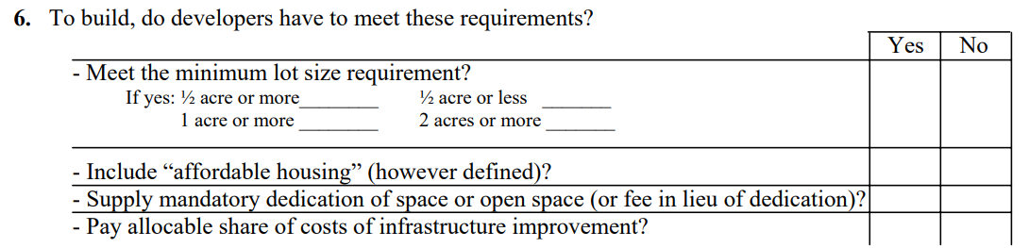
Online Appendix Figure 2: 2018 Survey Instrument
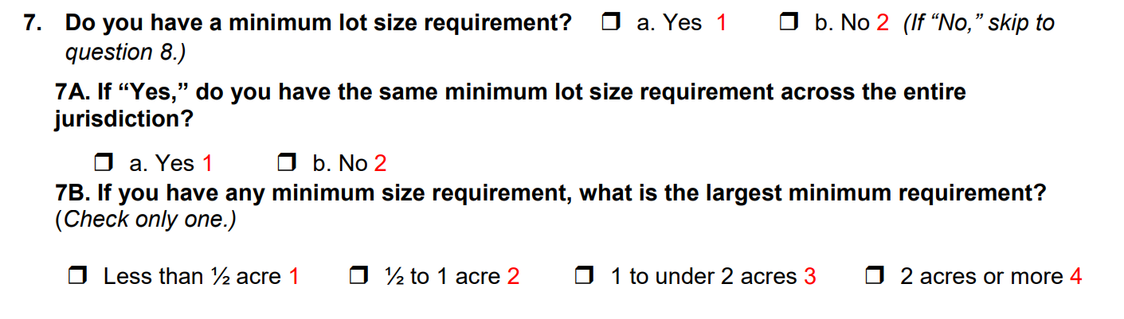

Online Appendix Figure 3: RD Scatter Plots
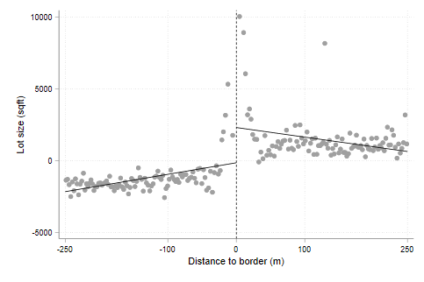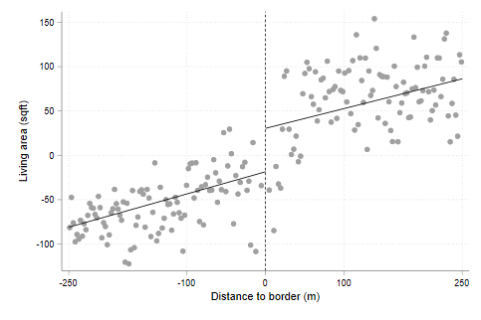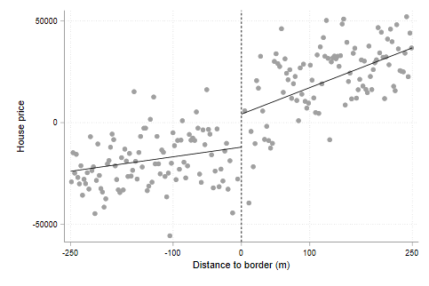
Note: Figures correspond to the RD estimates in Appendix Table 5. The y-axis plots outcomes after residualizing border fixed effects. The x-axis plots the distance to the border where a negative distance indicates being in a Least Strictly Regulated border area and a positive distance in a Most Strictly Regulated border area.
Online Appendix Table 1: Number of Borders by CBSA
CBSA | Number of Borders | CBSA | Number of Borders
Allentown | 3 | Miami | 24
Atlanta | 3 | Minneapolis | 37
Boston | 20 | Nashville | 2
Buffalo | 1 | New York | 28
Charlotte | 3 | Phoenix | 8
Chicago | 80 | Pittsburgh | 41
Cincinnati | 34 | Portland, ME | 1
Cleveland | 18 | Portland, OR | 6
Columbus | 11 | Providence | 10
Dallas | 38 | Riverside | 8
Denver | 14 | Rochester | 5
Detroit | 63 | St. Louis | 20
Harrisburg | 9 | San Antonio | 1
Houston | 12 | San Francisco | 18
Indianapolis | 5 | Seattle | 17
Kansas City | 13 | Washington | 3
Lancaster | 5 | Worcester | 1
Los Angeles | 72 | Youngstown | 1

Online Appendix Table 2: Minimum Lot Size Regressions
 |  | FULL RESULTS
 |  | BORDER DEPTH
 |  | 250 meters |  | 175 meters | 100 meters | 50 meters
Lot Size $(ft^{2})$
Moderately Regulated |  | 912**  (429) |  | 844*  (438) | 819  (524) | 1,122*  (577)
Most Strictly Regulated |  | 3,053***  (611) |  | 3,060***  (640) | 3,061***  (712) | 2,094**  (749)
Average School Quality |  | 881  (526) |  | 863  (546) | 906  (592) | 925  (667)
Highest School Quality |  | 1,913** (873) |  | 1,923**  (924) | 2,072**  (996) | 2,474*  (1364)
Constant |  | 9,073***  (466) |  | 9,213***  (485) | 9,490***  (536) | 10,264***  (690)
# obs |  | 732,042 |  | 494,114 | 259,268 | 110,238
Living Area $(ft^{2})$
Moderately Regulated |  | 54*  (28) |  | 52**  (24) | 34  (23) | 17  (18)
Most Strictly Regulated |  | 118***  (33) |  | 108***  (32) | 83***  (28) | 39*  (20)
Average School Quality |  | 91***  (26) |  | 78***  (26) | 64**  (24) | 79***  (19)
Highest School Quality |  | 226***  (37) |  | 203***  (36) | 165***  (27) | 154***  (21)
Constant |  | 1,708*** (21) |  | 1,720***  (20) | 1,736***  (17) | 1,724***  (15)
# obs |  | 732,042 |  | 494,114 | 259,268 | 110,238
Online Appendix Table 2 (cont’d): Full Results Minimum Lot Size Regressions
 |  | BORDER DEPTH
 |  | 250 meters |  | 175 meters | 100 meters | 50 meters
House Price$(2021 USD)$
Moderately Regulated |  | $17,690 (11,297) |  | $20,334**  (9,868) | $16,041  (9,522) | $8,745  (6,097)
Most Strictly Regulated |  | $40,469*** (11,268) |  | $35,922*** (10,778) | $29,070*** (10,546) | $17,526** (8,193)
Average School Quality |  | $38,281** (17,250) |  | $29,611*  (16,176) | $24,728  (15,944) | $20,919* (10,979)
Highest School Quality |  | $114,268***  (22,236) |  | $98,957*** (20,117) | $82,005*** (21,210) | $72,650*** (15,100)
Constant |  | $416,193*** (10253) |  | $425,496*** (9,639) | $433,038*** (10,092) | $433,491*** (7,143)
# obs |  | 465,236 |  | 314,196 | 164,986 | 69,316
Living Area$/ Lot Size$
Moderately Regulated |  | -0.009  (0.007) |  | -0.010  (0.008) | -0.012  (0.008) | -0.014*  (0.008)
Most Strictly Regulated |  | -0.015**  (0.008) |  | -0.018**  (0.008) | -0.021***  (0.007) | -0.020**  (0.008)
Average School Quality |  | -0.009  (0.008) |  | -0.006  (0.008) | -0.007  (0.009) | -0.003  (0.008)
Highest School Quality |  | -0.008  (0.011) |  | -0.006  (0.010) | -0.007  (0.010) | -0.008  (0.011)
Constant |  | 0.256***  (0.006) |  | 0.256***  (0.005) | 0.257***  (0.005) | 0.250***  (0.005)
# obs |  | 732,042 |  | 494,114 | 259,268 | 110238
Online Appendix Table 2 (cont’d): Full Results Minimum Lot Size Regressions

 |  | BORDER DEPTH
 |  | 250 meters |  | 175 meters | 100 meters | 50 meters
Homes per acre
Moderately Regulated |  | -0.15**  (0.06) |  | -0.14**  (0.06) | -0.10  (0.08) | -0.09  (0.14)
Most Strictly Regulated |  | -0.19***  (0.06) |  | -0.16**  (0.07) | -0.17***  (0.06) | -0.16  (0.12)
Average School Quality |  | -0.04  (0.13) |  | -0.04  (0.15) | -0.07  (0.13) | -0.16  (0.10)
Highest School Quality |  | -0.09  (0.12) |  | -0.07  (0.13) | -0.04  (0.14) | -0.08  (0.13)
Constant |  | 1.68***  (0.08) |  | 1.60***  (0.09) | 1.46***  (0.08) | 1.34***  (0.07)
# obs |  | 1,270 |  | 1,270 | 1,270 | 1,270
Note: All regressions include 635 border pair fixed effects.
*p<0.10; **p<0.05; ***p<0.01. Standard errors clustered by CBSA

Online Appendix Table 3: Lot Size and Living Area Controls Regressions
 | BORDER DEPTH
 | 250 meters | 175 meters | 100 meters | 50 meters
House Price$(2021 USD)$
Moderately Regulated | $2,736  (8,807) | $5,417  (7,755) | $4,133  (7,591) | -$401  (5,183)
Most Strictly Regulated | $8,826  (7,526) | $6,512  (7,296) | $5,567  (7,549) | $3,793  (6,357)
Average School Quality | $16,433  (13,685) | $11,439  (12,923) | $9,344  (12,776) | $3,236  (10,578)
Highest School Quality | $63,483***  (18,034) | $53,545***  (16,102) | $44,359**  (17,246) | $36,393**  (14,386)
Lot Size $(ft^{2})$ | $2.4***  (0.38) | $2.4***  (0.37) | $2.2***  (0.35) | $2.0***  (0.35)
Living Area $(ft^{2})$ | $195.6***  (16.4) | $193.3***  (16.6) | $192.7***  (16.5) | $192.7***  (16.9)
Constant | $53,020  (38,317) | $63,414  (38,298) | $70,786*  (38,503) | $74,308*  (37,408)
# obs | 465,236 | 314,196 | 164,986 | 69,316
Note: All regressions include 635 border pair fixed effects.
*p<0.10; **p<0.05; ***p<0.01. Standard errors clustered by CBSA.

Online Appendix Table 4: Survey Year Control Regressions
 | BORDER DEPTH
 | 250 meters | 175 meters |  | 100 meters |  | 50 meters
Lot Size $(ft^{2})$
Moderately Regulated | 911**  (427) | 845*  (436) |  | 814  (522) |  | 1,108*  (573)
Most Strictly Regulated | 3,050***  (616) | 3,060***  (642) |  | 3,046***  (707) |  | 2,873***  (725)
Average School Quality | 865  (515) | 865  (539) |  | 847  (582) |  | 812  (644)
Highest School Quality | 1,895**  (791) | 1,926**  (854) |  | 2,002**  (924) |  | 2,341*  (1,270)
Survey Year | 50  (459) | -6  (459) |  | 184  (499) |  | 374  (533)
Constant | 9,055***  (540) | 9,215**  (553) |  | 9,429***  (615) |  | 10,138***  (784)
# obs | 732,042 | 494,114 |  | 259,268 |  | 110,238
Living Area$(ft^{2})$
Moderately Regulated | 52*  (29) | 50*  (26) |  | 32  (24) |  | 16  (18)
Most Strictly Regulated | 114***  (35) | 103***  (34) |  | 79**  (30) |  | 35*  (20)
Average School Quality | 71***  (25) | 59**  (26) |  | 44*  (26) |  | 66***  (21)
Highest School Quality | 203***  (37) | 181***  (37) |  | 142***  (32) |  | 138***  (23)
Survey Year | 63***  (19) | 61***  (19) |  | 61***  (16) |  | 44**  (18)
Constant | 1,687***  (22) | 1,700**  (21) |  | 1,716***  (17) |  | 1,710**  (17)
# obs | 732,042 | 494,114 |  | 259,268 |  | 110,238
Online Appendix Table 4 (cont’d): Survey Year Control Regressions

 | BORDER DEPTH
 | 250 meters | 175 meters |  | 100 meters |  | 50 meters
House Price (2021 USD)
Moderately Regulated | $17,468  (11,640) | $20,016*  (10,267) |  | $15,660  (9,910) |  | $8,239  (6,437)
Most Strictly Regulated | $39,528***  (11,615) | $35,063***  (11,163) |  | $28,192**  (10,770) |  | $16,740**  (8,006)
Average School Quality | $32,027*  (16,553) | $23,648  (15,689) |  | $18,915  (16,182) |  | $16,378  (11,983)
Highest School Quality | $107,103***  (21,578) | $92,245***  (19,551) |  | $75,299***  (21,562) |  | $67,455***  (15,871)
Survey Year | $19,073**  (7,983) | $17,720**  (8,083) |  | $16,928**  (6,637) |  | $13,732*  (8,047)
Constant | $409,607***  (10,760) | $414,490***  (10,090) |  | $427,405**  (9,993) |  | $428,933**  (6,531)
# obs | 465,236 | 314,196 |  | 164,986 |  | 69,316
Living Area / Lot size
Moderately Regulated | -0.009  (0.007) | -0.011  (0.007) |  | -0.013  (0.008) |  | -0.014*  (0.008)
Most Strictly Regulated | -0.016**  (0.007) | -0.019**  (0.008) |  | -0.022***  (0.007) |  | -0.021**  (0.008)
Average School Quality | -0.013  (0.008) | -0.011  (0.008) |  | -0.011  (0.007) |  | -0.005  (0.007)
Highest School Quality | -0.013  (0.010) | -0.011  (0.010) |  | -0.012  (0.009) |  | -0.011  (0.010)
Survey Year | 0.014**  (0.005) | 0.014***  (0.005) |  | 0.012**  (0.005) |  | 0.007  (0.006)
Constant | 0.251**  (0.006) | 0.251***  (0.006) |  | 0.253***  (0.007) |  | 0.247***  (0. 007)
# obs | 732,042 | 494,114 |  | 259,268 |  | 110,238
Online Appendix Table 4 (cont’d): Survey Year Control Regressions
 | BORDER DEPTH
 | 200 meters | 150 meters |  | 100 meters |  | 50 meters
SF Homes per Acre
Moderately Regulated | -0.15**  (0.06) | -0.14**  (0.06) |  | -0.10  (0.08) |  | -0.09  (0.14)
Most Strictly Regulated | -0.19***  (0.06) | -0.17**  (0.07) |  | -0.17***  (0.05) |  | -0.17  (0.13)
Average School Quality | -0.05  (0.12) | -0.05  (0.14) |  | -0.08  (0.13) |  | -0.18*  (0.10)
Highest School Quality | -0.10  (0.11) | -0.08  (0.11) |  | -0.05  (0.13) |  | -0.10  (0.12)
Survey Year | 0.02  (0.10) | 0.01  (0.10) |  | 0.04  (0.09) |  | 0.07  (0.14)
Constant | 1.67***  (0.10) | 1.60***  (0.12) |  | 1.45***  (0.10) |  | 1.32***  (0.07)
# obs | 1,270 | 1,270 |  | 1,270 |  | 1,270
Note: All regressions include 635 border pair fixed effects. Survey Year is a dummy variable taking 1 if the border area’s density restriction measure is derived from the 2018 survey and 0 if derived from the 2006 survey.
*p<0.10; **p<0.05; ***p<0.01. Standard errors clustered by CBSA.

Online Appendix Table 5: RD Estimates from Local Linear Regressions
 | Dependent Variable
 | Lot Size  $(ft^{2})$ | Living Area  $$(ft^{2})$$ | House Price  (2021 USD)
RD Estimate | 2,451***  (579) | 49**  (18) | 16,260**  (6,445)
#obs | 219,383 | 219,383 | 141,360
Notes: Regression discontinuity estimates are based on pooling a subsample of 177 borders where one side of a border is Least Strictly Regulated and the other side is Most Strictly Regulated.
All regressions include 635 border pair fixed effects.
*p<0.10; **p<0.05; ***p<0.01. Standard errors clustered by CBSA.

Online Appendix Table 6: Log House Price Regressions
 | BORDER DEPTH
 | 250 meters | 175 meters | 100 meters | 50 meters
Log House Price$(2021 USD)$
Moderately Regulated | 0.05*  (0.026) | 0.05**  (0.023) | 0.03*  (0.019) | 0.01  (0.014)
Most Strictly Regulated | 0.09***  (0.019) | 0.08***  (0.018) | 0.07***  (0.018) | 0.04***  (0.014)
Average School Quality | 0.10***  (0.032) | 0.09***  (0.031) | 0.07**  (0.028) | 0.07***  (0.017)
Highest School Quality | 0.23***  (0.045) | 0.20***  (0.040) | 0.15***  (0.031) | 0.14***  (0.018)
Constant | 12.59***  (0.026) | 12.61***  (0.024) | 12.63***  (0.019) | 12.63***  (0.012)
# obs | 465,236 | 314,196 | 164,986 | 69,316
Note: All regressions include 635 border pair fixed effects.
*p<0.10; **p<0.05; ***p<0.01. Standard errors clustered by CBSA.

Online Appendix Table 7: Multi-Family Share Regression
 | Dependent Variable
 | Multi-Family Share
Moderately Regulated | -0.02  (0.03)
Most Strictly Regulated | -0.07**  (0.03)
Average School Quality | -0.07**  (0.04)
Highest School Quality | -0.17***  (0.04)
Constant | 0.37***  (0.03)
# obs | 1,270
Note: All regressions include 635 border pair fixed effects.
*p<0.10; **p<0.05; ***p<0.01. Standard errors clustered by CBSA.

Online Appendix Table 8: House Age Regressions
 | BORDER DEPTH
 | 250 meters | 175 meters | 100 meters | 50 meters
House Age (years)
Moderately Regulated | 0.65  (0.76) | 0.84  (0.71) | 1.38*  (0.72) | 1.43**  (0.70)
Most Strictly Regulated | -0.35  (0.82) | 0.12  (0.82) | 0.45  (0.84) | 0.75  (0.90)
Average School Quality | 1.26  (1.08) | 1.20  (1.01) | 1.38  (0.98) | 1.16  (0.94)
Highest School Quality | -0.99  (1.71) | -1.04  (1.70) | -0.31  (1.72) | 0.42  (1.91)
Constant | 54.30***  (0.86) | 54.25***  (0.82) | 54.02***  (0.85) | 55.08***  (0.93)
# obs | 722,790 | 487,928 | 256,128 | 108,977
Note: All regressions include 635 border pair fixed effects.
*p<0.10; **p<0.05; ***p<0.01. Standard errors clustered by CBSA.

Online Appendix Table 9: Split Sample on 100m Border Depth Regressions
 | Sample Split
100m Border Depth | Pre-1970 | Post-1970
Lot Size $(ft^{2})$
Moderately Regulated | 652  (424) | 793  (1,000)
Most Strictly Regulated | 2,041***  (530) | 3,892***  (914)
Average School Quality | -38  (358) | 1,779**  (858)
Highest School Quality | 979***  (348) | 2,724**  (1081)
Constant | 9,689***  (213) | 9,676***  (645)
# obs | 150,797 | 105,331
Living Area$(ft^{2})$
Moderately Regulated | 47**  (22) | 25  (46)
Most Strictly Regulated | 71**  (31) | 126***  (35)
Average School Quality | 64***  (19) | 120*  (62)
Highest School Quality | 131***  (30) | 235***  (72)
Constant | 1,490***  (16) | 2,029***  (49)
# obs | 150,797 | 105,331
Online Appendix Table 9 (cont’d): Split Sample on 100m Border Depth Regressions
 | Sample Split
100m Border Depth | Pre-1970 | Post-1970
House Price (2021 USD)
Moderately Regulated | $26,221**  (10,834) | $3,452  (13,376)
Most Strictly Regulated | $38,968***  (12,859) | $30,287**  (11,922)
Average School Quality | $31,590**  (15,530) | $12,044  (19,697)
Highest School Quality | $79,329***  (28,321) | $79,630***  (24,866)
Constant | $399,017***  (10,286) | $462,713***  (14,819)
# obs | 87,749 | 75,077
Living Area / Lot size
Moderately Regulated | -0.006  (0.004) | -0.016  (0.017)
Most Strictly Regulated | -0.012**  (0.005) | -0.028***  (0.010)
Average School Quality | 0.008  (0.006) | -0.019  (0.013)
Highest School Quality | -0.001  (0.010) | -0.017  (0.010)
Constant | 0.218***  (0.005) | 0.304***  (0.008)
# obs | 150,797 | 105,331
Note: All regressions include 635 border pair fixed effects.
*p<0.10; **p<0.05; ***p<0.01. Standard errors clustered by CBSA.

