Appendix A. Data Appendix
A1. Causes of Death
Table A1. ICD-10 Codes for various causes of death
Causes of Death | ICD-10 Codes | ICD-10 Description
Drug | X40-44 | Accidental poisoning by and exposure to drugs and other biological substances
 | X60-64 | Intentional self-poisoning (suicide) by and exposure to drugs and other biological substances
 | X85 | Assault (homicide) by drugs, biological substances and other and unspecified noxious substances
 | Y10-14 | Poisoning by and exposure to drugs and biological substances, undetermined intent
Alcohol | X45 | Accidental poisoning by and exposure to other and unspecified solid or liquids substances
 | X65 | Intentional self-poisoning (suicide) by and exposure to other and unspecified solid or liquid substances and their vapors
 | Y15 | Poisoning by and exposure to other and unspecified solid or liquid substance undetermined intent
 | K70 | Alcoholic liver disease
 | K73 | Chronic hepatitis, not elsewhere classified
 | K74 | Fibrosis and cirrhosis of liver
Suicide | X60-X84, Y87.0 (w/o X40-44, X60-64, X85, Y10-14) | Intentional self-harm (suicide), excluding drug overdose death codes
AMI | I21- I22 | Acute myocardial infarction

A2. Identifying ED Closures in the AHRF Data
To identify hospital-level ED closures between 2005 and 2018, we employ information sourced from the Area Health Resource File (AHRF) and devise an algorithm for identifying these closures.
Treated. There are three steps used to identify ED closure for a given county:
Step 1: The county must have had at least one operational ED in the year 2005.
Step 2: The count of hospital-based ED visits for the county decreased by 75%. Subsequently, we designate year "y" as the year of closure if there is a reduction of at least 75% in the number of hospital-based ED visits between year "y-1" and year "y."
Step 3: For those counties satisfying Step 2, they cannot regain ED visits above 50% of the ED visits in “y-1” after the year “y.”
Using this method, we identify 63 counties where an ED closure occurred. After PSM weighting, 59 treated counties remain.
Control. The control group in our study is comprised of rural counties that consistently had access to ED services from 2005 to 2018. We identify these counties based on data from the AHRF; specifically, we examine the variable representing the number of EDs in each county for each year. For a county to qualify as part of the control group, it must have had at least one short-term general hospital with an ED (STG-ED) available in every single year within the specified period. To be more precise, we require this variable to be equal to or greater than one from 2005 to 2018 for counties included in the control group. Consequently, our analysis identifies a total of 800 control counties meeting these criteria. The mean number of ED visits in the control group is about 51 per 100 people, which is close to that reported in Greenwood-Ericksen and Kocher (2019).
Note that the county-level variable STG-ED available in the AHRF is generated by aggregating hospital-level data from the AHA to the county level. The STG-ED variable is coded as zero in the AHRF in cases where no hospital in the county reports having an ED. However, hospitals with missing data for the hospital-level ED question are coded as zeros (rather than as missing cases) in the AHRF calculation of STG-ED. This is the reason why we can use STG-ED to define the control group, but not the treatment group in our study.
Cross-validating the information in AHRF and AHA. To ensure the accuracy of the information in the AHRF, we verify the information using the AHA Annual Survey Database (AHA). The AHA data are available at the hospital level, so we first aggregate these data to the county/year level. Specifically, we compare the number of ED visits reported in the two datasets at the county-year level. We sum the short-term general ED visits and long-term ED visits to compare with county-level AHA ED visits.
In the rural county sample (excluding Alaska and Hawaii), there are 1,948 counties. About 76% counties have same ED visits from both AHA and AHRF. The discrepancy comes from either unmatched visit numbers (0.2%) or missing ED visit numbers in the AHA dataset (24%). In our research sample before applying the PSM, 95% counties have matched AHA and AHRF ED visit for all years. This evidence gives us confidence that the ED visits number from the AHRF dataset provides valid information.

Appendix B. Propensity Score Matching
Figure B1. Common Support
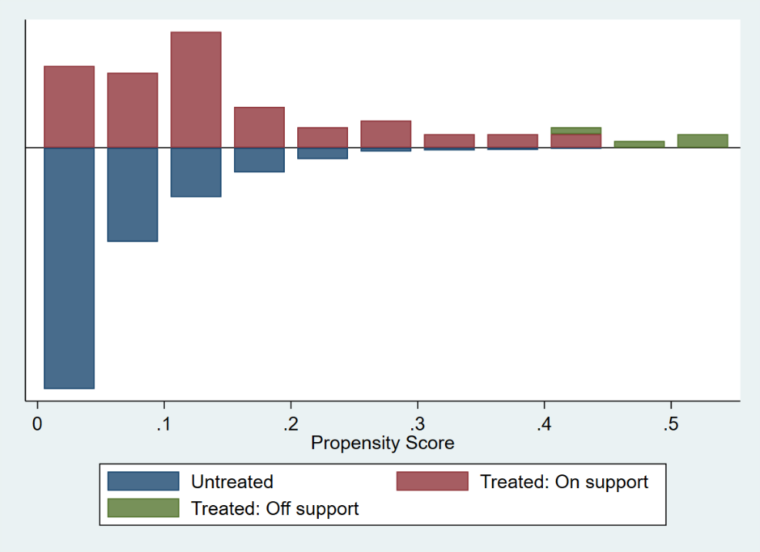

Table B1: Propensity Score Function
 | (1) | (2)
Variables | Logit | Average Marginal Effect
Unemployment Rate, 16+ | 0.00413 | 0.000247
 | (0.108) | (0.00644)
Uninsurance Rate, <65 | 0.0567* | 0.00339*
 | (0.0315) | (0.00190)
Poverty Rate | 0.0559 | 0.00334
 | (0.0560) | (0.00336)
Number of physicians per 1,000 population | -0.199 | -0.0119
 | (0.214) | (0.0128)
SNAP(recipient rate) | 4.492 | 0.269
 | (5.044) | (0.302)
Male population proportion, <15 | -13.02 | -0.779
 | (34.67) | (2.075)
Male population proportion, 15-19 | -29.48 | -1.764
 | (42.62) | (2.552)
Male population proportion, 20-24 | -81.84** | -4.898**
 | (32.29) | (1.961)
Male population proportion, 25-44 | -11.95 | -0.715
 | (18.33) | (1.098)
Male population proportion, 45-64 | -54.53* | -3.263*
 | (28.28) | (1.707)
Male population proportion, 65+ | -53.74 | -3.216
 | (37.21) | (2.236)
Female population proportion, <15 | -79.77** | -4.774**
 | (35.83) | (2.166)
Female population proportion, 15-19 | 38.57 | 2.308
 | (42.07) | (2.517)
Female population proportion, 20-24 | -65.33* | -3.909*
 | (34.11) | (2.060)
Female population proportion, 25-44 | -26.30 | -1.574
 | (21.99) | (1.320)
Female population proportion, 45-64 | 0.836 | 0.0500
 | (31.87) | (1.907)
ACA expansion | -0.610* | -0.0365*
 | (0.340) | (0.0205)
Constant | 23.83
 | (16.10)
Observations | 859 | 859

Appendix C. Results from Goodman-Bacon (2021) Test
We follow Goodman-Bacon (2021) to plot all the 2 × 2 pairwise DiD estimates (on the vertical axis) against their weights (on the horizontal axis) in Figure C1. The red line represents the weighted DID coefficient after accounting for the different weights associated with each component. First, we note that treated vs. never treated are the comparisons with the largest weights. The weight associated with this group is 97.3%. This suggests that the latter is the main source of identification in our setting. Second, although some 2 × 2 pairwise comparisons have the opposite sign compared to our results from the event study, their weights are very close to zero.

Figure C1: 2 x 2 DiD Estimates
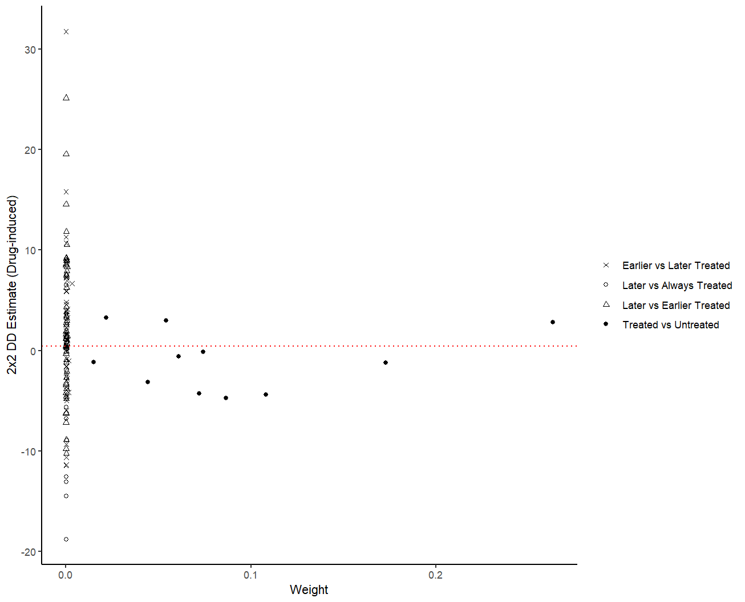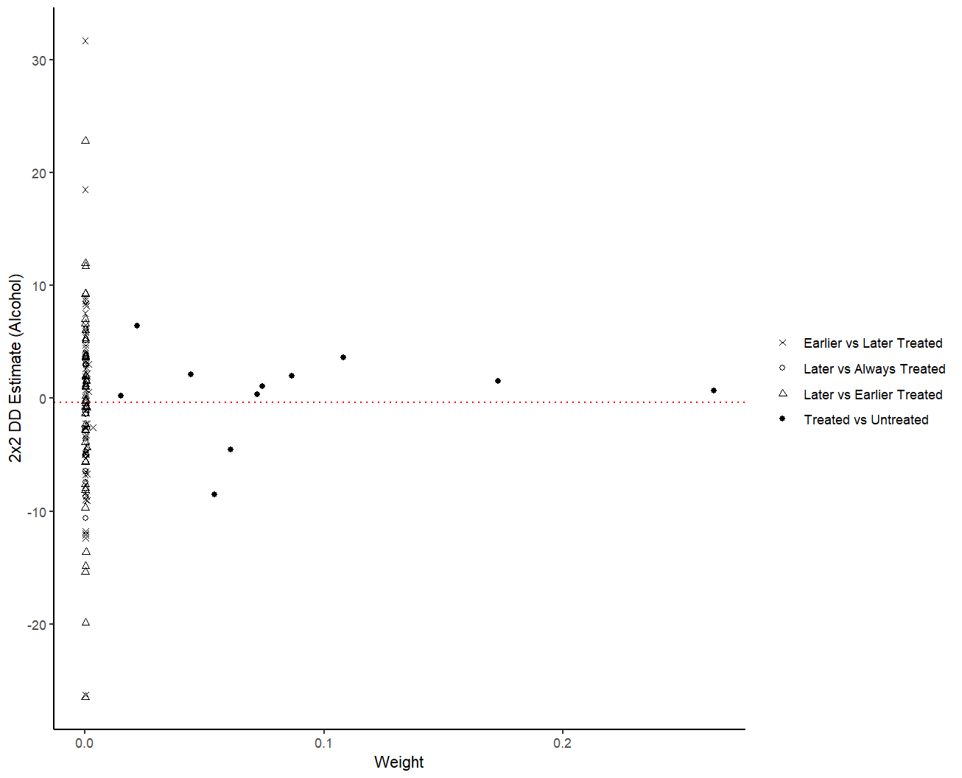
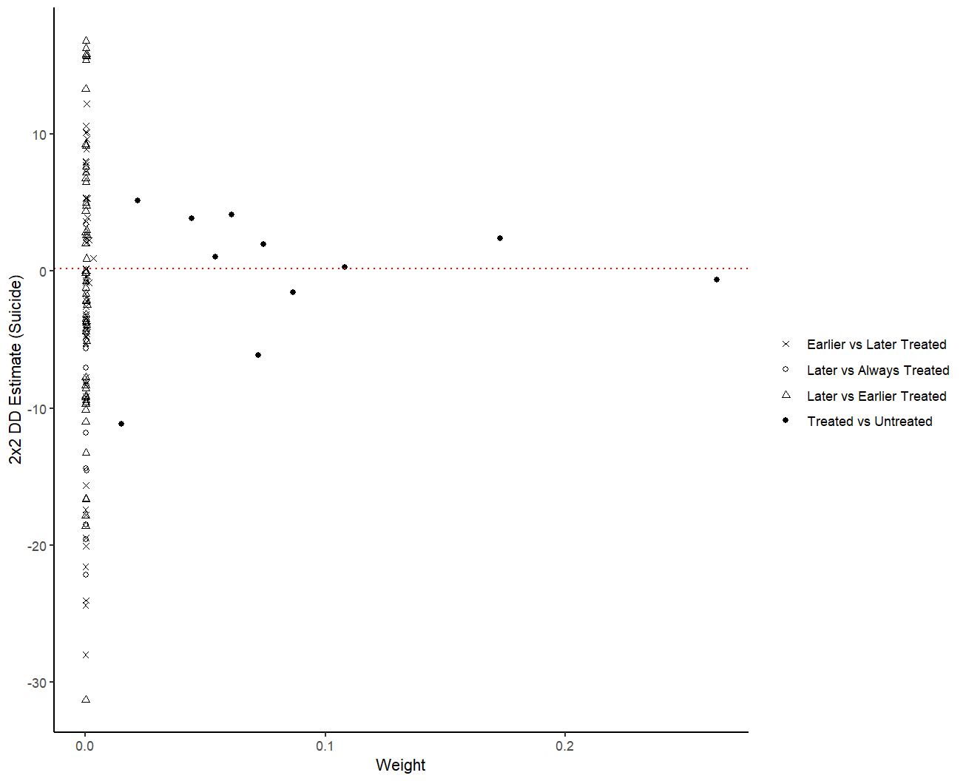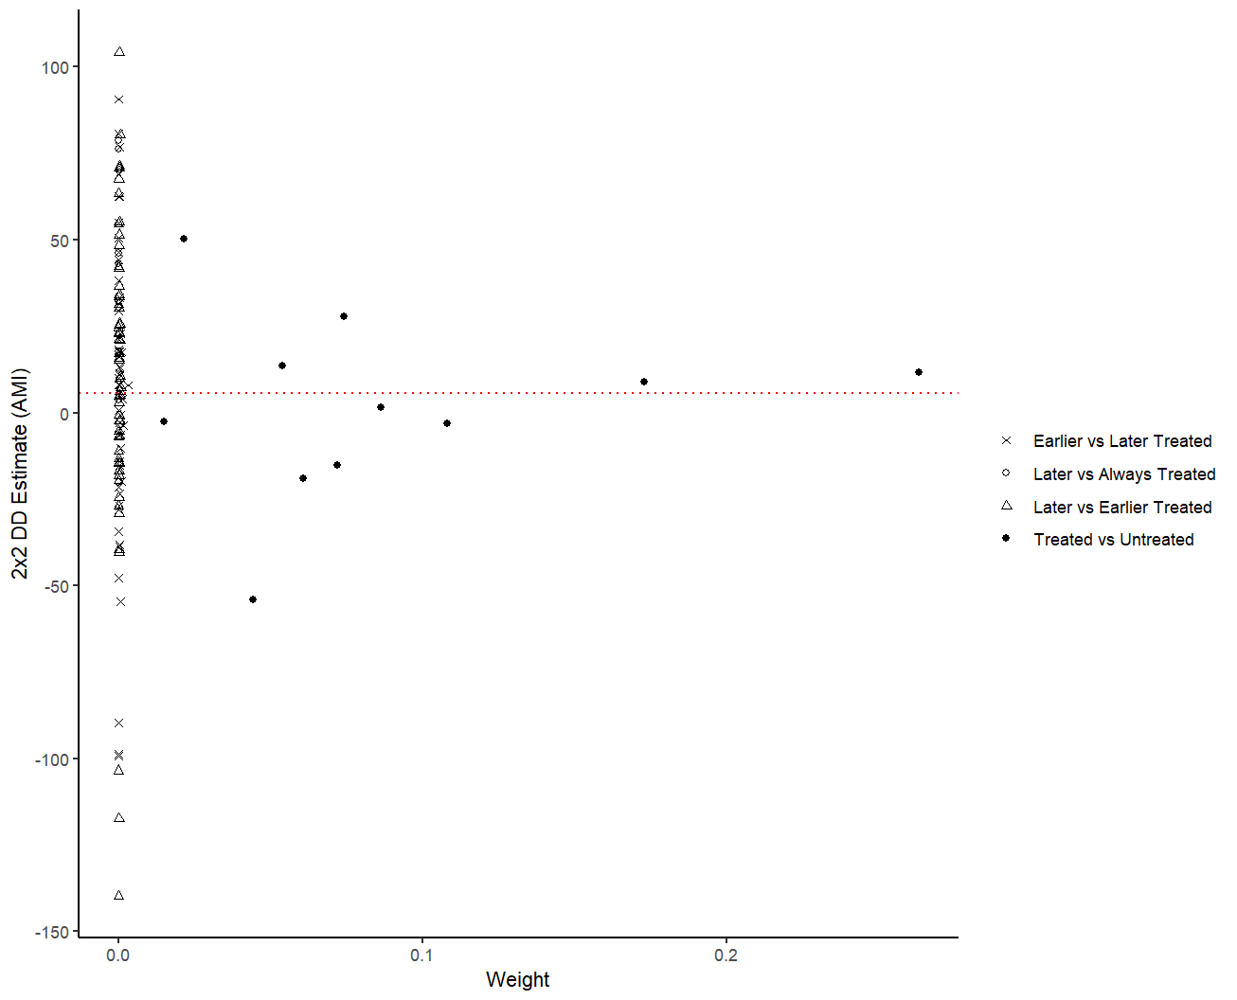
Note: This plots each 2×2 DiD estimate against their weights calculated following the Goodman-Bacon (2018)’s decomposition for all outcome variables. The triangle refers to estimates where one timing group acts as treatment group and the never treated country as control group. The cross refers to timing-only estimates in which the early treated group acts as treatment group and the later treated group as control group. The circle refers to timing-only estimates in which the later treated group acts as treatment group and the earlier treated group as control group. The red horizontal line refers to the weighted average DiD coefficient resulting from the Goodman-Bacon’s decomposition.
Appendix D. Robustness Checks
Table1 D1. Robustness Checks
 | (1) | (2) | (3)
Drug-induced
Early | 0.494 | 1.410 | 1.306
 | (1.387) | (1.317) | (1.310)
Late | -1.653 | -0.575 | -0.516
 | (1.928) | (1.803) | (1.844)
R-squared | 0.489 | 0.469 | 0.475
Mean of dependent variable | 12.70 | 12.39 | 12.54
Alcohol
Early | -0.0608 | -0.601 | -0.871
 | (2.126) | (1.964) | (1.944)
Late | 4.602 | 3.465 | 3.171
 | (3.104) | (2.721) | (2.788)
R-squared | 0.294 | 0.285 | 0.291
Mean of dependent variable | 15.50 | 15.29 | 15.39
Suicide
Early | -2.416 | -2.080 | -1.977
 | (1.602) | (1.465) | (1.476)
Late | -2.070 | -1.275 | -0.767
 | (2.047) | (1.958) | (1.927)
R-squared | 0.244 | 0.232 | 0.238
Mean of dependent variable | 15.59 | 15.48 | 15.50
AMI
Early | 5.883 | 8.788 | 8.973
 | (6.427) | (6.430) | (6.464)
Late | 0.928 | 5.775 | 4.568
 | (7.647) | (7.676) | (7.778)
R-squared | 0.661 | 0.632 | 0.640
Mean of dependent variable | 85.74 | 85.45 | 84.75
County FE | Yes | Yes | Yes
Year FE | Yes | Yes | Yes
Observations | 11,498 | 11,538 | 11,535
Note:
Column 1: No regaining of ED visits above 25% of ED visits at t-1 in county after closure.
Column 2: No urgent care center in county after closure.
Column 3: No free-standing outpatient center in county after closure

Figure D1: Placebo Tests – Drug-related Deaths
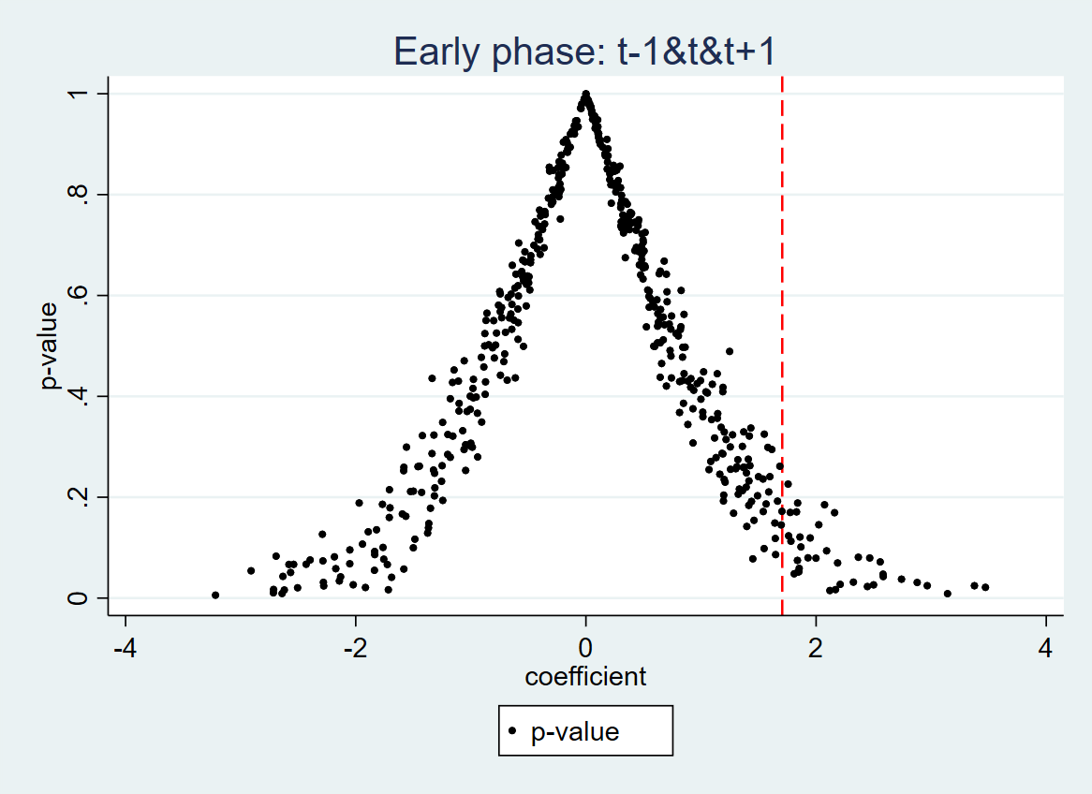

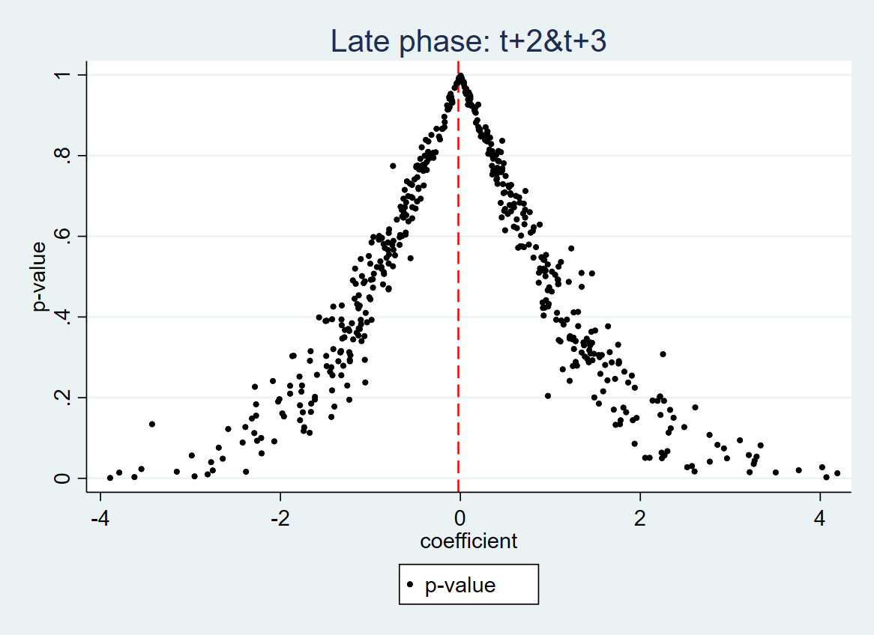

Note: To preserve the numbers of counties experiencing ED closure as depicted in Figure 1, we randomly assign the same number of counties as the treatment group without replacement in each year. For each picked treated county, randomly assign a year during 2005-2018 as closure year.

Figure D2: Placebo Tests – Alcohol
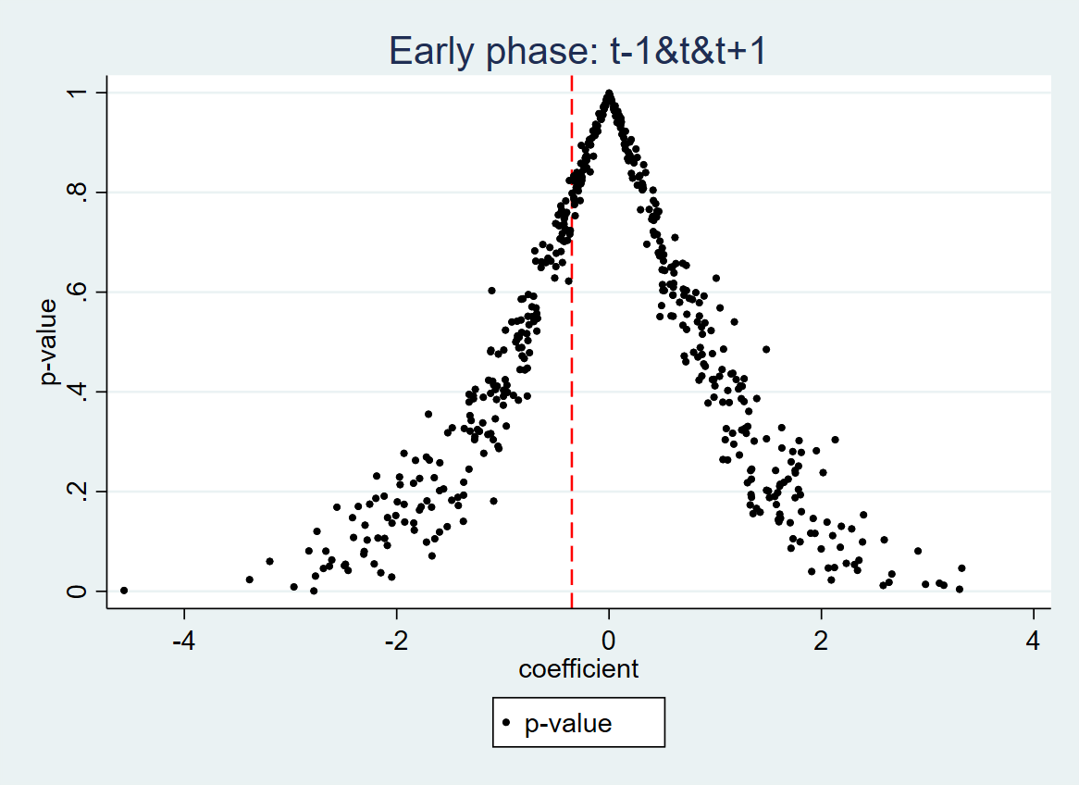

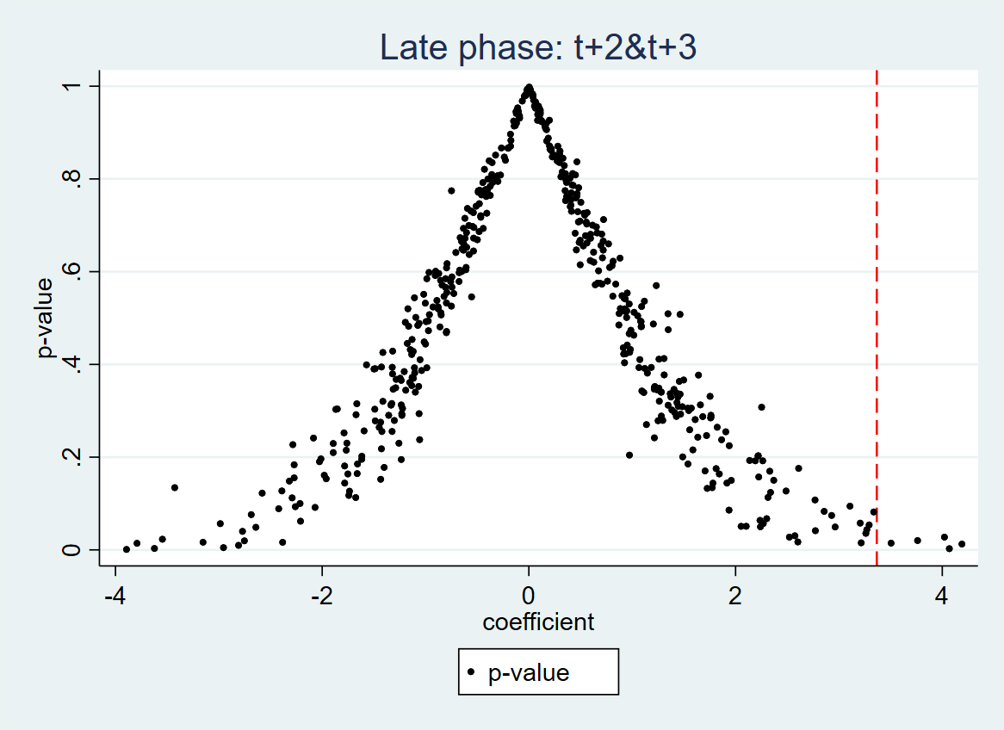

Note: Same as Figure D1.

Figure D3: Placebo Tests – Suicide
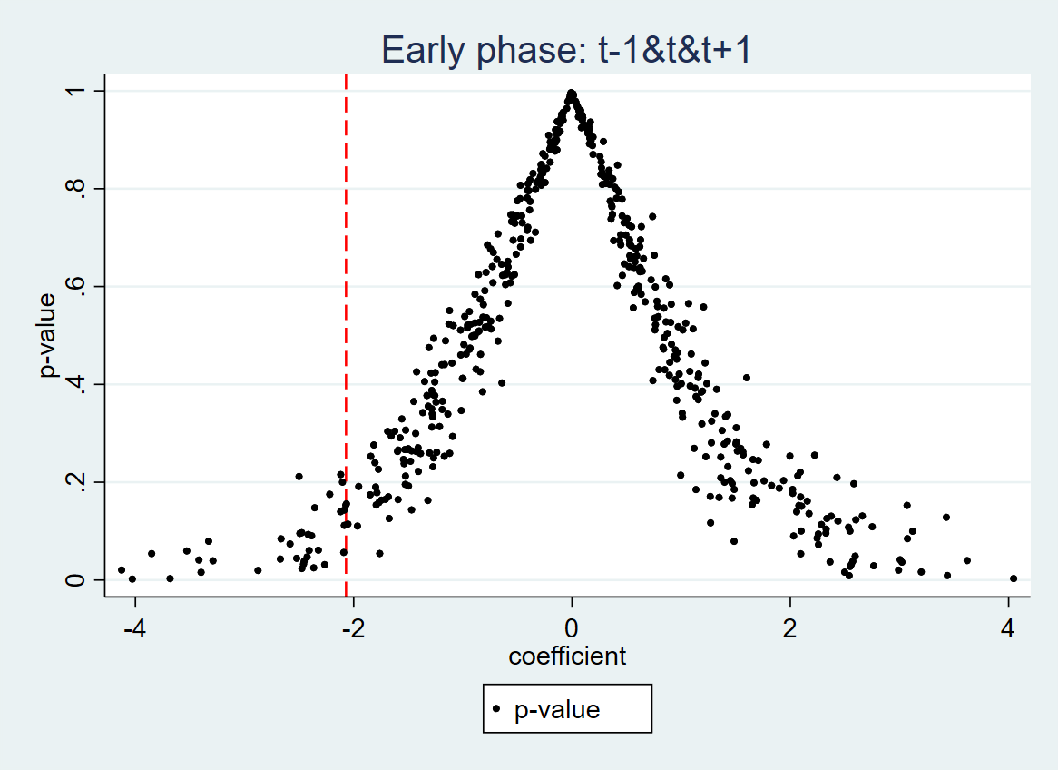

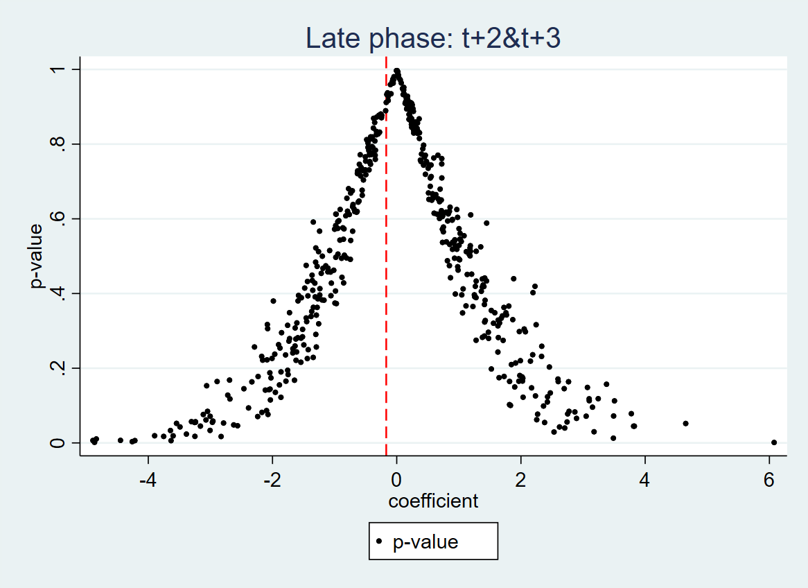

Note: Same as Figure D1.

Figure D4: Placebo Tests – AMI
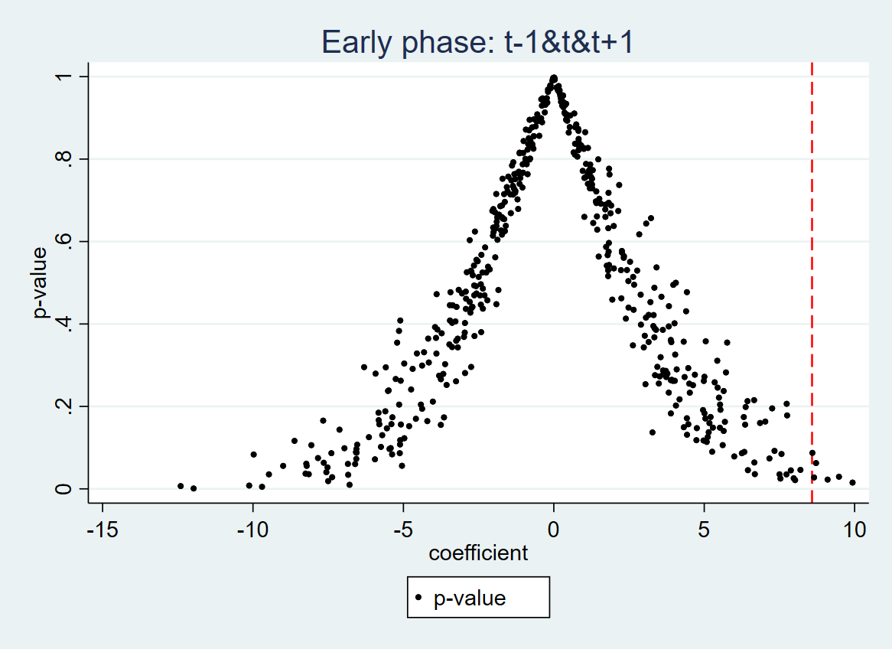

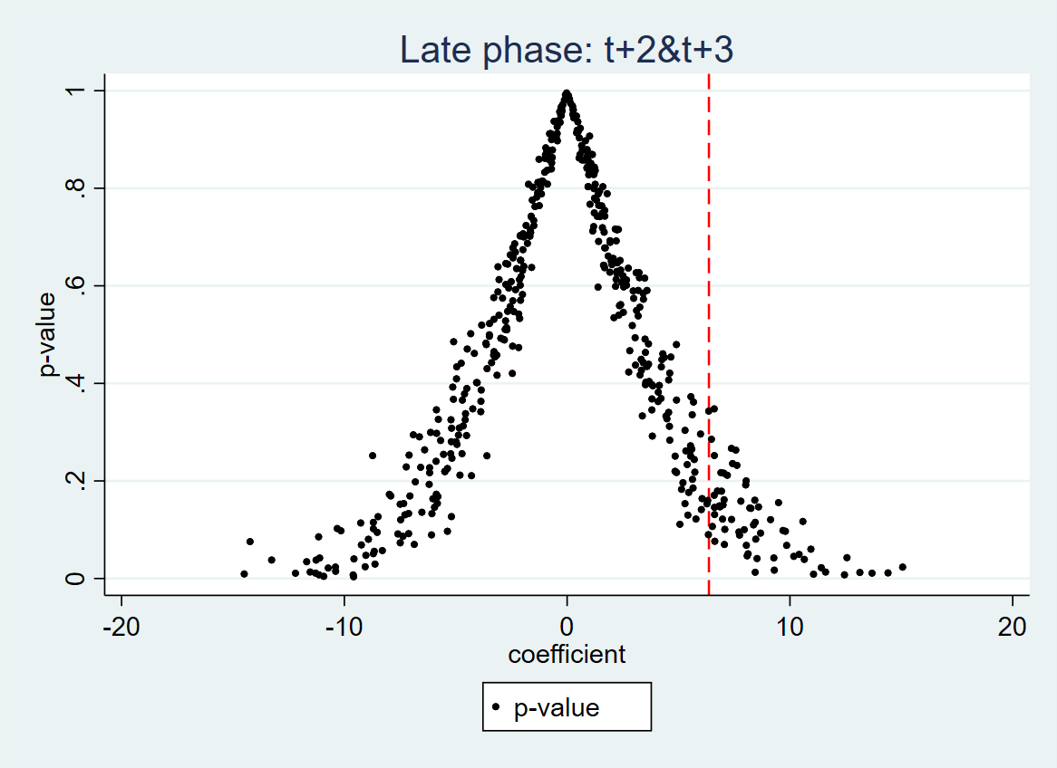

Note: Same as Figure D1.

