Appendix
Table A1. US main party presidential candidate speeches analyzed
Republican Leadership Summit, Donald Trump | 4/18/2015 | https://www.c-span.org/video/?325374-10/republican-leadership-summit-donald-trump
South Carolina Freedom Summit, Donald Trump | 5/9/2015 | https://www.c-span.org/video/?325754-7/south-carolina-freedom-summit-donald-trump
Full text: Donald Trump announces a presidential bid | 6/16/2015 | Full text: Donald Trump announces a presidential bid - The Washington Post
Presidential Candidate Donald Trump Campaign Event in South Carolina | 7/21/2015 | https://www.c-span.org/video/?327258-1/presidential-candidate-donald-trump-campaign-event-south-carolina
Presidential Candidate Donald Trump Speech in Nashville, Tennessee | 8/29/2015 | https://www.c-span.org/video/?327853-1/presidential-candidate-donald-trump-speech-nashville-tennessee
Presidential Candidate Donald Trump in Keene, New Hampshire | 9/30/2015 | Presidential Candidate Donald Trump in Keene, New Hampshire | C-SPAN.org
Presidential Candidate Donald Trump Campaign Rally in Sioux City, Iowa | 10/27/2015 | https://www.c-span.org/video/?329010-1/presidential-candidate-donald-trump-campaign-rally-sioux-city-iowa
Donald Trump Campaign Rally in Worcester, Massachusetts | 11/18/2015 | https://www.c-span.org/video/?400925-1/donald-trump-campaign-rally-worcester-massachusetts
Transcript of Donald Trump's Dec. 30 speech in Hilton Head, S.C. | 12/30/2015 | https://www.kansascity.com/news/local/news-columns-blogs/the-buzz/article55604115.html
Presidential Candidate Donald Trump Rally in Des Moines, Iowa | 1/28/2016 | Presidential Candidate Donald Trump Rally in Des Moines, Iowa | January 28, 2016 | C-SPAN.org
Donald Trump Campaign Rally in Valdosta, Georgia | 2/29/2016 | https://www.c-span.org/video/?405478-1/donald-trump-campaign-rally-valdosta-georgia
Presidential Candidate Donald Trump Rally in Arizona | 3/19/2016 | https://www.c-span.org/video/?406905-1/presidential-candidate-donald-trump-rally-arizona
Donald Trump Campaign Rally in Wilkes-Barre, Pennsylvania | 4/26/2016 | https://archive.org/details/CSPAN_20160426_070200_Donald_Trump_Campaign_Rally_in_Wilkes-Barre_Pennsylvania
Donald Trump Campaigns in San Diego, California | 5/27/2016 | https://archive.org/details/CSPAN_20160527_210000_Donald_Trump_Campaigns_in_San_Diego_California
Donald Trump Remarks in Monessen, Pennsylvania | 6/28/2016 | https://time.com/4386335/donald-trump-trade-speech-transcript/
Donald Trump Campaign Rally in Denver, Colorado | 7/29/2016 | https://www.c-span.org/video/?413365-1/donald-trump-campaign-rally-denver-colorado
Donald Trump Campaign Rally in Everett, Washington | 8/30/2016 | Donald Trump Campaign Rally in Everett, Washington | C-SPAN.org
Donald Trump Campaign Rally in Bedford, New Hampshire | 9/29/2016 | https://www.c-span.org/video/?416077-1/donald-trump-campaign-rally-bedford-hampshire
Presidential Candidate Donald Trump Rally in Warren, Michigan | 10/31/2016 | Presidential Candidate Donald Trump Rally in Warren, Michigan | C-SPAN.org
Transcript: Donald Trump Speaks At Victory Rally | 11/9/2016 | https://www.npr.org/2016/11/09/500715254/transcript-donald-trump-speaks-at-victory-rally
President-Elect Donald Trump Victory Rally in Mobile, Alabama | 12/17/2016 | President-Elect Donald Trump Victory Rally in Mobile, Alabama | C-SPAN.org
President Trump Remarks at Congressional Republican Retreat | 1/26/2017 | https://www.c-span.org/video/?422829-1/president-trump-remarks-congressional-republican-retreat
Remarks at a "Make America Great Again" Rally in Melbourne, Florida | 2/18/2017 | https://www.presidency.ucsb.edu/documents/remarks-make-america-great-again-rally-melbourne-florida
Remarks at a "Make America Great Again" Rally in Louisville, Kentucky | 3/20/2017 | https://www.presidency.ucsb.edu/documents/remarks-make-america-great-again-rally-louisville-kentucky
Remarks at a "Make America Great Again" Rally in Harrisburg, Pennsylvania | 4/29/2017 | https://www.presidency.ucsb.edu/documents/remarks-make-america-great-again-rally-harrisburg-pennsylvania
Remarks at a "Make America Great Again Rally" in Cedar Rapids, Iowa | 6/21/2017 | https://www.presidency.ucsb.edu/documents/remarks-make-america-great-again-rally-cedar-rapids-iowa
Remarks at a "Make America Great Again" Rally in Youngstown, Ohio | 7/25/2017 | https://www.presidency.ucsb.edu/documents/remarks-make-america-great-again-rally-youngstown-ohio
President Trump Rally in Phoenix, Arizona | 8/22/2017 | https://www.c-span.org/video/?432748-1/president-trump-rally-phoenix-arizona
Remarks at a Campaign Rally for Senator Luther J. Strange III in Huntsville, Alabama ["Make America Great Again" Rally] | 9/22/2017 | https://www.presidency.ucsb.edu/documents/remarks-campaign-rally-for-senator-luther-j-strange-iii-huntsville-alabama-make-america
President Trump Remarks at Heritage Foundation | 10/17/2017 | https://www.c-span.org/video/?435817-1/president-trump-remarks-heritage-foundation
President Trump Remarks in St. Louis | 11/29/2017 | https://www.c-span.org/video/?437874-1/president-trump-remarks-st-louis
Remarks at a "Make America Great Again" Rally in Pensacola, Florida | 12/8/2017 | https://www.presidency.ucsb.edu/documents/remarks-make-america-great-again-rally-pensacola-florida
Remarks by President Trump at H&K Equipment Company | Coraopolis, PA | 1/18/2018 | https://trumpwhitehouse.archives.gov/briefings-statements/remarks-president-trump-hk-equipment-company-coraopolis-pa/
Remarks by President Trump at the Conservative Political Action Conference | 2/23/2018 | https://trumpwhitehouse.archives.gov/briefings-statements/remarks-president-trump-conservative-political-action-conference-2/
President Trump in Moon Township, Pennsylvania | 3/10/2018 | https://www.c-span.org/video/?442305-1/president-trump-moon-township-pennsylvania
Remarks at a "Make America Great Again" Rally in Washington Township, Michigan | 4/28/2018 | https://www.presidency.ucsb.edu/documents/remarks-make-america-great-again-rally-washington-township-michigan
Remarks at a "Make America Great Again" Rally in Nashville, Tennessee | 5/29/2018 | https://www.presidency.ucsb.edu/documents/remarks-make-america-great-again-rally-nashville-tennessee-0
Remarks at a "Make America Great Again" Rally in Fargo, North Dakota | 6/27/2018 | https://www.presidency.ucsb.edu/documents/remarks-make-america-great-again-rally-fargo-north-dakota
Tampa rally | 7/31/2018 | Here's a full transcript of President Trump's speech from his Tampa rally (tampabay.com)
Remarks at a “Make America Great Again” Rally in Evansville, Indiana | 8/30/2018 | https://www.presidency.ucsb.edu/documents/remarks-make-america-great-again-rally-evansville-indiana
Remarks at a “Make America Great Again” Rally in Wheeling, West Virginia | 9/29/2018 | https://www.presidency.ucsb.edu/documents/remarks-make-america-great-again-rally-wheeling-west-virginia
Remarks at a "Make America Great Again" Rally in Estero, Florida | 10/30/2018 | https://www.presidency.ucsb.edu/documents/remarks-make-america-great-again-rally-estero-florida
Remarks at a "Make America Great Again" Rally in Biloxi, Mississippi | 11/26/2018 | https://www.presidency.ucsb.edu/documents/remarks-make-america-great-again-rally-biloxi-mississippi
Remarks at a "Make America Great Again" Rally in El Paso, Texas | 2/11/2019 | https://www.presidency.ucsb.edu/documents/remarks-make-america-great-again-rally-el-paso-texas
President Trump Rally in Grand Rapids, Michigan | 3/28/2019 | https://www.kaggle.com/datasets/tanpengshi/donald-trump-political-rallies-transcripts?resource=download
President Trump Holds Rally in Green Bay, Wisconsin | 4/27/2019 | https://www.kaggle.com/datasets/tanpengshi/donald-trump-political-rallies-transcripts?resource=download
Remarks at a "Make America Great Again" Rally in Montoursville, Pennsylvania | 5/20/2019 | https://www.presidency.ucsb.edu/documents/remarks-make-america-great-again-rally-montoursville-pennsylvania
President Trump Speaks at Faith and Freedom Conference | 6/26/2019 | https://www.c-span.org/video/?462107-1/president-trump-speaks-faith-freedom-conference
President Trump Remarks at Teen Student Action Summit | 7/23/2019 | https://www.c-span.org/video/?462913-1/president-trump-remarks-teen-student-action-summit
NewHampshireAug15_2019 | 8/15/2019 | Donald Trump Rally Speeches (kaggle.com)
TexasSep23_2019 | 9/23/2019 | Donald Trump Rally Speeches (kaggle.com)
DallasOct17_2019 | 10/17/2019 | Donald Trump Rally Speeches (kaggle.com)
Remarks at a "Make America Great Again" Rally in Sunrise, Florida | 11/26/2019 | https://www.presidency.ucsb.edu/documents/remarks-make-america-great-again-rally-sunrise-florida
President Trump at Turning Point USA's Student Action Summit | 12/21/2019 | https://www.c-span.org/video/?467575-1/president-trump-turning-point-usas-student-action-summit
DesMoinesJan30_2020 | 1/30/2020 | Donald Trump Rally Speeches (kaggle.com)
Donald Trump CPAC speech. | 2/29/2020
CharlotteMar2_2020 | 3/2/2020 | Donald Trump Rally Speeches (kaggle.com)
Remarks by President Trump at Ford Rawsonville Components Plant | 5/21/2020 | https://trumpwhitehouse.archives.gov/briefings-statements/remarks-president-trump-ford-rawsonville-components-plant/
Remarks by President Trump at Fincantieri Marinette Marine | Marinette, WI | 6/25/2020 | https://trumpwhitehouse.archives.gov/briefings-statements/remarks-president-trump-fincantieri-marinette-marine-marinette-wi/#:~:text=For%20more%20than%2075%20years,you've%20never%20done%20before.
President Trump Speaks in Manchester, New Hampshire | 8/28/2020 | President Trump Speaks in Manchester, New Hampshire | C-SPAN.org
Donald Trump Duluth, Minnesota Campaign Rally Transcript September 30: Night After First Debate | 9/30/2020 | https://www.rev.com/blog/transcripts/donald-trump-duluth-minnesota-campaign-rally-transcript-september-30-night-after-first-debate
Donald Trump Rally Speech Transcript Montoursville, PA October 31 | 10/31/2020 | https://www.rev.com/blog/transcripts/donald-trump-rally-speech-transcript-montoursville-pa-october-31
Donald Trump Rally Speech Transcript Grand Rapids, Michigan November 2 | 11/2/2020 | https://www.rev.com/blog/transcripts/donald-trump-rally-speech-transcript-grand-rapids-michigan-november-2
Donald Trump Georgia Rally Transcript Before Senate Runoff Elections December 5 | 12/6/2020 | https://www.rev.com/blog/transcripts/donald-trump-georgia-rally-transcript-before-senate-runoff-elections-december-5
Donald Trump Alamo, Texas Speech Transcript January 12: 25th Amendment “Zero Risk to Me” | 1/12/2021 | https://www.rev.com/blog/transcripts/donald-trump-alamo-texas-speech-transcript-january-12-25th-amendment-zero-risk-to-me
Donald Trump CPAC 2021 Speech Transcript | 2/28/2021 | https://www.rev.com/blog/transcripts/donald-trump-cpac-2021-speech-transcript
Donald Trump Wellington, Ohio Rally Speech Transcript: First Rally Since Leaving Office | 6/27/2021 | https://www.rev.com/blog/transcripts/donald-trump-wellington-ohio-rally-speech-transcript-first-rally-since-leaving-office
Donald Trump Phoenix, Arizona Rally Speech Transcript July 24 | 7/24/2021 | https://www.rev.com/blog/transcripts/donald-trump-phoenix-arizona-rally-speech-transcript-july-24
Donald Trump Cullman, Alabama Rally Speech Transcript | 8/22/2021 | https://www.rev.com/blog/transcripts/donald-trump-cullman-alabama-rally-speech-transcript
Donald Trump Perry, Georgia Rally Speech Transcript September 25 | 9/26/2021 | https://www.rev.com/blog/transcripts/donald-trump-perry-georgia-rally-speech-transcript-september-25
Donald Trump Des Moines, Iowa Rally Speech Transcript October 9 | 10/9/2021 | https://www.rev.com/blog/transcripts/donald-trump-des-moines-iowa-rally-speech-transcript-october-9
Former President Trump Texas Rally | 1/29/2022 | https://www.c-span.org/video/?517404-1/president-trump-texas-rally
Former President Trump Speaks at Conservative Political Action Conference | 2/26/2022 | https://www.c-span.org/video/?518150-1/president-trump-speaks-conservative-political-action-conference
Former President Trump Holds Rally in Commerce, Georgia | 3/26/2022 | Former President Trump Holds Rally in Commerce, Georgia | C-SPAN.org
Former President Trump Rally in Delaware, Ohio | 4/23/2022 | https://www.c-span.org/video/?519504-1/president-trump-rally-delaware-ohio
Former President Trump Rally for House Candidate in Wyoming | 5/28/2022 | https://www.c-span.org/video/?520178-1/president-trump-rally-house-candidate-wyoming
Trump gives speech in Illinois 6/25/22 Transcript | 6/26/2022 | https://www.rev.com/blog/transcripts/trump-gives-speech-in-illinois-6-25-22-transcript
Donald Trump speaks at America First Agenda Summit in Washington, DC Transcript | 7/27/2022 | https://www.rev.com/blog/transcripts/donald-trump-speaks-at-america-first-agenda-summit-in-washington-dc-transcript
Former President Donald Trump speaks at CPAC 8/06/22 Transcript, Dallas Texas. | 8/7/2022 | https://www.rev.com/blog/transcripts/former-president-donald-trump-speaks-at-cpac-8-06-22-transcript
Former President Trump speaks at NC campaign rally 9/23/22 Transcript | 9/23/2022 | https://www.rev.com/blog/transcripts/former-president-trump-speaks-at-nc-campaign-rally-9-23-22-transcript
Trump Holds Save America Rally in Robstown, Texas 10/22/22 Transcript | 10/23/2022 | https://www.rev.com/blog/transcripts/trump-holds-save-america-rally-in-robstown-texas-10-22-22-transcript; plus the end comes from cspan, cut off in the rev transcript.
Former President Trump announces 2024 presidential bid Transcript | 11/16/2022 | https://www.rev.com/blog/transcripts/former-president-trump-announces-2024-presidential-bid-transcript
Donald Trump Delivers Keynote Speech at New Hampshire GOP Annual Meeting Transcript | 1/30/2023 | https://www.rev.com/blog/transcripts/donald-trump-delivers-keynote-speech-at-new-hampshire-gop-annual-meeting-transcript
Donald Trump Hosts First 2024 Presidential Campaign Rally in Waco, Texas Transcript | 3/27/2023 | https://www.rev.com/blog/transcripts/donald-trump-hosts-first-2024-presidential-campaign-rally-in-waco-texas-transcript
Former President Trump Speaks in New Hampshire | 4/27/2023 | https://www.c-span.org/video/?527693-1/president-trump-speaks-hampshire
Former President Donald Trump Election Rally From New Hampshire Transcript | 5/1/2023 | https://www.rev.com/blog/transcripts/former-president-donald-trump-election-rally-from-new-hampshire-transcript
Donald Trump Speaks at Moms for Liberty Convention | 6/30/2023 | https://www.c-span.org/video/?529023-102/donald-trump-speaks-moms-liberty-convention
Former President Trump Holds Rally in Erie, Pennsylvania | 7/29/2023 | https://www.c-span.org/video/?529529-1/president-trump-holds-rally-erie-pennsylvania
Former President Trump Speaks in Windham, New Hampshire | 8/8/2023 | https://www.c-span.org/video/?529766-1/president-trump-speaks-windham-hampshire
Donald Trump Speaks During UAW Strike Transcript | 9/28/2023 | https://www.rev.com/blog/transcripts/donald-trump-speaks-to-striking-uaw-members-transcript
Donald Trump Speaks at Campaign Event in Derry, New Hampshire Transcript | 10/24/2023 | https://www.rev.com/blog/transcripts/donald-trump-speaks-at-campaign-event-in-derry-new-hampshire-transcript
Donald Trump at “Commit to Caucus” Event in Iowa Transcript | 11/20/2023 | https://www.rev.com/blog/transcripts/donald-trump-at-commit-to-caucus-event-in-iowa-transcript
Trump Holds Rally In Iowa Moments After Colorado Supreme Court Blocks Him From Ballot Transcript | 12/20/2023 | https://www.rev.com/blog/transcripts/trump-holds-rally-in-iowa-moments-after-colorado-supreme-court-blocks-him-from-ballot-transcript
Donald Trump Speaks at Rally in Las Vegas Transcript | 1/29/2024 | https://www.rev.com/blog/transcripts/donald-trump-speaks-at-rally-in-las-vegas-transcript
Donald Trump Holds Rally in Rock Hill, South Carolina | 2/23/2024 | https://www.c-span.org/video/?533736-1/donald-trump-holds-rally-rock-hill-south-carolina
Donald Trump Speaks at Rally in Ohio | 3/18/2024 | Donald Trump Dayton Ohio Buckeye Values PAC Rally | Rev
Donald Trump Rally in Schnecksville, Pennsylvania | 4/16/2024 | Donald Trump Schnecksville Pennsylvania Rally | Rev
Trump Speaks at Rally in the Bronx | 5/26/2024 | https://www.rev.com/blog/transcripts/trump-speaks-at-rally-in-the-bronx
Donald Trump Rally in Nevada | 6/10/2024 | https://www.rev.com/blog/transcripts/donald-trump-rally-in-nevada
Joe Biden in Iowa Former Vice President Joe Biden held a campaign rally in Iowa. | 4/30/2019 | https://www.c-span.org/video/?460257-1/joe-biden-iowa
Democratic Presidential Candidate Joe Biden Gives Campaign Rally Speech in Philadelphia | 5/18/2019 | http://www.cnn.com/TRANSCRIPTS/1905/18/cnr.05.html
Joe Biden Campaign Rally in Davenport, Iowa | 6/11/2019 | https://www.c-span.org/video/?461636-1/joe-biden-campaign-rally-davenport-iowa; transcribed with MS word
Joe Biden in Portsmouth, NH | 7/12/2019 | https://www.c-span.org/video/?462453-1/joe-biden-portsmouth-hampshire
Joe Biden in Keene, New Hampshire | 8/24/2019 | https://www.c-span.org/video/?463586-1/joe-biden-keene-hampshire
Joe Biden Comments, Polk County Democrats Annual Steak Fry | 9/21/2019 | https://www.c-span.org/video/?464318-1/polk-county-democrats-annual-steak-fry; transcribed with MS Word.
Joe Biden in Scranton, Pennsylvania  Former Vice President Joe Biden, a 2020 Democratic presidential candidate, spoke at a campaign event in his hometown of Scranton, Pennsylvania. | 10/23/2019 | https://www.c-span.org/video/?465578-1/joe-biden-scranton-pennsylvania
Joe Biden Campaign Rally at New Hampshire State House | 11/8/2019 | https://www.c-span.org/video/?466179-1/joe-biden-campaign-rally-hampshire-state-house
Joe Biden in Perry, Iowa | 12/22/2019 | https://www.c-span.org/video/?467527-1/joe-biden-perry-iowa; transcribed with MS Word
Joe Biden Campaign Event in Council Bluffs, Iowa  Former Vice President Joe Biden, a 2020 Democratic presidential candidate, campaigned in Council Bluffs, Iowa. | 1/29/2020 | https://www.c-span.org/video/?468675-1/joe-biden-campaign-event-council-bluffs-iowa
Joe Biden Victory Speech Transcript: Biden Wins South Carolina Democratic Primary | 2/29/2020 | https://www.rev.com/blog/transcripts/joe-biden-victory-speech-transcript-biden-wins-south-carolina-democratic-primary
Joe Biden Campaign Event in Philadelphia | 3/10/2020 | Joe Biden Campaign Event in Philadelphia | C-SPAN.org
Joe Biden Speaks in Darby, Pennsylvania | 6/17/2020 | https://www.c-span.org/video/?473161-1/joe-biden-speaks-darby-pennsylvania
Joe Biden Speaks in Dunmore, Pennsylvania | 7/9/2020 | https://www.c-span.org/video/?473701-1/joe-biden-speaks-dunmore-pennsylvania
Transcript: Joe Biden's DNC speech | 8/21/2020 | https://www.cnn.com/2020/08/20/politics/biden-dnc-speech-transcript/index.html
Joe Biden Campaign Remarks in Johnstown, Pennsylvania | 9/30/2020 | https://www.c-span.org/video/?476408-101/joe-biden-campaign-remarks-johnstown-pennsylvania
Joe Biden and Former President Obama Hold Rally in Detroit  2020 Democratic presidential nominee Joe Biden and former President Obama spoke at a drive-in campaign rally in Detroit, Michigan, three days before Election Day | 10/31/2020 | https://www.c-span.org/video/?477559-1/joe-biden-president-obama-hold-rally-detroit
Joe Biden Campaign Event Speech Transcript Pittsburgh, PA November 2 | 11/2/2020 | https://www.rev.com/blog/transcripts/joe-biden-campaign-event-speech-transcript-pittsburgh-pa-november-2
Remarks by President Biden at a Reception for the Democratic National Committee | 4/28/2023 | https://www.whitehouse.gov/briefing-room/speeches-remarks/2023/04/28/remarks-by-president-biden-at-a-reception-for-the-democratic-national-committee-7/
Remarks by President Biden at a Campaign Reception | 5/10/2023 | https://www.whitehouse.gov/briefing-room/speeches-remarks/2023/05/10/remarks-by-president-biden-at-a-democratic-national-committee-reception-5/
Remarks at a Campaign Reception in New York City | 6/29/2023 | https://www.presidency.ucsb.edu/documents/remarks-campaign-reception-new-york-city
Remarks at a Campaign Reception in Freeport, Maine | 7/28/2023 | https://www.presidency.ucsb.edu/documents/remarks-campaign-reception-freeport-maine
Remarks by President Biden at a Campaign Reception | Salt Lake City, UT | 8/10/2023 | https://www.whitehouse.gov/briefing-room/speeches-remarks/2023/08/10/remarks-by-president-biden-at-a-campaign-reception-salt-lake-city-ut/
Remarks at a Campaign Reception in Tempe, Arizona | 9/28/2023 | https://www.presidency.ucsb.edu/documents/remarks-campaign-reception-tempe-arizona
Remarks at a Campaign Reception | 10/27/2023 | https://www.presidency.ucsb.edu/documents/remarks-campaign-reception-0
Remarks at a Campaign Reception in Denver, Colorado | 11/28/2023 | https://www.presidency.ucsb.edu/documents/remarks-campaign-reception-denver-colorado
Remarks by President Biden at a Campaign Reception | 12/19/2024 | https://www.whitehouse.gov/briefing-room/speeches-remarks/2023/12/20/remarks-by-president-biden-at-a-campaign-reception-6/
Remarks at a Campaign Reception in Miami, Florida | 1/31/2024 | Remarks at a Campaign Reception in Miami, Florida | The American Presidency Project (ucsb.edu)
Remarks at a Campaign Reception in Los Altos Hills, California | 2/22/2024 | Remarks at a Campaign Reception in Los Altos Hills, California | The American Presidency Project (ucsb.edu)
Remarks at a Campaign Reception in New York City | 3/29/2024 | https://www.presidency.ucsb.edu/documents/remarks-campaign-reception-new-york-city-8
Remarks at a Campaign Event in Irvington, New York | 4/25/2024 | https://www.presidency.ucsb.edu/documents/remarks-campaign-event-irvington-new-york
Remarks by President Biden and Vice President Harris at a Campaign Event | Philadelphia, PA | 5/29/2024 | https://www.whitehouse.gov/briefing-room/speeches-remarks/2024/05/29/remarks-by-president-biden-and-vice-president-harris-at-a-campaign-event-philadelphia-pa/
Hillary Clinton at Kirkwood Community College (just HC extended remarks after introductions). | 4/14/2015 | https://www.c-span.org/video/?325353-1/hillary-clinton-kirkwood-community-college
Presidential Candidate Hillary Clinton in Columbia, South Carolina | 5/27/2015 | https://www.c-span.org/video/?326259-1/presidential-candidate-hillary-clinton-columbia-south-carolina
Transcript: Hillary Clinton's official campaign launch speech | 6/13/2015 | https://www.vox.com/2015/6/13/8776067/hillary-clinton-transcript-campaign-launch
Presidential Candidate Hillary Clinton Remarks at National Urban League Conference | 7/31/2015 | Presidential Candidate Hillary Clinton Remarks at National Urban League Conference | C-SPAN.org
Presidential Candidate Hillary Clinton at the Democratic National Committee Summer Meeting | 8/28/2015 | Presidential Candidate Hillary Clinton at the Democratic National Committee Summer Meeting | C-SPAN.org
New Hampshire Democratic Party Convention, Hillary Clinton Remarks | 9/19/2015 | https://www.c-span.org/video/?328108-2/hampshire-democratic-party-convention-hillary-clinton-remarks
Presidential Candidate Hillary Clinton Campaign Rally in Las Vegas  Former Secretary of State Hillary Clinton, a 2016 Democratic presidential candidate, spoke at a campaign rally at the Springs Preserve in Las Vegas. | 10/14/2015 | https://www.c-span.org/video/?328637-1/presidential-candidate-hillary-clinton-campaign-rally-las-vegas;
Women for Hillary Campaign Endorsement Announcement | 11/30/2015 | https://www.c-span.org/video/?401348-1/women-hillary-campaign-endorsement-announcement; MS Word transcript from cspan.
FNN: FULL Hillary Clinton Rally - Keota, Iowa - 12-22-15 | 12/22/2015 | https://www.youtube.com/watch?v=hIGqDWkTwpQ; transcribed with MS Word.
Hillary Clinton Campaign Rally in Cedar Rapids, Iowa | 1/30/2016 | https://www.c-span.org/video/?403935-1/hillary-clinton-campaign-rally-cedar-rapids-iowa; MS Word transcript from cspan.
Hillary Clinton Campaign Rally in Virginia | 2/29/2016 | https://www.c-span.org/video/?405409-1/hillary-clinton-campaign-rally-virginia; MS Word transcript from cspan.
Hillary Clinton Campaign Event in Harlem, New York | 3/30/2016 | https://www.c-span.org/video/?407457-1/hillary-clinton-campaign-event-harlem-york; transcript from c-span, checked against delivery.
Presidential Candidate Hillary Clinton Primary Night Speech | 4/26/2016 | https://www.c-span.org/video/?408722-1/presidential-candidate-hillary-clinton-primary-night-speech
Presidential Candidate Hillary Clinton Campaign Event in San Jose, California | 5/26/2016 | https://www.c-span.org/video/?410128-1/presidential-candidate-hillary-clinton-campaign-event-san-jose-california
Hillary Clinton Campaign Rally in Cincinnati, Ohio | 6/27/2016 | https://www.c-span.org/video/?411661-1/hillary-clinton-campaign-rally-cincinnati-ohio
Hillary Clinton Campaign Rally in Columbus, Ohio | 7/31/2016 | https://www.c-span.org/video/?413404-1/hillary-clinton-campaign-rally-columbus-ohio
Hillary Clinton Remarks in Reno, Nevada | 8/25/2016 | https://www.c-span.org/video/?414348-1/hillary-clinton-remarks-reno-nevada
Remarks at Coral Springs Gymnasium in Coral Springs, Florida | 9/30/2016 | https://www.presidency.ucsb.edu/documents/remarks-coral-springs-gymnasium-coral-springs-florida
Hillary Clinton Campaign Rally in Cincinnati, Ohio | 10/31/2016 | Hillary Clinton Campaign Rally in Cincinnati, Ohio | C-SPAN.org
Remarks at Grand Valley State University in Grand Rapids, Michigan | 11/7/2016 | https://www.presidency.ucsb.edu/documents/remarks-grand-valley-state-university-grand-rapids-michigan
Announcing presidential candidacy | 2/10/2007 | https://www.presidency.ucsb.edu/documents/remarks-announcing-candidacy-for-president-springfield-illinois
Democratic presidential candidate Senator Barack Obama delivered the luncheon speech at the ninth annual National Action Network convention. | 4/21/2007 | https://www.c-span.org/video/?197745-1/political-issues
Remarks to the Detroit Economic Club | 5/7/2007 | https://www.presidency.ucsb.edu/documents/remarks-the-detroit-economic-club-0
Obama Campaign Event | 6/22/2007 | https://www.c-span.org/video/?199383-1/obama-campaign-event
Obama Campaign Event | 7/27/2007 | https://www.c-span.org/video/?200207-1/obama-campaign-event
Obama Campaign Event | 8/15/2007 | https://www.c-span.org/video/?200446-1/obama-campaign-event
Iowa Democratic steak fry | 9/16/2007 | https://www.c-span.org/video/?201016-1/iowa-democratic-steak-fry
Obama Campaign Rally | 10/23/2007 | https://www.c-span.org/video/?201847-1/obama-campaign-rally
Obama Campaign Event | 12/30/2007 | https://www.c-span.org/video/?203192-1/obama-campaign-event
Obama SC primary victory | 1/26/2008 | American Rhetoric: Barack Obama - Victory Speech in South Carolina
Obama campaign rally in Dayton, OH | 2/25/2008 | https://www.c-span.org/video/?204172-1/obama-campaign-rally-dayton
Richardson Endorsement of Obama | 3/21/2008 | https://www.c-span.org/video/?204508-1/richardson-endorsement-obama
Obama Pennsylvania Primary reaction | 4/22/2008 | Barack Obama Speech - Pennsylvania Primary Night - COMPLETE TEXT (obamaspeeches.com)
Obama campaign rally in Tampa, FL | 5/21/2008 | https://www.c-span.org/video/?205557-1/obama-campaign-rally-tampa-fl
Obama campaign rally in Unity, NH | 6/27/2008 | https://www.c-span.org/video/?206208-3/obama-campaign-rally-unity-hampshire
Obama and Biden campaign rally Dublin, OH | 8/30/2008 | CNN.com - Transcripts
The Financial Crisis: Remarks in Nevada  Reno, Nevada  September 30, 2008 | 9/30/2008 | Barack Obama, The Financial Crisis: Remarks in Nevada—September 30, 2008 (presidentialrhetoric.com)
Obaman campaign event in Kissimee, Florida | 10/29/2008 | https://www.c-span.org/video/?282091-1/obama-campaign-event-kissimmee-florida
Obama speech at Manassas, Virginia | 11/3/2008 | Barack Obama Speech - Manassas - Virginia - Last Rally of 2008 Election - November 3, 2008 (obamaspeeches.com)
Remarks by the President at a DNC Event, 4/28/11 | 4/28/2011 | https://obamawhitehouse.archives.gov/the-press-office/2011/04/28/remarks-president-dnc-event-42811
Remarks by the President at a DNC Event | 5/19/2011 | https://obamawhitehouse.archives.gov/the-press-office/2011/05/19/remarks-president-dnc-event
Remarks at DNC fundraiser | 6/30/2011 | https://www.govinfo.gov/content/pkg/DCPD-201100484/pdf/DCPD-201100484.pdf
Remarks by the President at University of Maryland Town Hall | 7/22/2011 | https://obamawhitehouse.archives.gov/the-press-office/2011/07/22/remarks-president-university-maryland-town-hall
Remarks by the President in a Town Hall Meeting in Alpha, Illinois | 8/17/2011 | https://obamawhitehouse.archives.gov/the-press-office/2011/08/17/remarks-president-town-hall-meeting-alpha-illinois
Remarks by the President at DNC Event--Private Residence, Washington, DC | 9/30/2011 | https://obamawhitehouse.archives.gov/the-press-office/2011/09/30/remarks-president-dnc-event-private-residence-washington-dc
Remarks at campaign event, W Hotel | 10/25/2011 | Remarks by the President at a Campaign Event | whitehouse.gov (archives.gov)
Remarks by the President at a Campaign Event,  Sheraton Hotel  New York, New York | 11/30/2011 | https://obamawhitehouse.archives.gov/the-press-office/2011/11/30/remarks-president-campaign-event-1
Remarks by the President at a Campaign Event  Hyatt Regency Washington on Capitol Hill  Washington, D.C. | 12/13/2011 | https://obamawhitehouse.archives.gov/the-press-office/2011/12/13/remarks-president-campaign-event
Remarks by the President at a Campaign Event St. Regis Hotel Washington, D.C. | 1/31/2012 | https://obamawhitehouse.archives.gov/the-press-office/2012/01/31/remarks-president-campaign-event
Remarks by the President to UAW Conference | 2/28/2012 | https://www.c-span.org/video/?304564-1/president-obama-remarks-campaign-event
Remarks by the President at a Campaign Event -- Portland Museum of Art, Portland, ME | 3/30/2012 | https://obamawhitehouse.archives.gov/the-press-office/2012/03/30/remarks-president-campaign-event-portland-museum-art-portland-me
Remarks by President Obama and Former President Clinton at a Campaign Event | 4/29/2012 | https://obamawhitehouse.archives.gov/the-press-office/2012/04/29/remarks-president-obama-and-former-president-clinton-campaign-event
Obama campaign event in Des Moines | 5/24/2012 | Remarks by the President at a Campaign Event | whitehouse.gov (archives.gov)
Remarks by the President at a Campaign Event The Fillmore at the Jackie Gleason Theater Miami Beach, Florida | 6/26/2012 | https://obamawhitehouse.archives.gov/the-press-office/2012/06/26/remarks-president-campaign-event
Remarks by the President at a Campaign Event NoMad Hotel New York, New York | 7/30/2012 | https://obamawhitehouse.archives.gov/the-press-office/2012/07/30/remarks-president-campaign-event
Obama campaign speech in Charlottesville | 8/29/2012 | https://www.presidency.ucsb.edu/documents/remarks-campaign-rally-charlottesville-virginia
Obama in Las Vegas | 9/30/2012 | https://www.presidency.ucsb.edu/documents/remarks-campaign-rally-las-vegas-nevada-1
Remarks by the President at a Campaign Event in Nashua, NH | 10/27/2012 | https://obamawhitehouse.archives.gov/the-press-office/2012/10/28/remarks-president-campaign-event-nashua-nh
Obama final campaign rally in Iowa | 11/5/2012 | Remarks by the First Lady and the President at Final Campaign Rally -- Des Moines, IA | whitehouse.gov (archives.gov)
Mitt Romney Town Hall Meeting | 6/3/2011 | https://www.c-span.org/video/?299864-1/mitt-romney-town-hall-meeting
Mitt Romney remarks at Iowa State Fair | 8/11/2011 | https://www.c-span.org/video/?300933-1/mitt-romney-remarks
Mitt Romney Remarks at Tea Party Express Rally | 9/4/2011 | https://www.c-span.org/video/?301363-1/mitt-romney-remarks-tea-party-express-rally
Mitt Romney Town Hall Meeting | 10/20/2011 | https://www.c-span.org/video/?302187-1/mitt-romney-town-hall-meeting
Mitt Romney remarks | 11/23/2011 | https://www.c-span.org/video/?302845-1/mitt-romney-remarks
Romney campaing rally | 12/30/2011 | https://www.c-span.org/video/?303440-1/romney-campaign-rally
Romney primary night | 1/31/2012 | https://www.presidency.ucsb.edu/documents/remarks-tampa-following-the-florida-primary
Romney primary night | 2/28/2012 | https://www.c-span.org/video/?304631-1/mitt-romney-arizona-michigan-primary-night-speech
Wisconsin faith and freedom coalition | 3/31/2012 | https://www.c-span.org/video/?305242-1/wisconsin-faith-freedom-coalition
Romney campaign event | 4/24/2012 | https://www.presidency.ucsb.edu/documents/remarks-manchester-new-hampshire-following-the-connecticut-delaware-new-york-pennsylvania
Romney campaign event Las Vegas | 5/29/2012 | https://www.c-span.org/video/?306298-1/mitt-romney-campaign-event-las-vegas
Romney rally Salem, VA | 6/26/2012 | https://www.c-span.org/video/?306784-1/mitt-romney-campaign-rally-salem-virginia
Mitt Romney Town Hall Meeting | 7/18/2012 | https://www.c-span.org/video/?307130-1/mitt-romney-town-hall-meeting
Romney rally Lakeland, FL | 8/31/2012 | https://www.c-span.org/video/?307900-1/romney-ryan-campaign-rally-lakeland-florida
Romney campaign rally | 9/25/2012 | https://www.c-span.org/video/?308387-1/mitt-romney-paul-ryan-campaign-rally
Romney in Jacksonville, FL | 10/31/2012 | https://www.c-span.org/video/?309133-1/mitt-romney-jeb-bush-jacksonville-florida
Romney campaign rally | 11/5/2012 | https://www.c-span.org/video/?309281-1/mitt-romney-campaign-rally-manchester-hampshire
McCain campaign announcement | 4/25/2007 | https://transcripts.cnn.com/show/ywt/date/2007-04-25/segment/01
New York Republican Party Event | 5/17/2007 | https://www.c-span.org/video/?198188-1/york-republican-party-event
McCain campaign event | 6/1/2007 | https://www.c-span.org/video/?198421-1/McCain-campaign-event
McCain campaign event | 7/28/2007 | https://www.c-span.org/video/?200215-1/McCain-campaign-event
McCain campaign event | 8/10/2007 | https://www.c-span.org/video/?200431-1/McCain-campaign-event
McCain campaign event | 9/30/2007 | https://www.c-span.org/video/?201285-1/McCain-campaign-event
McCain campaign event | 10/14/2007 | https://www.c-span.org/video/?201489-1/McCain-campaign-event
McCain campaign event | 12/27/2007 | https://www.c-span.org/video/?203117-1/McCain-campaign-event
McCain Florida victory | 1/29/2008 | https://www.realclearpolitics.com/articles/2008/01/john_McCains_florida_victory_s.html
McCain Victory Speech Wisconsin | 2/19/2008 | https://www.c-span.org/video/?204102-1/McCain-victory-speech
McCain Victory Speech Dallas | 3/5/2008 | https://www.c-span.org/video/?204294-1/McCain-victory-speech-dallas-texas
McCain Town Hall Meeting in Alexandria | 4/1/2008 | https://www.c-span.org/video/?204662-1/McCain-town-hall-meeting-alexandria
McCain Campaign Event at Wake Forest | 5/6/2008 | https://www.c-span.org/video/?205211-1/McCain-campaign-event-wake-forest-university
McCain Primary Elections Reaction | 6/3/2008 | https://www.politico.com/story/2008/06/transcript-of-McCain-speech-010820
McCain Speech at GM | 7/18/2008 | https://www.c-span.org/video/?206478-1/McCain-speech-general-motors
McCain Palin Rally | 8/31/2008 | https://www.c-span.org/video/?280825-1/McCain-palin-campaign-rally
McCain Rally Columbus Ohio | 9/29/2008 | https://www.c-span.org/video/?281484-1/McCain-campaign-rally-columbus-ohio
McCain Rally Columbus Ohio | 10/31/2008 | https://www.c-span.org/video/?282135-1/McCain-campaign-rally-columbus
McCain Speech in Indianapolis, IN | 11/3/2008 | https://www.c-span.org/video/?282200-1/McCain-speech-indianapolis

Memo: Bernie Sanders speeches analyzed
 | 4/8/2020 | https://www.nytimes.com/2020/04/08/us/politics/bernie-sanders-concession-speech.html
 | 3/9/2020 | https://www.rev.com/blog/transcripts/bernie-sanders-st-louis-rally-speech-transcript-march-9-2020
 | 2/28/2020 | https://www.rev.com/blog/transcripts/bernie-sanders-columbia-south-carolina-rally-transcript
 | 1/20/2020 | https://www.c-span.org/video/?468273-1/senator-bernie-sanders-des-moines-iowa
 | 12/21/2019 | https://www.c-span.org/video/?467622-1/senator-sanders-campaigns-california-representative-alexandria-ocasio-cortez
 | 11/24/2019 | https://www.c-span.org/video/?466602-1/bernie-sanders-rally-portsmouth-hampshire
 | 10/19/2019 | https://www.c-span.org/video/?465364-1/senator-sanders-representative-ocasio-cortez
 | 9/21/2019 | https://www.c-span.org/video/?464318-1/polk-county-democrats-annual-steak-fry
 | 8/25/2019 | https://www.c-span.org/video/?463670-1/senator-bernie-sanders-louisville-kentucky
 | 6/23/2019 | https://www.c-span.org/video/?461881-1/senator-bernie-sanders-town-hall-clinton-college
 | 5/25/2019 | https://www.c-span.org/video/?460966-1/senator-bernie-sanders-rally-montpelier-vermont
 | 4/12/2019 | https://www.c-span.org/video/?459755-1/senator-sanders-campaign-rally-madison-wisconsin
 | 3/10/2019 | https://www.c-span.org/video/?458676-1/senator-bernie-sanders-campaign-event-concord-hampshire

Table A2. Dictionaries
Violence (Guriev and Treisman 2019)
dead, death*, deadly, casualt*, die, died, dies, dying, exterminat*, annihilat*, fatal*, funeral*, holocaust*, kill*, massacre*, mourn*, murder*, slaughter*, war, warfare*, wars, warring, smash*, rout, routed, routs, routing, strike, struck, harass*, conflict*, hostil*, weapon*, gun, guns, gunned, battle, battles, armed , hurt, hurts, harm, harmed, harms, assault*, fight*, fought, aggress*, attack*, clash*, oppress*, destroy*, destruct*, prison*, jail*, punish*, enslave*, slave*, prey, blood*, bleed*, bled, martyr, martyrs, martyred, armies, army, pain, painful, pains, invade*, invasion, violence, violent, explode*, explos*, bomb*, crush*, wound*, injur*, combat*, persecut*, tyranniz*, eradicat*, skirmish*, soldier*, conquer*, cannon*, terror, terrorism, terrorist*, atrocity, atrocities, brutal*, cruel*, torment*, bayonet*, starv*, siege*, surrender*, shatter*, armament*, tanks, artillery, mortar*, armor*, conquest, militar*, crusade*, criminal*, crime*, arrest*, prosecut*, navy, enemy, enemies, enmity, captive, scourge, mutilat*, perish*, ravage*, barbar*, police*, vanquish*, victim*, hostage*, bullet*, weapon*, butcher*, demise, troops, plunder*, hatred*, suffer*, brigade*, detention, liquidation, mistreat*, imprison*, incarcerat*, hostage*
Violence (ChatGPT)
Abuse*, Aggress*, Agon*, Ambush*, Anger, Annihilat*, Antagon*, Assault*, Attack*, Atrocit*, Battle*, Beat*, Blood*, Bomb*, Brutal*, Bully, Carnage, Chok*, Clash*, Combat*, Confront*, Conflict*, Crim*, Cruel*, Crush*, Cut*, Damage*, Death*, Decimat*, Defeat*, Destruct*, Devastat*, Disput*, Dominat*, Domestic*, Duel*, Enmity, Explod*, Explos*, Extort*, Fatal*, Fear*, Feud*, Fight*, Forc*, Fracture*, Fury, Genocid*, Gun*, Harm*, Hatred*, Homicid*, Hostilit*, Hurt*, Injur*, Insult*, Intimidat*, Invas*, Kill*, Knife*, Lacerat*, Lethal*, Lynch*, Malic*, Maim*, Manslaughter, Massacr*, Mayhem, Murder*, Mutin*, Neglect*, Oppress*, Outburst, Outrag*, Overpower*, Pain*, Persecut*, Pillage*, Plunder*, Poison*, Punch*, Quarrel*, Rage*, Rampage*, Rape*, Ravage*, Rebellion*, Revenge*, Riot*, Sabotage*, Scuffle*, Shoot*, Slap*, Slaughter*, Slay*, Smack*, Smash*, Smite, Spite*, Stab*, Stalk*, Stoning*, Strike, Struggle*, Subdue*, Suffer*, Suppress*, Terror*, Threat*, Torment*, Torture*, Traumatiz*, Treason*, Trampl*, Trap*, Trauma*, Trespass*, Trigger*, Troops, Tumult*, Turmoil, Tyrann*, Unrest, Vandal*, Venom*, Vengeance, Victim*, Violate*, Violen*, War*, Weapon*, Whip*, Wound*, Wreck*, Wrestl*, Wring*, Wrath*, Wretched, Zealot*, Zealous, Kidnap*
Crime (subset of GT 2019)
murder*, prison*, jail*, punish*, prey, criminal*, crime*, arrest*, prosecut*, police*, detention, imprison*, incarcerat*
War (subset of GT 2019)
massacre*, war, warfare*, wars, warring, rout, routed, routs, routing, battle, battles, martyr, martyrs, martyred, armies, army, invade*, invasion, skirmish*, soldier*, conquer*, cannon*, atrocity, atrocities, bayonet*, siege*, surrender*, armament*, tanks, artillery, mortar*, armor*, conquest, militar*, crusade*, navy, scourge, vanquish*, troops, brigade*
Economic performance (Guriev and Treisman 2019)
affordable, auditor, auditors, borrow*, bought, budget*, buy*, cheap, cheaper, currenc*, customer*, debt*, deposit*, discount*, dollar, dollars, earnings, econ*, recession*, rent*, retail*, revenue*, richer, riches, richest, salar*, sale, sales, saving*, sell, selling, shop, sold, store, trade*, trading , wage, wages, wealth, wealthier, wealthiest, wealthy, exchang*, expenses, expensive, fees, financ*, fund, income*, insurance, invest, investment*, invested, invests, lease*, lend, lending, loan*, market*, merchant*, money*, monopol*, mortg*, pension*, pesetas, poverty*, price*, prici*, profit*, purchas*, salary, stock, commerc*, growth, job, jobs, product*, industry, industries, industrial, industrializing, industrialization, manufactur*, labour*, labor, labored, laboring, labors, produce*, consum*, factory, factories, remunerat*, goods, employ*, unemploy*, inflation, agricultur*, agrarian, tariff, ration, rationing, export*, import, imports, imported, output, entrepreneur*, efficien*, prosper*, deficit, farming, cultivation
Public service provision (Guriev and Treisman 2019)
budget*, revenue*, fees, fund, insurance, pension*, expenditure*, medical, medicine*, education*, housing, school, schools, universities, university, classroom*, childcare, hospital, hospitals, doctor*, maternity, infrastructure, literacy, administration, transportation, retirement, funding, disabled
the people
the people of, the American people, Americans, patriots
elites
corrupt*, liar*, lie*, lying, donor*, phony, crooked, hate* the United States, rot*, traitor*, incompetent, conspire* , collud*, collusion, ripped off, cover* up, rigged, rig, save our country, hate our country, smears, dishonest*, big fix, the stupidity of our President, our enemies, than Watergate, drain the swamp, crony, cronies, schem*, lobby*, special interest*, scam*, deep state, globalist*, fascist*, political class, Wall Street, establishment, betray*, big corporation*, big pharma, big oil, billionaire*, Washington

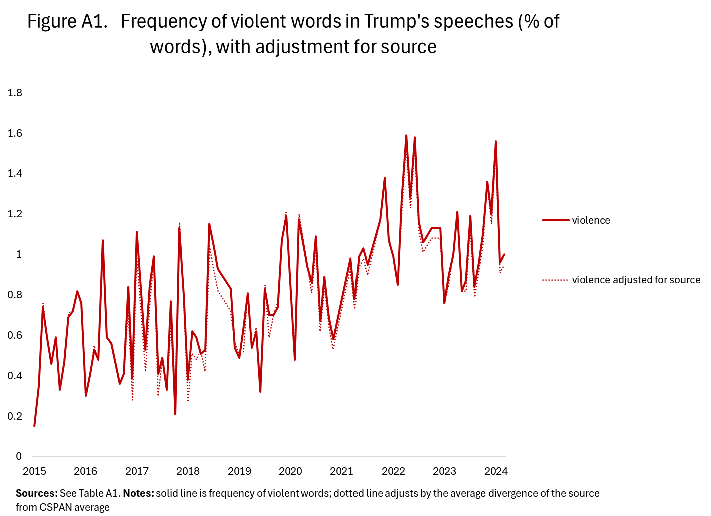
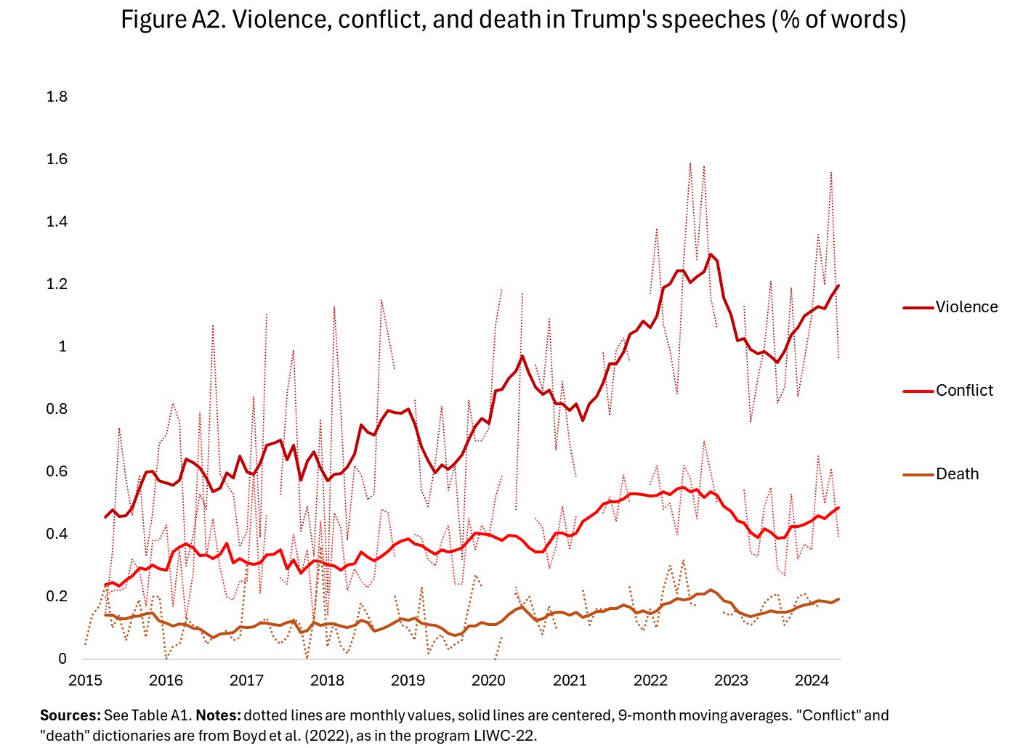
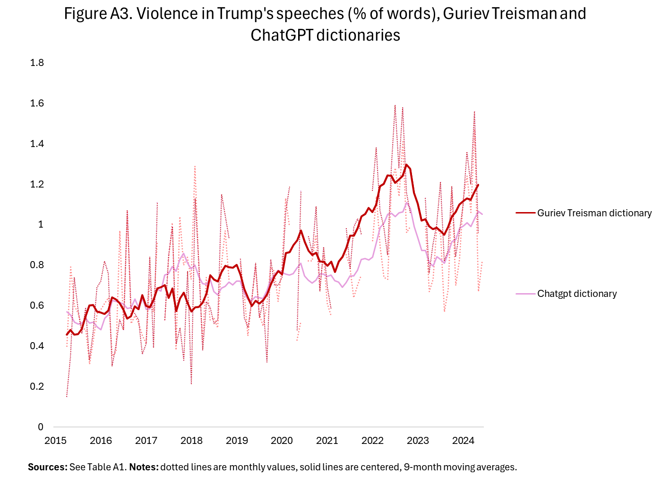
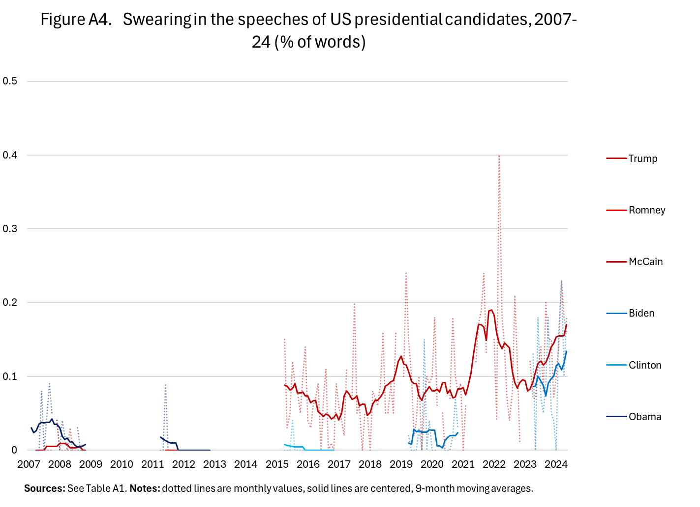
Note: “swearing” uses dictionary of Boyd et al. (2022). Most common swear words in these speeches are “hell” and “damn.”
Figure A5. Validation of Guriev and Treisman (2019) Dictionary
