Appendix A. Appendix Figures and Tables
Figure A1. Share of population waived: comparison between our data and Harris (2021)
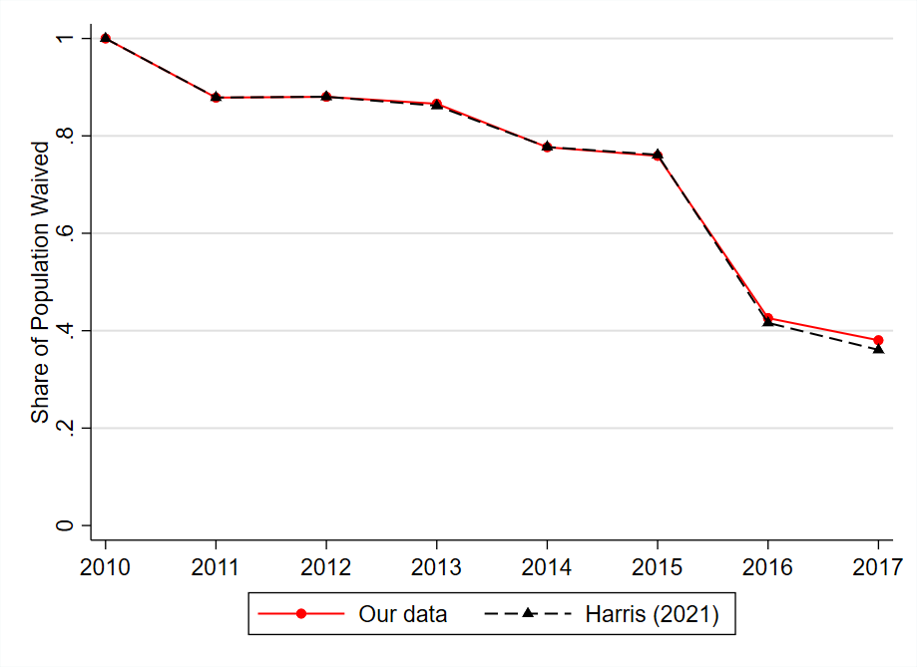
Notes: Figure reports share of the U.S. population that is waived according to our data collection and according to Harris (2021).
Sources: Harris (2021); United States Department of Agriculture; Authors’ calculations.

Figure A2. Unemployment rate among various groups of counties, monthly, January 1997-December 2023: waived counties and comparison groups
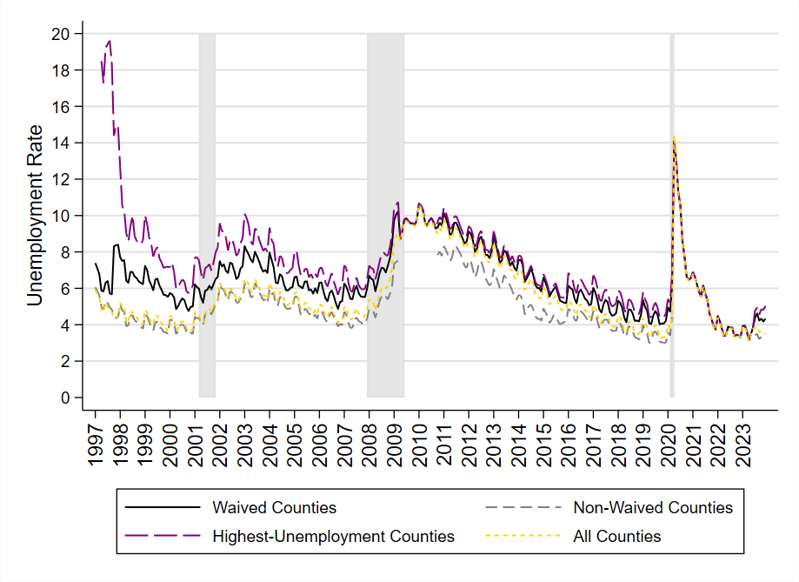
Notes: Figure reports the unemployment rate among various groups of counties in a given month. Waived counties include all counties with a waiver. Highest-unemployment counties include in a given month the counties with the highest rates of unemployment, whose total population equals the population of waived counties in that month. Non-waived counties include all counties without a waiver. All counties include all counties regardless of waiver status. Grey shaded areas indicate recessions as defined by the National Bureau of Economic Research.
Sources: United States Department of Agriculture; Bureau of Labor Statistics Local Area Unemployment Statistics; Authors’ calculations.

Figure A3. Unemployment rate among counties eligible for a work requirement waiver under existing and counterfactual policies, monthly, January 1997- December 2023
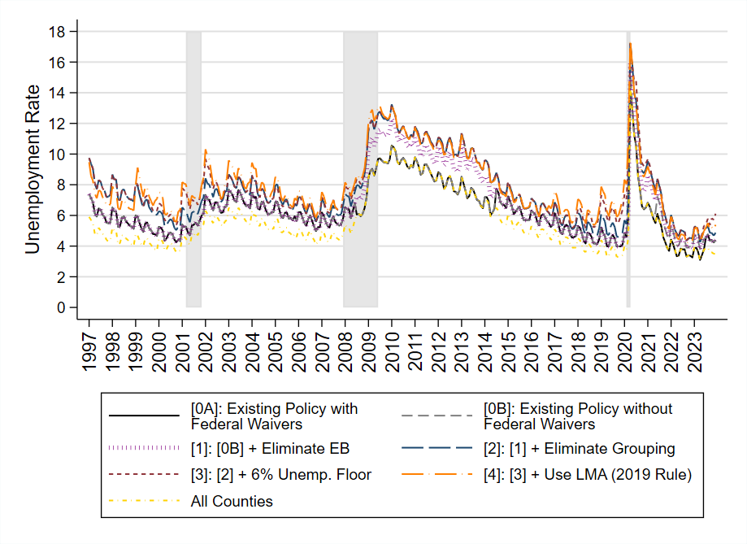
Notes: Figure reports the unemployment rate among counties eligible for a waiver in a given month, under existing and counterfactual policies. Grey shaded areas indicate recessions as defined by the National Bureau of Economic Research. Policy [0A] refers to existing waiver policy as of 2024 with federal waivers. Policy [0B] refers to existing waiver policy without federal waivers. Policy [1] revokes eligibility for states eligible only based on eligibility for Extended Unemployment Benefits (EB). Policy [2] prohibits grouping of counties into a single area, and instead requires counties to be eligible on their own accord. Policy [3] imposes a 6 percent unemployment rate floor for any county eligible under the 20 percent rule. Policy [4] requires Labor Market Areas (LMAs) rather than counties to qualify for waivers. Policy [4] represents the major provisions of the 2019 final rule published by the Department of Agriculture, which was ultimately not put into effect. When simulating states’ grouping, we exclude the District of Columbia, Hawaii, and Alaska.
Sources: United States Department of Agriculture; Bureau of Labor Statistics Local Area Unemployment Statistics; Department of Labor; Authors’ calculations.

Figure A4. Population-weighted share of U.S. counties eligible for a work requirement waiver, monthly, January 1997-December 2023: various periods for calculating Labor Market Area average unemployment rate
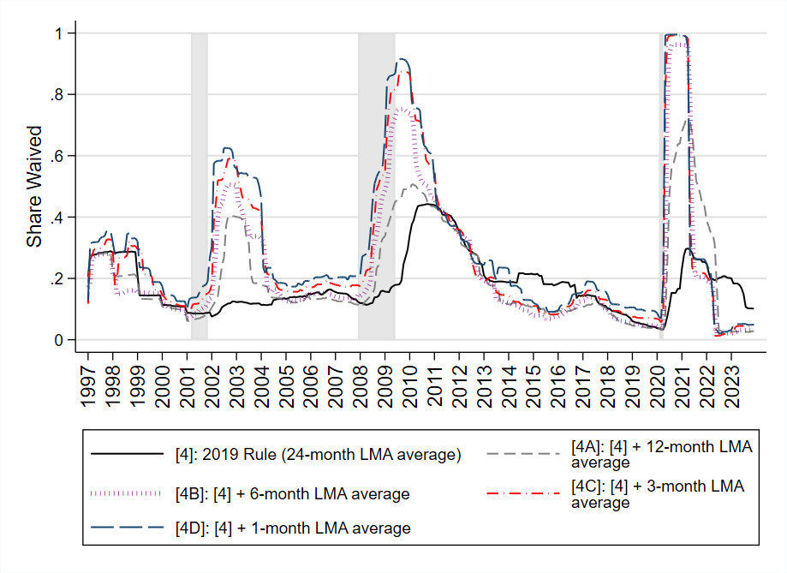
Notes: Figure reports share of population-weighted counties in the United States eligible for a work requirement waiver in a given month, as simulated under counterfactual policies with various periods for calculating Labor Market Area average unemployment rates for purposes of the 20 percent rule. Under the 2019 final rule, a 24-month average is used for the Labor Market Area unemployment rate. Each of the simulations eliminate Extended Unemployment Benefits criterion, prohibit grouping, impose a 6 percent unemployment rate floor for the 20 percent rule, and switch to the Labor Market Area as the geographic unit of analysis. Grey shaded areas indicate recessions as defined by the National Bureau of Economic Research.
Sources: United States Department of Agriculture; Bureau of Labor Statistics Local Area Unemployment Statistics; Department of Labor; Authors’ calculations.

Figure A5. Population-weighted share of U.S. counties eligible for a work requirement waiver, monthly, January 1997-December 2023: various periods for calculating national average unemployment rate
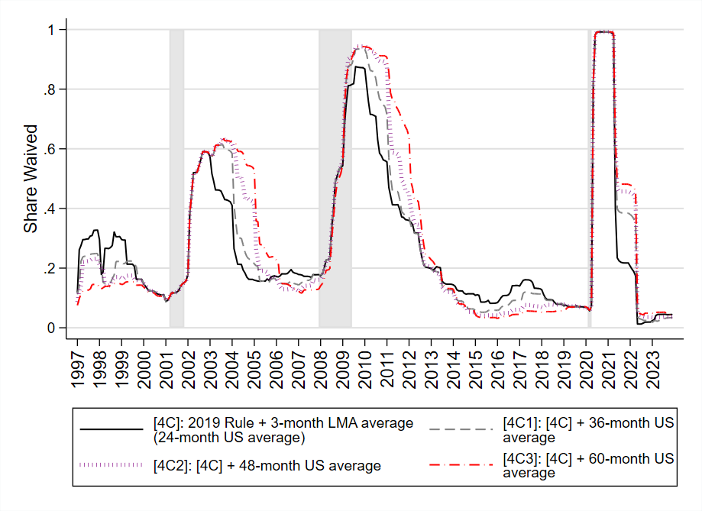
Notes: Figure reports share of population-weighted counties in the United States eligible for a work requirement waiver in a given month, as simulated under counterfactual policies with various periods for calculating U.S. average unemployment rates for purposes of the 20 percent rule. All policies shown in figure use a 3-month average Labor Market Area unemployment rate, differing from the 24-month average used in the 2019 final rule. Policy [4C] uses a 24-month average U.S. unemployment rate for purposes of the 20 percent rule, the same as used in the 2019 final rule. Each of the simulations eliminate Extended Unemployment Benefits criterion, prohibit grouping, impose a 6 percent unemployment rate floor for the 20 percent rule, and switch to the Labor Market Area as the geographic unit of analysis. Grey shaded areas indicate recessions as defined by the National Bureau of Economic Research.
Sources: United States Department of Agriculture; Bureau of Labor Statistics Local Area Unemployment Statistics; Department of Labor; Authors’ calculations.

Figure A6. Cumulative unemployment rate distribution among counties eligible for a work requirement waiver in 1997-2023: various periods for calculating Labor Market Area average unemployment rate
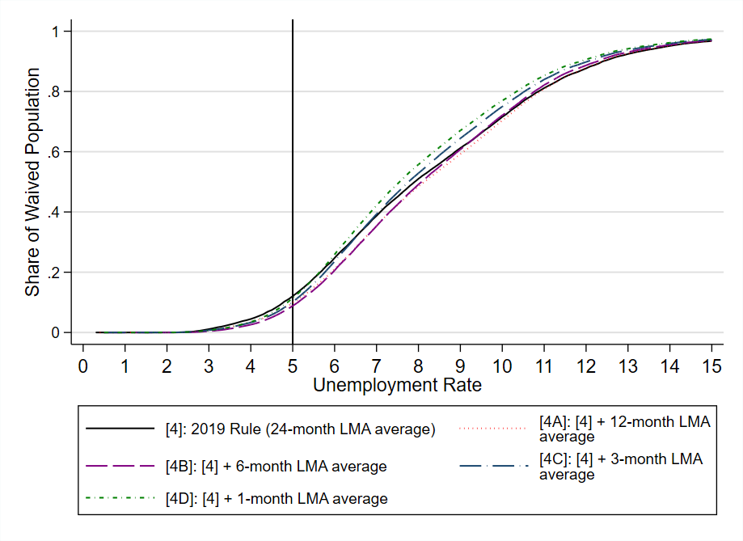
Notes: Figure reports, among county-months with a work requirement waiver in 1997-2023, the population-weighted share with an unemployment rate equal to or below any given level, as simulated under counterfactual policies with various periods for calculating Labor Market Area average unemployment rates for purposes of the 20 percent rule. Under the 2019 final rule, a 24-month average is used for the Labor Market Area unemployment rate. Each of the simulations eliminate Extended Unemployment Benefits criterion, prohibit grouping, impose a 6 percent unemployment rate floor for the 20 percent rule, and switch to the Labor Market Area as the geographic unit of analysis.
Sources: United States Department of Agriculture; Bureau of Labor Statistics Local Area Unemployment Statistics; Department of Labor; Authors’ calculations.

Figure A7. Unemployment rate distribution among counties eligible for a work requirement waiver in 1997-2023: various periods for calculating national average unemployment
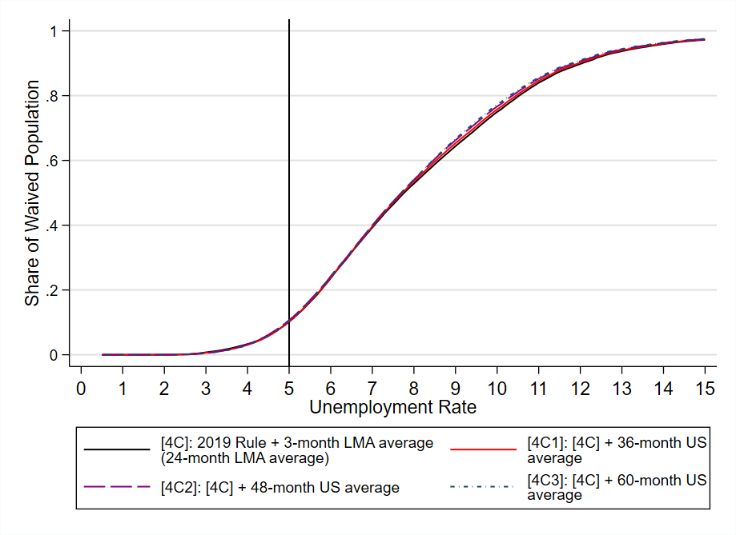
Notes: Figure reports, among county-months with a work requirement waiver in 1997-2023, the population-weighted share with an unemployment rate equal to or below any given level, as simulated under counterfactual policies with various periods for calculating U.S. average unemployment rates for purposes of the 20 percent rule. All policies shown in figure use a 3-month average Labor Market Area unemployment rate, differing from the 24-month average used in the 2019 final rule. Policy [4C] uses a 24-month average U.S. unemployment rate for purposes of the 20 percent rule, the same as used in the 2019 final rule. Each of the simulations eliminate Extended Unemployment Benefits criterion, prohibit grouping, impose a 6 percent unemployment rate floor for the 20 percent rule, and switch to the Labor Market Area as the geographic unit of analysis. Grey shaded areas indicate recessions as defined by the National Bureau of Economic Research.
Sources: United States Department of Agriculture; Bureau of Labor Statistics Local Area Unemployment Statistics; Department of Labor; Authors’ calculations.

Table A1. County-level association between waiver status and unemployment rate, including lags and leads of unemployment rates, 1997-2023
 | (1) | (2) | (3) | (4)
Contemporaneous only | 0.0737 (0.0002) | 0.0196 (0.0003) | 0.0900 (0.0002) | 0.0312 (0.0003)
Sum of contemporaneous and lags for 1-6 months | 0.0908 (0.0002) | 0.0276 (0.0003) | 0.1032 (0.0002) | 0.0421 (0.0004)
Sum of contemporaneous and lags for 1-12 months | 0.0994 (0.0002) | 0.0335 (0.0003) | 0.1027 (0.002) | 0.0459 (0.0004)
Sum of contemporaneous and lags for 1-24 months | 0.1177 (0.0002) | 0.0506 (0.0003) | 0.1169 (0.0002) | 0.0580 (0.0004)
Sum of contemporaneous and leads for 1-6 months | 0.0742 (0.0002) | 0.0261 (0.0003) | 0.0951 (0.0002) | 0.0375 (0.0004)
Exclude Federal Waiver Period | — | — | X | X
County Fixed Effects | X | X | X | X
Year-Month Fixed Effects | — | X | — | X
Observations | 1,016,342 | 1,016,342 | 837,521 | 837,521
Notes: Table reports Ordinary Least Squares regression coefficients corresponding to the county unemployment rate, summed across all included lags and/or leads. Standard errors in parentheses. Dependent variable is an indicator equal to one if a waiver is in effect in a given county and month. Federal waiver periods were April 2009 to October 2010 and April 2020 to June 2023. Observations are weighted by 2010 county populations. All models only include counties with available data for the entire sample period.
Sources: United States Department of Agriculture; Bureau of Labor Statistics Local Area Unemployment Statistics; Authors’ calculations.

Table A2. County-level association between waiver eligibility status and unemployment rate, 1997-2023, existing and counterfactual policies
 | (1) | (2)
[4]: 2019 Rule (24-month LMA average) | 0.0409  (0.0001) | 0.0813  (0.0002)
[4A]: [4] + 12-month LMA average | 0.0620  (0.0001) | 0.0973  (0.0002)
[4B]: [4] + 6-month LMA average | 0.0787  (0.0001) | 0.0916  (0.0002)
[4C]: [4] + 3-month LMA average | 0.0853  (0.0001) | 0.0894  (0.0002)
[4D]: [4] + 1-month LMA average | 0.0875  (0.0001) | 0.0899  (0.0002)
[4C1]: [4C] + 36-month US average | 0.0909  (0.0002) | 0.0814  (0.0002)
[4C2]: [4C] + 48-month US average | 0.0959  (0.0002) | 0.0753  (0.0002)
[4C3]: [4C] + 60-month US average | 0.1007  (0.0002) | 0.0708  (0.0002)
County Fixed Effects | X | X
Year-Month Fixed Effects | — | X
Observations: County-months | 1,016,474 | 1,016,474
Notes: Table reports Ordinary Least Squares regression coefficients corresponding to the county unemployment rate. Standard errors in parentheses. Dependent variable is an indicator equal to one if a county is eligible for a waiver in a given county and month. Observations are weighted by county population. All models rely on 2010 county populations as weights. Under the 2019 final rule, a 24-month average is used for the Labor Market Area unemployment rate. Each of the simulations eliminate Extended Unemployment Benefits criterion, prohibit grouping, impose a 6 percent unemployment rate floor for the 20 percent rule, and switch to the Labor Market Area as the geographic unit of analysis.
Sources: United States Department of Agriculture; Bureau of Labor Statistics Local Area Unemployment Statistics; Department of Labor; Authors’ calculations.

Appendix B. Grouping Algorithm Description
In this appendix, we describe our methodology for simulating waiver eligibility under policies that permit states to group contiguous counties into a single area.
There are many possible ways for a state to group counties, and maximizing the number of counties waived sometimes requires forming multiple groups. As an illustration, we consider three simple examples in Figure B1 below. In each of the three scenarios, we assume that there is a state with five counties, each with equal population. For each county $i∈\{1, 2, 3, 4, 5\}$, its unemployment rate is assumed equal to $i$. For simplicity, we assume that a county or group of counties must have an unemployment rate of at least 3.5 percent to qualify for a waiver. Figure B1 illustrates three different configurations of counties that would require different grouping strategies to maximize waiver coverage. Each hexagon represents a county, and all five hexagons represent all counties in one state. In Scenario A, the state would maximize waiver coverage by creating a single group consisting of counties 2, 3, 4, and 5. In this scenario, the group would be eligible for a waiver because its average unemployment rate is 3.5 percent. In Scenario B, the state would maximize waiver coverage by creating two groups, one that includes counties 2 and 5 and another that includes counties 3 and 4—both of which would have an average unemployment rate of 3.5 percent. Lastly, in Scenario C, the state could only waive counties 4 and 5 separately, and could not group any counties that would individually be ineligible for a waiver. Therefore, even in this simple example of a five-county state, waiver coverage could be maximized by creating zero, one, or two contiguous groups of counties depending on the configuration of counties within the state.
In each of these examples, determining the grouping strategy that maximizes waiver coverage is relatively straightforward, because it is possible to test all of the possible combinations of contiguous counties that could qualify for a waiver, and select the grouping strategy that maximizes waiver coverage. However, in reality, states contain dozens or even hundreds of counties, each with a unique set of borders. Therefore, it is not practical to test all possible combinations of contiguous counties to determine the state’s grouping strategy that maximizes waiver coverage. Instead, we develop an algorithm that can be applied to all states to simulate grouping. While it does not necessarily maximize waiver coverage in all scenarios, we view it as a natural approach that states seeking to waive a large number of counties might implement.
Figure B1. Hypothetical Grouping Decisions
Scenario A | Scenario B | Scenario C
Notes: Each scenario depicts an arrangement of counties within a given state. County numbers 1 through 5 also represent the counties’ unemployment rates, such that County 1 has an unemployment rate of 1 percent, County 2 has an unemployment rate of 2 percent, etc. In order to qualify for a waiver, a county—or group of contiguous counties—must have an unemployment rate of 3.5 percent or higher.

The algorithm proceeds as follows:
- Identify the highest unemployment county in the state. If its unemployment rate is less than the threshold, the group is empty and the algorithm ends. Otherwise, include the county as the first member of the first (and current) group and proceed to step (ii).
- Add to the current group the highest unemployment rate county that meets all of the following conditions: (a) is contiguous to the current group, (b) is not a member of the current or any former group, and (c) when added to the group, the group average unemployment rate is weakly greater than the threshold. Then repeat step (ii). If no such county exists, proceed instead to step (iii).
- Create a new group by identifying the highest unemployment county in the state that is not part of any already-formed group. If its unemployment rate is less than the threshold, the subsequent group is empty, and the algorithm ends. If its unemployment rate is greater than the threshold, return to step (ii).
The algorithm attempts to form the first group beginning with the highest unemployment county in the state, and incrementally adds to the group the contiguous county with the highest unemployment rate until doing so would cause the group to no longer be eligible for a waiver. In certain instances, it is possible that adding the highest-unemployment contiguous county causes the group to lose its waiver eligibility, while adding a lower-unemployment contiguous county could allow the group to retain its eligibility. Therefore, in step (ii) we require the added county to retain eligibility for the group when added. We continue this process until no additional counties can be added to the group. When no additional counties can be added, the group is fully formed. We then repeat the process with counties not included in the initial group, thereby allowing states to create multiple groups of counties. We allow states to continue forming groups until no eligible counties remain.
We simulate grouping using two waiver eligibility criteria: the 20 percent rule and having an unemployment rate of at least 10 percent. In the former case the threshold is 120 percent of the national unemployment rate over the past 24 months, and in the latter case the threshold is 10 percent. For both the 20 percent rule and the 10 percent condition, we use the FNS’s preferred method for calculating an area’s unemployment rate (USDA 2021). We rely on county-level data from the Bureau of Labor Statistics (BLS) Local Area Unemployment Statistics (LAUS) database, which provides estimates of the total number of individuals in the labor force in a given county, as well as the total number of unemployed individuals. In order to calculate the unemployment rate of a given group, we divide the sum of all unemployed individuals in the group by the sum of all individuals in the labor force in the group over the entire period. Therefore, if a group consists of two counties, we determine the group’s unemployment rate by calculating the sum of both counties’ labor forces and number of unemployed individuals over the preceding 24-month period. We then divide the total number of unemployed individuals by the total labor force, multiply by 100, and round to the nearest tenth. If the resulting unemployment rate is greater than or equal to the associated threshold, the group is eligible for a waiver.
We simulate grouping under the 20 percent rule and the 10 percent condition for each state, beginning in January of each year from 1997 to 2023. We implement the algorithm in January of each year because it is the month during which states most often request ABAWD waivers from FNS and because states typically receive one-year waivers. After implementing simulations under both the 20 percent rule and 10 percent condition in each January, we identify the rule under which a larger group is formed, measured by the total population of the counties included in the group(s). We then use the group(s) from that simulation as the state’s group(s) for that year.
To help validate our algorithm, we compare its performance to actual grouping decisions made by states in the three examples shown in Figure B2: Arizona in 2006, California in 2019, and Pennsylvania in 2017. The left figure displays the actual groups formed by the state, and the right figure displays the group(s) formed by our algorithm applied to the same 24-month reference time period. In Panel A, our algorithm exactly replicates Arizona’s grouping strategy in 2006. Arizona grouped 13 of its 15 counties under the 20 percent rule, and our algorithm grouped the same 13 counties under the same criterion. Our algorithm begins with Yuma County, the highest unemployment county in the state over the preceding 24-month period. The algorithm then adds the next highest unemployment county, La Paz County. Adding the next highest unemployment county, Maricopa County, would cause the group’s unemployment rate to fall below the unemployment rate threshold. This occurs because Maricopa County’s population is roughly 18 times greater than the combined population of Yuma and La Paz County and Maricopa County’s 24-month unemployment rate is slightly below the required threshold. Therefore, adding Maricopa County to the group makes the entire group ineligible. However, our algorithm is able to add other counties to the group while retaining the group’s eligibility.
In Panel B, our algorithm slightly underperforms California’s actual grouping decision. California waived 52 of its 58 counties covering 83 percent of the state population in 2019 by forming a single group under the 20 percent rule. Our algorithm grouped 48 counties covering 65 percent of the state population. The discrepancy appears to result from California calculating an unemployment rate for their group that was lower than it actually was according to the BLS county-level unemployment data upon which we rely. According to California’s waiver request, the state relied on unemployment data from January 2016 to December 2017. California claimed that the group’s unemployment rate was 5.5 percent, 120 percent greater than the 4.6 percent national average unemployment rate over the same 24-month period. However, when relying on BLS LAUS data, we calculated the state’s group unemployment rate as 5.2 percent, below the required threshold.
In Panel C, our algorithm outperforms Pennsylvania’s actual grouping decision. While Pennsylvania created two groups consisting of 42 total counties and covering 42 percent of the state population in 2017, our algorithm waived a total of 55 counties across two groups covering 61 percent of the state population. Our first group consists of 52 counties, while Pennsylvania’s larger group consists of 41 counties. Our second group consists of three counties while Pennsylvania’s smaller group consists of two counties.
Figure B2. Grouping Simulation Comparison

Panel A. Arizona, 2006
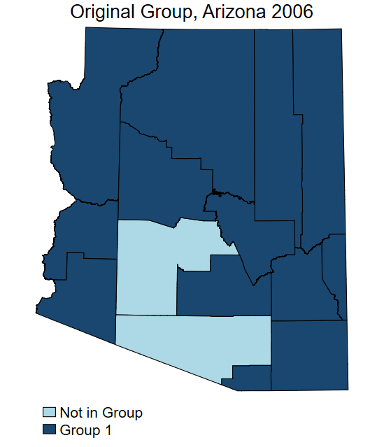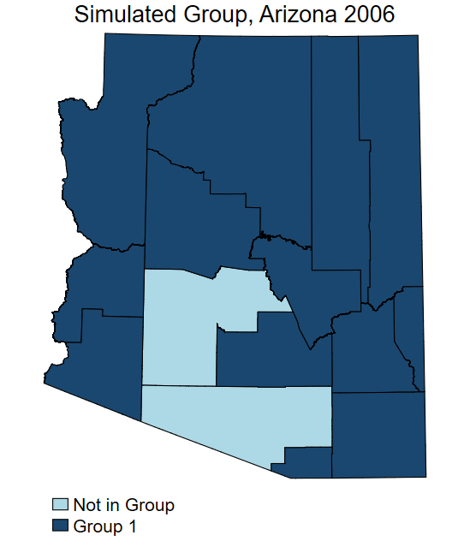

Panel B. California, 2019
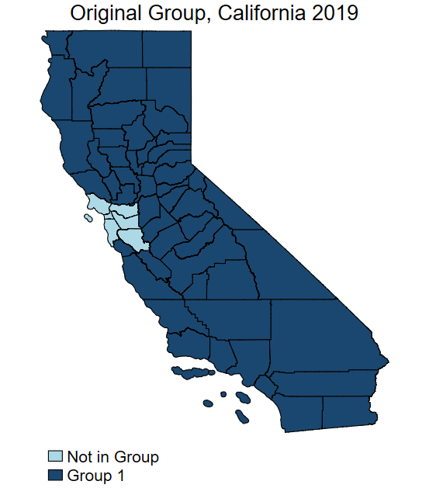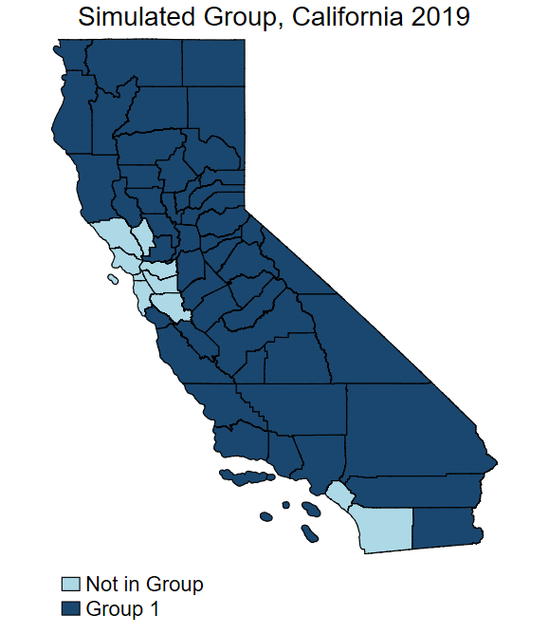

Panel C. Pennsylvania, 2017
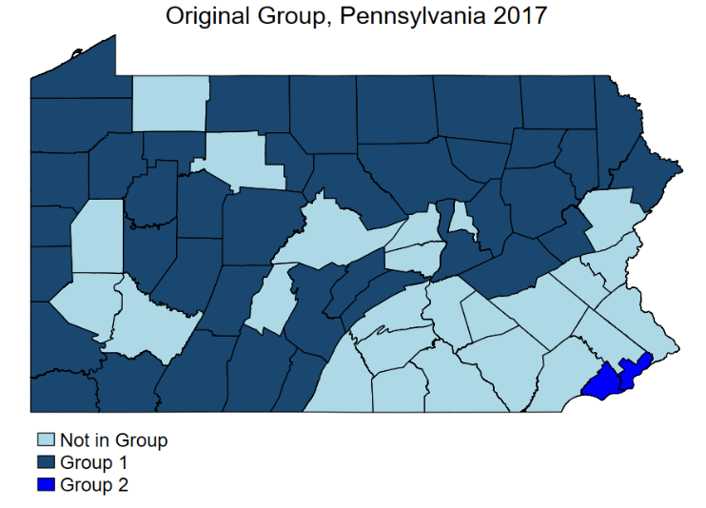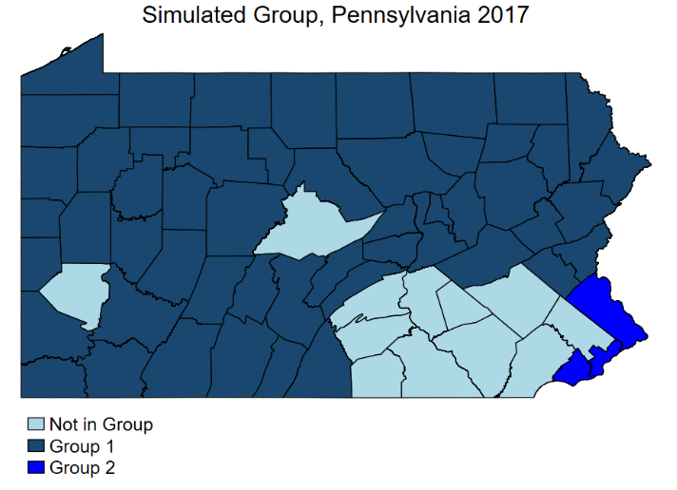
Notes: Figure displays three sets of county-level state maps, comparing results of our grouping simulation to states’ actual grouping decision. Maps in the left column display the set of contiguous counties grouped according to the state’s actual grouping decision, while maps in the right column display the set of contiguous counties grouped according to our simulation.
Sources: United States Department of Agriculture; Bureau of Labor Statistics Local Area Unemployment Statistics; Authors’ calculations.

This is common when there are significant disparities in the labor force sizes of contiguous counties, where a county with a lower unemployment rate but a smaller labor force allows the group to remain eligible when added, while a county with a higher unemployment rate but a larger labor force does not allow the group to remain eligible when added.
We do not allow grouping for any other waiver eligibility criteria because it is impossible to do so. For example, individual counties can be waived because they are designated as an LSA and entire states can be waived if the state qualifies for Extended Unemployment Benefits, but individual counties cannot be grouped under either criterion.
This method applies to individual counties and groups of contiguous counties.
If we are applying the 10 percent grouping algorithm, we calculate the total unemployed and labor forces over the preceding 12 months rather than the preceding 24 months.
We do not simulate grouping for the District of Columbia, Hawaii, or Alaska. We exclude the District of Columbia because it is a single county, and can therefore not be grouped with any other counties. We exclude Hawaii because it only contains five counties, and none of its counties share a border. Lastly, we exclude Alaska because its county-equivalents underwent several changes during the sample period.

