Appendix for “The Effects of Switching Electronic Health Record Developer on Specialty Referrals”

- Additional tables and figures.
- Estimates using the 2013-2015 sample.
- Proof of distorted referral patterns.
- Proof of market agglomeration.

- Additional tables and figures
Table A1. Two-way fixed effect estimation results with all control variables.
Variables | Coeff. | S.E. | t-statistic | p-value | 95% Conf. Interval
Switch-to-same | 0.056 | 0.025 | 2.210 | 0.028 | 0.006 | 0.106
EHR market share of NPI1 | 0.000 | 0.000 | -0.930 | 0.353 | 0.000 | 0.000
Same HSA | 0.312 | 0.173 | 1.810 | 0.071 | -0.027 | 0.650
Long-term sharing relationship | 0.023 | 0.005 | 4.580 | 0.000 | 0.013 | 0.033
PCP characteristics
Emergency hospital | 0.021 | 0.025 | 0.840 | 0.400 | -0.028 | 0.071
Number of hospital beds | 0.000 | 0.000 | 1.050 | 0.296 | 0.000 | 0.000
number of heart failure patients | 0.000 | 0.000 | -0.650 | 0.513 | 0.000 | 0.000
number of pneumonia patients | 0.001 | 0.000 | 2.520 | 0.012 | 0.000 | 0.001
30-day readmission rate relative to national average (0/1)
Heart failure, Similar | 0.023 | 0.019 | 1.200 | 0.230 | -0.014 | 0.060
Heart failure, Lower | 0.014 | 0.015 | 0.990 | 0.324 | -0.014 | 0.043
Pneumonia, Similar | 0.016 | 0.028 | 0.580 | 0.560 | -0.039 | 0.071
Pneumonia, Lower | 0.006 | 0.026 | 0.220 | 0.826 | -0.045 | 0.057
30-day mortality rate relative to national average (0/1)
Heart failure, Similar | 0.003 | 0.018 | 0.140 | 0.891 | -0.033 | 0.038
Heart failure, Lower | 0.013 | 0.012 | 1.150 | 0.250 | -0.009 | 0.036
Pneumonia, Similar | 0.010 | 0.015 | 0.670 | 0.501 | -0.019 | 0.040
Pneumonia, Lower | 0.023 | 0.010 | 2.270 | 0.024 | 0.003 | 0.043
Note: The table shows full estimates for Table 2, column (2) where the dependent variable is ln(proportion of shared patients from PCP j to specialists k). Standard errors are clustered at the PCP’s affiliated hospital level.

Table A1, continued.
Variables | Coeff. | S.E. | t-statistic | p-value | 95% Conf. Interval
Specialist characteristics
Emergency hospital | 0.013 | 0.024 | 0.530 | 0.598 | -0.034 | 0.060
Number of hospital beds | 0.000 | 0.000 | 0.830 | 0.407 | 0.000 | 0.000
number of heart failure patients | 0.000 | 0.000 | -0.190 | 0.846 | 0.000 | 0.000
number of pneumonia patients | 0.000 | 0.000 | 1.090 | 0.277 | 0.000 | 0.001
30-day readmission rate relative to national average (0/1)
Heart failure, Similar | -0.011 | 0.016 | -0.680 | 0.499 | -0.043 | 0.021
Heart failure, Lower | -0.007 | 0.011 | -0.620 | 0.534 | -0.027 | 0.014
Pneumonia, Similar | 0.019 | 0.018 | 1.030 | 0.303 | -0.017 | 0.054
Pneumonia, Lower | 0.018 | 0.015 | 1.230 | 0.218 | -0.011 | 0.046
30-day mortality rate relative to national average (0/1)
Heart failure, Similar | 0.007 | 0.014 | 0.540 | 0.592 | -0.020 | 0.034
Heart failure, Lower | 0.002 | 0.009 | 0.170 | 0.862 | -0.017 | 0.020
Pneumonia, Similar | 0.021 | 0.014 | 1.510 | 0.132 | -0.006 | 0.048
Pneumonia, Lower | 0.002 | 0.010 | 0.210 | 0.832 | -0.017 | 0.021
Year
2012 | 0.039 | 0.005 | 8.660 | 0.000 | 0.030 | 0.048
2013 | 0.074 | 0.007 | 10.670 | 0.000 | 0.061 | 0.088
2014 | 0.096 | 0.008 | 12.190 | 0.000 | 0.080 | 0.111
2015 | 0.394 | 0.013 | 29.590 | 0.000 | 0.368 | 0.420
Constant | 1.927 | 0.092 | 20.930 | 0.000 | 1.746 | 2.107
Note: The table shows full estimates for Table 2, column (2) where the dependent variable is ln(proportion of shared patients from PCP j to specialists k). Standard errors are clustered at the PCP’s affiliated hospital level.

Table A2. Two-way fixed effect estimates for other patient-sharing channels.
 | Specialist-to-PCP |  | PCP-to-PCP |  | Specialist-to-specialist
 | (1) | (2) | (3) | (4) | (5) | (6)
Switch-to-same | 0.013 | 0.018 | 0.022 | 0.019 | 0.016 | 0.017
 | (0.020) | (0.020) | (0.047) | (0.047) | (0.013) | (0.012)
 | [0.013] | [0.018] | [0.022] | [0.019] | [0.016] | [0.017]
N | 316,876 | 316,876 | 40,338 | 40,338 | 1,189,635 | 1,189,635
Year FE | Yes | Yes | Yes | Yes | Yes | Yes
Physician pair FE | Yes | Yes | Yes | Yes | Yes | Yes
Controls | Yes | Yes | Yes | Yes | Yes | Yes
HRR-specific time trend |  | Yes |  | Yes |  | Yes
Note: Estimates in Table A2 are based on three different samples: Specialist-to-PCP, PCP-to-PCP, and Specialist-to-specialist. For each subsample, we estimate a model with the same specification as Table 2, column (2) and a model with HRR-specific time trends. In all columns, we include physician-pair fixed effects, year-fixed effects, and physician and hospital characteristics. Standard errors are clustered at the affiliated hospital of NPI-1. Exact percentage changes calculate as $e^{β}-1$ are in square brackets. * p < 0.1 ** p < 0.05 *** p < 0.01.
Table A3. Goodman-Bacon decomposition results.
 | Beta | Total weight
Timing groups | 0.012 | 0.006
 | [0.012]
Timing vs. never treated | 0.043 | 0.985
 | [0.044]
Within | -0.111 | 0.010
 | [-0.105]
Note: Goodman-Bacon decomposition is performed using bacondecomp command in STATA using the baseline specification and including physician-pair fixed effects, year-fixed effects, and physician and hospital characteristics. The weights do not sum up to 1 due to rounding. The within row accounts for the inclusion of control variables in Goodman-Bacon decomposition. Exact percentage changes calculate as $e^{β}-1$ are in square brackets. * p < 0.1 ** p < 0.05 *** p < 0.01

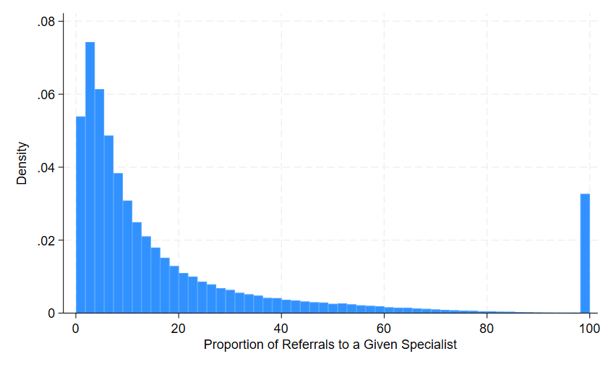
Figure A1. Empirical distribution of the proportion of referrals to a given specialist.
Note: This figure presents the empirical density of the main outcome variable: the proportion of referrals from a primary care provider (PCP) to a given specialist, scaled from 0 to 100. The mass point at 100 indicates cases where the specialist was the sole recipient of referrals from a PCP—i.e., the only specialist to whom the PCP referred more than 10 patients in a given year.

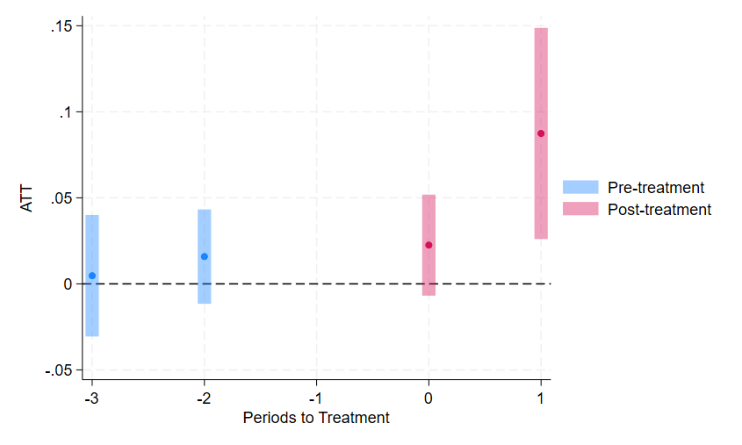
Figure A2. Event study for CS DiD model.
Note: This figure presents the event-study estimates using the doubly robust CS DiD estimator not-yet-treated observations as control group. The horizontal shows the relative time to the Switch-to-same treatment effect, with rime = -1 set as the base period. Coefficients on the leads and lags of the treatment effect are measured on the vertical axis with 95% confidence intervals constructed using standard errors clustered at the level of the PCPs’ affiliated hospital.

B. Estimates using the 2013-2015 sample
When constructing the main sample, we assumed physicians did not change their hospital affiliation in 2011 and 2012 if they reported the same primary practice location during 2011-2015 and did not change their hospital affiliation from 2013 to 2015. To test whether our findings are sensitive to this assumption we re-estimated the models reported in Tables 2 and 3 using data from 2013-2015 for which we directly observe hospital affiliation.
Table B1 reports analogous results to those in Table 2, but for the shorter panel. The treatment effect coefficients all have the same sign for the main sample, but there are some small changes in the magnitudes. The coefficient on the Switch-to-same treatment effect in column 2 increases from 0.056 in Table 2 to 0.082 in Table B1 when the sample is restricted to 2013-2015. Coefficients on the Switch-to-different treatment effect are almost the same in the full and restricted sample, increasing in magnitude to only -0.047 form -0.043.
Table B2 contains estimates from the models with interacted treatment effects using the short panel that are analogous to Table 3. The results are qualitatively similar across the two samples. The coefficients on the interaction effects for long-term relationship and Male PCP-to-female specialist are slightly smaller in magnitude in the 2013-2015 sample in Table B2, but the coefficient on the interaction term for EHR market share > 50% is larger in the short panel. The coefficient on the interaction term for PCP had more experience becomes statistically insignificant when the model is estimated using the short panel.
Table B1. Difference-in-differences estimates of switching the PCP’s EHR developer on out-of-network specialist referrals (2013-2015).
 | (1) | (2) | (3) | (4) | (5) | (6)
Switch-to-same | 0.071*** | 0.082*** | 0.063*** | 0.052***
 | (0.023) | (0.024) | (0.024) | (0.017)
 | [0.074] | [0.085] | [0.065] | [0.053]
Switch-to-different |  |  |  |  | -0.047*
 |  |  |  |  | (0.025)
 |  |  |  |  | [-0.046]
Different-to-different |  |  |  |  |  | 0.001
 |  |  |  |  |  | (0.010)
 |  |  |  |  |  | [0.001]
N | 158,824 | 158,824 | 158,824 | 123,787 | 158,824 | 158,824
Time FE | Yes | Yes | Yes | Yes | Yes | Yes
Physician pair FE | Yes | Yes | Yes | Yes | Yes | Yes
Controls |  | Yes | Yes | Time invariant | Yes | Yes
HRR-specific time trend |  |  | Yes
CS-DiD |  |  |  | Yes
Note: The treatment variable in columns (1)-(3) measures PCP switching to the same EHR developer as the specialist (including simultaneous switching). Column (4) shows the PCP switching from the same to a different EHR developer as the specialist and column (5) shows the PCP switching from a different EHR than the specialist to another different EHR. Exact percentage changes calculate as $e^{β}-1$ are in square brackets. All standard errors are clustered at the PCP’s affiliated hospital level and are reported in parentheses. * p < 0.10 ** p < 0.05 *** p < 0.01. †Estimated using a balanced panel.

Table B2. Difference-in-differences estimates of switching the PCP’s EHR developer on same-developer specialist referrals, by subgroups (2013-2015).
 | (1) | (2) | (3) | (4) | (5) | (6) | (7) | (8)
Switch-to-same | 0.149*** | 0.060* | 0.104** | 0.117*** | 0.073*** | 0.080*** | 0.086*** | 0.024
 | (0.044) | (0.032) | (0.049) | (0.039) | (0.022) | (0.024) | (0.025) | (0.031)
Interactions (0/1)
Long-term | -0.080*
relationship | (0.041)
Same HSA |  | 0.055
 |  | (0.043)
Same HRR |  |  | -0.025
 |  |  | (0.056)
Same gender |  |  |  | -0.047
 |  |  |  | (0.033)
Male PCP to female |  |  |  |  | 0.106*
specialist |  |  |  |  | (0.058)
Female PCP to male |  |  |  |  |  | 0.007
specialist |  |  |  |  |  | (0.042)
PCP has more |  |  |  |  |  |  | -0.009
experience |  |  |  |  |  |  | (0.031)
EHR share > 50% |  |  |  |  |  |  |  | 0.093**
 |  |  |  |  |  |  |  | (0.040)
Sub-group treatment | 0.069 | 0.110 | 0.079 | 0.070 | 0.179 | 0.087 | 0.077 | 0.117
 | [0.071] | [0.116] | [0.082] | [0.073] | [0.196] | [0.091] | [0.080] | [0.124]
N
Clusters | 158,824 | 158,824 | 158,824 | 158,824 | 158,824 | 158,824 | 158,824 | 158,824
Outcome Mean | 2,572 | 2,572 | 2,572 | 2,572 | 2,572 | 2,572 | 2,572 | 2,572
Indicator Mean | 20.591 | 20.591 | 20.591 | 20.591 | 20.591 | 20.591 | 20.591 | 20.591
Year FE | Yes | Yes | Yes | Yes | Yes | Yes | Yes | Yes
Physician Pair FE | Yes | Yes | Yes | Yes | Yes | Yes | Yes | Yes
Controls | Yes | Yes | Yes | Yes | Yes | Yes | Yes | Yes
Note: Each column in Table B2 represents a triple-difference model that includes the Switch-to-same treatment effect and its interaction with various physician-pair characteristics. Exact percentage changes calculate as $e^{β}-1$ are in square brackets. All standard errors are clustered at the PCP's affiliated hospital level and are reported in parentheses. * p < 0.10 ** p<0.05 *** p<0.01.

C. Distorted referral patterns

C1. Proof of Proposition 1.
Consider a local physician referral market ($J,K$) with only two EHR developers. Assume $k^{*}∈ K$ is the specialist of the highest quality and let $h^{*}$ denote the EHR developer he/she uses. The number of specialists using $h^{*}$ is denoted by $n_{same}$, and the number of specialists using the other developer is denoted by $n_{diff}$. $P_{same,k^{*}}$ and $P_{diff,k^{*}}$ denotes the probability of $k^{*}$ receiving patients from PCPs using either $h^{*}$ or the other EHR developer, respectively. $δ_{h}≡\frac{E[e^{x_{h}γ}]}{e^{x_{k^{*}}γ}}$, with $h ∈ \{same,diff\}$ measures the expected quality of the specialist pool using $h^{*}$ (same) or the other EHR developer (diff), relative to the quality of $k^{*}$. We have:
(C1) $P_{same,k^{*}}=\frac{e^{β+x_{k^{*}}γ}}{\sum_{κ}{e^{v_{jκ}}}}$
(C2) $=\frac{e^{β+x_{k^{*}}γ}}{\sum_{κ:h_{κ}=h^{*}}{e^{β+x_{κ}γ}}+\sum_{κ:h_{κ}≠h^{*}}{e^{x_{κ}γ}}}$
(C3) $\underset{→}{p} \frac{1}{n_{same}δ_{same}+ e^{-β}n_{diff}δ_{diff}}$
The derivation of $P_{diff,k^{*}}\underset{→}{p}\frac{1}{n_{same}δ_{same}+e^{β}n_{diff}δ_{diff}}$ is similar.
When the market has more than two EHR developers, i.e. |H| > 2, we have:
(C4) $P_{same,k^{*}}\underset{→}{p} \frac{1}{n_{h^{*}}δ_{h^{*}}+e^{-β}\sum_{h∈H\backslash h^{*}}{n_{h}δ_{h}}}$,
and the probability of $k^{*}$ receiving patients from PCPs using a different EHR developer $h' ∈ H\backslash h^{*}$ is:
(C5) $P_{h^{'},k^{*}}\underset{→}{p} \frac{1}{n_{h^{*}}δ_{h^{*}}+\sum_{h∈H:h_{k}≠h^{*}}{n_{h}δ_{h}}+\left(e^{β}-1\right)n_{h'}δ_{h'} }$ .

When $β = 0$, $P_{same,k^{*}}=P_{h^{'},k^{*}}$ for ∀$h' ∈ H\backslash h^{*}$. When β > 0, $P_{same,k^{*}}$ > $P_{h^{'},k^{*}}$ because $\sum_{h∈H:h_{k}≠h^{*}}{n_{h}δ_{h}}>e^{-β}\sum_{h∈H\backslash h^{*}}{n_{h}δ_{h}}$ and $\left(e^{β}-1\right)n_{h'}δ_{h'}>0$.

C2. Proof of Proposition 2.
The odds ratio of same versus different EHR developer referring to q is given by:
(C6) $\frac{P_{same,q}}{P_{diff,q}}=\frac{e^{β}n_{diff}δ_{diff}+n_{same}δ_{same}}{e^{-β}n_{diff}δ_{diff}+n_{same}δ_{same}}$
(C7) $=\frac{e^{β}+\frac{n_{sameδ_{same}}}{n_{diff}δ_{diff}}}{e^{-β}+\frac{n_{sameδ_{same}}}{n_{diff}δ_{diff}}}$
Taking the derivative of the odds ratio with respect to the relative quality of $\frac{δ_{same}}{δ_{diff}}$:
(C8) $\frac{∂\frac{P_{same,q}}{P_{diff,q}}}{∂\frac{δ_{same}}{δ_{diff}}}=\frac{\frac{n_{same}}{n_{diff}}\left(e^{-β}+\frac{n_{sameδ_{same}}}{n_{diff}δ_{diff}}\right)-\frac{n_{same}}{n_{diff}}(e^{β}+\frac{n_{sameδ_{same}}}{n_{diff}δ_{diff}})}{{\left(e^{-β}+\frac{n_{sameδ_{same}}}{n_{diff}δ_{diff}}\right)}^{2}}$
(C9) $=\frac{\left(e^{-β}-e^{β}\right)\frac{n_{same}}{n_{diff}} }{{\left(e^{-β}+\frac{n_{sameδ_{same}}}{n_{diff}δ_{diff}}\right)}^{2}}<0$

D. Proof of market agglomeration
Consider a market of two EHR developers {$A,B$} with the proportion of PCPs using A greater than the proportion of PCPs using B. A specialist k is choosing between A and B to maximize his/her probability of receiving referrals, denoted by $π_{h} : h ∈ \{A,B\}$. When the number of specialists is sufficiently large to prevent $n_{h}$ from affecting the choice of k, we have:
(D1) $π_{A} = P\left(A\right)P_{A,k} + P\left(B\right)P_{B,k}$
(D2) $=\frac{P\left(A\right)}{n_{A}δ_{A}+e^{-β}n_{B}δ_{B}}+\frac{P\left(B\right)}{n_{A}δ_{A}+e^{β}n_{B}δ_{B}}$ ,
and
(D3) $π_{B} = P\left(A\right)P_{A,k} + P\left(B\right)P_{B,k}$
(D4) $=\frac{P\left(A\right)}{n_{A}δ_{A}+e^{β}n_{B}δ_{B}}+\frac{P\left(B\right)}{n_{A}δ_{A}+e^{-β}n_{B}δ_{B}}$

When $β = 0, π_{A} = π_{B}$. When β > 0, we have $\frac{1}{n_{A}δ_{A}+e^{-β}n_{B}δ_{B}}>\frac{1}{n_{A}δ_{A}+e^{β}n_{B}δ_{B}}$. Because P(A) > P(B), pairing P(A) with $\frac{1}{n_{A}δ_{A}+e^{-β}n_{B}δ_{B}}$ will yield the greatest summation of products (rearrangement inequality).
Next, consider a market with more than two EHR developers. Without loss and generality, let $H={\left\{h_{i}\right\}}_{i=1}^{|H|}$ with $P(h_{1}) > P(h_{2}) > ... > P(h_{\left|H\right|})$.
(D5) $π_{i}=\sum_{ι }{P\left(h_{ι}\right)P_{ι,k}}$,
where
(D6) $P_{ι,k}=\left\{\begin{aligned}\frac{1}{n_{i}δ_{i}+e^{-β}\sum_{h≠h_{i}}{n_{h}δ_{h}}}, if i=ι \\ \frac{1}{n_{i}δ_{i}+\sum_{h≠h_{i}}{n_{h}δ_{h}}+\left(e^{β}-1\right)n_{i}δ_{i}}, if i≠ι\end{aligned}\right.$
When comparing $π_{1}$ with any other choice $π_{i:i≠1}$, most terms in Equation (D5) cancel out. As a result, comparing $π_{1}$ with $π_{i:i≠1}$ is equivalent to comparing $\frac{P(h_{1})}{n_{1}δ_{1}+e^{-β}\sum_{h≠h_{i}}{n_{h}δ_{h}}}+\frac{P(h_{i})}{n_{1}δ_{1}+\sum_{h≠h_{1}}{n_{h}δ_{h}}+\left(e^{β}-1\right)n_{i}δ_{i}},$with $\frac{P(h_{1})}{n_{i}δ_{i}+\sum_{h≠h_{i}}{n_{h}δ_{h}}+\left(e^{β}-1\right)n_{1}δ_{1}}+\frac{P(h_{i})}{n_{i}δ_{i}+e^{-β}\sum_{h≠h_{i}}{n_{h}δ_{h}}}$. Assuming all EHR developers have similar aggregated quality, nδ, the multiple-developer scenario degenerates to the two-developer case.

