Appendix. Quality of EITC Imputation
We impute EITC receipt in the CEX based on earnings, family structure and the prior year’s EITC schedule. In this Appendix, we compare variables from our imputation procedure to IRS data on EITC receipt and expenditures. We find some underestimation of both EITC receipt and average benefits in our CEX imputation relative to the official data. There are two explanations that emerge based on the patterns in the data. First, as is a well-known issue in the EITC, some households may claim children for tax purposes that are not reported on their CEX household roster. Second, some income under reporting in the CEX may lead us to underestimate the number of EITC beneficiaries and the amount of the benefit (among those on the phase-in range of the credit).
Each year the IRS reports data on the number of tax returns receiving the EITC and the amount of money spent on the program in the Statistics of Income (SOI) Publication. From this, we calculate the average credit per recipient family. We compare aggregate and average data from the SOI and the CEX. We perform our analysis both for all CEX families and for just those families where we have high-quality income data. Prior to 2004, we only have high-quality data for “complete income reporters” which means that the household provided data on at least one major income source. Beginning in 2004, we are able to include all households due to income imputation in the CEX. To match timing, we compare CEX data in year t to SOI data for the tax year t-1 because EITC payments related to earnings in year t-1 are received in year t. Accordingly, our imputation procedure is based on the prior year’s tax schedule.
In Figure B1, we compare total spending on the EITC in the CEX and SOI data. The CEX data are quite a bit below the SOI data—generally 2/3 of the SOI aggregate spending is captured in the CEX. Note that prior to 2004, a small amount of the gap is due to the facts that the sample of complete income reporters are the only ones for whom we can reasonably impute EITC, and the CEX survey weights are such that complete reporters do not represent the entire population.
To further explore the measurement error, we investigate the average benefit per recipient household (Figure B2) and the number of beneficiary households (Figure B3). As shown in Figure B2, the average imputed credit tracks the SOI data fairly closely but always lies below it. As shown in Figure B3, we also underestimate the total number of beneficiaries.
What can explain these patterns of difference?
To start, we can rule out incomplete program take up among household with low benefits as an explanation for these patterns. We assume that all eligible households in the CEX take up benefits, but the SOI data is based on actual household participation. If the assumption of complete take up were driving the difference, we would observe lower average benefits in the CEX data than in the SOI data and a greater number of recipient households in the CEX than in the SOI data. These patterns do not hold in the data, as shown in Figures B2 and B3.
A second potential explanation for lower imputed benefits would be if there was misreporting of income in the CEX. If income is underreported in the EITC phase-in range, we would see lower imputed average benefits. If income is underreported in the EITC phase-out range we would observe higher average benefits. To investigate the role of income underreporting further, we compare pretax income (earned income and other sources) reported in the CEX to Census income data. In Figure B4, we display household median pre-tax income by year according to the CEX and the Census. We chose to look at median income rather than mean income because the CEX income data is top coded making mean comparisons inappropriate. This graph shows some underreporting of total income in the CEX relative to the Census.
Income underreporting can explain the patterns in Figures B2 and B3. If some households report no income on the CEX but positive income to the IRS, this would lower both our measure of both the number of eligible households (because households must have earnings to receive the EITC) and our estimate of benefits paid. If some households who report income to the IRS that is at or below the plateau range of the EITC schedule, but report a smaller but still-positive income that is in the EITC phase-in range in the CEX, we would also underestimate EITC benefits paid. Note that CEX income underreporting in the phase-out range would result in an overestimate of EITC benefits.
An explanatory factor for the difference in EITC benefits in the CEX vs. SOI data stems from differences in reporting of children across sources. The issue here is not aggregate underreporting of children, and as shown in Figure B5 the total number of children reported in the CEX is a bit higher than in Census data. Instead, the difference arises from disparities in who claims the children on their tax form vs. where they are reported on the household roster. In particular, a household may report fewer (or no) children on the CEX than to the IRS. As a result, they would receive an EITC payment captured in the SOI data, but our imputation procedure would underestimate EITC receipt in the CEX. The CEX’s definition of a child in a household is one that usually lives there is quite similar to the IRS’s definition of “more than half the tax year”. That said, the IRS notes that incorrectly claiming a non-qualifying child is the most common EITC error. In other words, part of the gap between our measure of EITC spending, average payments and recipients could be because the IRS data include households who receive incorrect or higher payments because they claim children incorrectly. In that sense, we measure eligible households in the CEX data while the IRS data measure recipient households, which is higher due to improper payments.

Tables and Figures
Figure B1: Total EITC Spending, IRS Statistics of Income vs CEX Imputation
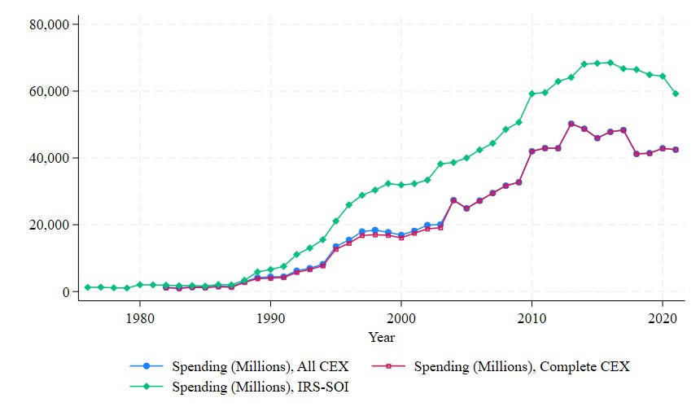
Notes: Authors’ tabulations from Bureau of Labor Statistics Consumer Expenditure Survey and Internal Revenue Service Statistics of Income data.

Figure B2: Average Benefit, IRS Recipient Families vs Eligible CEX Consumer Units
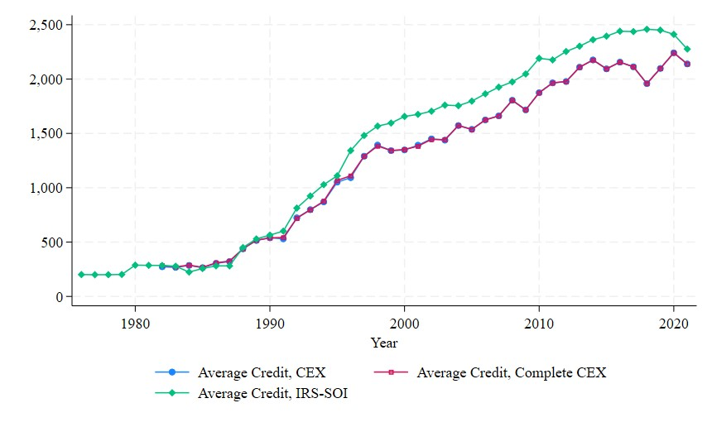
Notes: See Figure B1.

Figure B3: Number of Beneficiaries, IRS Returns vs CEX Consumer Units
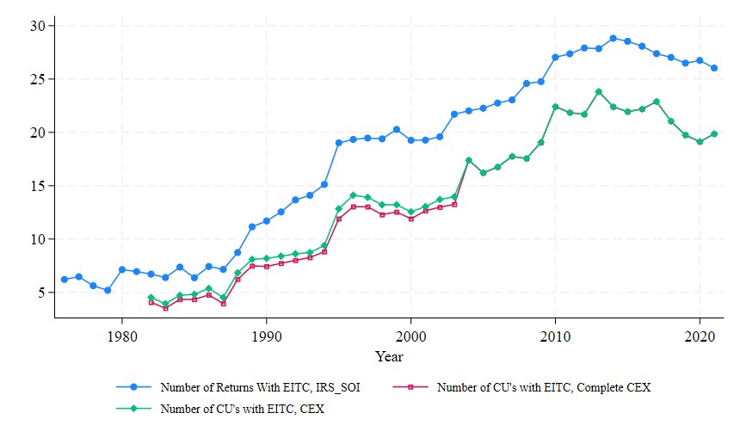
Notes: See Figure B1.

Figure B4: Median Household Pre-tax Income, Census vs CEX
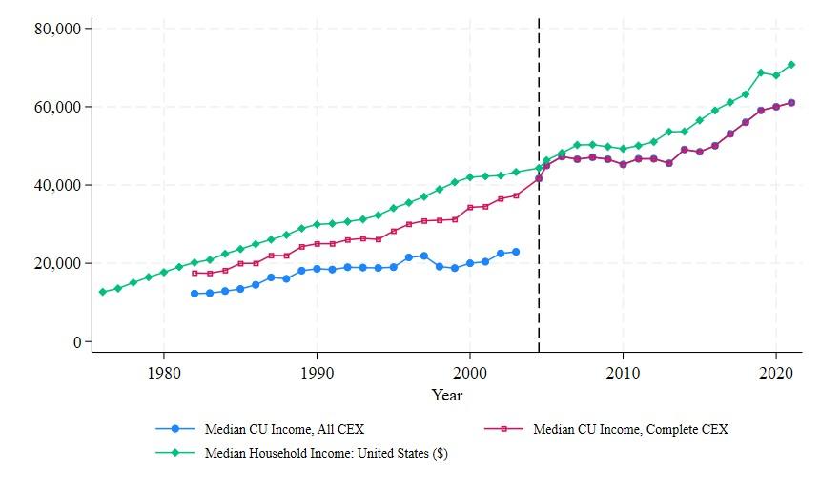
Source: Authors’ tabulations Bureau of Labor Statistics Consumer Expenditure Survey and Census Bureau.

Figure B5: Number of Children Under 18, Census vs CEX
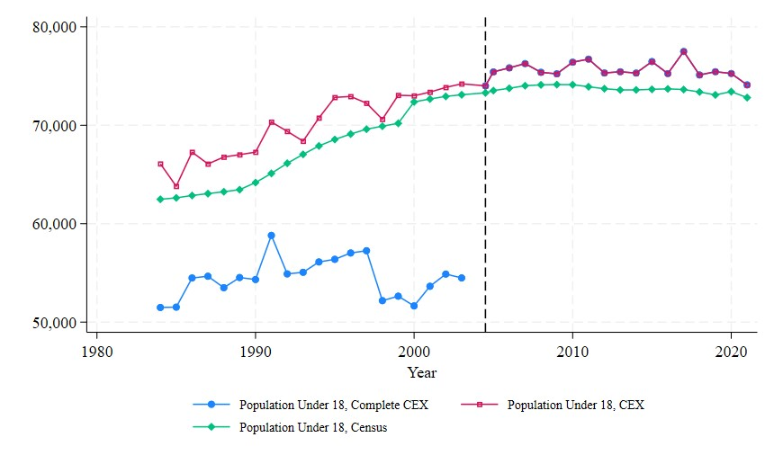
Source: See Table B4.

Data for all years are here: SOI Tax Stats – Individual Income Tax Returns Complete Report (Publication 1304) — Internal Revenue Service (irs.gov). As of April 4, 2024 data are available through Tax Year 2020.
Common Errors for the Earned Income Tax Credit (EITC) — Internal Revenue Service (irs.gov) and Department of the Treasury Agency Financial Report, p. 239.

