Appendix to Marijuana Legalization and Suicides Among Older Adults

- Dates of recreational and medical dispensary openings, and decriminalization
- Full Regression Results from Main Paper Table 1
- Wooldridge (2023) nonlinear difference-in-differences estimator
- Leave-one-state-out analyses
- Falsification test

1. Dates of recreational and medical dispensary openings, and decriminalization

Appendix Table A1: Dates of Dispensary Openings and Decriminalization
State | Recreational Marijuana Dispensary | Medical Marijuana Dispensary | Decriminalization
Alaska | 10/1/2016 | 10/1/2016 | 2/1/2015
Alabama
Arkansas |  | 5/11/2019
Arizona | 1/22/2021 | 12/6/2012 | 11/30/2020
California | 1/1/2018 | 1/1/2004 | 1/1/1976
Colorado | 1/1/2014 | 6/7/2010 | 12/1/2021
Connecticut |  | 8/20/2014 | 7/1/2011
Washington DC |  | 7/29/2013
Delaware |  | 6/26/2015 | 12/1/2015
Florida |  | 12/19/2018
Georgia
Hawaii |  | 8/8/2017 | 1/1/2020
Iowa
Idaho
Illinois | 1/1/2020 | 11/9/2015 | 7/1/2016
Indiana
Kansas
Kentucky
Louisiana |  | 8/6/2019 | 6/14/2021
Massachusetts | 11/20/2018 | 6/24/2015 | 1/1/2009
Maryland |  | 7/6/2017 | 10/1/2014
Maine | 10/9/2020 | 3/31/2011 | 5/1/1976
Michigan | 12/1/2019 | 6/15/2018 | 12/6/2018
Minnesota |  | 7/1/2015 | 1/1/1976
Missouri |  | 10/17/2020 | 12/8/2022
Mississippi |  | 1/25/2023 | 7/1/1977
Montana | 1/1/2021 | 12/1/2016 | 1/1/2021
North Carolina |  |  | 7/1/1977
North Dakota |  | 3/1/2019 | 7/1/2019
Nebraska |  |  | 1/1/1979
New Hampshire |  | 4/30/2016 | 9/1/2017
New Jersey | 4/21/2022 | 12/6/2012 | 2/22/2021
New Mexico | 4/1/2022 | 7/1/2009 | 5/1/2019
Nevada | 7/1/2017 | 7/31/2015 | 10/1/2001
New York | 12/29/2022 | 1/7/2016 | 7/1/1977
Ohio |  | 1/16/2019 | 8/1/1975
Oklahoma |  | 10/26/2018
Oregon | 10/1/2015 | 3/24/2014 | 1/1/1973
Pennsylvania
Rhode Island | 12/2/2022 | 4/19/2013 | 4/1/2013
South Carolina
South Dakota |  | 7/27/2022
Tennessee
Texas
Utah |  | 3/2/2020
Virginia |  | 10/17/2020 | 7/1/2020
Vermont | 10/1/2022 | 6/21/2013 | 6/1/2013
Washington | 7/1/2014 | 7/22/2011 | 12/6/2012
Wisconsin
West Virginia
Wyoming
Marijuana laws and active dispensary dates until December 2019 come from the OPTIC-Vetted Medical Marijuana Policy Data from RAND (RAND-USC Schaeffer Opioid Policy Tools and Information Center 2020). Additional dates through 2022 are collected from news articles and Anderson and Rees (2023). Decriminalization dates come from NORML (2023).

- Full Regression Results from Main Paper Table 1

Appendix Table A2: Full Results from Main Table 1, Effects of Marijuana Laws on Suicides, by Age
 | Age 45 + | Age 45-54 | Age 55-64 | Age 65-74 | Age 75 + | Age 25-34 | Age 35-44
 | (1) | (2) | (3) | (4) | (5) | (6) | (7)
Recreational dispensary | -0.044**  (0.021) | -0.066**  (0.027) | -0.043*  (0.025) | -0.020  (0.031) | -0.037  (0.030) | -0.008  (0.030) | -0.027  (0.028)
Medical dispensary | 0.00002  (0.014) | -0.001  (0.022) | 0.002  (0.018) | 0.037*  (0.022) | -0.026  (0.019) | -0.019  (0.016) | -0.024  (0.019)
Decriminalization | 0.030  (0.022) | 0.031  (0.029) | 0.039  (0.026) | 0.007  (0.026) | 0.033  (0.029) | -0.014  (0.024) | 0.032  (0.028)
Unemployment rate | -0.003  (0.004) | -0.005  (0.006) | 0.003  (0.005) | 0.004  (0.006) | -0.017**  (0.007) | -0.013***  (0.005) | -0.004  (0.005)
Percent poverty | -0.000  (0.003) | -0.002  (0.004) | -0.000  (0.003) | 0.003  (0.004) | 0.003  (0.003) | -0.002  (0.003) | 0.001  (0.004)
Real income per capita | -0.007  (0.011) | -0.010  (0.013) | -0.005  (0.014) | 0.001  (0.010) | -0.015  (0.010) | -0.013**  (0.006) | -0.008  (0.009)
Uninsurance rate | 0.474**  (0.203) | 0.382  (0.306) | 0.777***  (0.286) | 0.449**  (0.210) | 0.726***  (0.188) | 0.129  (0.210) | -0.037  (0.228)
Real beer tax | 0.074  (0.083) | 0.104  (0.130) | 0.033  (0.105) | -0.037  (0.063) | 0.200***  (0.074) | -0.019  (0.136) | 0.038  (0.106)
Real cigarette tax | 0.015  (0.009) | 0.015  (0.014) | 0.015  (0.011) | 0.010  (0.014) | 0.015*  (0.009) | 0.001  (0.012) | 0.002  (0.012)
Prescription drug monitoring program | -0.005  (0.017) | -0.001  (0.021) | 0.004  (0.020) | -0.013  (0.022) | -0.023  (0.021) | 0.002  (0.021) | -0.016  (0.021)
Initial prescription limit | 0.020  (0.020) | -0.006  (0.027) | 0.045**  (0.023) | -0.012  (0.023) | 0.075***  (0.027) | -0.061***  (0.022) | -0.025  (0.027)
Pill-mill law | -0.023  (0.024) | -0.055  (0.037) | -0.030  (0.027) | 0.019  (0.022) | -0.004  (0.022) | -0.033  (0.029) | -0.026  (0.040)
Covid death rate | 0.000  (0.000) | 0.001*  (0.000) | -0.000  (0.000) | 0.001  (0.000) | 0.000  (0.000) | 0.000  (0.000) | 0.001***  (0.000)
Observations | 1173 | 1173 | 1173 | 1173 | 1173 | 1173 | 1173
Mean suicide count | 408.38 | 152.26 | 119.29 | 68.57 | 68.25 | 124.65 | 132.92
Mean suicide count, pre-period, recreational dispensary states | 434.01 | 166.68 | 126.05 | 67.73 | 73.54 | 123.73 | 140.78
Recreational dispensary semi-elasticity | -0.04 | -0.06 | -0.04 | -0.02 | -0.04 | -0.01 | -0.03
Recreational dispensary marginal effect | -18.59 | -10.57 | -5.36 | -1.35 | -2.69 | -1.01 | -3.70
Standard errors in parentheses. State population used as exposure variable. Models also include state and year fixed effects.
* p < 0.10, ** p < 0.05, *** p < 0.01

3. Wooldridge (2023) nonlinear difference-in-differences estimator.

Estimates for suicides among people ages 45 and up are presented below using Wooldridge’s (2023) non-linear DiD estimator (using poisson). The model uses states that are never treated and not-yet-treated as the control group to be consistent with the ratio-in-ratios models in the main paper. Below, we present the average treatment effect among the treated (ATT), along with effects that show heterogeneity in states and time. That is, we present ATTs by state cohorts (grouping states that open dispensaries in the same year) and then by calendar year.

While this method provides insight into the time and states that drive the ATT, there are a few limitations to this method. The first is that the method only allows for the evaluation of one policy at a time. Given that medical marijuana dispensaries are relevant policy, it is important to include both laws and therefore we prefer the ratio-in-ratios model presented in Table 1. The second limitation of the Wooldridge estimator is that it does not allow for time-varying control variables in the model. Our main models include the time-varying state population on the right-hand side with the coefficient constrained to one to adjust for population exposure. Below we include the natural log of the average state population over the 20 years to adjust for population, but this is not a great assumption as some states’ populations have grown much faster than others.

The results in Appendix Table A3 show a statistically significant average treatment effect among the treated of -13.57 deaths. This translates into a reduction of about 3 percent, which is not far off from the 4 percent reduction shown in Table 1. The cohort analysis below shows positive ATTs for states that open dispensaries in the early years, but negative effects for most in later years. Similarly, the time analysis shows positive effects in the early years, and negative effects starting in 2018. This result is consistent with the event study analysis that shows negative effects starting about 3-4 years after the policies are passed.

Appendix Table A3: Results from Wooldridge’s estimator
ATT | -13.57 (6.61)
By Cohort
2014 (CO) | 30.16
2015 (WA) | 9.39
2016 (OR) | 2.55
2017 (AK) | -4.77
2018 (CA, NV) | -107.22
2019 (MA) | -2.37
2020 (IL, MI) | -18.45
2021 (AZ, ME, MT) | 16.57
2022 (NJ, NM) | -14.90
By Year
2014 (1 state) | 18.30
2015 (2 states) | -1.79
2016 (3 states) | 3.55
2017 (4 states) | 6.40
2018 (6 states) | -33.46
2019 (7 states) | -6.74
2020 (9 states) | -9.52
2021 (12 states) | -16.50
2022 (14 states) | -21.87

4. Leave-one-state-out analyses

We check for the influence of individual states by conducting a ‘leave-one-state-out’ analysis for each of the nineteen samples we analyze throughout the paper. The tables below summarize all results for recreational dispensaries, and select figures are shown. The full set of figures is available upon request.

In the tables below, the first row repeats the coefficients and standard errors on recreational dispensaries for full sample of states as reported in the paper. Below that we summarize the results of the fifty-one regressions that each omit one state. We report the number of coefficients that change sign, the number of coefficients that are statistically significant at the 5 and 10 percent levels, and we report the effect of removing largest influencers as determined by large changes in the magnitude of the coefficient. The results show that omitting some states can influence the results. Not surprisingly, omitting the early adopters and large population states (California, Nevada) exerts some influence on many results. This is also evident in the cohort analysis in Table A3 that shows large effects among these states. However, it is also notable that the results among individuals of different education levels are not influenced by any one particular state. This can be seen in Appendix Table A7 and in the figure A2 below for low educated, White males ages 45-54. Overall the results are nuanced but generally do not alter our main conclusions.

Appendix Table A4: Leave-one-state-out analysis summary, by Age Group

 | Age 45 + | Age 45-54 | Age 55-64 | Age 65-74 | Age 75 + | Age 25-34 | Age 35-44
Recreational dispensary – All States | -0.044**  (0.021) | -0.066**  (0.027) | -0.043*  (0.025) | -0.020  (0.031) | -0.037  (0.030) | -0.008  (0.030) | -0.027  (0.028)
Leave-one-state-out analysis summary
Sign of coefficients | All negative | All negative | All negative | All negative except for two | All negative except for one | All negative except for one | All negative
Number of models the coefficient on recreational dispensary is statistically significant (51 total models):
5% level | 41 | 49 | 2 | 0 | 0 | 0 | 0
10% level | 49 | 50 | 37 | 0 | 1 | 1 | 1
Effect of removing largest influencers. Beta and (SE) from omitting reported state. | CA = -0.015 (0.022) | CA = -0.038  (0.026) | CA= -0.014 (0.029)  NV = -0.026  (0.021) | CA = 0.015 (0.034)  NV = 0.003 (0.025)  OR = -0.037 (0.029) | CA = 0.0002 (0.032)  NV = 0.02 (0.028) | CO = -0.037 (0.022) | CO = -0.047 (0.026)

Appendix Table A5: Leave-one-state-out analysis summary, by Gender and Race/Ethnicity

 | Male | Female | White | Black | Hispanic | Asian | Native American
Recreational dispensary –All states | -0.038*  (0.020) | -0.057*  (0.030) | -0.048***  (0.014) | 0.003  (0.053) | 0.108**  (0.043) | 0.030  (0.063) | -0.065  (0.100)
Leave-one-state-out analysis summary
Sign of coefficients | All negative | All negative | All negative | 13 negative | All positive | All positive except for 1 | All negative except for 1
Number of models the coefficient on recreational dispensary is statistically significant (51 total models):
5% level | 9 | 7 | 50 | 0 | 50 | 0 | 0
10% level | 47 | 48 | 51 | 0 | 51 | 0 | 0
Effect of removing largest influencers. Beta and (SE) from omitting reported state. | CA = -0.014 (0.022)  NV = -0.024 (0.017) | CA = -0.015 (0.026)  OR -.074 (0.029)  WA -.0699 (0.032) | CA = -0.026 (0.014) | CA =0.078 (0.052) | CO = 0.076 (0.041)  FL .082 (0.042) | NV =0.076 (0.06)  WA -.002 (0.064) | CA =0.034 (0.11)

Appendix Table A6: Leave-one-state-out analysis summary, by Education Level

 | HS or less | Some college | College | Low educated white males age 45-54 | Low educated white females age 45-54
Recreational dispensary –All states | -0.062*  (0.032) | 0.007  (0.030) | -0.056**  (0.026) | -0.066**  (0.033) | -0.068  (0.044)
Leave-one-state-out analysis summary
Sign of coefficients | All negative | All positive except for 3 | All negative | All negative | All negative
Number of models the coefficient on recreational dispensary is statistically significant (51 total models):
5% level | 15 | 0 | 44 | 29 | 2
10% level | 47 | 0 | 49 | 48 | 4
Apparent influencers | None | None | None | None | None

Figure A1

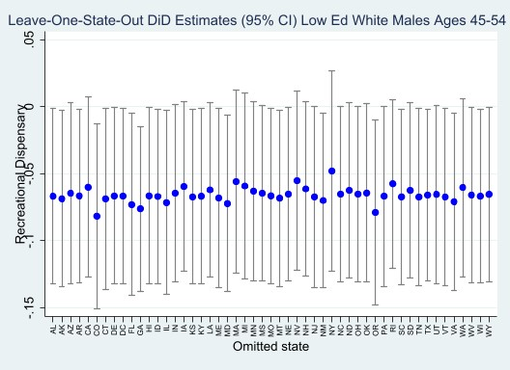

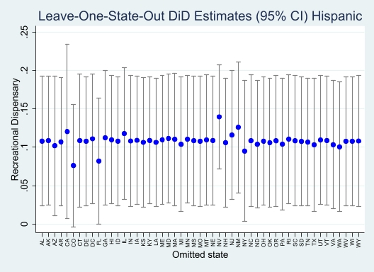
Figure A2

5. Falsification test

In order to conduct a falsification test, a desirable outcome should not be related to marijuana consumption but should follow a similar trend to suicide rates. Deaths from falls meet these criteria since falls tend to be accidents, should be unrelated to chronic pain, and not affected by marijuana consumption. The figure below confirms that both deaths have trended up over time, with the exception of the Covid dip for suicides. Regressing the count of deaths by falling on the recreational and medical marijuana dispensary opening dates, the marijuana decriminalization indicator, all other state-specific variables, and state and year fixed effects yields the results presented in Table A4 below. Importantly, the results show small and statistically insignificant coefficients on recreational and medical dispensary openings providing some evidence that the suicide results are not spurious.

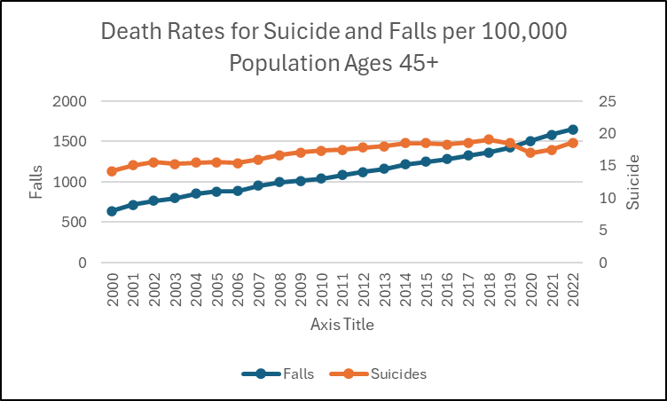
Figure A3
Appendix Table A7: Effects of Marijuana Dispensary Openings on Deaths from Falls,
Ages 45 and Up
Recreational dispensary | 0.022  (0.030)
Medical dispensary | -0.005  (0.019)
Decriminalization | 0.005  (0.035)
Unemployment rate | -0.015*  (0.008)
Percent poverty | 0.008*  (0.005)
Real income per capita | -0.018  (0.013)
Uninsurance rate | 0.709**  (0.322)
Real beer tax | 0.016  (0.101)
Real cigarette tax | 0.013  (0.015)
Prescription drug monitoring program | -0.024  (0.030)
Initial prescription limit | 0.102***  (0.027)
Pill-mill law | -0.027  (0.040)
Covid death rate | -0.000  (0.000)
Observations | 1173
Standard errors in parentheses. State population used as exposure variable. Model also includes state and year fixed effects.
* p < 0.10, ** p < 0.05, *** p < 0.01

